**Polysensor**

A Sensor System for Water Quality Monitoring

Indian Institute of Technology – Bombay / Media Lab Asia

Presently the purity of water in our increasingly polluted environment can only be tested in laboratories using expensive equipment and highly trained technicians. This project aims at providing a low-cost and easy method of testing the impurities in water, with low-cost, rugged and tropicalized sensors.

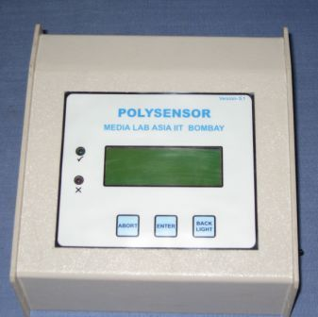

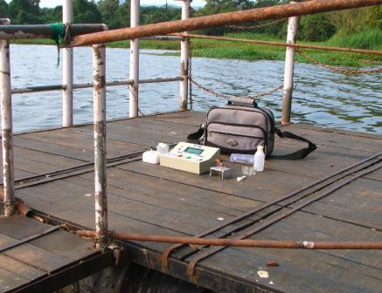

**Features of Instrument:**

* Basic Operating Principle – Potentiometry
* Lower limit as specified by WHO, no other instrument can go till that limit without pre-concentration
* Direct readout after automatic comparison with WHO specified limits
* Small size ; can be easily taken to site
* Convenient for application in rural areas, particularly un-electrified areas
* One instrument, one cartridge, many parameters together
* Easily repairable, Fully indigenous
* Any other parameter can be added theoretically. Only suitable sensor designing required
* Highly cost effective compared to existing technologies

**Technical Features:**

* The instrument works on +/- 3.6 Volts battery
* In-built battery charging facility
* 20 char X 4 line LCD
* Green and Red LED indicator for illiterate users
* User-friendly 2 key(enter and abort) interface
* Serial data upload
* MSP430F449 micro-controller ; with 64KB flash memory
* Backlight to the display
* Provision for storing the calibration and last measured data in flash memory automatically
* 8 channel 12 bit ADC for 8 different parameters

Current instrument can measure:

pH

Electrical Conductance(EC)

Total Dissolved Solids (TDS)

Nitrate Ion

Chloride Ion

Salinity

Fluoride ion (to be added soon).

Measurement Window of Polysensor & WHO limits:

|  |  |  |  |
| --- | --- | --- | --- |
| Parameter | WHO Limit | Polysensor Window Lower | Polysensor Window Higher |
| pH | 6.5 to 8.5 | 5 | 9 |
| Chloride | < 600 ppm | 5 ppm | 1000 ppm |
| Nitrate | < 45 ppm | 1 ppm | 100 ppm |
| EC | < 2500 μS/cm | 10 μS/cm | 3000 μS/cm |
| Salinity | < 987 ppm | 8.5 ppm | 1640 ppm |
| TDS | < 1600 ppm | 6.5 ppm | 1920 ppm |

Target Users:

General household applications ; complimentary to the purification technologies

People in potentially hazardous areas

Water quality & Pollution monitoring agencies

Medical practitioners & patients in economically backward areas

Food processing, Beverages

Fisheries

Possible Extensions of the technology:

Healthcare

Agriculture

Diary

Contact Information:

Prof. A Q Contractor  
Department of Chemistry  
Indian Institute of Technology - Bombay,  
Powai, Mumbai - 400 076  
Maharastra, INDIA  
E-mail: [aqcontractor@iitb.ac.in](mailto:aqcontractor@iitb.ac.in)  
URL: [http://www.dil.iitb.ac.in/poly/index.htm](%20http://www.dil.iitb.ac.in/poly/index.htm)  
References: [http://www.medialabasia.org/](%20http://www.medialabasia.org/)  
Tel: +91-22-25764193