
How an Elephant Pump is built
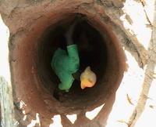 | First, a well is dug by the local community.  The person digging the well climbs down using holes cut into the walls, as shown on the left.  The well is then lined with bricks to prevent the walls collapsing while allowing infiltration of ground water. A cement ring at the top prevents burrowing animals entering the well.
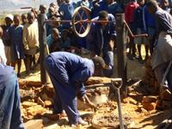 | The axle is supported above the centre of the well by two treated poles.
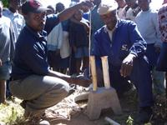 | The rope guide, which sits at the bottom of the well, is carefully assembled
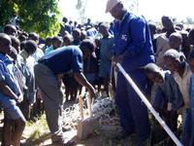 | The nylon rope, with washers every 70cm, is threaded through the rope guide and PVC pipe. The design allows for a large margin of error in choosing the washer size, which makes the pump easier for the community to repair.
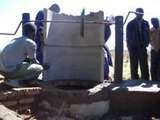 | The concrete housing in assembled. This ensures that the water source is totally protected from contamination. It (and the concrete apron below) is completely separate from the working mechanism of the pump, which prevents cracks appearing in the concrete over time. Such cracks would allow the water supply to be contaminated by dirty surface water.
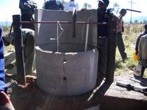 | The rope guide, PVC pipe, and nylon rope are lowered into the well.
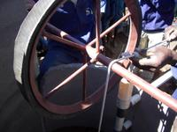 | The two ends of the nylon rope are tied together before being looped over the central wheel on the axle
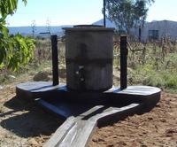 | A concrete slab with a removable lid covers the top of the pump. All that remains is for the Elephant Pump to be painted

