How to build an Elephant Toilet
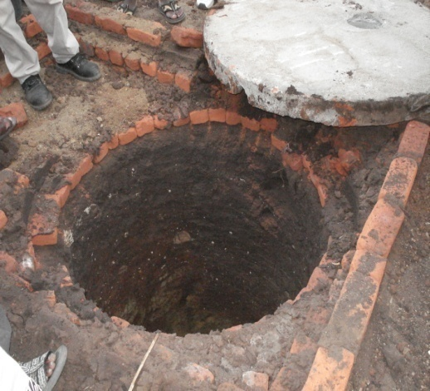
First a pit about 3 metres deep is dup and lined with stones.

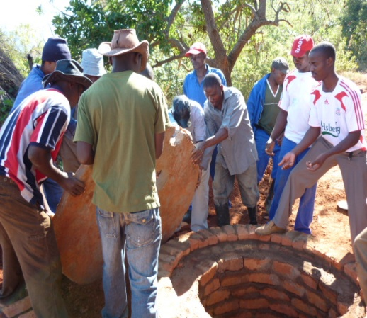
A concrete slab is then laid over the pit.

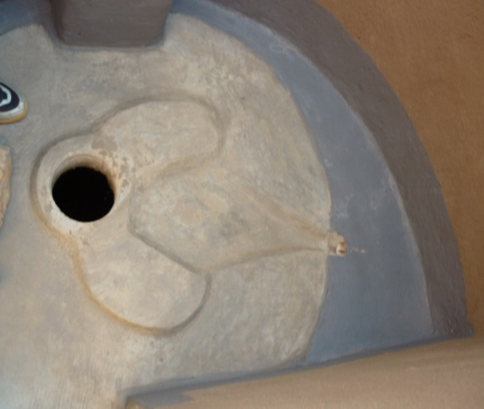
The concrete slab has two elephant ears as a marker of where to stand, a hole for solid matter and an elephant’s trunk to channel the urine away from the pit. This allows the faeces to decompose and can be used as a fertiliser once the pit is full.

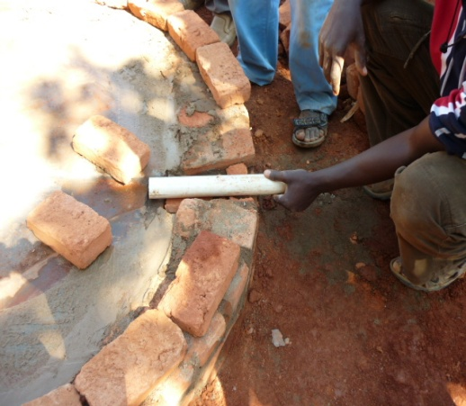

This is the urine diversion from the toilet. It goes into a soil pit behind the toilet, enriching the soil with nutrients. The soil can be used for fertilising crops.
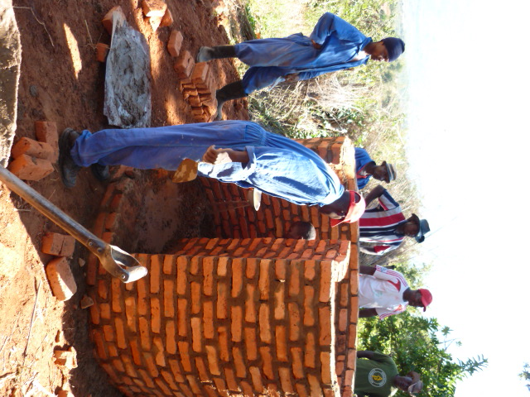
A wall, using sundried bricks rather than wood to prevent deforestation, is then built around the pit.

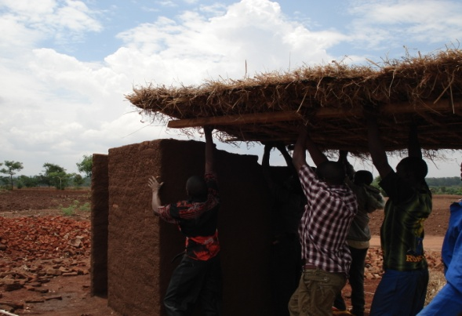
Once the wall is built a thatched roof is placed on top of it providing users with shelter and privacy.

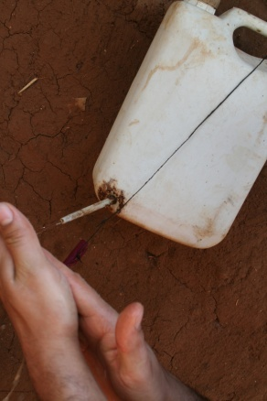

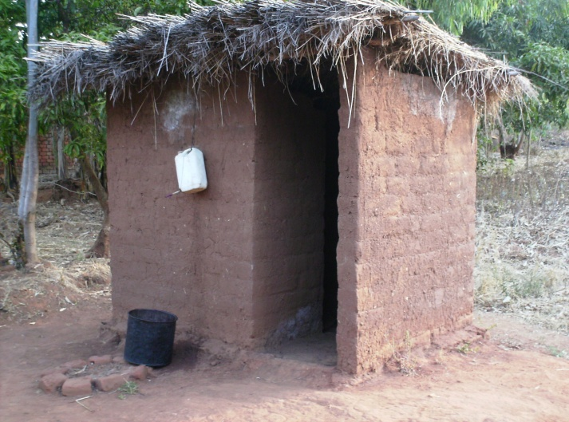
This is a container with hand wash. The hand wash is made using the local plant Seso.

This is the completed Elephant Toilet.

