Referenced file contains errors (http://www.springframework.org/schema/data/jpa/spring-jpa.xsd). For more information, right click on the message in the Problems
View and select "Show Details...",配置文件出现如上所示的错误信息
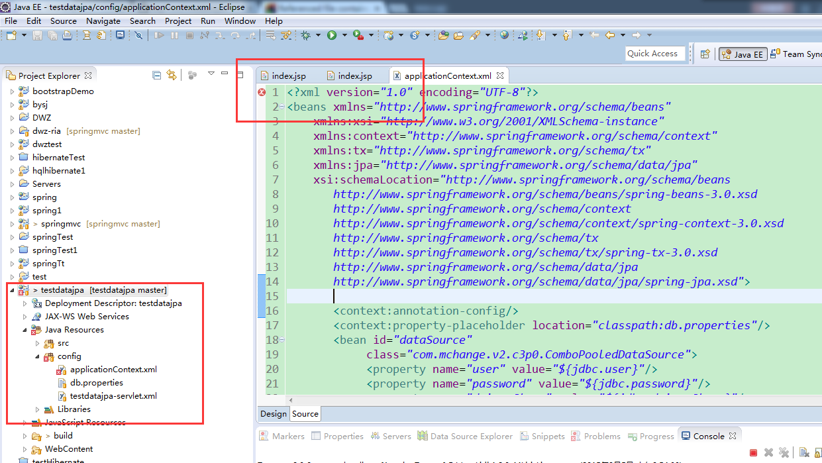

解决方法：
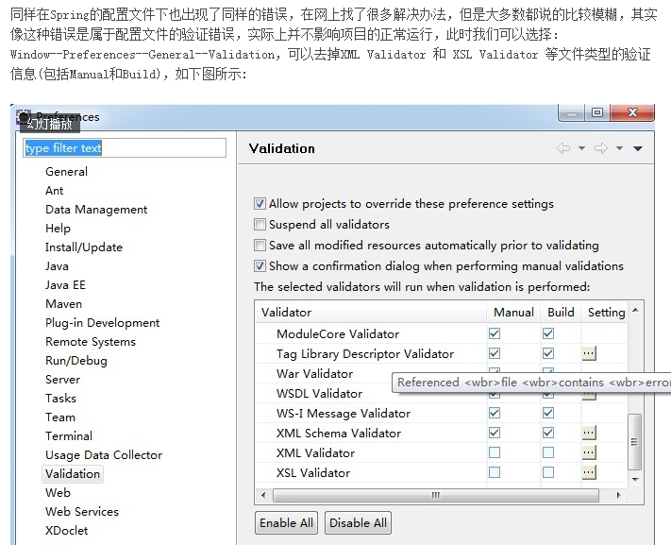

在写安卓端的webService接口时，用浏览器访问时出现如下错误
