Fractured Order 2.0
Blue Team National Interest
Methodology & Adjudication Process
Statecraft Simulations Group · T20 Adjudication Deliverable
Version 1.0 · July 08, 2026

1. Executive Summary
This report describes how White Cell adjudicates Blue Team national interest in Fractured Order 2.0. The approach combines a bipartisan six-domain framework grounded in 30+ years of National Security Strategy language, NWC tier grammar for scoring rigor, and a four-layer decision process applied per economic action each MOVE.
U.S. National Interest is scored on a cumulative −5 to +5 scale. PRC Competitive Position (not symmetric PRC NI) tracks competition separately. Domain-level detail is White Cell and post-game export; players see a simplified plenary band (Stronger / Mixed / Weaker) plus Glasl escalation.

2. Purpose & Scenario Context
FO2.0 adjudicates U.S. national interest movement for each Blue economic action in a 2027–2031 competitive-stability scenario. Inputs come from the Blue MOVE Sheet parsed as BlueEconomicAction JSON (action ID, SSG-B-01 levers, strategic orientation, sector, target, allies, implementation specificity).
Evidence base for domain definitions: NSS corpus (1993–2025), NSS Interest Matrix, and 2025 NWC NSS Primer. Methodology reference: US_National_Interest_Assessment_Methodology.md.

Design Decisions (Locked)
Decision | FO2.0 Choice
PRC scoring | PRC Competitive Position only (−5 to +5). PRC NI retired.
Live vs. analytic | Plenary: U.S. NI + band + Glasl + PRC Competitive Position. Domain tier Δs: White Cell / export only.
Administration Lens | No default. Bipartisan weights. Optional facilitator toggle: Biden 2022 or Trump 2025 (±0.2).

3. Six National Interest Categories (NI-1 through NI-6)
Presidential NSS documents emphasize objectives and regional priorities rather than explicit vital/major/peripheral labels. These six domains distill bipartisan language across administrations into FO2.0 scoring dimensions.
ID | Domain | Definition
NI-1 | Homeland & Strategic Access | Protection of the American people, territory, and critical infrastructure; energy and strategic supply access; force posture adequate to deny catastrophic harm.
NI-2 | Economic Prosperity & Tech Leadership | U.S. competitiveness, jobs, innovation, industrial capacity, and leadership in sectors that define long-run power (semiconductors, biotech, telecom, critical minerals).
NI-3 | Alliance / Partner Credibility | Willingness of allies and key partners to align with U.S. policy, share burden, and resist hedging toward adversaries or alternative blocs (e.g., BRICS+).
NI-4 | Indo-Pacific Stability & Deterrence | Regional balance that prevents PRC coercion, preserves Taiwan-related supply chains, and avoids uncontrolled escalation — without assuming general war.
NI-5 | Rules / Market Integrity / Reciprocity | U.S. ability to shape standards, trade rules, financial architecture, and nonproliferation norms; enforce reciprocity against unfair practices.
NI-6 | Domestic Political Sustainability | Congressional and public support for the strategy; industry acceptance; avoidance of self-inflicted economic shock that undermines policy continuity.

Domain Detail & FO2.0 Action Signals
NI-1: Homeland & Strategic Access
Protection of the American people, territory, and critical infrastructure; energy and strategic supply access; force posture adequate to deny catastrophic harm.
Typical FO2.0 action signals: Stockpiling, DPA authorities, critical infrastructure protection, energy and mineral access.
NI-2: Economic Prosperity & Tech Leadership
U.S. competitiveness, jobs, innovation, industrial capacity, and leadership in sectors that define long-run power (semiconductors, biotech, telecom, critical minerals).
Typical FO2.0 action signals: Industrial policy, R&D consortia, export promotion, sector-specific reshoring.
NI-3: Alliance / Partner Credibility
Willingness of allies and key partners to align with U.S. policy, share burden, and resist hedging toward adversaries or alternative blocs (e.g., BRICS+).
Typical FO2.0 action signals: Allied compacts, DFC/BUILD financing, EU coordination, third-party alignment choices.
NI-4: Indo-Pacific Stability & Deterrence
Regional balance that prevents PRC coercion, preserves Taiwan-related supply chains, and avoids uncontrolled escalation — without assuming general war.
Typical FO2.0 action signals: Taiwan-adjacent measures, Korea/Taiwan supply chains, escalation-sensitive actions.
NI-5: Rules / Market Integrity / Reciprocity
U.S. ability to shape standards, trade rules, financial architecture, and nonproliferation norms; enforce reciprocity against unfair practices.
Typical FO2.0 action signals: Section 301/232, export controls, IEEPA, standards bundles, digital finance rules.
NI-6: Domestic Political Sustainability
Congressional and public support for the strategy; industry acceptance; avoidance of self-inflicted economic shock that undermines policy continuity.
Typical FO2.0 action signals: Inflation impact, congressional feasibility, industry backlash, procurement cost.

Domain Weights (Competitive-Stability Baseline)
Domain | Weight
NI-2 Economic Prosperity & Tech Leadership | 1.0
NI-3 Alliance / Partner Credibility | 1.0
NI-4 Indo-Pacific Stability & Deterrence | 0.9
NI-5 Rules / Market Integrity / Reciprocity | 0.8
NI-1 Homeland & Strategic Access | 0.7
NI-6 Domestic Political Sustainability | 0.6

4. Four-Layer Adjudication Process
Layer 1 — Tag Inputs. Tag SSG-B-01 levers (rank 1–8, weights sum ≈ 1). Record strategic orientation (Pressure, Stabilization, Reframing), sector, target, allies, and implementation specificity.
Layer 2 — Domain Mapping. Apply orientation priors to shortlist NI domains. Assign 1–2 primary domains and 0–1 secondary domain. Reference NSS Interest Matrix for NSS alignment notes.
Layer 3 — NWC Tier Deltas (White Cell). For each mapped domain, assign tier Δ from −2 to +2 using NWC Vital/Major/Peripheral grammar. Record confidence and effect horizon. Domain detail is not shown in plenary.
Layer 4 — Roll-Up & Plenary Output. Compute weighted U.S. NI delta, update cumulative score (−5 to +5), score PRC Competitive Position separately, assign plenary band, update Glasl. Output national_interest_assessment JSON.

Orientation Priors
Orientation | Primary Domains | Effect Horizon
Pressure | NI-4, NI-3, NI-5 | Same MOVE (~2 notional years)
Stabilization | NI-3, NI-1, NI-6 | 1 MOVE
Reframing | NI-2, NI-5, NI-4 | 1–2 MOVEs

5. Layer Decision Flowchart
Figure 1 depicts the complete decision process from Blue MOVE Sheet submission through post-MOVE summary.
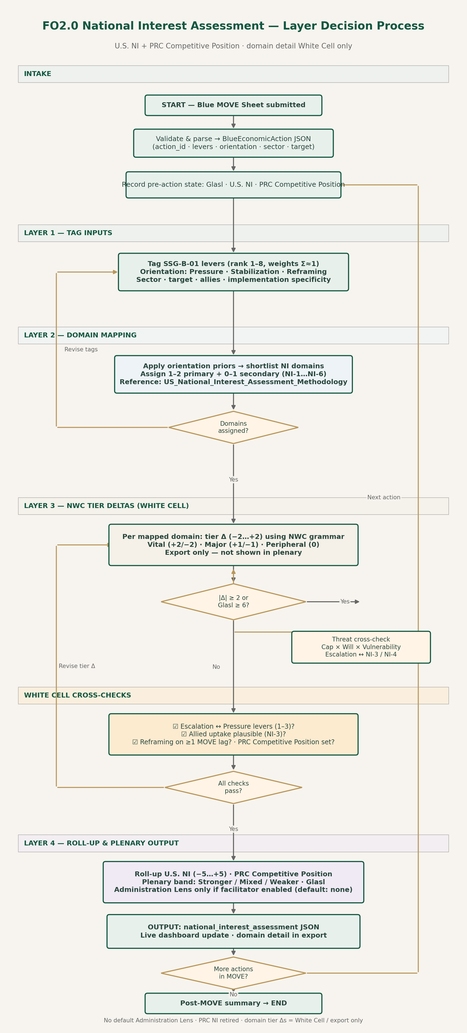
Figure 1. FO2.0 National Interest Assessment — Layer Decision Process
Process summary:
- INTAKE: Validate BlueEconomicAction JSON; record pre-action Glasl, U.S. NI, PRC Competitive Position.
- LAYER 1: Tag SSG-B-01 levers, orientation, sector, target.
- LAYER 2: Map NI domains — if unassigned, revise tags.
- LAYER 3: Assign NWC tier Δ per domain; threat cross-check if |Δ| ≥ 2 or Glasl ≥ 6.
- WHITE CELL: Cross-check escalation, allied uptake, reframing horizon, PRC Competitive Position.
- LAYER 4: Roll up U.S. NI, assign plenary band, update dashboard; loop for next action or post-MOVE summary.

6. NWC Tier Rubric (White Cell Grammar)
Source: 2025 NWC NSS Primer. Presidential NSS texts rarely use these labels; White Cell applies them as adjudication grammar.
Tier | Definition | Tier Δ Use
Vital | State would bear nearly any cost/risk to protect | +2 / −2 sparingly
Important / Major | State weakened if it did not act; costs weighed | Default +1 / −1
Peripheral | Desirable only if costs/risks extremely limited | 0 unless trivial

Code | Meaning
+2 | Advances vital-level stake in domain
+1 | Supports major interest — clear net gain if credible
0 | Neutral or offsetting second-order effects
−1 | Weakens major interest
−2 | Damages vital-level stake (alliance rupture, catastrophic credibility loss)

Threat cross-check (high-magnitude negatives): Threat = Capability × Will × Vulnerability
Roll-up formula: us_ni_delta = clamp(Σ domain_weight × tier_delta × orientation_multiplier, −5, +5)

7. Dashboard & Plenary Output
Metric | Scale | Live in Plenary?
U.S. National Interest | −5 to +5 (cumulative) | Yes
Plenary band | Stronger / Mixed / Weaker | Yes
Glasl escalation | 1–9 | Yes
PRC Competitive Position | −5 to +5 (cumulative) | Yes
Domain tier Δs (NI-1…NI-6) | −2 to +2 per action | No — export only

Plenary Band Rules
Band | Default Condition
Stronger | U.S. NI delta ≥ +1 and no domain at −2
Mixed | Net change 0 or offsetting domain signs
Weaker | U.S. NI delta ≤ −1 or any domain −2

8. PRC Competitive Position — Explainer
PRC Competitive Position (−5 to +5, cumulative) measures whether the United States is gaining or losing ground relative to the PRC in long-run strategic competition — not whether China's "national interests" improved or declined. FO2.0 retired symmetric PRC NI from FO1.0.
Metric | Question It Answers
U.S. National Interest | Are America's interests (NI-1 through NI-6) stronger or weaker?
PRC Competitive Position | Did we win or lose ground vs. China in sectors, standards, and partner alignment?

Three Scoring Dimensions (White Cell)
- Sector ecosystem — leadership in telecom, biotech, agriculture, critical minerals.
- Standards uptake — partners on U.S./allied rules and tech vs. PRC or BRICS+ alternatives.
- Partner autonomy risk — allies aligning with Washington vs. hedging toward Beijing.

Why It Is Not a Mirror of U.S. NI
An action can advance U.S. NI with little competitive gain, or improve competitive position while damaging U.S. NI (e.g., sanctions that pressure China but fracture alliances). White Cell scores each track independently.
Action Pattern | U.S. NI (typical) | PRC Competitive Position (typical)
Allied minerals compact (Reframing) | Up modest | Up — reduced PRC leverage over time
Trusted connectivity financing (Reframing) | Up | Up — erodes PRC/BRICS+ digital appeal
Broad secondary sanctions (Pressure) | Down or flat (NI-3 cost) | Up short-run — may flatten if partners bypass

Scoring Guidance
- +1: Clear competitive gain in at least one dimension.
- 0: Neutral or offsetting; gains too slow to count this MOVE.
- −1: PRC or BRICS+ gains relative position.
One-line definition: Did this action shift the competitive balance toward or away from the United States in sectors, standards, and partner alignment — regardless of net U.S. national interest?

9. Scoring Worksheet — One MOVE Cycle
Up to four Blue economic actions per MOVE (~2 notional years).

Step A — Pre-MOVE State
Field | Record
MOVE number
Glasl (start) | 1–9
U.S. NI (start) | −5 to +5
PRC Competitive Position (start) | −5 to +5
Administration lens | null (default) / biden_2022 / trump_2025

Step B — Per Action (repeat ×4)
Field | Entry
Action ID | M_-A_
Orientation | Pressure / Stabilization / Reframing
Primary levers | SSG-B-01 ranks
Sector | Telecom / Biotech / Ag / Minerals / Mixed
Target | PRC / Ally / Third party / Domestic

Domain mapping (White Cell): for each NI-1…NI-6, record primary/secondary, tier Δ (−2…+2), confidence, horizon, rationale.
Cross-checks: escalation ↔ Pressure levers; allied uptake (NI-3); Reframing horizon ≥1 MOVE; PRC Competitive Position set.
Outputs: U.S. NI before→after, PRC Competitive Position before→after, Glasl, plenary band.

Step C — Post-MOVE Summary
- U.S. NI start → end
- PRC Competitive Position start → end
- Glasl start → end
- Dominant domain movers
- White Cell narrative (2–3 sentences)

10. Related Files
File | Location
FO2.0_NI_Adjudication_Spec.md | design/adjudication/
national_interest_assessment.schema.json | design/adjudication/
US_National_Interest_Assessment_Methodology.md | Summer 26 Research / NSS Folder
NSS_Interest_Matrix.xlsx | Summer 26 Research / NSS Folder
FO2.0_NI_Assessment_Flowchart.png | design/adjudication/

— End of Report —

