Scene Recognition with Convolutional Networks on 2,400 Images
Swapn Shah · ITCS 6169/8169 Assignment 1 · Code and checkpoint: https://github.com/sshah100-clt/CV_Assignment
1. Final Result
The submitted model averages five ResNet-18s, one from each cross-validation fold, pretrained on Places365 and fine-tuned on this set. Between them they have seen all 2,400 training images. On the 400 test images the average reaches 96.5% (95% CI 94.7–98.3%). Leaving Flower out and scoring only the 15 scene classes gives 96.3%. Removing the 4 test images that also appear in training leaves the accuracy at 96.5%, so those copies are not carrying the result. The test set was used once, after the recipe was fixed. Forest and Mountain are the weak classes, at 80% and 84% (5 and 4 wrong out of 25).
Validation strategy. Every model was chosen by stratified 5-fold cross-validation on the training set, three seeds each. CV accuracy pools the final-epoch prediction on each held-out fold, so every training image is scored once by a network that did not train on it. That is 2,400 predictions rather than 480. A single 480-image split has a standard error of about 1.4 points, wider than most of the gaps I was comparing. I report the final epoch, not the best epoch, because the best of many noisy checks runs high. Comparisons are paired McNemar tests [4] on the same images. The recipe I kept reaches 95.4 ± 0.2% CV accuracy (mean ± std over seeds).
Data audit. This is the 15-Scene benchmark [1] with a Flower class added, and three properties of the files changed the protocol. Only Flower is in colour. A colour model could name that class from the mode alone, so every image is converted to grayscale. Size is a cue as well: eight classes are always 256×256 and Suburb is always 330×220. A lookup on width, height and colour mode reaches 27.0% test accuracy without reading a pixel (chance is 6.25%). Training also contains 14 groups of exact duplicates, and 4 test images occur in the training set. A duplicate group stays inside one fold, and test accuracy is reported with those 4 copies and without them.
2. Secret Recipe
The network is a ResNet-18 [2] with Places365 weights [3], about 1.8 million scene images. The 365-way head is replaced by a 16-way layer, and every layer is fine-tuned. Input is the grayscale image copied onto three channels, 224×224, ImageNet normalisation. Augmentation is a random resized crop of 50–100% of the area and a horizontal flip. Training is AdamW, 10⁻³ on the new layer and 10⁻⁴ on the pretrained layers, weight decay 0.05, cosine decay with 2 warm-up epochs, batch size 64, 30 epochs, cross-entropy. The submitted prediction is the average of the five fold models’ softmax outputs. There is no test-time augmentation.
What mattered. The pretraining set mattered more than anything I changed after it. With the backbone frozen, Places365 features reach 94.4% CV accuracy and ImageNet features 90.8%. Frozen Places365 also beats a fully fine-tuned ImageNet model (93.3%). Places365 is higher in all three seeds, by 0.8 to 1.4 points (1.1 on average). The paired test is significant in two (p = 0.011 and 0.025) and not in the third (p = 0.16). Fine-tuning adds another 1.0 point. Weights learned on scenes transfer better here than weights learned on objects.
3. Experimental Journey
I trained from scratch first, one change at a time, and only then tried transfer learning (Table 1). Figure 1 is the from-scratch half of that path. It splits the third table row into its three changes: 60 epochs, the cosine schedule and AdamW.
Experiment (one change per row) | Accuracy (%) | Observation
Starter TNet, 64 px gray, 20 epochs | 44.7 ± 1.6 | already 99% train accuracy
+ 8-layer CNN with BatchNorm | 68.4 ± 0.3 | starter lacked capacity
+ 60 epochs, cosine schedule, AdamW | 79.7 ± 0.8 | 100% train accuracy: memorises
+ random crop and flip | 83.2 ± 0.3 | reduces overfitting
+ 128 px input | 85.6 ± 0.3 | finer detail helps
+ 150 epochs (best from scratch) | 86.5 ± 0.7 | better in all 3 seeds
ResNet-18, ImageNet, frozen backbone | 90.8 ± 0.3 | new linear layer only
ResNet-18, ImageNet, fine-tuned | 93.3 ± 0.2 | +2.5 from fine-tuning
ResNet-18, Places365, frozen backbone | 94.4 ± 0.1 | beats fine-tuned ImageNet
ResNet-18, Places365, fine-tuned | 95.4 ± 0.2 | selected recipe
Final model: average of the 5 fold models above | 96.5 (test) | test set, used once
Table 1. CV accuracy (mean ± std over 3 seeds, 5 folds each), except the last row (test). From-scratch rows are cumulative.
The starter network was already at 99% training accuracy, so it was memorising from the start. A deeper network and longer training gave most of the gain. Training accuracy then sat at 100% against about 80% CV accuracy, which is why augmentation was the next thing to try. Learning rate mattered and weight decay did not: 3×10⁻⁴ gave 73% and 3×10⁻³ gave 80%, for every weight decay from 5×10⁻⁴ to 0.05. After augmentation, learning rates from 10⁻³ to 3×10⁻³ were tied (85.5–85.6%), while 10⁻² lost 1.0 point. Dropout, squeeze-and-excitation [5], Mixup [6]/CutMix [7] and label smoothing each moved accuracy by less than 0.4 points, so I left them out.
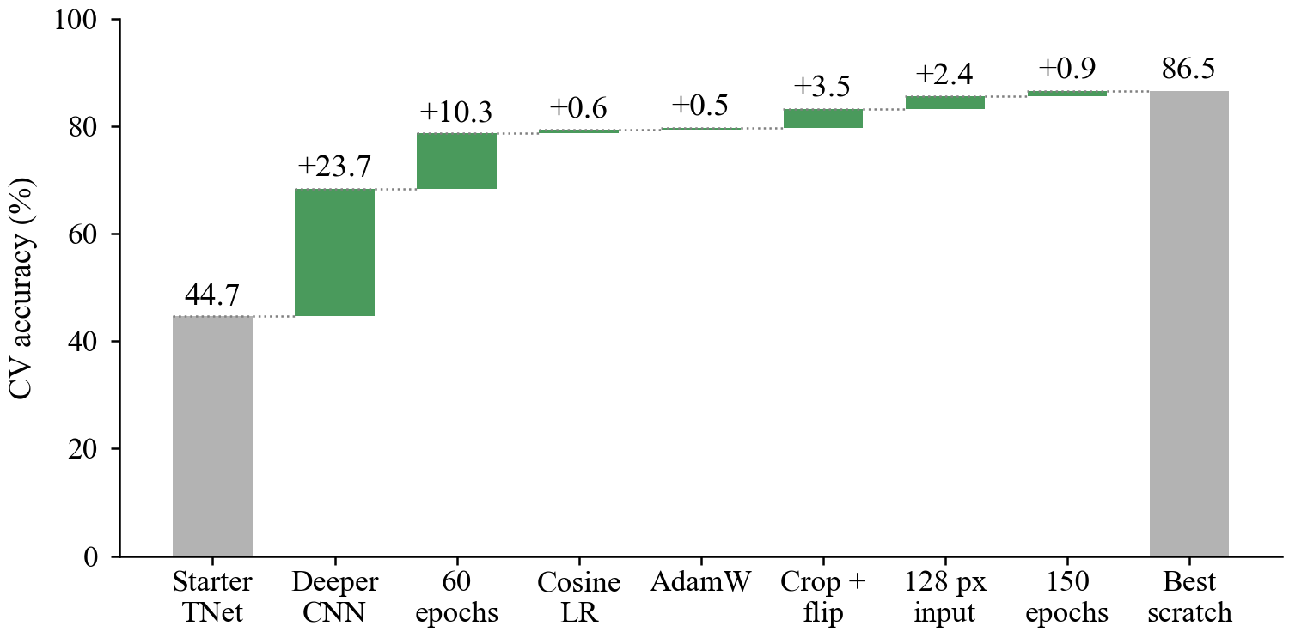
Figure 1. CV accuracy of the from-scratch CNN as changes are added one at a time.
4. Failure Analysis
The change I expected to help, and that did not, was the pooling layer on the from-scratch CNN. I replaced global average pooling with soft spatial attention: a 1×1 convolution scores each location, and a softmax over locations turns those scores into pooling weights. The idea was that the classifier would put its weight on the region that matters, a bird rather than the sky around it. Accuracy fell from 85.6% to 82.5%, in all three seeds (McNemar p < 0.001 each). On this data a scene is a layout, not an object in one region, and averaging the whole map is the better summary.
The mistakes line up with that. On the pooled cross-validation predictions of the selected model, not on the test set, the common confusions are OpenCountry called Coast (14 images) and Bedroom mixed with LivingRoom (15 images). Both pairs share a layout, an open horizon or a furnished room. A second guess also failed. I expected squashing each image to a square to help, because the stretch would keep the class-specific size visible. Keeping the aspect ratio instead made no measurable difference (−0.4 points, p > 0.2 in each seed, on the 8-layer CNN at 64 px), so the network does not seem to use the size cue.
5. AI + Human
Claude Code was the pair programmer. It turned the starter notebook into a script pipeline with cross-validation and a multi-GPU launcher, and a data check it wrote is what found the duplicates and the size shortcut. I did not take its suggestions as given. It wanted RGB input, on the usual grounds that colour helps with scenes. Only Flower is in colour, so RGB would have marked that class from the mode alone, and the input stayed grayscale. Its first frozen-backbone option still updated BatchNorm statistics, so it was not a true frozen extractor until the bug was caught in review and fixed. From the 60-epoch curves it also said longer training would barely help. The 150-epoch run gained 0.9 points, better in all three seeds. Stopping at ResNet-18, rather than waiting on larger models, was my call. Cross-validation had already answered the comparison I cared about. The longer notes are in AI_USAGE.md.
References
[1] S. Lazebnik, C. Schmid, J. Ponce. Beyond bags of features: spatial pyramid matching for recognizing natural scene categories. CVPR, 2006.
[2] K. He, X. Zhang, S. Ren, J. Sun. Deep residual learning for image recognition. CVPR, 2016.
[3] B. Zhou, A. Lapedriza, A. Khosla, A. Oliva, A. Torralba. Places: a 10 million image database for scene recognition. IEEE TPAMI, 2018.
[4] Q. McNemar. Note on the sampling error of the difference between correlated proportions or percentages. Psychometrika, 1947.
[5] J. Hu, L. Shen, G. Sun. Squeeze-and-excitation networks. CVPR, 2018.
[6] H. Zhang, M. Cisse, Y. N. Dauphin, D. Lopez-Paz. mixup: beyond empirical risk minimization. ICLR, 2018.
[7] S. Yun, D. Han, S. J. Oh, S. Chun, J. Choe, Y. Yoo. CutMix: regularization strategy to train strong classifiers with localizable features. ICCV, 2019.

