Model 2 - Predicting total sales of Peanut Butter (PB) for each household in a year.

PB manufacturers and grocery stores would like to know how they can sell more PB each year. So it would be useful to get a sense of what factors affect annual sales for a particular household. This model tries to find significant variables that explain the total sales of PB for a household. For the dependent variables, we used quantitative variables of the households such as price (per oz) extended to that household and demographic variables such as income quartiles of the households. The dependent variable was the log of total amount of PB (oz) purchased by household. Below are the results:

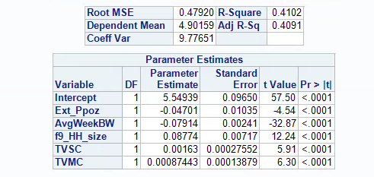

We initially used the total PB purchased as the dependent variable. However when we used the log of total PB purchased we got a more random distribution of the residuals (one of the assumptions of linear regression) and a higher R-squared. Hence we used the log of sales as a dependent variable.

The significant variables are price (per oz) of PB extended to the household, household size, average weeks between PB purchases, total value of store coupons and total value of manufacturer coupons. We also ran the regression with many other demographic variables such as income level and working status of male and female heads in the household. A common use of Peanut Butter may be in making sandwiches, so we also checked if whether the household has a toaster or not affects PB purchases. And finally, if a household having cable or not (because of the increased advertising reach) has an effect on PB purchases. However, none of the additional variables just mentioned had a significant effect on total PB purchases.

The results give us some interesting insights and some obvious ones. It is obvious that as price extended increases, total PB purchase decreases. It is also obvious that as a household becomes bigger, total PB purchase increases. However, the value of these coefficients is interesting. As one member is added to a household, total PB purchase goes up 8.8%. This information may be valuable to advertising companies if they need to promote PB sales. They could target larger households. Similarly, PB selling stores could try to decrease time between PB purchases, maybe by better placement of products in their stores. And finally, PB manufacturers could try to reduce prices or increase PB coupon values to increase sales.

The R-Square of this model was 41%. Predicting household-level sales is a somewhat difficult task given that there is a high amount of randomness in household-level behavior, as there is in consumer-level behavior. However, this is a decent value for R-squared and the PB manufacturers and stores may derive useful insights from this model.

Model 3 - Logistic Regression to find factors that influence high loyalty towards Jif.

The next step was to analyze PB purchasing from the perspective of the major brands. To do this analysis, we first looked at how just the price of a brand and the price of the competitors brands affected the total PB purchased (oz) in each week. To account for the market share, we used the log of total sales as the dependent variable and the price of the own brand the two competitor brands as the independent variables. We ran this regression for all three brand. Here are the results:

|  |  |  |  |  |
| --- | --- | --- | --- | --- |
| Brand | Own Price | Competitor1 Price | Competitor2 Price | R-Squared |
| Jif | Insignificant | Insignificant | Insignificant | 0.11 |
| Skippy | -0.48 | Insignificant | Inisignificant | 0.54 |
| Peter Pan | -0.48 | Insignificant | Insignificant | 0.70 |

A notable observation from these results are that price is a significant predictor for Skippy and Peter Pan. but not for Jif. The R-squared for the regression with Jif is also quite low. For Skippy and Peter Pan, it is much higher. This tells us that for Jif, there are factors other than price that play an important role in its purchasing.

So we did a deep dive on what kind of customers are loyal to Jif. In our annual table, for each household we have how much of their total annual purchases come from each brand. For households that have purchased 50% or more of their total PB from Jif, we defined them as loyal to Jif. We created a dummy variable that would be 1 if a household had a Jif share of more than 50%, and 0 otherwise. We also have demographic information for each household in the annual table. We ran a logistic regression on this dummy variable as the dependent variable and the demographic variables as the independent variables. Here are the results:

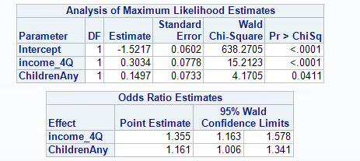

The significant variables are “Income_4Q” which is a dummy variable indicates if a household is in the 4th quartile of income (households with income more than $35K), and “ChildrenAny” which indicates if a household has any children or not. We also used the interaction term as an independent variable but that turned out to be insiginficant. From the odds ratios, it can be inferred that households with income in the 4th quartile are 35.5% more likely to be loyal to Jif than households in the first three quartiles, and households with children are 16.1% more likely to be loyal to Jif than households without children. These results tell us that high income households and households with children are loyal to Jif. Jif is fortunate to be in this position, as it may be able to get away with charging a higher price point than other brands.

It is possible that Jif was able to make this connect with high income households and households with children because of better marketing and advertising campaigns. There was a popular marketing campaign in the 1980’s, called “Choosy mothers choose Jif”, that may have played a part in building this loyalty.

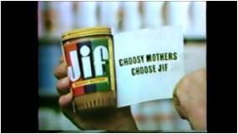

Jif appealed to mothers by pitching itself as a brand that was tastier and healthier than its competitors[1]. While we have not established a causal relationship between this campaign and Jif loyalty, it is possible that this campaign may have played a part in building Jif loyalty.

Bibliography

[1] Lane, Frank. Killer Brands: Create and Market a Brand That Will Annihilate the Competition. Avon, Mass: Adams Media, 2007. Print.