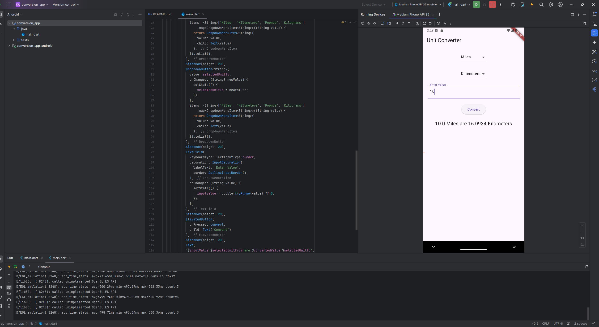

This is the output of the app. I am using Android Studio and Android Simulator to test this app.

