

**KING ABDUL AZIZ UNIVERSITY**

**COLLEGE OF COMPUTING AND INFORMATION**

**TECHNOLOGY DEPARTMENT OF INFORMATION SYSTEM**

**CPCS 324: Algorithms and Data Structures (II)**

**Spring 2021**

**Group Project**

**Students:**

|  |  |  |
| --- | --- | --- |
| **Name** | **ID** | **Section** |
| **Safia Aljahdali** | **1807806** | **DAR** |
| **Shahad Shamsan** | **1808718** | **DAR** |
| **Suha Shafi** | **1806004** | **DAR** |

**Instructor: Dr. Bassma Alsulami**

**Table of Contents**

**Phase 1: Floyd’s algorithm** 3

**Introduction** 3

**The problem in question** 3

**Screenshots of the outputs** 4

**Difficulties faced during the phase design** 7

**Conclusion** 7

# **Phase 1: Floyd’s algorithm**

## **Introduction**

Floyd’s Algorithm is used to find the all-pairs shortest paths in a weighted graph. This algorithm operates on both directed and non-directed weighted graphs. But it does not work with graphs with negative cycles, where the sum of the edges in a cycle is negative. The algorithm serves variant applications such communications, transportation networks and motion planning in computer games. The algorithm operates by generating n x n distance matrices D and starting from the weight matrix as the first distance matrix.

## **The problem in question**

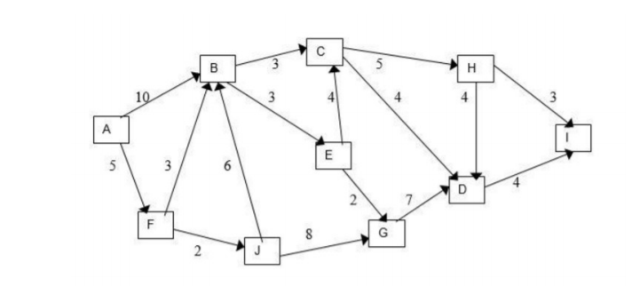

## **Screenshots of the outputs**

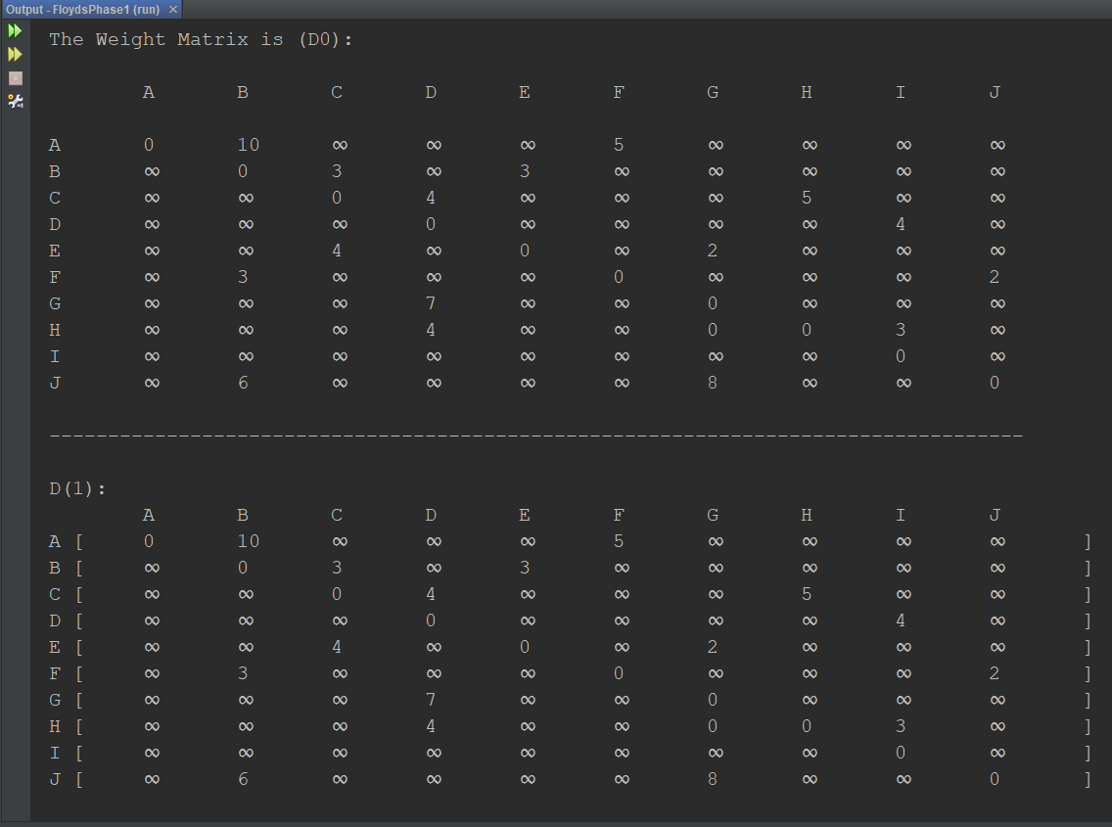

Figure 1: D(0) and D(1)

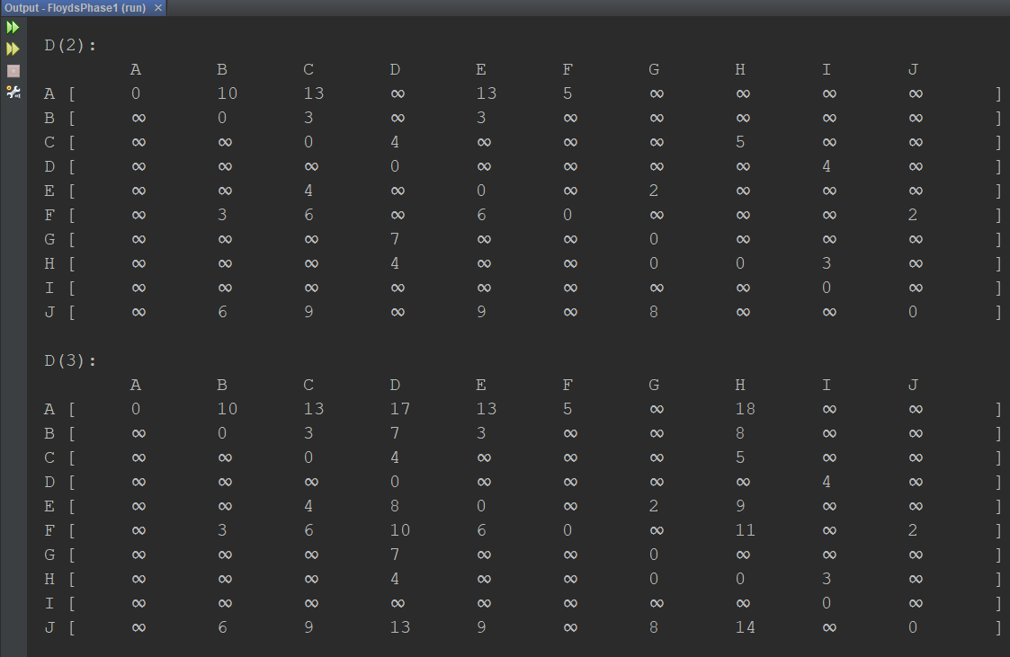

Figure 2: D(2) and D(3)

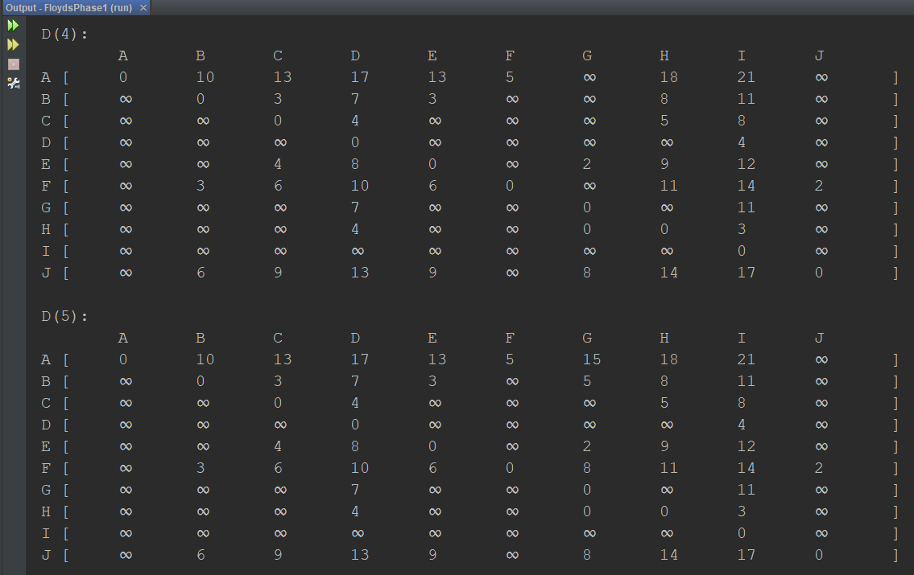

Figure 3: D(4) and D(5)

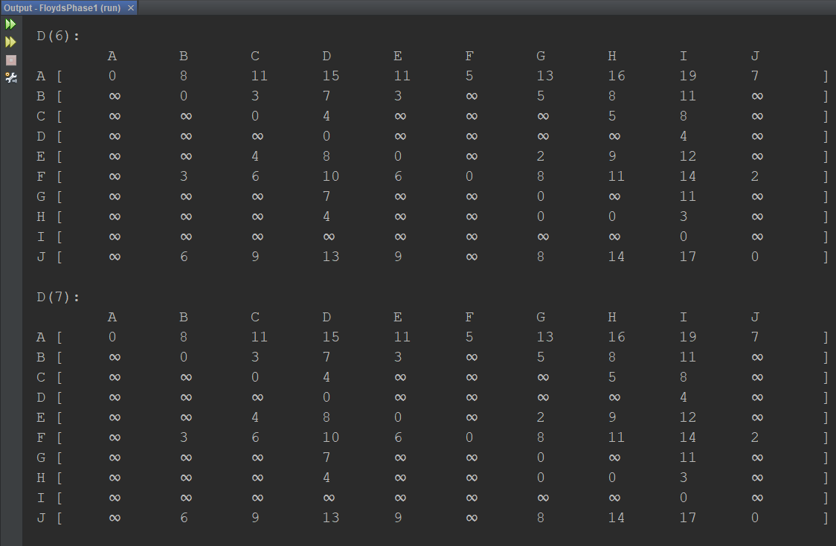

Figure 4: D(6) and D(7)

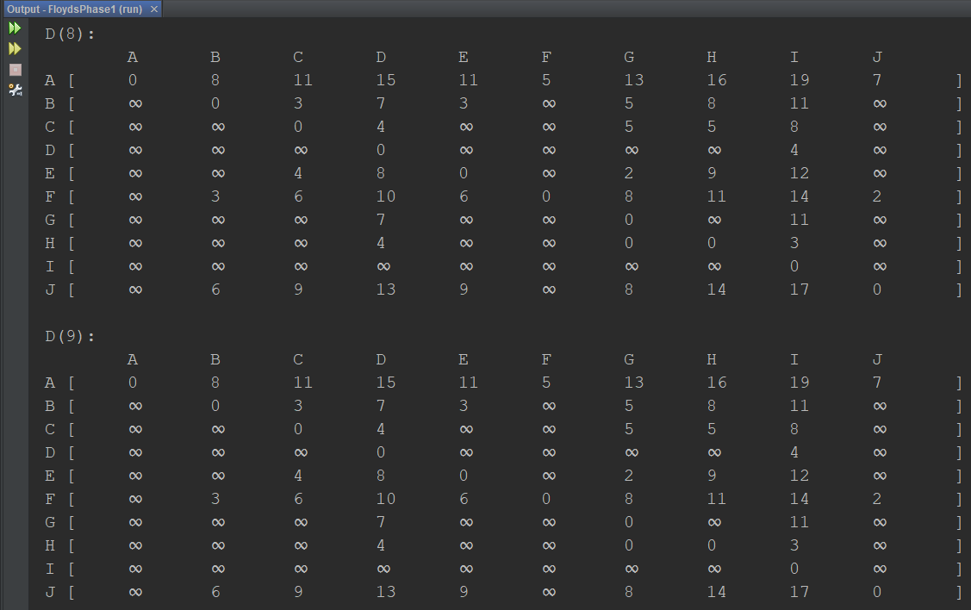

Figure 5: D(8) and D(9)

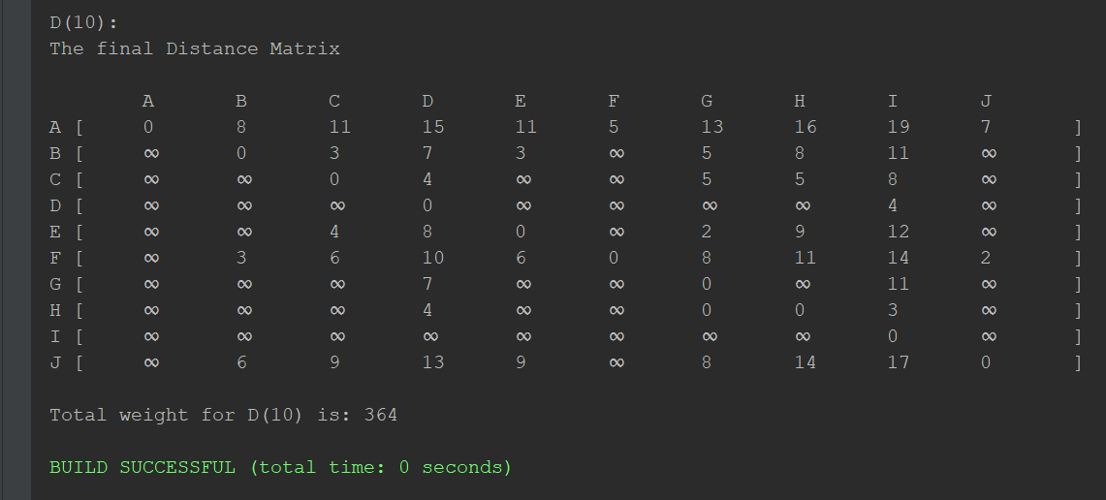

Figure 6: D(10) the final distance matrix

## **Difficulties faced during the phase design**

The algorithm was straightforward and easy to implement, and no complications were run into.

## **Conclusion**

The Floyd-Warshall algorithm depends on the number of vertices and does not depend on the number of edges. The algorithm will generate n matrices for n vertices. The Algorithm’s main operation is in its most nested loop and has a complexity of O(n3).