**Analog stimuli (2 channels) and digital trigger (1 channel):**

* Analog output signal (sound)
  + waveform samples – min. 250 kHz output rate
* Analog output signal (LED or laser stimulus gating)
  + waveform samples – lower bandwidth, 2-5 kHz
* Digital output signal
  + TTL trigger pulse to synchronize separate neural data DAQ system

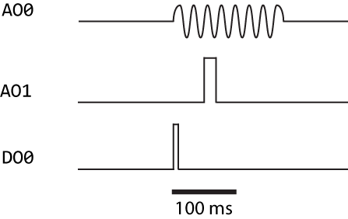

**Steps on each epoch:**

1. load sound stimulus analog signal data to uStar system
2. load light stimulus signal data to uStar system
3. configure digital output signal timing
   1. timing relative to analog stimulus output start
4. start output
5. wait for completion
   1. epoch of 250 – 1000 msec
6. repeat sequence from step 1
   1. stimuli (sound and light gating) are randomized within matlab, so they will need to be loaded before each presentation epoch
   2. playwav.m shows how to load and play 2 channels of analog data, but not how to trigger the output to start synchronously with a digital output.

**Issues:**

* playwav.m doesn’t work, but I figured out corrections
* How to configure analog outputs in DAPL to deal with different length of stimuli?
  + The example playwav.dap program has a fixed COUNT value but my stimuli typically will vary in length. Can this be changed dynamically from my Matlab program?
  + There might be a workaround by padding my stimuli with zeros to achieve a fixed target sample length, but this is not ideal.
* How to configure digital outputs in DAPL and control from Matlab?
* How to trigger synchronous start of analog and digital output from Matlab (i.e., a software trigger)?