Contractor Management System
Frontend Architecture Guide

UI Directory Structure, Component Architecture, and Data Flow
Version 1.0 | March 2026

Tech Stack: React + TypeScript + Vite
AWS Amplify + Cognito + DynamoDB + Lambda
AI Agent powered by Claude API

1. Overview
The Contractor Management System (CMS) is a two-sided platform connecting Business Owners with Contractors, with an AI Agent orchestrating the entire project lifecycle. The frontend is built as a React + TypeScript application using Vite as the build tool, deployed via AWS Amplify.
The application follows a clear separation of concerns:
- Components are reusable UI building blocks organized by business domain
- Routes are full-page screens that compose components together
- Hooks manage data fetching, transformation, and local state
- Services handle HTTP calls to the AWS backend (API Gateway + Lambda)
- Store provides global state management via Zustand

2. Directory Structure
The frontend follows a monorepo-style organization under frontend/src/ with clear boundaries between layers. Each directory has a specific role in the architecture.
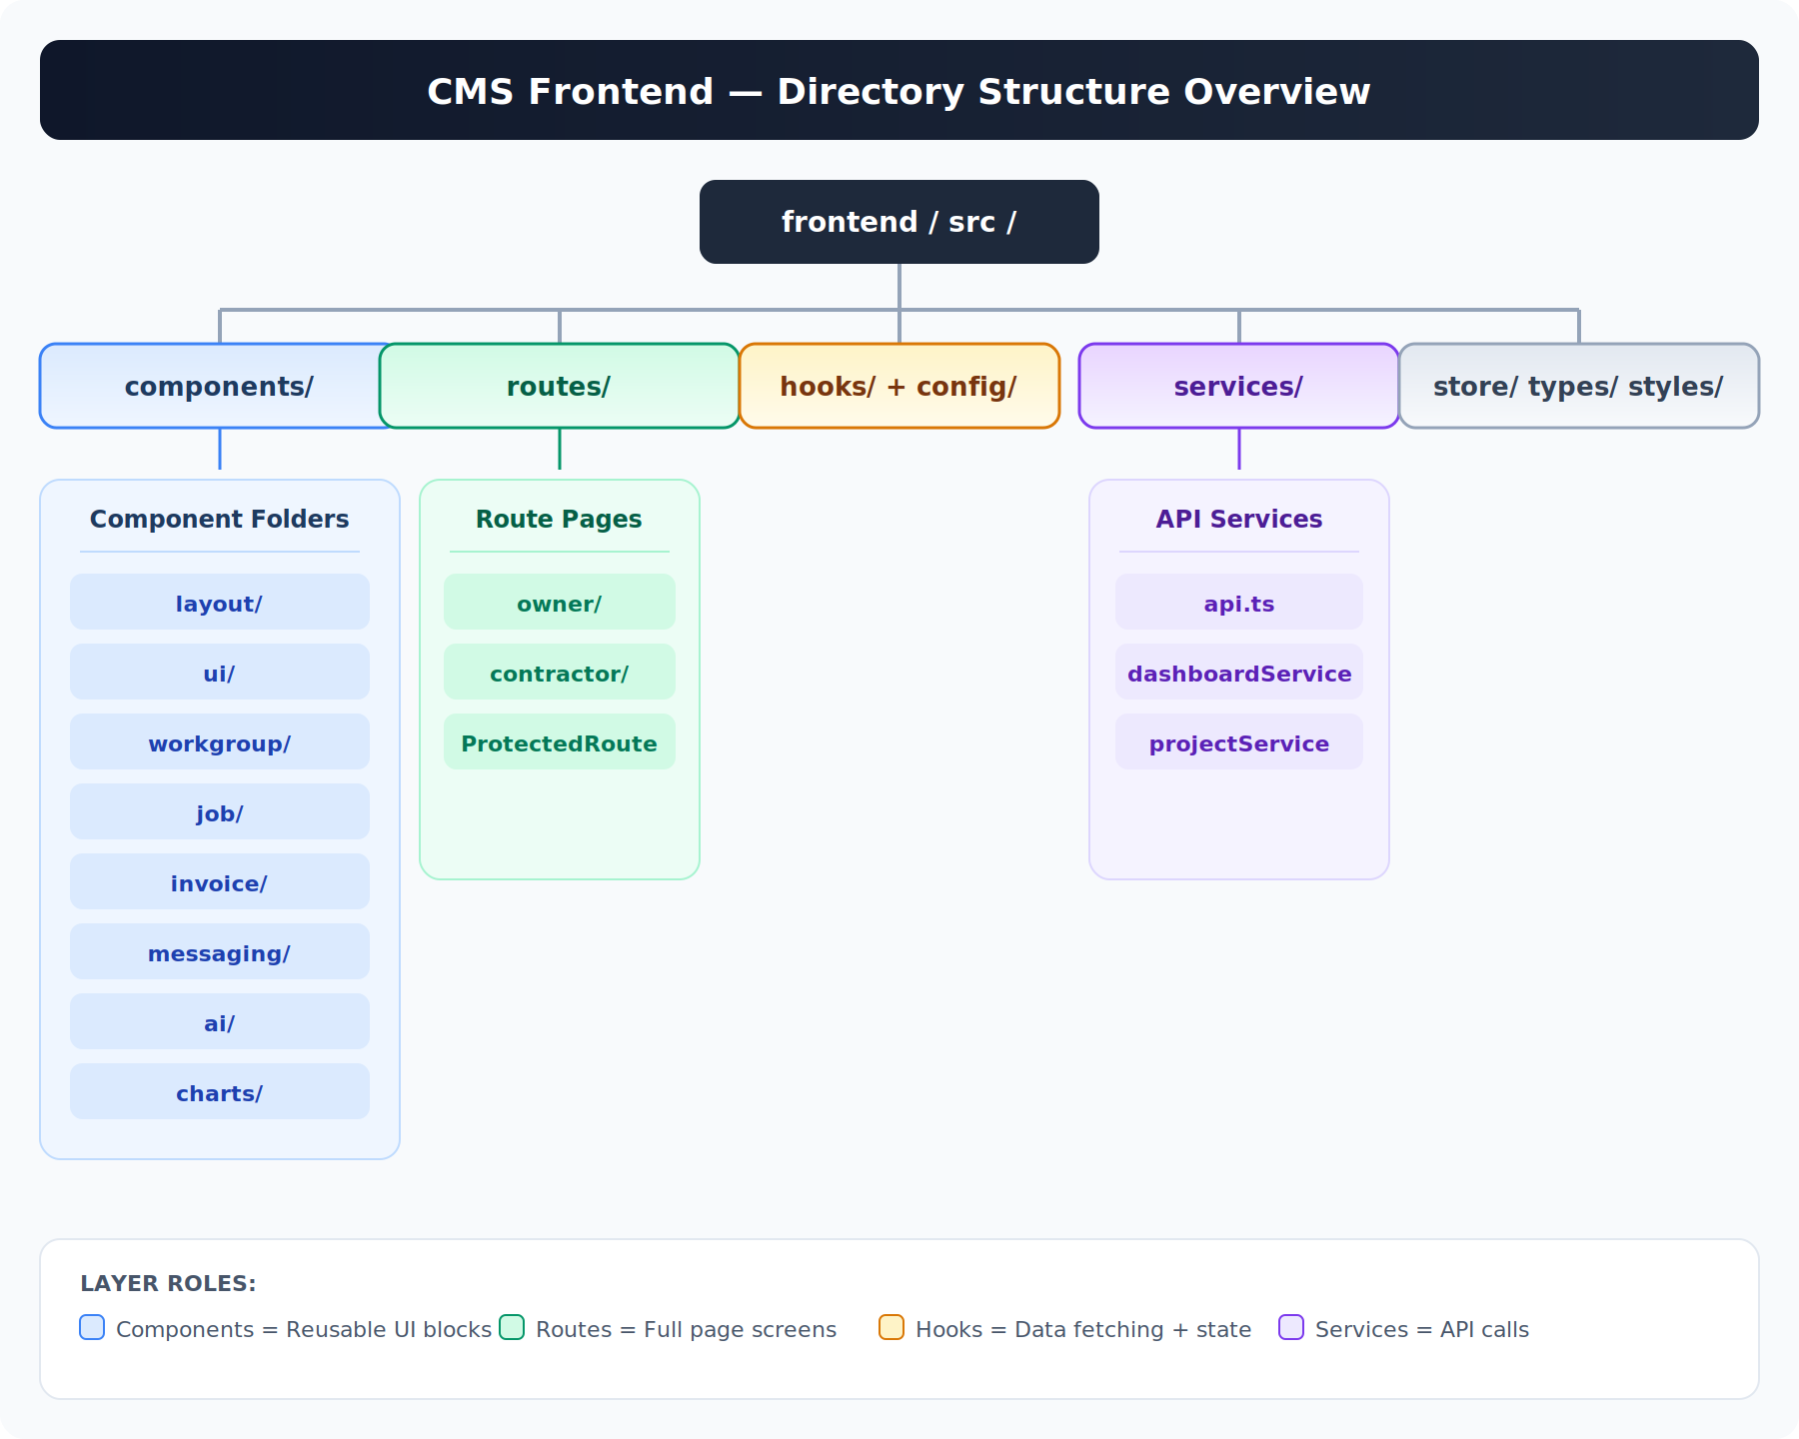
Figure 1: High-level directory structure of the CMS frontend
Directory | Purpose | Key Files
components/ | Reusable UI building blocks organized by business domain | workgroup/, job/, invoice/, messaging/, ai/, charts/, ui/, layout/, project/
routes/ | Full-page screens composed from components, organized by user role | owner/ (Dashboard, ProjectDetail, Invoices...), contractor/, ProtectedRoute.tsx
hooks/ | Custom React hooks for data fetching, state management, and data transformation | useDashboard.ts, useProject.ts, useWorkgroup.ts, dashboardBridge.ts
services/ | HTTP API client and domain-specific service modules | api.ts, dashboardService.ts, projectService.ts
store/ | Zustand-based global state that persists across page navigation | Global auth state, selected project, UI preferences
types/ | TypeScript interfaces and type definitions shared across the app | Project, Workgroup, Job, Invoice, User, API response types
styles/ | Global CSS, design tokens, theme variables | Global styles, CSS variables, animation keyframes
config/ | Application configuration and environment-specific settings | API endpoints, Cognito pool IDs, feature flags

3. User Authentication and Navigation Flow
When a user accesses the CMS application, they first authenticate through AWS Cognito. The ProtectedRoute.tsx component verifies the authentication token and checks the user role to determine which layout shell to render.
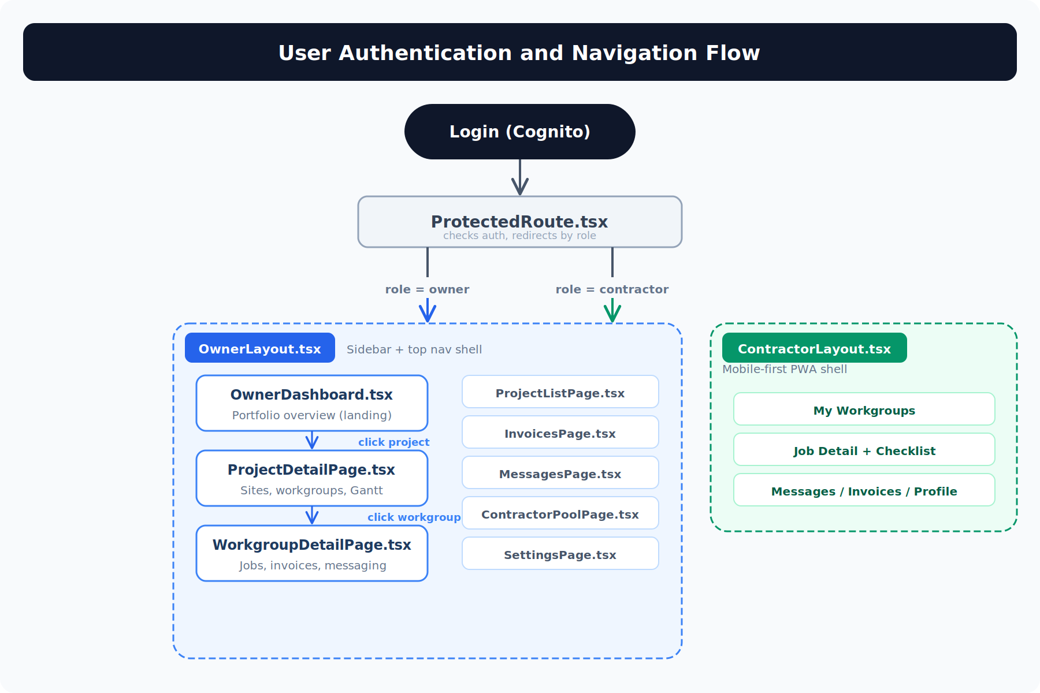
Figure 2: Authentication and navigation flow from login to page rendering

3.1 Owner Flow
Business Owners are wrapped in OwnerLayout.tsx, which renders the dark sidebar navigation (Dashboard, Projects, Contractors, Messages, Invoices, Settings) and the top header bar. The inner content area swaps between pages as the user navigates.
The primary navigation drill-down is:
- OwnerDashboard (landing page) — Portfolio overview with stat cards, AI insights, pending invoices across all projects
- ProjectDetailPage — Click a project to see work sites, workgroup cards/Gantt timeline, and the Project Outlook sidebar
- WorkgroupDetailPage — Click a workgroup for full job list, inline messaging, and per-job invoice management

3.2 Contractor Flow
Contractors are wrapped in ContractorLayout.tsx, which provides a mobile-first Progressive Web App (PWA) shell with bottom-tab navigation. The contractor sees their assigned workgroups, can accept/reject work, communicate with the owner, upload photos/files, and submit invoices per job.

3.3 Owner Route Pages
Page File | Description
OwnerDashboard.tsx | Landing page. Portfolio overview showing active projects count, pending approvals, total spend, AI insights, worksite activity, and pending invoices across all projects.
ProjectListPage.tsx | Grid/list of all projects with status, budget summary, and progress indicators. Entry point to drill into any project.
ProjectDetailPage.tsx | Full project view with work site tabs, workgroup cards (card view) or Gantt timeline, budget breakdowns, and the Project Outlook sidebar with AI insights and critical path analysis.
WorkgroupDetailPage.tsx | Deep dive into a single workgroup showing all jobs with status/budget, inline messaging thread with the contractor, file/photo uploads, and per-job invoice tracking.
InvoicesPage.tsx | Invoice management across all projects. Filter by status (pending, paid, rejected), project, contractor. Invoices are per-job (not per-workgroup).
MessagesPage.tsx | All messaging conversations organized by workgroup. Real-time communication between owner and contractors.
ContractorPoolPage.tsx | Manage the contractor roster. View contractor profiles, skills, ratings, availability. AI allocation scoring visible here.
SettingsPage.tsx | Account settings, project configuration, notification preferences, and system administration.

4. Component Architecture
Components are the reusable UI building blocks that pages assemble together. They are organized by business domain rather than by technical type, making it easy to find and maintain related functionality. Each component folder contains all the UI pieces for that domain.
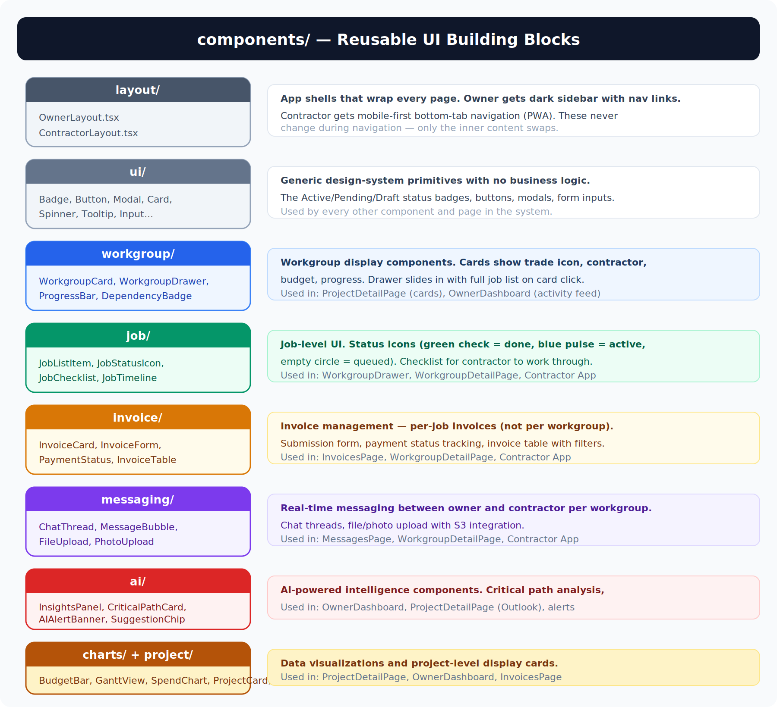
Figure 3: Component folders, their contents, and which pages use them

4.1 layout/
The app shell components that wrap every page. OwnerLayout.tsx renders the persistent dark sidebar with navigation links (Dashboard, Projects, Contractors, Messages, Invoices, Settings) plus the top header bar showing the current context. ContractorLayout.tsx provides the mobile-first bottom-tab navigation optimized for the contractor’s PWA experience. These layouts never change during navigation — only the inner content area swaps.

4.2 ui/
Generic design-system primitives that carry no business logic. These are the atomic building blocks: Badge (the Active/Pending/Draft status pills), Button, Modal, Card, Spinner, Tooltip, Input, and other form elements. Every other component in the system is built from these atoms. They enforce visual consistency across the entire application.

4.3 workgroup/
Everything related to displaying a workgroup. The WorkgroupCard shows the trade icon (Electrical, Plumbing, etc.), contractor name, budget, progress bar, job list, and schedule. The WorkgroupDrawer slides in from the right when a card is clicked, revealing the full job list with status indicators, budget breakdown, and dependency information. ProgressBar visualizes completion percentage, and DependencyBadge shows blocking relationships (e.g., “Blocked by Plumbing”).
Used in: ProjectDetailPage (card view), OwnerDashboard (activity feed)

4.4 job/
Job-level UI components. JobListItem displays a job with its status icon (green check = complete, blue pulse = in progress, empty circle = queued), title, and budget. JobStatusIcon handles the animated status indicators. JobChecklist is the checklist contractors work through to track progress on each job. JobTimeline shows the sequential timeline of jobs within a workgroup.
Used in: WorkgroupDrawer (job list), WorkgroupDetailPage (full job view), Contractor App (job checklist)

4.5 invoice/
Invoice management components. A key architectural decision: invoices are per-job, not per-workgroup, meaning a contractor can submit multiple invoices within a single workgroup (one for each completed job). InvoiceCard displays an invoice summary. InvoiceForm handles submission with line items. PaymentStatus tracks the payment lifecycle. InvoiceTable provides a filterable table view across all invoices.
Used in: InvoicesPage (full invoice list), WorkgroupDetailPage (per-job invoices), Contractor App (submit invoice)

4.6 messaging/
Real-time communication components shared between owner and contractor. ChatThread renders the conversation view with message history. MessageBubble displays individual messages with sender, timestamp, and read receipts. FileUpload and PhotoUpload handle document and image uploads to S3. Messages are scoped per workgroup — each workgroup has its own conversation thread between the owner and assigned contractor.
Used in: MessagesPage (all conversations), WorkgroupDetailPage (inline chat), Contractor App (message owner)

4.7 ai/
AI-powered intelligence components driven by the Claude API backend. InsightsPanel displays real-time AI observations (“2 jobs complete, 4 workgroups pending”). CriticalPathCard shows dependency chain analysis with delay warnings (“Plumbing → Painting delayed ~3 wks”). AIAlertBanner surfaces urgent items. SuggestionChip offers AI-recommended actions the owner can take.
Used in: OwnerDashboard (AI insights section), ProjectDetailPage (Project Outlook sidebar), WorkgroupDetailPage (alerts)

4.8 charts/ and project/
Data visualization and project-level display components. BudgetBar renders the three-segment bar (green = paid, yellow = invoiced, gray = remaining). GanttView provides the full Gantt timeline with expandable workgroups and job-level bars. SpendChart shows spend over time. ProjectCard and SiteTab display project summaries and work site selection tabs.
Used in: ProjectDetailPage (Gantt + budget), OwnerDashboard (spend overview), InvoicesPage (payment charts)

5. Data Layer Architecture
The data layer follows a clean three-tier pattern: Pages call Hooks, Hooks call Services, and Services make HTTP requests to the AWS backend. This separation ensures that UI components never make API calls directly, making them easier to test and reuse.
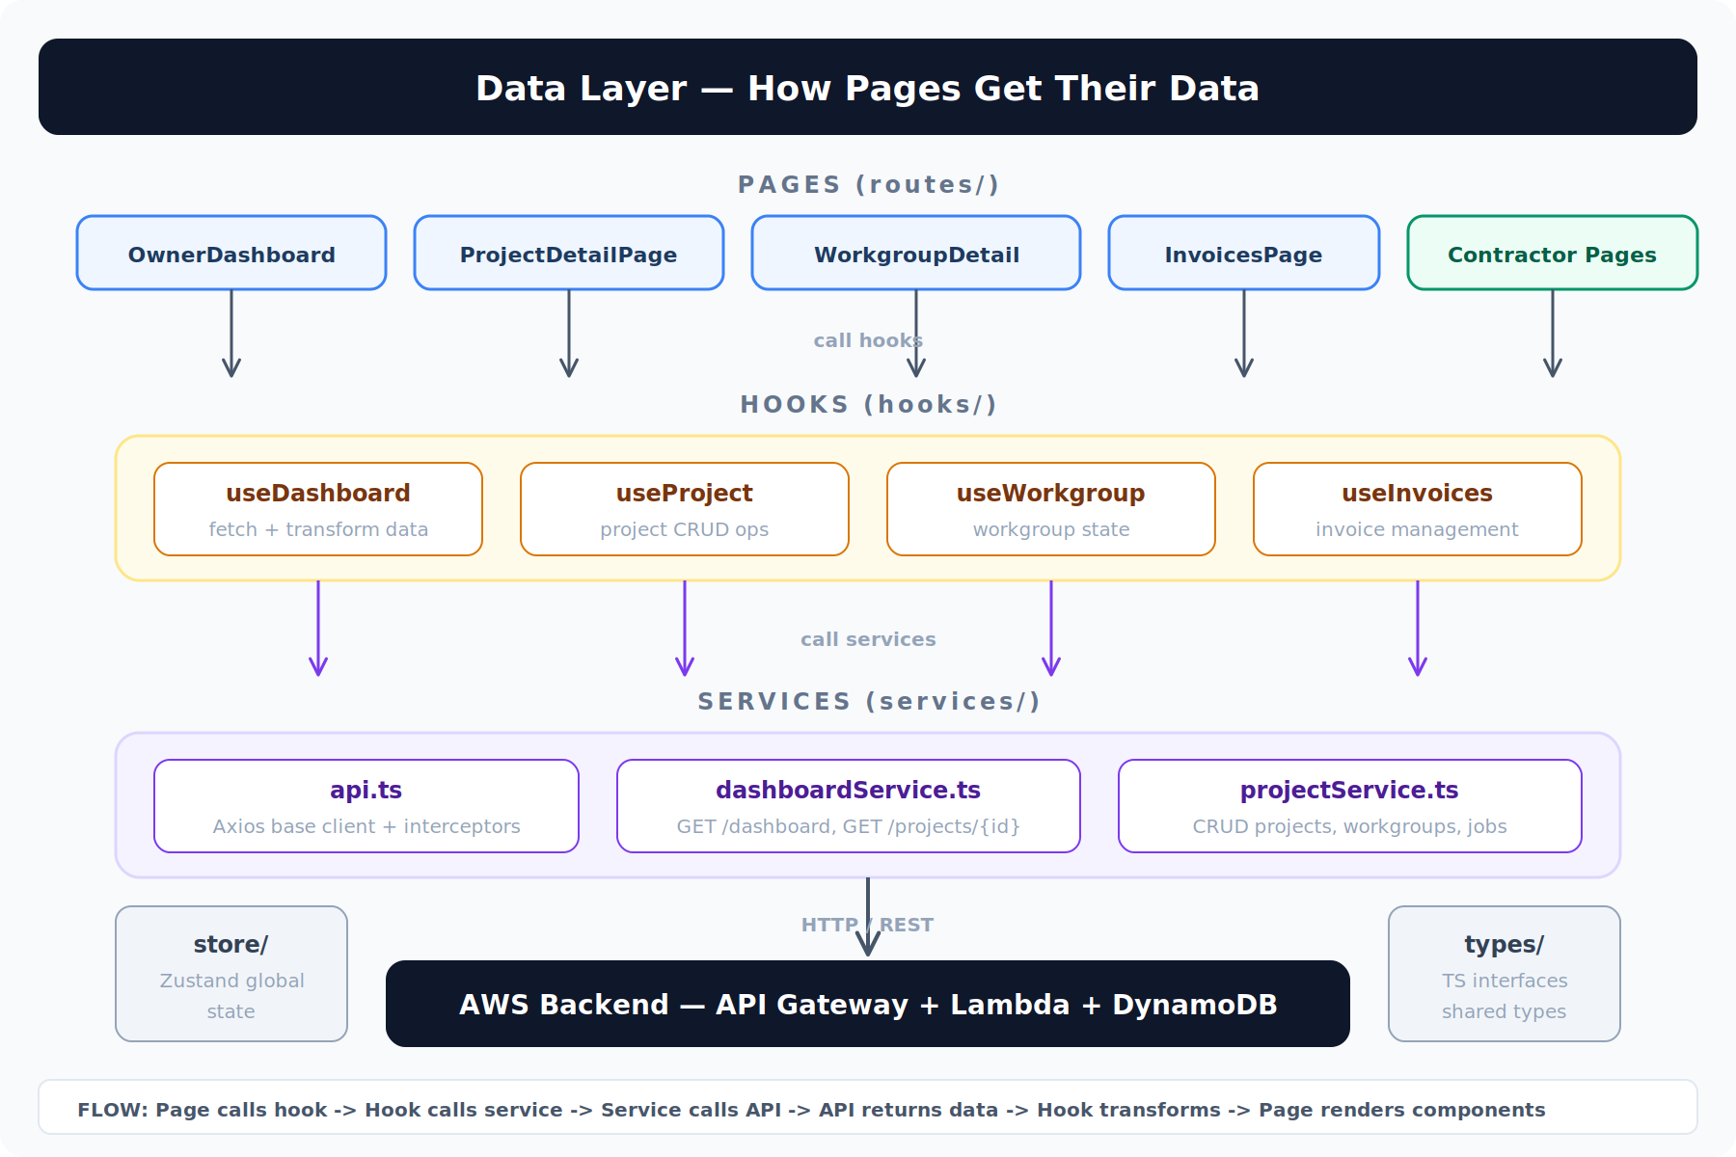
Figure 4: Data flow from pages through hooks and services to the AWS backend

5.1 services/
File | Role
api.ts | Base Axios HTTP client with request/response interceptors. Attaches the Cognito JWT token to every request. Handles token refresh, error normalization, and retry logic. All other services import from this file.
dashboardService.ts | Dashboard-specific API calls: GET /dashboard (portfolio overview), GET /projects/{id}/dashboard (project detail with all workgroups and jobs). Returns raw API response data that hooks transform into UI-ready shapes.
projectService.ts | CRUD operations for projects, workgroups, and jobs. Create/update/delete projects, assign contractors to workgroups, update job status, manage dependencies. Also handles invoice submission and messaging endpoints.

5.2 hooks/
Custom React hooks serve as the bridge between services (raw API data) and components (UI-ready data). The useDashboard hook is a key example: it calls dashboardService.ts to fetch raw data, then uses a dashboardBridge.ts transformer to convert the API response into the UIDashboard shape that components expect. This includes computing derived values like completion percentages, budget rollups, and status cascades.
Hooks also manage loading/error states and provide a refresh function, so pages don’t need to handle any of this plumbing themselves.

5.3 store/
Zustand-based global state that persists across page navigation. This holds cross-cutting concerns: the authenticated user identity and role, the currently selected project (so switching between pages retains context), and UI preferences like the selected view mode (cards vs. Gantt timeline). Hooks read from the store when they need global context, and pages dispatch updates to it.

5.4 types/
TypeScript interfaces shared across the entire frontend. These mirror the backend data model: Project, Workgroup, Job, Invoice, User, Contractor, Message, and Upload types. The types/ directory is the single source of truth for data shapes, ensuring consistency between services, hooks, and components.

6. Page Composition Example
To illustrate how these layers work together, here is a visual breakdown of the ProjectDetailPage — the most complex page in the owner’s experience. Each labeled region maps to a specific component from the components/ directory.
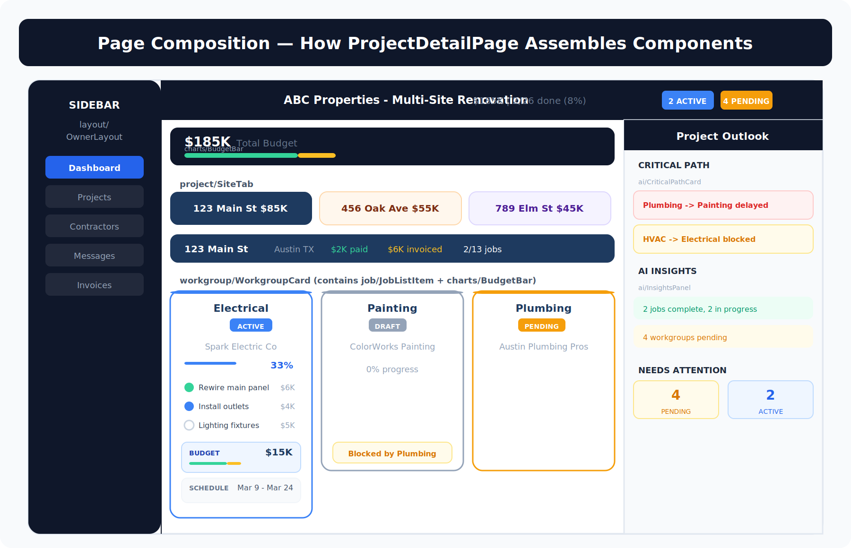
Figure 5: ProjectDetailPage assembles components from workgroup/, job/, charts/, ai/, and project/
The page itself is lean — it primarily wires together pre-built components and feeds them data from the useDashboard hook. This composition pattern means:
- The same WorkgroupCard can appear on both the ProjectDetailPage and the OwnerDashboard
- The BudgetBar component is reused at the portfolio, site, and workgroup levels with different data
- AI components (InsightsPanel, CriticalPathCard) can be placed on any page that needs AI intelligence
- Adding a new page is just a matter of composing existing components with a new data hook

7. Key Architecture Decisions

7.1 Single App, Role-Based Routing
Rather than building separate applications for owners and contractors, the CMS uses a single React app with role-based routing. ProtectedRoute.tsx checks the Cognito user group and renders the appropriate layout shell. This simplifies deployment (one Amplify app) while keeping the experiences completely distinct.

7.2 Domain-Organized Components
Components are organized by business domain (workgroup/, job/, invoice/) rather than by technical type (buttons/, forms/, tables/). This makes it natural to find all UI related to a particular feature in one place, and supports a clean module boundary if the app ever needs to be split.

7.3 Per-Job Invoices
Invoices are per-job, not per-workgroup. This allows contractors to invoice incrementally as they complete individual jobs, rather than waiting for an entire workgroup scope to finish. It also gives business owners finer-grained visibility into spend per task.

7.4 Hooks as Data Bridge
The dashboardBridge.ts pattern (transformer functions used by hooks) cleanly separates the API contract from the UI contract. If the backend changes its response shape, only the bridge function needs updating — all components continue receiving the same UIDashboard interface.

7.5 PWA for Contractor App
The contractor experience is built as a Progressive Web App with offline capability using Service Workers and IndexedDB. Contractors can view workgroup details, take photos, write messages, and update checklists while offline. Everything syncs automatically when they come back online — critical for job sites with poor cell coverage.

