

Introduction to Python

Heavily based on presentations by Matt Huenerfauth (Penn State) Guido van Rossum (Google) Richard P. Muller (Caltech) ...

Monday, October 19, 2009

Python

- Open source general-purpose language.

- Object Oriented, Procedural, Functional

- Easy to interface with C/ObjC/Java/Fortran

- Easy-ish to interface with C++ (via SWIG)

- Great interactive environment

- Downloads: http://www.python.org

- Documentation: http://www.python.org/doc/

- Free book: http://www.diveintopython.org

Monday, October 19, 2009

2.5.x / 2.6.x / 3.x ???

- “Current” version is 2.6.x

- “Mainstream” version is 2.5.x

- The new kid on the block is 3.x

You probably want 2.5.x unless you are starting from scratch. Then maybe 3.x

Monday, October 19, 2009

Technical Issues

Installing & Running Python

Monday, October 19, 2009

Binaries

- Python comes pre-installed with Mac OS X and Linux.

- Windows binaries from http://python.org/

- You might not have to do anything!

Monday, October 19, 2009

The Python Interpreter

- Interactive interface to Python

% python

Python 2.5 (r25:51908, May 25 2007, 16:14:04)

[GCC 4.1.2 20061115 (prerelease) (SUSE Linux)] on linux2

Type "help", "copyright", "credits" or "license" for more information.

>>>

- Python interpreter evaluates inputs:

  - 3*(7+2)

27

- Python prompts with ‘>>>’.

- To exit Python:

  - CTRL-D

Monday, October 19, 2009

Running Programs on UNIX

- python filename.py

You could make the *.py file executable and add the following #!/usr/bin/env python to the top to make it runnable.

Monday, October 19, 2009

Batteries Included

- Large collection of proven modules included in the standard distribution.

http://docs.python.org/modindex.html

Monday, October 19, 2009

numpy

- Offers Matlab-ish capabilities within Python

- Fast array operations

- 2D arrays, multi-D arrays, linear algebra etc.

- Downloads: http://numpy.scipy.org/

- Tutorial: http://www.scipy.org/ Tentative_NumPy_Tutorial

Monday, October 19, 2009

matplotlib

- High quality plotting library.

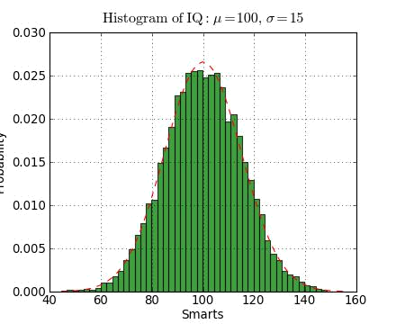

#!/usr/bin/env python

import numpy as np

import matplotlib.mlab as mlab

import matplotlib.pyplot as plt

mu, sigma = 100, 15

x = mu + sigma*np.random.randn(10000)

# the histogram of the data

n, bins, patches = plt.hist(x, 50, normed=1, facecolor='green', alpha=0.75)

# add a 'best fit' line

y = mlab.normpdf( bins, mu, sigma)

l = plt.plot(bins, y, 'r--', linewidth=1)

plt.xlabel('Smarts')

plt.ylabel('Probability')

plt.title(r'$\mathrm{Histogram\ of\ IQ:}\ \mu=100,\ \sigma=15$')

plt.axis([40, 160, 0, 0.03])

plt.grid(True)

plt.show()

- Downloads: http://matplotlib.sourceforge.net/

Monday, October 19, 2009

PyFITS

- FITS I/O made simple:

- import pyfits

- hdulist = pyfits.open(’input.fits’)

- hdulist.info()

Filename: test1.fits

No. Name Type Cards Dimensions Format

0 PRIMARY PrimaryHDU 220 () Int16

1 SCI ImageHDU 61 (800, 800) Float32

2 SCI ImageHDU 61 (800, 800) Float32

3 SCI ImageHDU 61 (800, 800) Float32

4 SCI ImageHDU 61 (800, 800) Float32

- hdulist[0].header[’targname’]

’NGC121’

- scidata = hdulist[1].data

- scidata.shape

(800, 800)

  - scidata.dtype.name ’float32’

  - scidata[30:40,10:20] = scidata[1,4] = 999

- Downloads: http://www.stsci.edu/resources/ software_hardware/pyfits

Monday, October 19, 2009

pyds9 / python-sao

- Interaction with DS9

- Display Python 1-D and 2-D arrays in DS9

- Display FITS files in DS9

- Downloads: Ask Eric Mandel :-)

- Downloads: http://code.google.com/p/python-sao/

Monday, October 19, 2009

Wrappers for Astronomical Packages

- CasaPy (Casa)

- PYGILDAS (GILDAS)

- ParselTongue (AIPS)

- PyRAF (IRAF)

- PyMIDAS (MIDAS)

- PyIMSL (IMSL)

Monday, October 19, 2009

Custom Distributions

- Python(x,y): http://www.pythonxy.com/

  - Python(x,y) is a free scientific and engineering development software for numerical computations, data analysis and data visualization

- Sage: http://www.sagemath.org/

  - Sage is a free open-source mathematics software system licensed under the GPL. It combines the power of many existing open-source packages into a common Python-based interface.

Monday, October 19, 2009

Extra Astronomy Links

- iPython (better shell, distributed computing): http://ipython.scipy.org/

- SciPy (collection of science tools): http:// www.scipy.org/

- Python Astronomy Modules: http:// astlib.sourceforge.net/

- Python Astronomer Wiki: http://macsingularity.org/ astrowiki/tiki-index.php?page=python

- AstroPy: http://www.astro.washington.edu/users/ rowen/AstroPy.html

- Python for Astronomers: http://www.iac.es/ sieinvens/siepedia/pmwiki.php? n=HOWTOs.EmpezandoPython

Monday, October 19, 2009

The Basics

Monday, October 19, 2009

A Code Sample

x = 34 - 23 |  |  | # A comment.
y = “Hello” |  |  | # Another one.
z = 3.45
if z == |  | 3.45 or y == “Hello”:
x | = | x + 1
y | = y + “ World” |  | # String concat.
print | x
print | y

Monday, October 19, 2009

Enough to Understand the Code

- Assignment uses = and comparison uses ==.

- For numbers + - * / % are as expected.

  - Special use of + for string concatenation.
  - Special use of % for string formatting (as with printf in C)

- Logical operators are words (and, or, not) not symbols
- The basic printing command is print.

- The first assignment to a variable creates it.

  - Variable types don’t need to be declared.

  - Python figures out the variable types on its own.

Monday, October 19, 2009

Basic Datatypes

- Integers (default for numbers)

z = 5 / 2 # Answer is 2, integer division.
- Floats

    - = 3.456

- Strings

  - Can use “” or ‘’ to specify. “abc” ‘abc’ (Same thing.)

  - Unmatched can occur within the string.

“matt’s”

  - Use triple double-quotes for multi-line strings or strings than contain both ‘ and “ inside of them:
“““a‘b“c”””

Monday, October 19, 2009

Whitespace

Whitespace is meaningful in Python: especially indentation and placement of newlines.
- Use a newline to end a line of code.

  - Use \ when must go to next line prematurely.

- No braces { } to mark blocks of code in Python…

Use consistent indentation instead.

  - The first line with less indentation is outside of the block.

  - The first line with more indentation starts a nested block

- Often a colon appears at the start of a new block. (E.g. for function and class definitions.)

Monday, October 19, 2009

Comments

- Start comments with # – the rest of line is ignored.

- Can include a “documentation string” as the first line of any new function or class that you define.

- The development environment, debugger, and other tools use it: it’s good style to include one.

def my_function(x, y):

“““This is the docstring. This
function does blah blah blah.”””

# The code would go here...

Monday, October 19, 2009

Assignment

- Binding a variable in Python means setting a name to hold a reference to some object.

    - Assignment creates references, not copies

- Names in Python do not have an intrinsic type. Objects have types.

    - Python determines the type of the reference automatically based on the data object assigned to it.

- You create a name the first time it appears on the left side of an assignment expression:
  - x = 3

- A reference is deleted via garbage collection after any names bound to it have passed out of scope.

Monday, October 19, 2009

Accessing Non-Existent Names

- If you try to access a name before it’s been properly created (by placing it on the left side of an assignment), you’ll get an error.

  - y

Traceback (most recent call last):

File "<pyshell#16>", line 1, in -toplevel-y

NameError: name ‘y' is not defined

- y = 3

- y

3

Monday, October 19, 2009

Multiple Assignment

- You can also assign to multiple names at the same time.

  - x, y = 2, 3

  - x

2

- y

3

Monday, October 19, 2009

Naming Rules

- Names are case sensitive and cannot start with a number. They can contain letters, numbers, and underscores.

bob Bob _bob _2_bob_ bob_2 BoB
- There are some reserved words:

and, assert, break, class, continue, def, del, elif, else, except, exec, finally, for, from, global, if, import, in, is, lambda, not, or, pass, print, raise, return, try, while

Monday, October 19, 2009

Understanding Reference Semantics in Python

Monday, October 19, 2009

Understanding Reference Semantics

- Assignment manipulates references

—x = y does not make a copy of the object y references —x = y makes x reference the object y references
- Very useful; but beware!

- Example:

>>> a = [1, 2, 3] # a now references the list [1, 2, 3]

>>> b = a # b now references what a references

>>> a.append(4) # this changes the list a references

>>> print b # if we print what b references,

[1, 2, 3, 4] # SURPRISE! It has changed…

Why??

Monday, October 19, 2009

Understanding Reference Semantics II

- There is a lot going on when we type:
x = 3

- First, an integer 3 is created and stored in memory

- A name x is created

- An reference to the memory location storing the 3 is then

assigned to the name x
- So: When we say that the value of x is 3

- we mean that x now refers to the integer 3
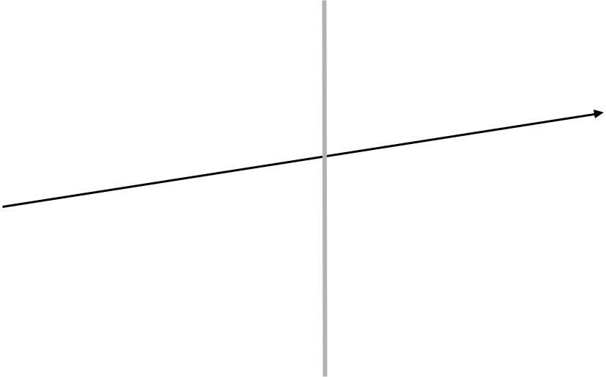

Name: x |  | Type: Integer
Ref: <address1> |  | Data: 3

name list memory

Monday, October 19, 2009

Understanding Reference Semantics III

- The data 3 we created is of type integer. In Python, the datatypes integer, float, and string (and tuple) are “immutable.”

- This doesn’t mean we can’t change the value of x, i.e. change what x refers to …

- For example, we could increment x:

  - x = 3

  - x = x + 1

  - print x

4

Monday, October 19, 2009

Understanding Reference Semantics IV

- If we increment x, then what’s really happening is:

1. The reference of name x is looked up. _{>>> x = x + 1}

- The value at that reference is retrieved.
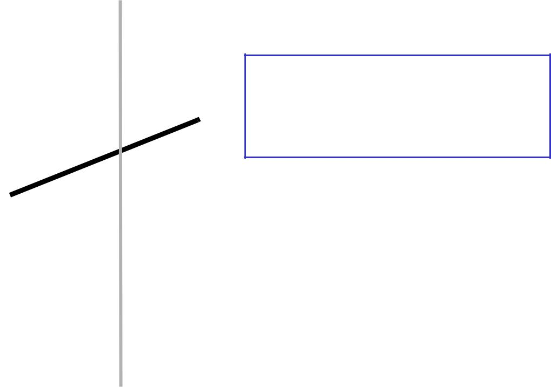

Type: Integer
Name: x  ^{Data: 3}

Ref: <address1>

Monday, October 19, 2009

Understanding Reference Semantics IV

- If we increment x, then what’s really happening is:

1. The reference of name x is looked up. _{>>> x = x + 1}

- The value at that reference is retrieved.

- The 3+1 calculation occurs, producing a new data element 4 which is assigned to a fresh memory location with a new reference.

Type: Integer
Name: x ^{Data: 3}
Ref: <address1>

Type: Integer

Data: 4

Monday, October 19, 2009

Understanding Reference Semantics IV

- If we increment x, then what’s really happening is:

1. The reference of name x is looked up. _{>>> x = x + 1}

- The value at that reference is retrieved.

- The 3+1 calculation occurs, producing a new data element 4 which is assigned to a fresh memory location with a new reference.

- The name x is changed to point to this new reference.
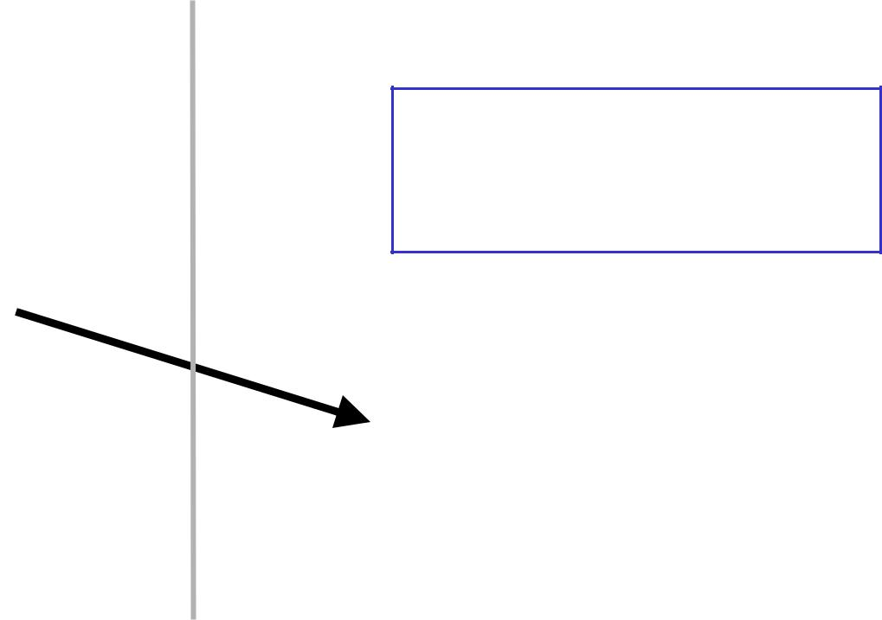

Type: Integer
Name: x ^{Data: 3}
Ref: <address1>
Type: Integer

Data: 4

Monday, October 19, 2009

Understanding Reference Semantics IV

- If we increment x, then what’s really happening is:

1. The reference of name x is looked up. _{>>> x = x + 1}

- The value at that reference is retrieved.

- The 3+1 calculation occurs, producing a new data element 4 which is assigned to a fresh memory location with a new reference.

- The name x is changed to point to this new reference.

- The old data 3 is garbage collected if no name still refers to it.
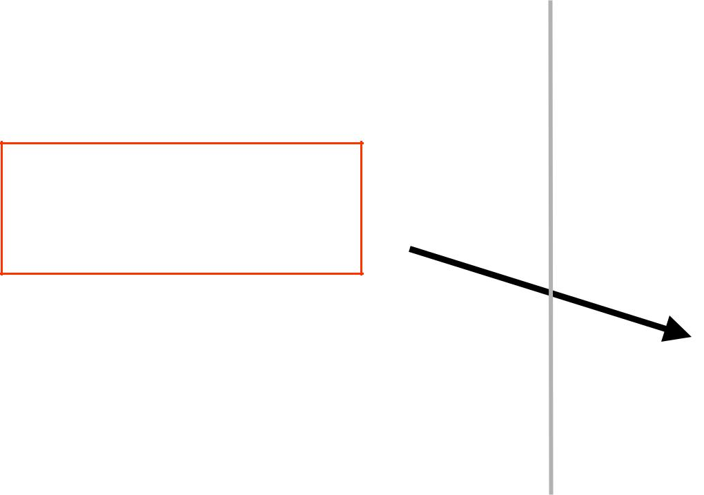

Name: x

Ref: <address1>
Type: Integer

Data: 4

Monday, October 19, 2009

Assignment 1

- So, for simple built-in datatypes (integers, floats, strings), assignment behaves as you would expect:

  - x = 3# Creates 3, name x refers to 3

  - y = x# Creates name y, refers to 3.

  - y = 4# Creates ref for 4. Changes y.

  - print x# No effect on x, still ref 3.

3

Monday, October 19, 2009

Assignment 1

- So, for simple built-in datatypes (integers, floats, strings), assignment behaves as you would expect:

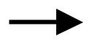 >>> x = 3 # Creates 3, name x refers to 3

- y = x# Creates name y, refers to 3.

- y = 4# Creates ref for 4. Changes y.

- print x# No effect on x, still ref 3.

3
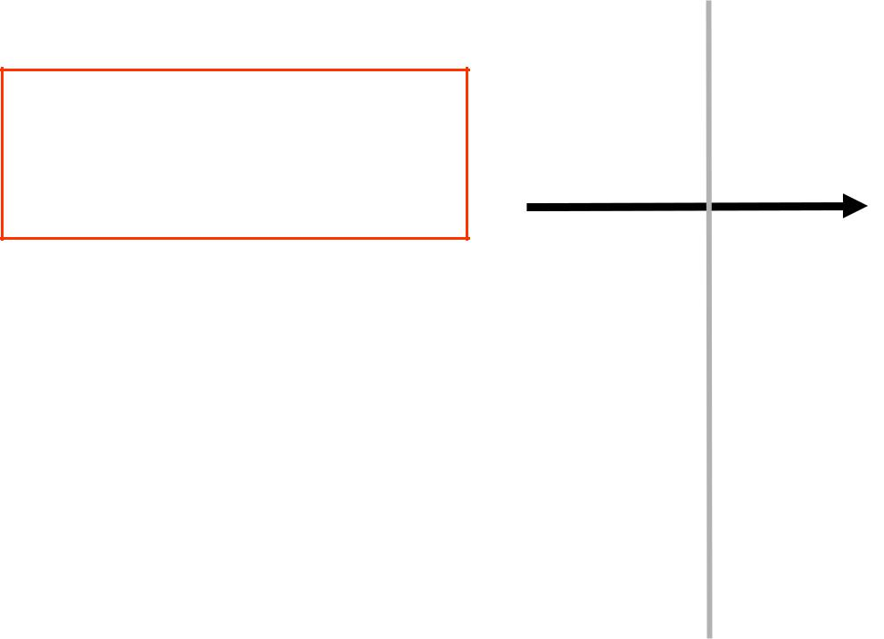

Name: x
Ref: <address1> ^{Type: Integer}

Data: 3

Monday, October 19, 2009

Assignment 1

- So, for simple built-in datatypes (integers, floats, strings), assignment behaves as you would expect:

- x = 3# Creates 3, name x refers to 3

>>> y = x # Creates name y, refers to 3.
- y = 4# Creates ref for 4. Changes y.

- print x# No effect on x, still ref 3.

3
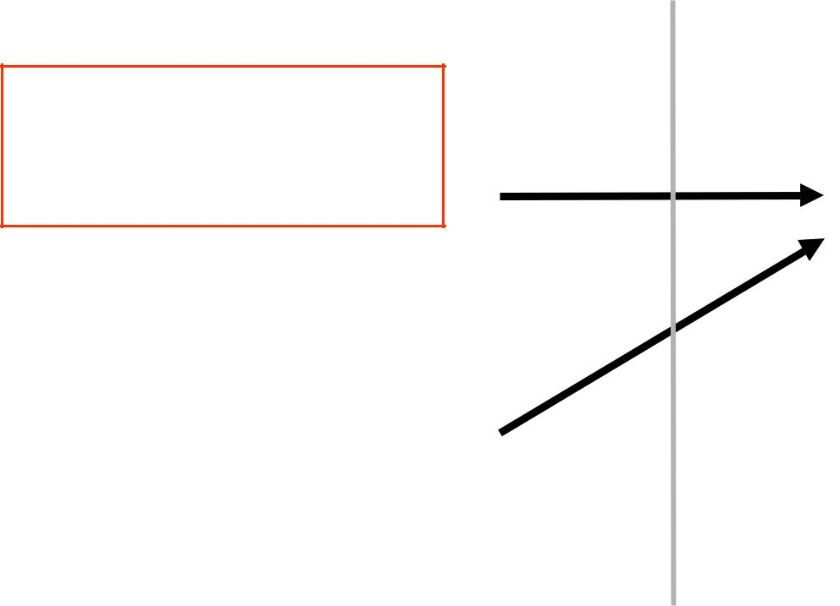

Name: x
Ref: <address1> ^{Type: Integer}

Data: 3

Name: y

Ref: <address1>

Monday, October 19, 2009

Assignment 1

- So, for simple built-in datatypes (integers, floats, strings), assignment behaves as you would expect:

- x = 3# Creates 3, name x refers to 3

>>> y = x # Creates name y, refers to 3.
- y = 4# Creates ref for 4. Changes y.

- print x# No effect on x, still ref 3.

3

Name: x

Ref: <address1>

Name: y

Ref: <address1>

Type: Integer

Data: 3

Type: Integer

Data: 4

Monday, October 19, 2009

Assignment 1

- So, for simple built-in datatypes (integers, floats, strings), assignment behaves as you would expect:

  - x = 3# Creates 3, name x refers to 3

  - y = x# Creates name y, refers to 3.
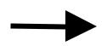 >>> y = 4 # Creates ref for 4. Changes y.

- print x# No effect on x, still ref 3.

3
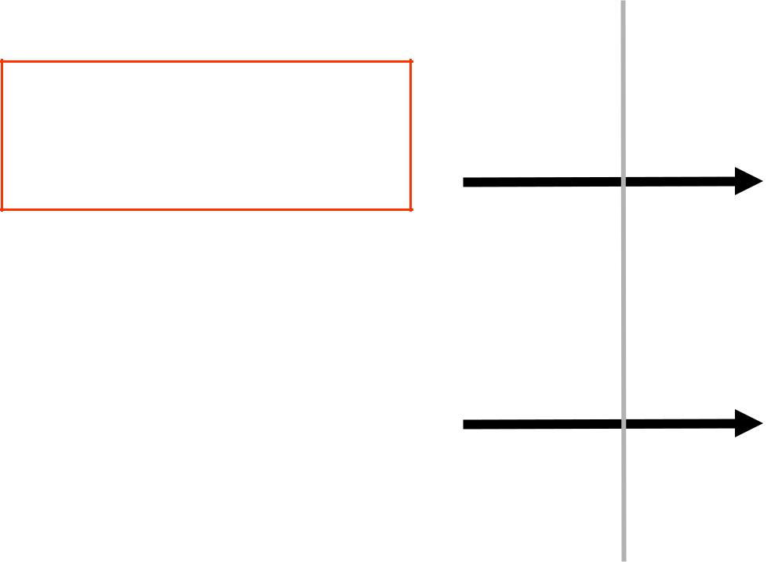

Name: x

Ref: <address1>

Name: y

Ref: <address2>

Type: Integer

Data: 3

Type: Integer

Data: 4

Monday, October 19, 2009

Assignment 1

- So, for simple built-in datatypes (integers, floats, strings), assignment behaves as you would expect:

  - x = 3# Creates 3, name x refers to 3

  - y = x# Creates name y, refers to 3.

  - y = 4# Creates ref for 4. Changes y.
>>> print x # No effect on x, still ref 3.

3

Name: x

Ref: <address1>

Name: y

Ref: <address2>

Type: Integer

Data: 3

Type: Integer

Data: 4

Monday, October 19, 2009

Assignment 2

- For other data types (lists, dictionaries, user-defined types), assignment works differently.

  - These datatypes are “mutable.”

  - When we change these data, we do it in place.

  - We don’t copy them into a new memory address each time.

  - If we type y=x and then modify y, both x and y are changed.

immutable _{mutable}

>>> x = 3 | x = | some mutable object
>>> y = x | y = | x
>>> y = 4 | make a change to y
>>> print x | look at x
3 | x will be changed as well

Monday, October 19, 2009

Why? Changing a Shared List

a = [1, 2, 3] | a | 1 | 2 | 3
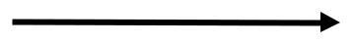

b = a | a
b = a | a | 1 | 2 | 3
 | b
 | a
a.append(4) | a | 1 | 2 | 3 | 4
 | b
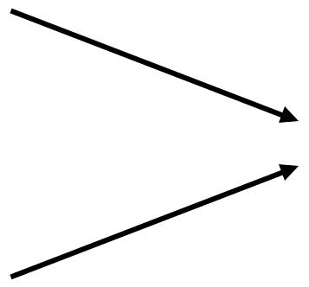
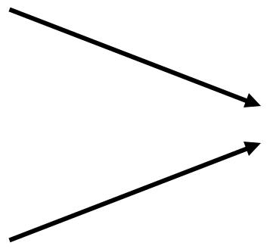

Monday, October 19, 2009

Our surprising example surprising no more...

- So now, here’s our code:

>>> a = [1, 2, 3] # a now references the list [1, 2, 3]

>>> b = a # b now references what a references

>>> a.append(4) # this changes the list a references

>>> print b # if we print what b references,

[1, 2, 3, 4] # SURPRISE! It has changed…

Monday, October 19, 2009

Sequence types:

Tuples, Lists, and Strings

Monday, October 19, 2009

Sequence Types

- Tuple

  - A simple immutable ordered sequence of items

  - Items can be of mixed types, including collection types

- Strings

  - Immutable

  - Conceptually very much like a tuple

- List

  - Mutable ordered sequence of items of mixed types

Monday, October 19, 2009

Similar Syntax

- All three sequence types (tuples, strings, and lists) share much of the same syntax and functionality.

- Key difference:

  - Tuples and strings are immutable

  - Lists are mutable

- The operations shown in this section can be

applied to all sequence types

- most examples will just show the operation performed on one

Monday, October 19, 2009

Sequence Types 1

- Tuples are defined using parentheses (and commas).

  - tu = (23, ‘abc’, 4.56, (2,3), ‘def’)

- Lists are defined using square brackets (and commas).

  - li = [“abc”, 34, 4.34, 23]

- Strings are defined using quotes (“, ‘, or “““).

  - st = “Hello World”

  - st = ‘Hello World’

  - st = “““This is a multi-line

string that uses triple quotes.”””

Monday, October 19, 2009

Sequence Types 2

- We can access individual members of a tuple, list, or string using square bracket “array” notation.

- Note that all are 0 based…

  - tu = (23, ‘abc’, 4.56, (2,3), ‘def’)

>>> tu[1] # Second item in the tuple.

‘abc’

- li = [“abc”, 34, 4.34, 23]

>>> li[1] # Second item in the list.

34

- st = “Hello World”

>>> st[1] # Second character in string.

‘e’

Monday, October 19, 2009

Positive and negative indices

- t = (23, ‘abc’, 4.56, (2,3), ‘def’)

Positive index: count from the left, starting with 0.

- t[1]

‘abc’

Negative lookup: count from right, starting with –1.

- t[-3]

4.56

Monday, October 19, 2009

Slicing: Return Copy of a Subset 1

- t = (23, ‘abc’, 4.56, (2,3), ‘def’)

Return a copy of the container with a subset of the original members. Start copying at the first index, and stop copying before the second index.

- t[1:4]

(‘abc’, 4.56, (2,3))

You can also use negative indices when slicing.

- t[1:-1]

(‘abc’, 4.56, (2,3))

Monday, October 19, 2009

Slicing: Return Copy of a Subset 2

- t = (23, ‘abc’, 4.56, (2,3), ‘def’)

Omit the first index to make a copy starting from the beginning of the container.

- t[:2]

(23, ‘abc’)

Omit the second index to make a copy starting at the first index and going to the end of the container.

- t[2:]

(4.56, (2,3), ‘def’)

Monday, October 19, 2009

Copying the Whole Sequence

To make a copy of an entire sequence, you can use [:].

- t[:]

(23, ‘abc’, 4.56, (2,3), ‘def’)

Note the difference between these two lines for mutable sequences:

>>> list2 = list1 # 2 names refer to 1 ref

  - Changing one affects both

- list2 = list1[:] # Two independent copies, two refs

Monday, October 19, 2009

The ‘in’ Operator
- Boolean test whether a value is inside a container:

  - t = [1, 2, 4, 5]

  - 3 in t
False
  - 4 in t
True

  - 4 not in t False

- For strings, tests for substrings

  - a = 'abcde'

  - 'c' in a
True
  - 'cd' in a
True

  - 'ac' in a False

- Be careful: the in keyword is also used in the syntax of for loops and list comprehensions.

Monday, October 19, 2009

The + Operator

- The + operator produces a new tuple, list, or string whose value is the concatenation of its arguments.

  - (1, 2, 3) + (4, 5, 6)

(1, 2, 3, 4, 5, 6)

- [1, 2, 3] + [4, 5, 6] [1, 2, 3, 4, 5, 6]

- “Hello” + “ ” + “World” ‘Hello World’

Monday, October 19, 2009

The * Operator

- The * operator produces a new tuple, list, or string that “repeats” the original content.

  - (1, 2, 3) * 3

(1, 2, 3, 1, 2, 3, 1, 2, 3)

- [1, 2, 3] * 3

[1, 2, 3, 1, 2, 3, 1, 2, 3]

- “Hello” * 3 ‘HelloHelloHello’

Monday, October 19, 2009

Mutability:

Tuples vs. Lists

Monday, October 19, 2009

Tuples: Immutable

- t = (23, ‘abc’, 4.56, (2,3), ‘def’)

- t[2] = 3.14

Traceback (most recent call last):

File "<pyshell#75>", line 1, in -toplevel-tu[2] = 3.14

TypeError: object doesn't support item assignment

You can’t change a tuple.

You can make a fresh tuple and assign its reference to a previously used name.

>>> t = (23, ‘abc’, 3.14, (2,3), ‘def’)

Monday, October 19, 2009

Lists: Mutable

- li = [‘abc’, 23, 4.34, 23]

- li[1] = 45

- li

[‘abc’, 45, 4.34, 23]
- We can change lists in place.

- Name li still points to the same memory reference when we’re done.

- The mutability of lists means that they aren’t as fast as tuples.

Monday, October 19, 2009

Operations on Lists Only 1

- li = [1, 11, 3, 4, 5]

>>> li.append(‘a’) # Our first exposure to method syntax

- li

[1, 11, 3, 4, 5, ‘a’]

- li.insert(2, ‘i’)

>>>li

[1, 11, ‘i’, 3, 4, 5, ‘a’]

Monday, October 19, 2009

The extend method vs the + operator.

- + creates a fresh list (with a new memory reference)

- extend operates on list li in place.

  - li.extend([9, 8, 7])

>>>li

[1, 2, ‘i’, 3, 4, 5, ‘a’, 9, 8, 7]

Confusing:
- Extend takes a list as an argument.

- Append takes a singleton as an argument.

  - li.append([10, 11, 12])

  - li

[1, 2, ‘i’, 3, 4, 5, ‘a’, 9, 8, 7, [10, 11, 12]]

Monday, October 19, 2009

Operations on Lists Only 3

- li = [‘a’, ‘b’, ‘c’, ‘b’]

>>> li.index(‘b’) # index of first occurrence

1

>>> li.count(‘b’) # number of occurrences

2

>>> li.remove(‘b’) # remove first occurrence

- li

[‘a’, ‘c’, ‘b’]

Monday, October 19, 2009

Operations on Lists Only 4

- li = [5, 2, 6, 8]

>>> li.reverse() # reverse the list *in place*

- li

[8, 6, 2, 5]

>>> li.sort() # sort the list *in place*

- li

[2, 5, 6, 8]

- li.sort(some_function)

# sort in place using user-defined comparison

Monday, October 19, 2009

Tuples vs. Lists

- Lists slower but more powerful than tuples.

  - Lists can be modified, and they have lots of handy operations we can perform on them.

  - Tuples are immutable and have fewer features.

- To convert between tuples and lists use the list() and tuple() functions:

li = list(tu)

tu = tuple(li)

Monday, October 19, 2009

Dictionaries

63

Monday, October 19, 2009

Dictionaries: A Mapping type

- Dictionaries store a mapping between a set of keys and a set of values.

  - Keys can be any immutable type.

  - Values can be any type

  - A single dictionary can store values of different types

- You can define, modify, view, lookup, and delete the key-value pairs in the dictionary.

Monday, October 19, 2009

Using dictionaries

- d = {‘user’:‘bozo’, ‘pswd’:1234}

- d[‘user’]

‘bozo’

- d[‘pswd’]

1234

- d[‘bozo’]

Traceback (innermost last):

File ‘<interactive input>’ line 1, in ?

KeyError: bozo

- d = {‘user’:‘bozo’, ‘pswd’:1234}

- d[‘user’] = ‘clown’

- d

{‘user’:‘clown’, ‘pswd’:1234}

- d[‘id’] = 45

- d

{‘user’:‘clown’, ‘id’:45, ‘pswd’:1234}

- d = {‘user’:‘bozo’, ‘p’:1234, ‘i’:34}

>>> del d[‘user’] |  | # Remove | one.
>>> | d
{‘p’:1234, ‘i’:34} |  | # Remove | all.
>>> | d.clear() | # Remove | all.
- d

{}

- d = {‘user’:‘bozo’, ‘p’:1234, ‘i’:34}

>>> d.keys() |  |  | # | List of keys.
[‘user’, |  | ‘p’, ‘i’] | # | List of values.
>>> | d.values() |  | # | List of values.
[‘bozo’, |  | 1234, 34] | # List | of item tuples.
>>> | d.items() |  | # List | of item tuples.
[(‘user’,‘bozo’), (‘p’,1234), (‘i’,34)]

Monday, October 19, 2009

Functions

Monday, October 19, 2009

Functions

- def creates a function and assigns it a name

- return sends a result back to the caller

- Arguments are passed by assignment

- Arguments and return types are not declared

def <name>(arg1, arg2, ..., argN):

- <statements>

- return <value>

def times(x,y):

! return x*y

Monday, October 19, 2009

Passing Arguments to Functions

- Arguments are passed by assignment

- Passed arguments are assigned to local names

- Assignment to argument names don't affect the caller

- Changing a mutable argument may affect the caller

def changer (x,y):

! x = 2 ! ! ! # changes local value of x only

! y[0] = 'hi' !! # changes shared object

Monday, October 19, 2009

Optional Arguments

- Can define defaults for arguments that need not be passed

def func(a, b, c=10, d=100):

- print a, b, c, d

- func(1,2)

1 2 10 100

- func(1,2,3,4)

1,2,3,4

Monday, October 19, 2009

Gotchas

- All functions in Python have a return value

  - even if no return line inside the code.

- Functions without a return return the special value None.

- There is no function overloading in Python.

  - Two different functions can’t have the same name, even if they have different arguments.

- Functions can be used as any other data type. They can be:

  - Arguments to function

  - Return values of functions

  - Assigned to variables

  - Parts of tuples, lists, etc

Monday, October 19, 2009

Control of Flow

71

Monday, October 19, 2009

Examples

if x == 3:
print “X equals 3.” | assert(number_of_players < 5)
elif x == 2: | assert(number_of_players < 5)
print “X equals 2.”
else:
print “X equals something else.”
print “This is outside the ‘if’.”

x = 3

while x < 10:

if x > 7:

x += 2

continue

x = x + 1

print “Still in the loop.”

if x == 8:

break

print “Outside of the loop.”

for x in range(10):

if x > 7:

x += 2

continue

x = x + 1

print “Still in the loop.” if x == 8:
break

print “Outside of the loop.”

Monday, October 19, 2009

Modules

Monday, October 19, 2009

Why Use Modules?

- Code reuse

  - Routines can be called multiple times within a program

  - Routines can be used from multiple programs

- Namespace partitioning

  - Group data together with functions used for that data

- Implementing shared services or data

  - Can provide global data structure that is accessed by multiple subprograms

Monday, October 19, 2009

Modules

- Modules are functions and variables defined in separate files

- Items are imported using from or import

from module import function

function()

import module

module.function()
- Modules are namespaces

- Can be used to organize variable names, i.e.

atom.position = atom.position - molecule.position

Monday, October 19, 2009

Classes and Objects

Monday, October 19, 2009

What is an Object?

- A software item that contains variables and methods

- Object Oriented Design focuses on

- Encapsulation:

—dividing the code into a public interface, and a private implementation of that interface

- Polymorphism:

—the ability to overload standard operators so that they have appropriate behavior based on their context

- Inheritance:

—the ability to create subclasses that contain specializations of their parents

Monday, October 19, 2009

Example

class atom(object):

- def __init__(self,atno,x,y,z):

- ! self.atno = atno

- ! self.position = (x,y,z)

- def symbol(self): # a class method

- ! return Atno_to_Symbol[atno]

- def __repr__(self): # overloads printing

- ! return '%d %10.4f %10.4f %10.4f' %

- !! (self.atno, self.position[0],

- !! self.position[1],self.position[2])

- at = atom(6,0.0,1.0,2.0)

- print at

- 0.0000 1.0000 2.0000

>>> at.symbol() 'C'

Monday, October 19, 2009

Atom Class

- Overloaded the default constructor

- Defined class variables (atno,position) that are persistent and local to the atom object

- Good way to manage shared memory:

  - instead of passing long lists of arguments, encapsulate some of this data into an object, and pass the object.
  - much cleaner programs result

- Overloaded the print operator

- We now want to use the atom class to build molecules...

Monday, October 19, 2009

Molecule Class

class molecule:

- def __init__(self,name='Generic'):

- ! self.name = name

- ! self.atomlist = []

- def addatom(self,atom):

- ! self.atomlist.append(atom)

- def __repr__(self):

- ! str = 'This is a molecule named %s\n' % self.name

- ! str = str+'It has %d atoms\n' % len(self.atomlist)

- ! for atom in self.atomlist:

- !! str = str + `atom` + '\n'

- ! return str

Monday, October 19, 2009

Using Molecule Class

- mol = molecule('Water')

  - at = atom(8,0.,0.,0.)

  - mol.addatom(at)

  - mol.addatom(atom(1,0.,0.,1.))

  - mol.addatom(atom(1,0.,1.,0.))

  - print mol

This is a molecule named Water

It has 3 atoms

    - 0.000 0.000 0.000

    - 0.000 0.000 1.000

    - 0.000 1.000 0.000

- Note that the print function calls the atoms print function

  - Code reuse: only have to type the code that prints an atom once; this means that if you change the atom specification, you only have one place to update.

Monday, October 19, 2009

Inheritance

class qm_molecule(molecule):

def addbasis(self):

self.basis = []

for atom in self.atomlist:

self.basis = add_bf(atom,self.basis)

- __init__, __repr__, and __addatom__ are taken from the parent class (molecule)

- Added a new function addbasis() to add a basis set

- Another example of code reuse

  - Basic functions don't have to be retyped, just inherited

  - Less to rewrite when specifications change

Monday, October 19, 2009

Overloading

class qm_molecule(molecule):

def __repr__(self):

  - !str = 'QM Rules!\n'

  - !for atom in self.atomlist:

  - !! str = str + `atom` + '\n'

  - !return str

- Now we only inherit __init__ and addatom from the parent

- We define a new version of __repr__ specially for
QM

Monday, October 19, 2009

Adding to Parent Functions

- Sometimes you want to extend, rather than replace, the parent functions.

class qm_molecule(molecule):

! def __init__(self,name="Generic",basis="6-31G**"):

- !self.basis = basis

- !super(qm_molecule, self).__init__(name)

Monday, October 19, 2009

Public and Private Data

- In Python anything with two leading underscores is private

__a, __my_variable

- Anything with one leading underscore is semi-private, and you should feel guilty accessing this data directly.

_b

- Sometimes useful as an intermediate step to making data private

Monday, October 19, 2009

The Extra Stuff...

86

Monday, October 19, 2009

fileptr = open(‘filename’) somestring = fileptr.read()
for line in fileptr: print line
fileptr.close()
File I/O, Strings, Exceptions...

- try:

... 1 / 0

... except:

... print('That was silly!')

... finally:

... print('This gets executed no matter what')

...

That was silly!

This gets executed no matter what

>>> a = 1

>>> b = 2.4

>>> c = 'Tom'

>>> '%s has %d coins worth a total of $%.02f' % (c, a, b)

'Tom has 1 coins worth a total of $2.40'

Monday, October 19, 2009

