WORKFLEX BD
Software Quality Assurance & Testing Report
Industry-Style Test Summary • Test Execution • Defect Report • CI/CD Verification

164  Automated Tests | 162  Passed | 2  Failed | 98.78%  Pass Rate

Project | WorkFlex BD
Repository | ssharkar-2000/workflex-bd
Current main commit | 5b8dc17153612f6b6b5f2bae05261b036f3e2fe3
Current CI status | SUCCESS (latest inspected run)
Report status | Draft v1 – automated/CI verified; manual UI evidence pending
Prepared | 30 September 2026

CONFIDENTIAL • ACADEMIC / PROJECT QA DOCUMENTATION

Contents
1 | Executive Summary
2 | Test Objectives
3 | Test Scope
4 | Test Environment & Tooling
5 | Test Strategy & Test Types
6 | Test Execution Report
7 | Automated Test Suite Inventory
8 | Defect Report & Analysis
9 | CI/CD Automated Report
10 | Risk Assessment
11 | Recommendations & Release Assessment
12 | Manual Test Plan / Evidence Register
Appendix A | Traceability & Evidence Index

1. Executive Summary
This report presents the quality-assurance status of WorkFlex BD using an industry-style structure that separates executive test summary, detailed execution evidence, defect tracking, CI/CD health, risk assessment and release recommendations. Results are only labelled as verified where evidence was available.
164  Executed | 162  Pass | 2  Fail | ~12.5%  Coverage

Area | Current status | Evidence basis | QA interpretation
Automated unit/service tests | Mostly Pass | Earlier test execution: 162/164 passed | Strong pass rate in tested code, but limited overall coverage
Current workspace CI | Pass | Latest inspected GitHub Actions run completed successfully | Build, typecheck, tests and migrations passed for CI-scoped workspace
Standalone backend/mobile | Attention | Earlier compilation/type issues were identified | Not fully represented by the current workspace CI
Lint/static style check | Blocked / incomplete | ESLint configuration did not provide reliable end-to-end lint evidence | Do not claim lint passed until configuration is corrected
Manual functional/UI | Pending | Screenshots and phone-based execution not yet supplied | Required to complete end-user workflow evidence
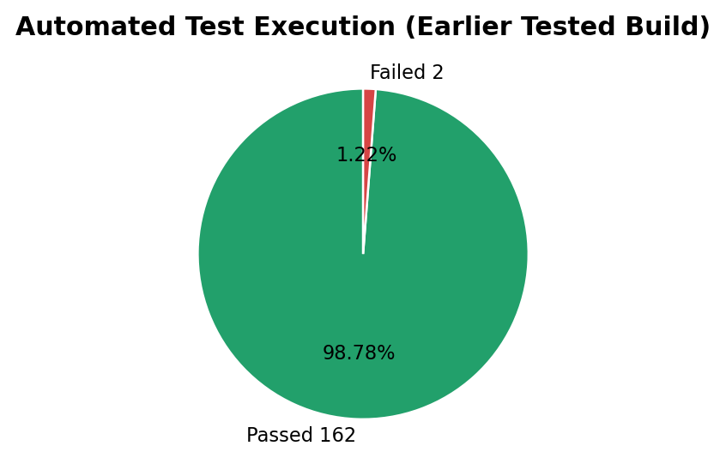
Release posture Conditional / not final. The workspace CI is healthy, but manual end-user evidence remains pending and known findings should be tracked. This report intentionally does not label the entire product as fully tested.

2. Test Objectives
- Validate core backend business logic and helper functions through automated tests.
- Verify workspace build, TypeScript type-checking, test execution and database migration health in CI.
- Identify regressions, failed automated cases, compilation risks and gaps in pipeline coverage.
- Provide traceable QA evidence suitable for an academic submission and professional review.
- Define a manual test plan for critical user journeys that require real device/UI interaction.

3. Test Scope
Scope category | Included | Notes
In scope | Workspace API unit/service tests; root workspace build/typecheck/test; DB migration CI; selected configuration and repository quality checks | Evidence obtained from repository configuration, test inventory, earlier execution results and GitHub Actions
Partially in scope | Standalone `backend/` and `mobile/` | Earlier issues were identified, but they are not equivalently covered by the current root workspace CI
Pending manual scope | Authentication, onboarding/profile, jobs, wallet/payment, subscription, messaging, navigation, UI/validation | Requires real app execution and screenshots
Out of scope for this draft | Performance/load benchmarking, penetration testing, accessibility audit, production payment transaction, production disaster recovery | No verified evidence supplied for these areas

4. Test Environment & Tooling
Component | Verified configuration / tool | Purpose
Repository | GitHub – ssharkar-2000/workflex-bd | Source, branches, CI and traceability
Runtime | Node.js 22 in GitHub Actions; project requires Node >=20 | Build/test runtime
Package manager | npm 11.13.0 declared at root | Workspace dependency management
Workspace orchestration | Turborepo | Root build/typecheck/test
Backend API | NestJS + TypeScript + Jest | API/business logic and unit/service testing
Database layer | Prisma + PostgreSQL/PostGIS 16-3.4 in CI | Schema/migration verification
Integration tooling | Supertest available in API dev dependencies | HTTP/API integration testing capability
Mobile client | React Native / Expo workspace | Manual device/UI verification pending

5. Test Strategy & Test Types
Test type | Objective | Execution mode | Status
Unit / service testing | Verify isolated business logic and utilities | Jest automated tests | Executed
API / integration testing | Verify service interaction and HTTP behaviour | Jest/Supertest capability; earlier integration additions | Executed / evidence partially available
Build verification | Confirm workspace compiles/builds | npm + Turborepo | Verified in CI
Type checking | Detect TypeScript errors | tsc / workspace typecheck | Verified in CI
Migration verification | Ensure committed migrations apply | Prisma deploy against PostGIS service | Verified in CI
Lint / static style | Enforce code quality rules | ESLint | Incomplete / configuration issue
Manual functional testing | Validate user journeys on real app | Phone + screenshots | Pending
Regression testing | Re-run automated checks after changes | GitHub Actions CI | Active for CI-scoped workspace

6. Test Execution Report
164  Total | 162  Passed | 2  Failed | 98.78%  Pass Rate | ~12.5%  Coverage

Traceability note The 162/164 result belongs to the earlier tested build. The repository has since changed. The current main commit inspected for CI is 5b8dc17; its latest inspected CI run is successful. Do not present the earlier 164-test count as a fresh rerun on the latest commit.

Exec ID | Layer | Scenario | Expected | Observed | Status
EX-001 | Automated suite | Run Jest automated tests | All tests execute and defects are surfaced | 164 executed; 162 pass; 2 fail | FAIL / Findings
EX-002 | Workspace build | Run root build | All workspace build tasks complete | Current CI: success | PASS
EX-003 | Typecheck | Run root typecheck | No blocking TypeScript errors in CI-scoped workspace | Current CI: success | PASS
EX-004 | CI test stage | Run root test command in GitHub Actions | Tests complete successfully for current CI build | Current CI: success | PASS
EX-005 | DB migrations | Apply committed migrations to PostGIS service | Migration deploy completes | Current CI: success | PASS
EX-006 | Standalone compile | Validate standalone backend/mobile | Components compile without blocking issues | Earlier compilation/type issues identified | ATTENTION
EX-007 | Lint | Run repository lint checks | Static analysis completes | Reliable full lint evidence unavailable | BLOCKED
EX-008 | Manual mobile/UI | Execute critical end-user workflows | Screenshots + actual results collected | Not yet executed in this report | PENDING

7. Automated Test Suite Inventory
The current repository exposes eight Jest specification files in the API workspace. These files represent the directly discoverable automated unit/service test inventory at the time of inspection.
Suite ID | Specification file | Functional area | Evidence status
UT-01 | apps/api/src/auth/phone.spec.ts | Phone/authentication logic | Present
UT-02 | apps/api/src/auth/password.spec.ts | Password/authentication logic | Present
UT-03 | apps/api/src/sms/dev-outbox.spec.ts | Development SMS outbox | Present
UT-04 | apps/api/src/wallet/return-url.spec.ts | Wallet/payment return URL handling | Present
UT-05 | apps/api/src/onboarding/sanitize.spec.ts | Onboarding input sanitization | Present
UT-06 | apps/api/src/common/otp-code.util.spec.ts | OTP code utility | Present
UT-07 | apps/api/src/wallet/wallet-features.spec.ts | Wallet feature logic | Present
UT-08 | apps/api/src/wallet/gateway/sslcommerz.gateway.spec.ts | SSLCommerz gateway integration logic | Present
Coverage interpretation ~12.5% coverage is relatively low for a whole-product assurance claim. A high pass rate shows that executed tests mostly passed; it does not mean 98.78% of all application behaviour is verified.

8. Defect Report & Analysis
ID | Area | Finding | Severity | Priority | Status | Evidence | Next action
DEF-001 | Subscription | Subscription cancellation automated scenario failed | High | High | Open | Earlier automated output | Reproduce, inspect service state and retest
DEF-002 | Payment / Subscription | Payment/subscription save-related scenario failed | High | High | Open | Earlier automated output | Trace persistence flow; add regression test
DEF-003 | Standalone backend | Compilation/type issues identified outside workspace CI | High | Medium | Open | Earlier compile verification | Run clean install + build and fix blockers
DEF-004 | Standalone mobile | Compilation/type issues identified outside workspace CI | High | Medium | Open | Earlier compile verification | Run clean Expo/TypeScript verification
DEF-005 | CI scope | CI does not equivalently validate standalone backend/mobile trees | Medium | Medium | Open | ci.yml + repository layout | Add explicit jobs or remove obsolete duplicate stacks
DEF-006 | Lint | End-to-end lint evidence unavailable due configuration mismatch/incompleteness | Medium | Medium | Open | Lint attempt / config review | Standardize ESLint config and add lint to CI
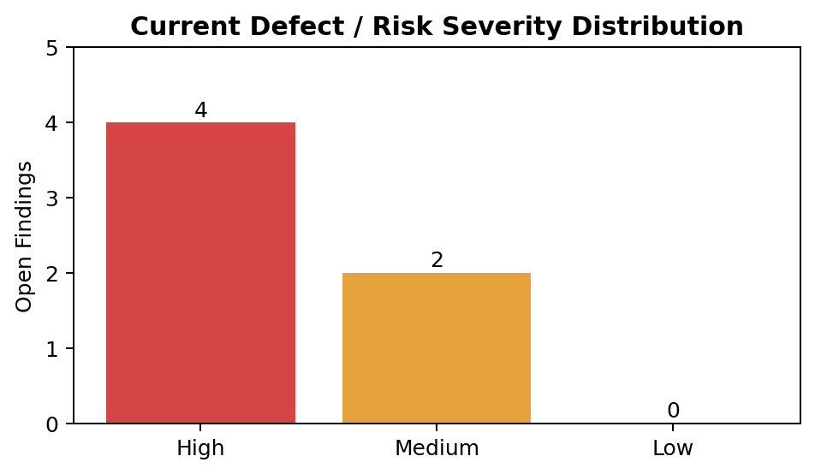

8.1 Defect Analysis
- The two observed automated failures are functionally important because they affect subscription/payment lifecycle behaviour.
- The build/CI findings are quality-system risks: a green CI badge may not represent every code tree in the repository.
- The lint issue reduces preventive defect detection and should be treated as a tooling/configuration gap rather than a passed test.
- No Critical severity defect is claimed in this draft because no verified evidence demonstrated complete service outage, irreversible data loss or a production security compromise.

9. CI/CD Automated Report
CI  Workflow | PASS  Verify job | PASS  Migration job | 5b8dc17  Current main

The inspected GitHub Actions workflow is triggered on pushes to main and pull requests. It contains a verification job and a database migration job.
CI stage | Command / mechanism | Purpose | Current inspected result
Install | npm ci | Reproducible dependency installation | Success
Build | npm run build | Build all root workspaces through Turborepo | Success
Typecheck | npm run typecheck | TypeScript validation for workspace packages | Success
Test | npm run test | Run configured workspace tests | Success
Migration service | postgis/postgis:16-3.4 | Provide PostgreSQL/PostGIS test database | Healthy / job success
Migration deploy | npm run db:deploy -w @workflex/api | Verify committed migrations apply | Success
CI gap Root workspaces are defined as apps/* and packages/*. Standalone top-level `backend/` and `mobile/` are therefore not automatically equivalent to the workspace scope. A successful root CI run should not be used as evidence that those separate trees are clean.

10. Risk Assessment
Risk ID | Risk | Likelihood | Impact | Mitigation
R-01 | Low automated code coverage leaves untested behaviours | High | High | Increase tests around auth, jobs, payments, messaging, validation and failure paths
R-02 | Manual critical workflows are not yet evidenced | High | High | Execute phone-based manual test run and attach screenshots
R-03 | Subscription/payment failures can affect transaction lifecycle | Medium | High | Fix DEF-001/002 and add regression coverage
R-04 | Green CI may hide issues in standalone trees | Medium | High | Expand CI scope or remove/deprecate duplicate application structures
R-05 | Lint configuration gap allows style/static issues to escape | Medium | Medium | Standardize ESLint and make lint a required CI stage
R-06 | Repository changed after earlier 164-test execution | High | Medium | Rerun full suite against final submission commit and archive output

11. Recommendations & Release Assessment
Current assessment CONDITIONAL GO for demonstration/development use, subject to manual critical-path verification and documented known issues. This is not a production-readiness certification.

Priority | Recommendation
P0 – Before final submission | Rerun automated tests on the final commit; capture terminal/CI screenshots; manually test authentication, job workflow, wallet/subscription and messaging.
P0 – Defect closure | Investigate and retest the two subscription/payment failures. Record actual cause, fix commit and regression result.
P1 – CI improvement | Add lint and explicit verification for any standalone backend/mobile code that remains part of the submitted product.
P1 – Coverage improvement | Raise automated coverage in critical modules; prioritize negative/edge cases rather than only happy paths.
P2 – Test management | Maintain test cases with stable IDs, priorities, owners, environment, expected/actual results and evidence links.
P2 – Future quality | Add API integration/E2E tests and optionally performance/accessibility/security testing if required by course scope.

12. Manual Test Plan / Evidence Register
The following cases are intentionally marked Pending. They should be executed on the final mobile/web build. For each case, capture at least one screenshot showing the resulting UI; for a failure, capture the error state and record reproduction steps.
TC ID | Module | Test scenario | Priority | Expected result | Actual result | Status | Evidence
MTC-001 | Authentication | Register a new valid user | High | Account created and user proceeds to onboarding | — | Pending | Screenshot required
MTC-002 | Authentication | Login with valid credentials | Critical | User enters authenticated home/dashboard | — | Pending | Screenshot required
MTC-003 | Authentication | Login with invalid password | High | Clear validation/error; no login | — | Pending | Screenshot required
MTC-004 | Profile | View and update profile | Medium | Updated data persists after refresh/reopen | — | Pending | Before/after screenshot
MTC-005 | Jobs | Browse/search available jobs | High | Relevant job list renders without crash | — | Pending | Screenshot required
MTC-006 | Jobs | Open job details | High | Correct details and available actions display | — | Pending | Screenshot required
MTC-007 | Jobs | Perform primary job action (apply/create as supported) | Critical | Action succeeds and state updates | — | Pending | Screenshot required
MTC-008 | Wallet | Open wallet and history | High | Balance/history page renders correctly | — | Pending | Screenshot required
MTC-009 | Subscription | View subscription state | High | Current plan/status is displayed correctly | — | Pending | Screenshot required
MTC-010 | Subscription | Cancel subscription in safe test mode if available | Critical | Cancellation state updates or safe expected response | — | Pending | Screenshot/video recommended
MTC-011 | Messaging | Open conversation and send message | High | Message appears/sends without duplicate or crash | — | Pending | Screenshot required
MTC-012 | Navigation | Navigate all primary tabs/screens | Medium | No dead links, blank pages or loops | — | Pending | Representative screenshots
MTC-013 | Validation | Submit required form with missing/invalid inputs | High | Field-level validation appears | — | Pending | Screenshot required
MTC-014 | Session | Logout and attempt protected navigation | High | Session ends; protected screen inaccessible | — | Pending | Screenshot required
MTC-015 | Basic UI | Check key screens on target phone | Medium | Readable, non-overlapping layout | — | Pending | Screenshots required

Appendix A – Traceability & Evidence Index
Evidence ID | Evidence | Current state | How to include in final submission
EV-01 | Automated test terminal output showing 164 / 162 / 2 | Earlier result available from prior test cycle | Insert screenshot immediately after Section 6
EV-02 | Coverage output (~12.5%) | Earlier result available | Insert screenshot or coverage summary file
EV-03 | GitHub Actions latest successful CI run for main | Verified in repository inspection | Insert Actions page screenshot
EV-04 | CI workflow configuration (`.github/workflows/ci.yml`) | Verified | Optional code screenshot in CI section
EV-05 | Automated Jest spec files | Verified – 8 discoverable spec files | Use code screenshots for 2–4 representative tests
EV-06 | Manual mobile authentication | Pending | Add MTC-001 to MTC-003 screenshots
EV-07 | Manual jobs/wallet/subscription | Pending | Add MTC-005 to MTC-010 screenshots
EV-08 | Manual messaging/navigation/UI | Pending | Add MTC-011 to MTC-015 screenshots

Document Control
Version | 1.0 Draft | Date | 30 Sep 2026
Prepared for | WorkFlex BD project | Prepared by | Project QA / Test Documentation
Status | Automated + CI documented | Manual evidence | Pending
Next revision | After manual test execution | Finalization | Update results, defects and evidence

