**Question 1)**

|  |
| --- |
| a)> pairs(iris[,1:4], pch = 19) |
|  |
| |  | | --- | |  | |

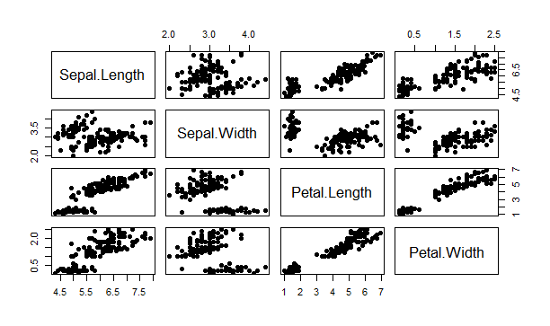

b) > cor(iris[,1:4], method = c("pearson"))

Sepal.Length Sepal.Width Petal.Length Petal.Width

Sepal.Length 1.0000000 -0.1175698 0.8717538 0.8179411

Sepal.Width -0.1175698 1.0000000 -0.4284401 -0.3661259

Petal.Length 0.8717538 -0.4284401 1.0000000 0.9628654

Petal.Width 0.8179411 -0.3661259 0.9628654 1.0000000

The pairs of variables: 1) Petal.Length and Sepal.Length 2) Sepal.Length and Petal.Length 3) Sepal.Length and Petal.Width 4) Petal.Length and Petal.Width

5)Petal.Width and Petal.Length have high correlations with each other.

c) > linearMod<-lm(Sepal.Length ~ Petal.Length, data=iris)

> print(linearMod)

Call:

lm(formula = Sepal.Length ~ Petal.Length, data = iris)

Coefficients:

(Intercept) Petal.Length

4.3066 0.4089

> summary(linearMod)

Call:

lm(formula = Sepal.Length ~ Petal.Length, data = iris)

Residuals:

Min 1Q Median 3Q Max

-1.24675 -0.29657 -0.01515 0.27676 1.00269

Coefficients:

Estimate Std. Error t value Pr(>|t|)

(Intercept) 4.30660 0.07839 54.94 <2e-16 ***

Petal.Length 0.40892 0.01889 21.65 <2e-16 ***

---

Signif. codes: 0 ‘***’ 0.001 ‘**’ 0.01 ‘*’ 0.05 ‘.’ 0.1 ‘ ’ 1

Residual standard error: 0.4071 on 148 degrees of freedom

Multiple R-squared: 0.76, Adjusted R-squared: 0.7583

F-statistic: 468.6 on 1 and 148 DF, p-value: < 2.2e-16

**--R-Squared=0.76**

d)> plot(iris$Sepal.Length ~ iris$Petal.Length)

> abline(linearMod)

