
Application Overview

Internal documentation. Not for publication.

This document describes the SSHCONTROL application, its features, dashboards, and technical stack.

1. Technical Stack

Frontend
Framework: React 18
Build tool: Vite 5
Language: TypeScript
Routing: React Router DOM 6
Libraries:
qrcode.react – TOTP QR code generation for 2FA setup

Backend
Framework: FastAPI
Server: Uvicorn
Database: PostgreSQL (async via asyncpg)
ORM: SQLAlchemy 2 (async)
Migrations: Alembic

Backend Libraries
Library Purpose
fastapi Web API framework
uvicorn ASGI server
sqlalchemy ORM and database access
asyncpg Async PostgreSQL driver
psycopg2binary Sync PostgreSQL (Alembic migrations)
pydantic Data validation
pythonjose JWT tokens
passlib / bcrypt Password hashing
pyotp TOTP 2FA
paramiko SSH key handling
cryptography Cryptographic operations
Pillow Image processing
sendgrid Transactional email
stripe Payments
reportlab PDF generation
httpx HTTP client (Google OAuth, etc.)
smpplib SMS via SMPP

2. Dashboards Overview

SSHCONTROL has three distinct dashboards depending on user role:

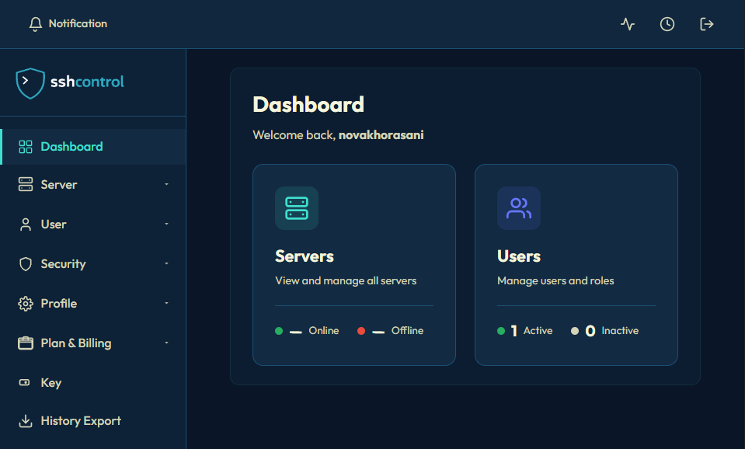
Admin Dashboard

User Dashboard
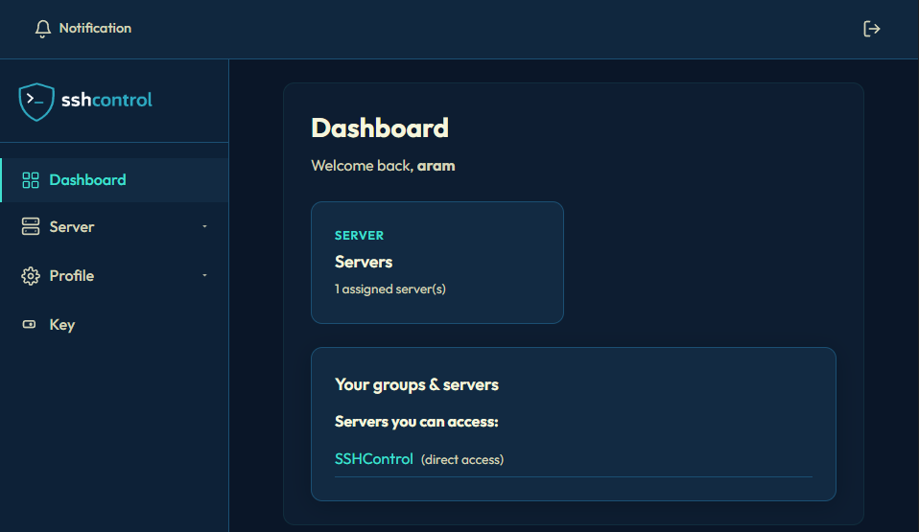
Superadmin Dashboard
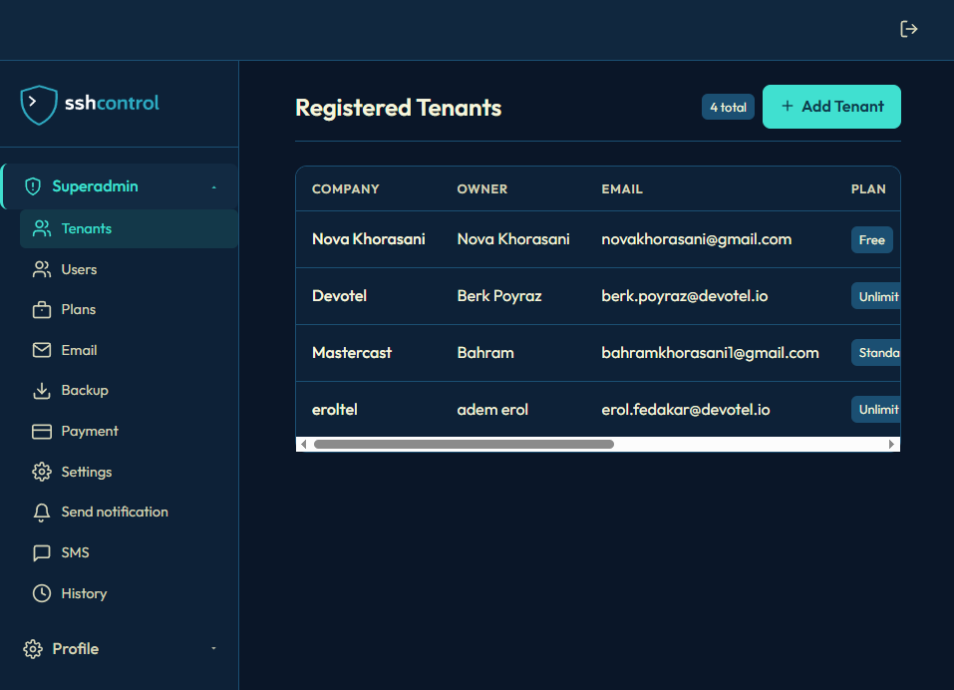

3. Public Pages (No Login Required)
3.1 Landing Page


Marketing page with features, benefits, how it works, pricing, FAQ, contact

Sign In and Sign Up tabs in popup (email/password + Google OAuth)
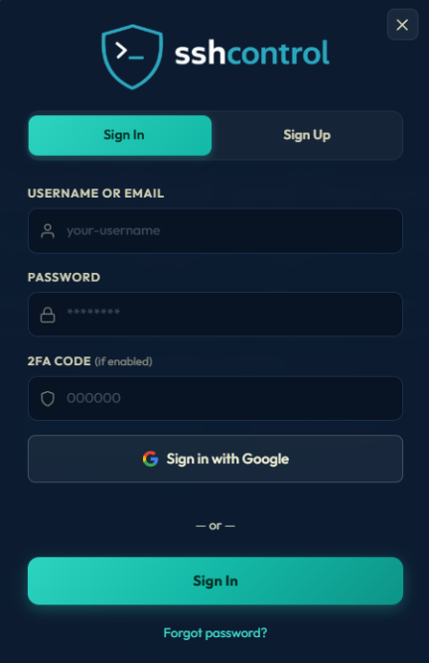
reCAPTCHA on login when configured

3.2 Login Page (//login)

Username, password, optional 2FA code, optional SMS code
Sign in with Google (when OAuth configured)
Links: Forgot password, Create account
reCAPTCHA when enabled

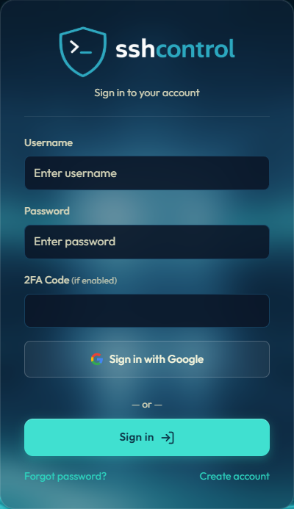

3.3 Signup Page (//signup)

Company name, full name, email, password
Sign up with Google (when OAuth configured)
Terms and conditions checkbox
Link to Sign in

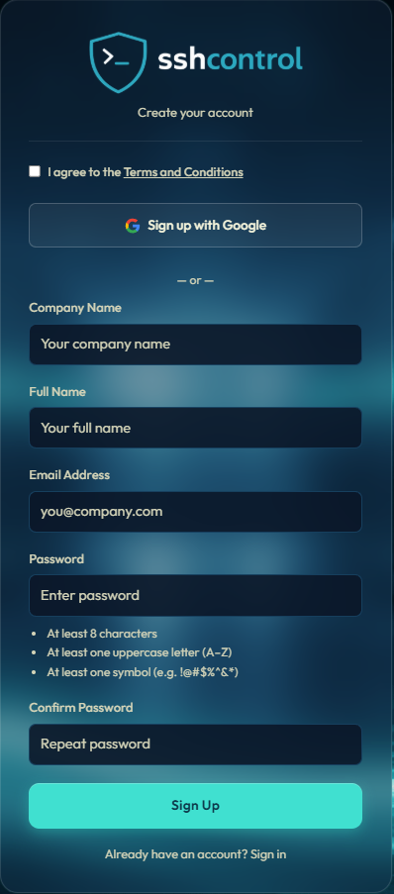
3.4 Public Plans (//plans)

List of available plans with pricing (Plans can be modify from superadmin page)
Sign In link

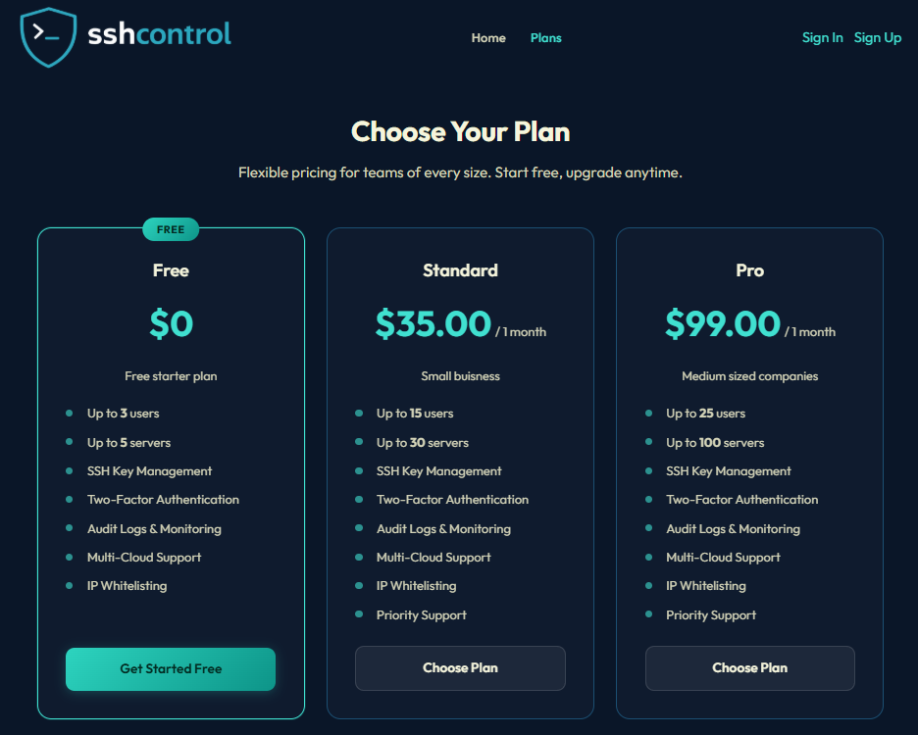

3.5 Forgot Password / Reset Password

Request reset link via email
Reset password with token from email
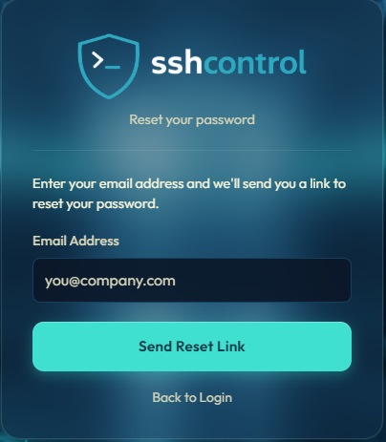

3.6 Accept Invitation (//acceptinvitation)
Accept tenant invitation via token link
Set password and complete signup

3.7 Verify Email
Email verification after signup (when verification is enabled)
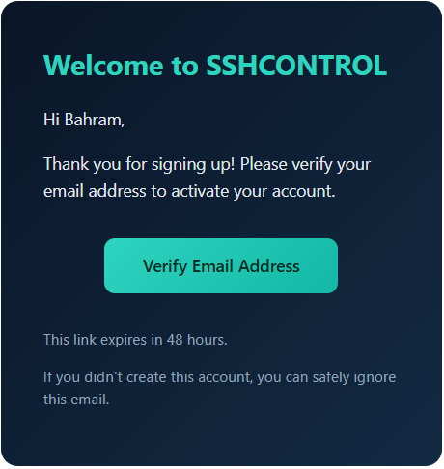

4. Onboarding (Welcome Flow)
Welcome / Onboarding (//welcome)

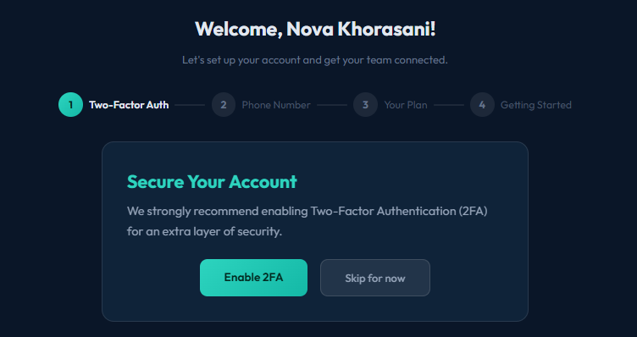

Multistep onboarding for new users:
Set username (if required)
Set password (if required)
TwoFactor Auth (2FA) – TOTP setup with QR code
Phone number – Optional, for SMS verification
Plan selection (admins only)
Getting started – Short guide

5. Tenant Admin Dashboard (Main App)

5.1 Dashboard (/)
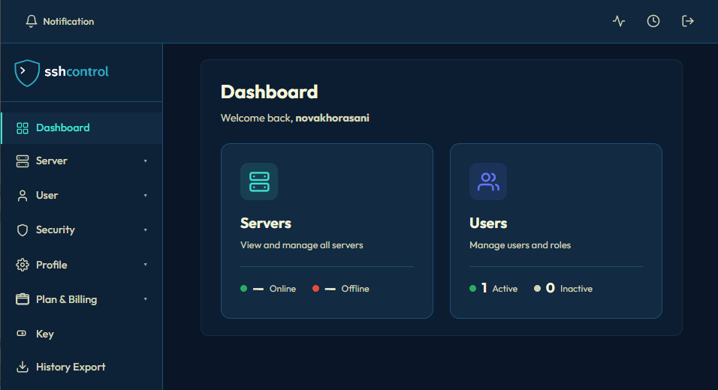
Admin view:
Welcome message
Servers card: online/offline counts, link to server list
Users card: active/inactive counts, link to users
My groups section: user groups, server groups, assigned servers

User view:
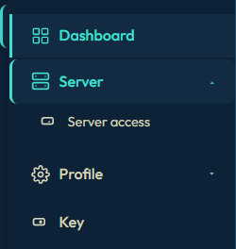
Simplified dashboard with assigned servers and groups

5.2 Servers

Add Server (/server/add)
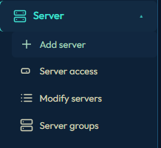

Add server by hostname
Deploy script / registration token
Server appears after agent registration
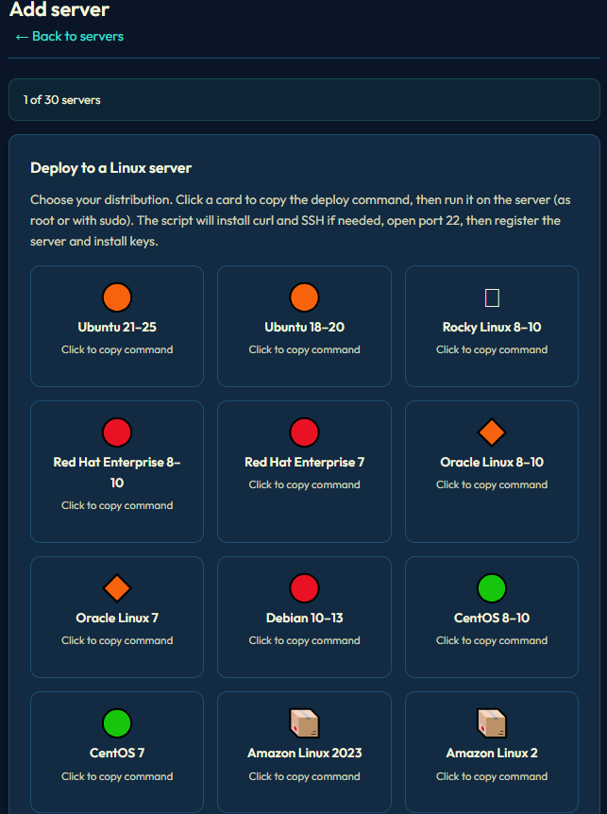
Server Access (/server/access)

View servers the user can access
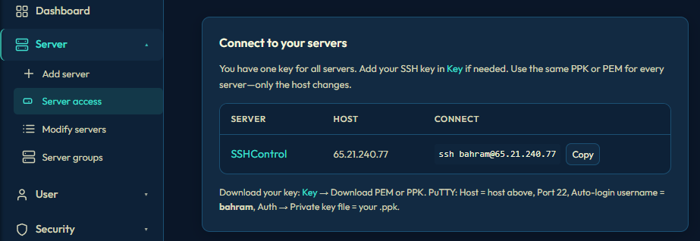

Modify Servers (/server)
List all servers (admin)
Status, hostname, IP, sync status
Edit, deploy script, delete

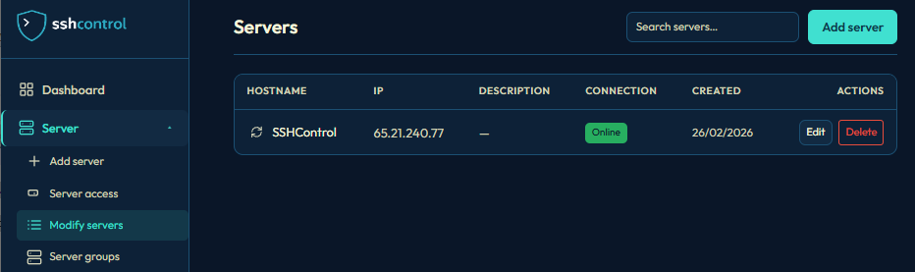

Server Groups (/servergroups)
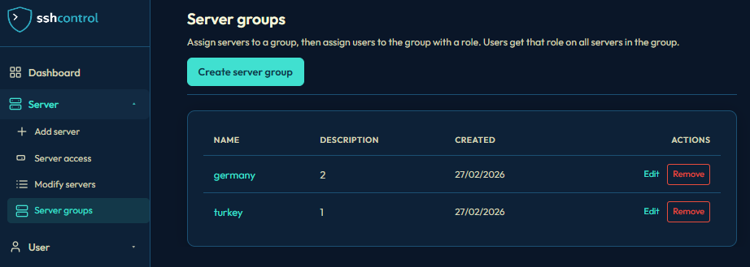

Create and manage server groups
Assign users/groups to server groups with roles

5.3 Users
Add User (/users/add)
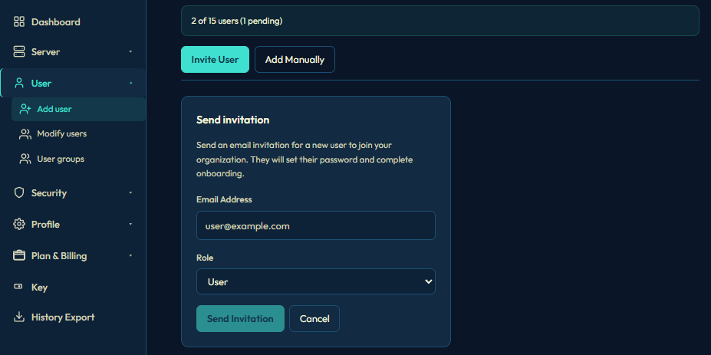
Invite mode: Send email invitation
Manual mode: Create user with email, username, password, optional phone, roles, server access
Phone verification flow when phone is provided
Modify Users (/users)
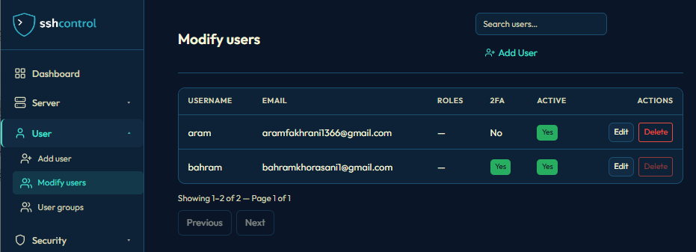
List users with search
Edit: username, email, status, 2FA, phone, roles, server access
Delete user (with destructive verification)
Pending invitations
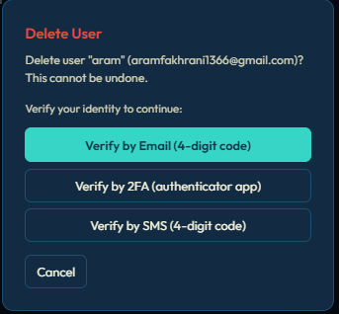

User Groups (/usergroups)

Create and manage user groups
Assign members to groups
Used for server group access
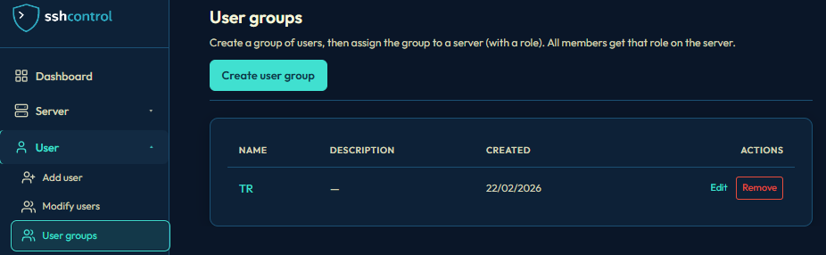

5.4 Security

Whitelist IP (/security/whitelistip)
Restrict SSH access to whitelisted IPs
Add IPs per user or globally
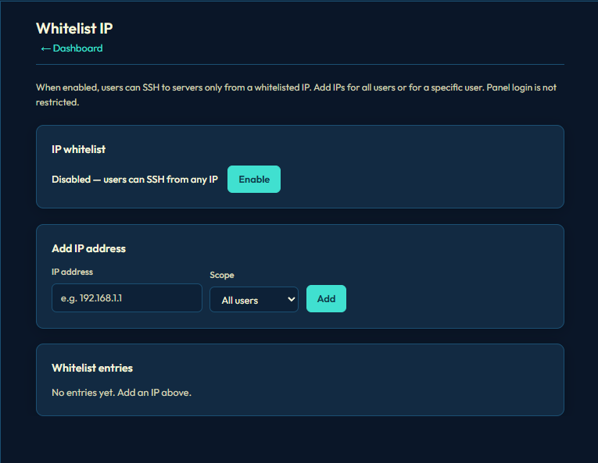

5.5 Monitor & History

Online Users (/monitor)
Users with active panel sessions (last 5 minutes)
SSH session status per server
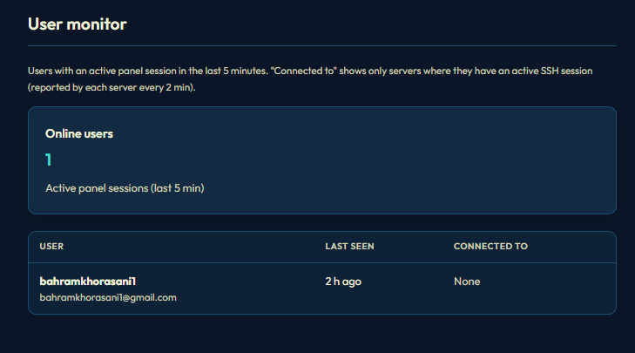

History (/history)
Audit log of actions (logins, changes, etc.)

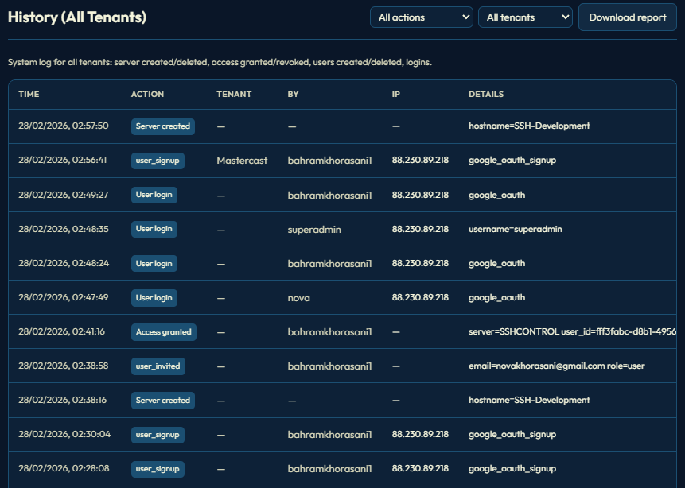
5.6 Profile

Account (/profile/account)
View/edit full name, email, username
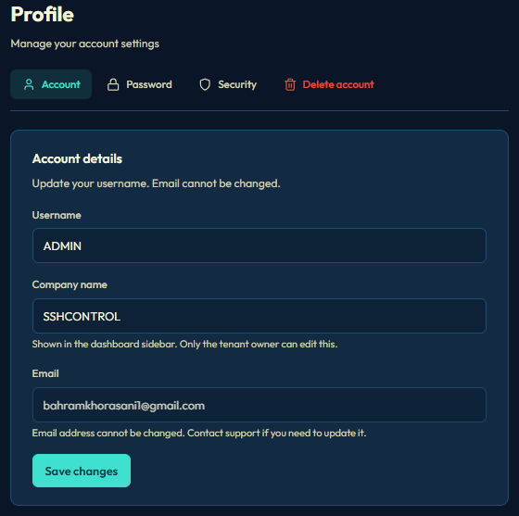

Password (/profile/password)
Change password
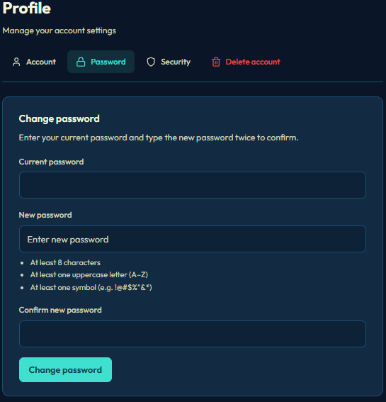

Security (/profile/security)
2FA (TOTP): enable/disable
Phone: add/verify for SMS
SMS verification toggle
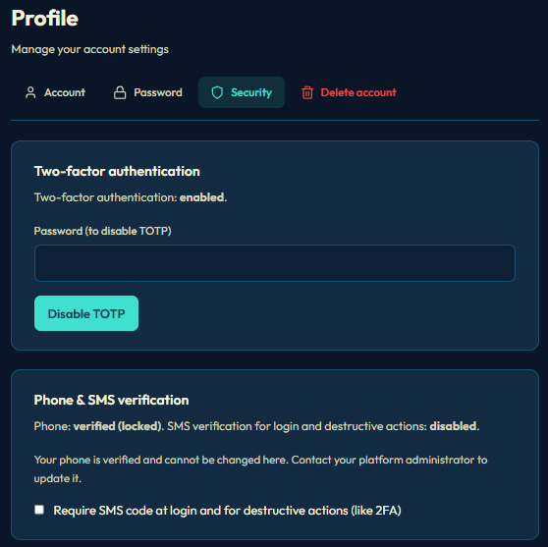

5.7 Plan & Billing
Plan (/planbilling/plan)
Current plan, limits (users, servers)
Upgrade options (Stripe checkout)
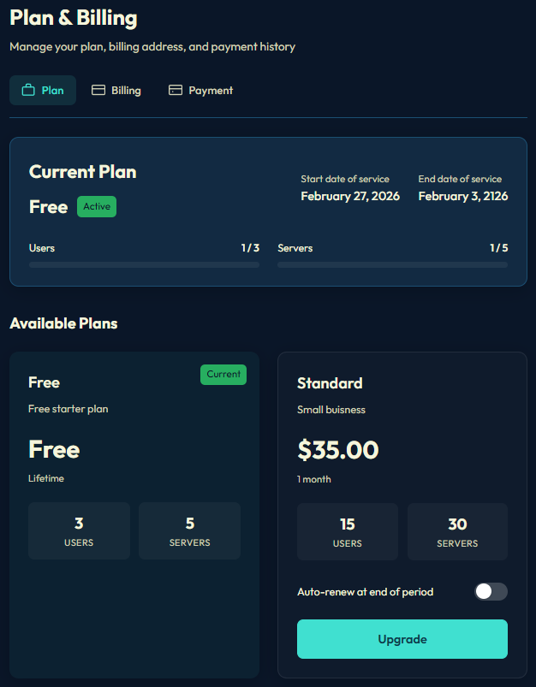
Billing (/planbilling/billing)
Billing info, payment method
Stripe customer portal
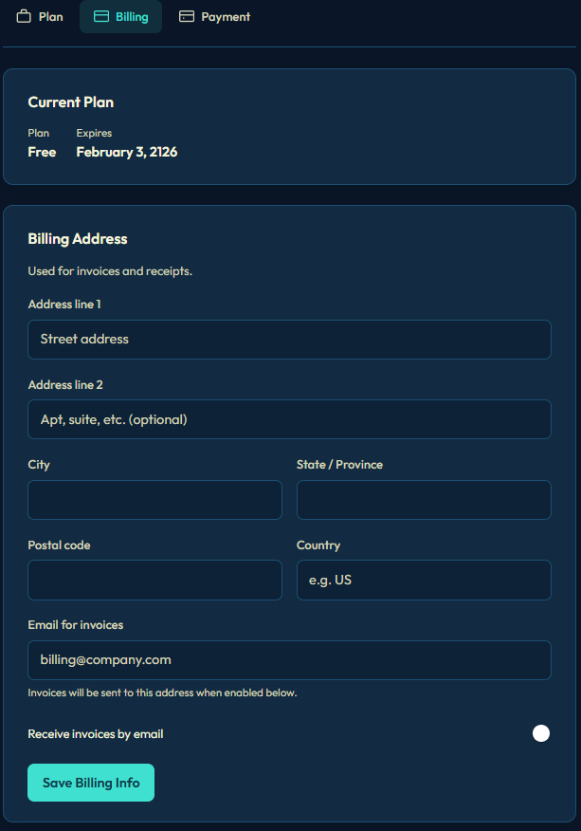
Payment History (/planbilling/payment)
List of past payments
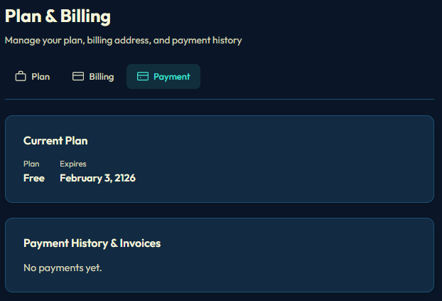
5.8 SSH Keys
Keys (/keys)
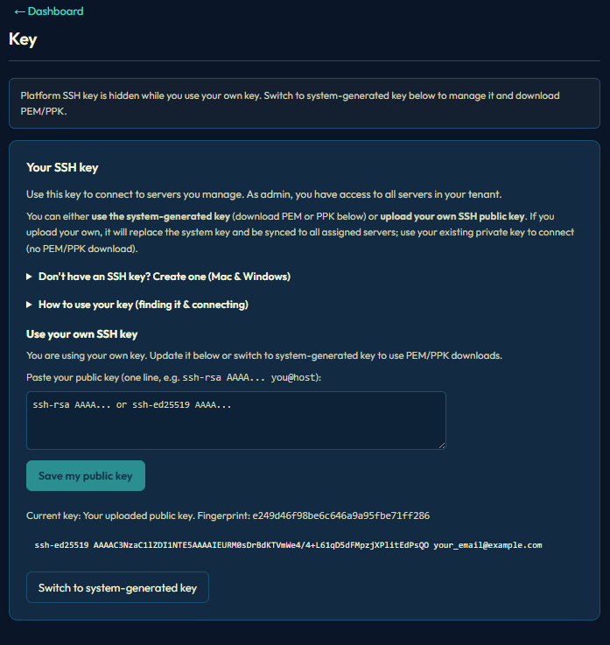
User’s SSH public keys
Add, remove keys
Keys are synced to servers where the user has access

5.9 History Export
History Export (/historyexport)
Export audit log (CSV/PDF)
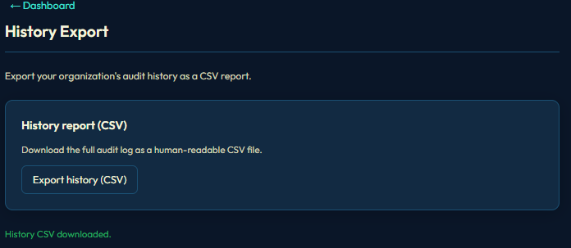

6. Platform Superadmin Dashboard
Only for platform owner (superuser with no tenant).
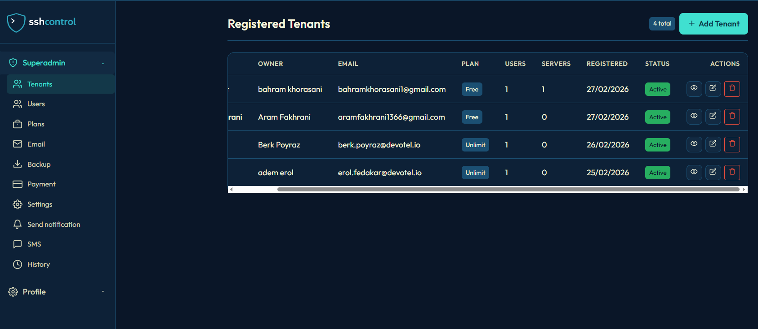
6.1 Tenants (/superadmin/tenants)
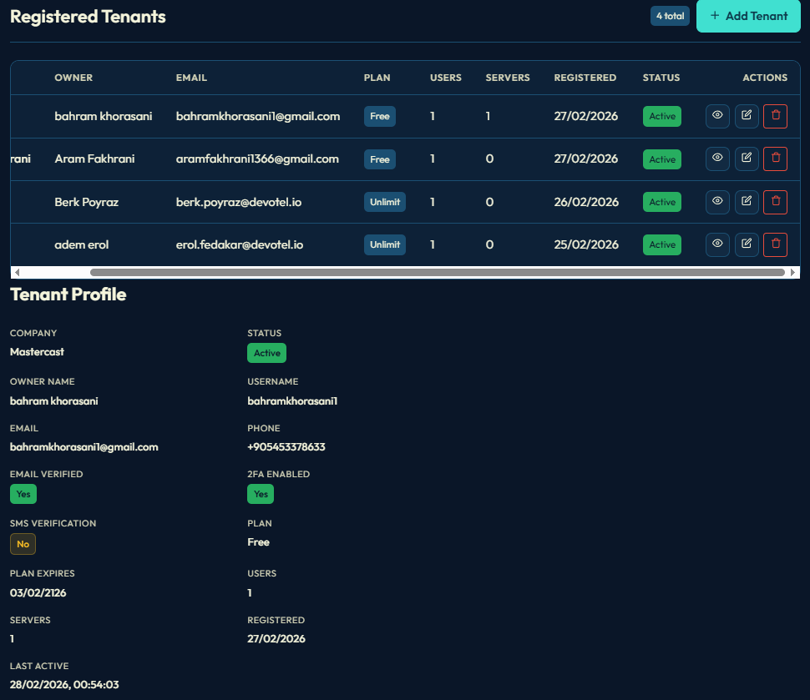

List all tenants (organizations)
Create, edit, delete tenants
Owner info, plan, status
Assign plans to tenants

6.2 Users (/superadmin/users)
[Add screenshot: Superadmin users]

All users across tenants
Search, filter
Edit user details

6.3 Plans (/superadmin/plans)
[Add screenshot: Superadmin plans]
Define plans (name, limits, price, Stripe price ID)
Create, edit plans

6.4 Email (/superadmin/email)
[Add screenshot: Superadmin email]

Email templates (verification, reset password, etc.)
SendGrid configuration

6.5 Backup (/superadmin/backup)
[Add screenshot: Superadmin backup]

Database backup
Download backup files

6.6 Payment (/superadmin/payment)
[Add screenshot: Superadmin payment]

Payment transactions across tenants
Revenue reports, filters

6.7 Settings (/superadmin/settings)
[Add screenshot: Superadmin settings]

Google Analytics, Ads, Tag Manager
Google OAuth (Sign in with Google)
reCAPTCHA (login protection)
SEO (meta tags, description)

6.8 Notifications (/superadmin/notifications)
[Add screenshot: Superadmin notifications]

Send inapp notifications to users/tenants

6.9 SMS (/superadmin/sms)
[Add screenshot: Superadmin SMS]

SMPP configuration for SMS
SMS verification settings

6.10 History (/superadmin/history)
[Add screenshot: Superadmin history]

Platformwide audit log

7. Other Pages

Payment Result (/paymentresult)
Stripe checkout success/cancel redirect
Shows payment status

Auth Callback (//auth/callback)
OAuth callback (e.g. Google)
Stores tokens and redirects to app

8. Key Features Summary

Feature Description

- Multitenant Organizations (tenants) with isolated data
- SSH key management Add keys, sync to servers via agent
- Server groups Group servers, assign access by user/group
- User groups Group users for access control
- 2FA (TOTP) Optional two factor authentication
- SMS verification Optional phone verification
- Google OAuth Sign in / sign up with Google
- IP whitelisting Restrict SSH by IP
- Plan & billing Stripe subscriptions, plan limits
- Audit log Action history, export
- Email Verification, reset password, invitations
- SMS SMPPbased SMS for verification

9. User Roles

Role Access

Platform Superadmin Full platform control, superadmin dashboard
Admin (tenant) Full tenant control: servers, users, billing, security
User (tenant) Server access, profile, SSH keys

