Environment/Reflection maps

Environment/reflection maps
Load image(s) that represent the environment
For each pixel showing a reflective object:
Compute object's normal
Compute reflection direction
Compute index(s) into environment map
Use texel to color pixel
An environment reflection needs position and direction
Position from renderer
Direction from normal and view direction:
Simplify to use just direction
That's a reasonable approximation if object is
small, simple, and distant from other objects.

Polar Spherical texture environment map
Texture: One full texture with polar distortion
Map: Polar map inverse:

Pro:
Simple
Was first
Con:
Distortion is very bad.
Linear interpolation of texture coords fails when:
cross boundary
contain poles

Cubic texture environment map
Texture: 6 square texture maps for axis aligned directions.
Map: 2 stage:
Stage 2: Cube to surface inverse: follow reflection direction
Reflection direction:
Project from center of cube to cube surface. by scaling R to

Stage 1: Texture to cube inverse: Just six planar texture maps
Choose which of six from Stage 2 results
Pro:
Little distortion
No pole/boundary interpolation problems
Can be generated programatically
Are view independent
Con:
Needs six images

Spherical texture environment map
Texture: One full texture using center circle portion only
Map: For
N is half-way between E=(0,0,-1) and R

so a good choice of coordinates is

which maps all (unit) directions into a unit circle, and

which maps
Pro:
Can be generated with a camera
or programatically followed by distortion calc
No pole/boundary interpolation problems
Needs one image.
Con:
Is view dependent
Linear interpolation is only an approximation.
Both Pro/Con
Low resolution on sphere edges.
Short cut:
Since scanline produces N, don't compute R then N then (u,v),
instead just
OpenGL note
In class, the eye coordinate system looks along the +z axis, in OpenGL, the eye looks along the -z axis, so the above equation hasinstead ofin the OpenGL manuals.

Paraboloid Mapping
Like sphere, but using two hemispheres to retain resolution for view independence.

Features:
Needs two image.
Pro:
No pole/boundary interpolation problems
Is view independent.
Con:
Generate only by distorting calculation

Tennisball map
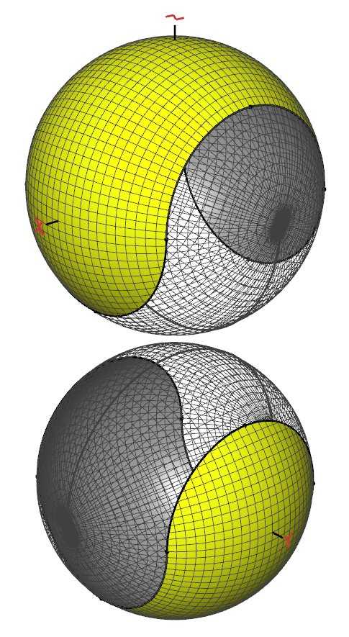
Two maps of sphere, each with its bad areas (poles and seams) covered by the others nice areas (equator, non-seam). For a vector

For a given vector , compute which component via
to get the parameter ranges

For rendering into the map:
