Shadow Maps

Shadow maps
Pass 1: Render from light's POV, to a Frame Buffer Object (FBO)
Viewing: = gluLookAt from light's POV
Projection: = glFrustum from light's POV
Vertex processor:
Usual gl_Position = ftransform() for the scan conversion
varying position = gl_Position;
Pixel processor:
Write depth (that is position.w) to gl_FragColor or gl_FragData[0]
(alternately: write full position and extract itsw comp in pass 2)

Pass 2: Render from eye's POV to screen:
Viewing: = gluLookAt from eye's POV
Projection: = glFrustum from eye's POV
ShadowTr: (Used to transform position in eye coordinates to shadow-texture coordinates)
Vertex processor:
Usual ftransform() for the scan conversion
Varying position = gl_ModelViewMatrix * gl_Vertex
Fragment shader:
shadowCoord = ShadowTr*position
(For efficiency sake, consider moving this
multiplication to the vertex shader.)
Light-depth = w coordinate from indexing shadow-texture at
shadowCoord.xy/shadowCoord.w
Pixel-depth = shadowCoord.w
Pixel is in shadow if: Pixel-depth > Light-depth
Color pixel accordingly: ambient only (if in shadow),
ambient+diffuse+specular (if not in shadow).

Examples
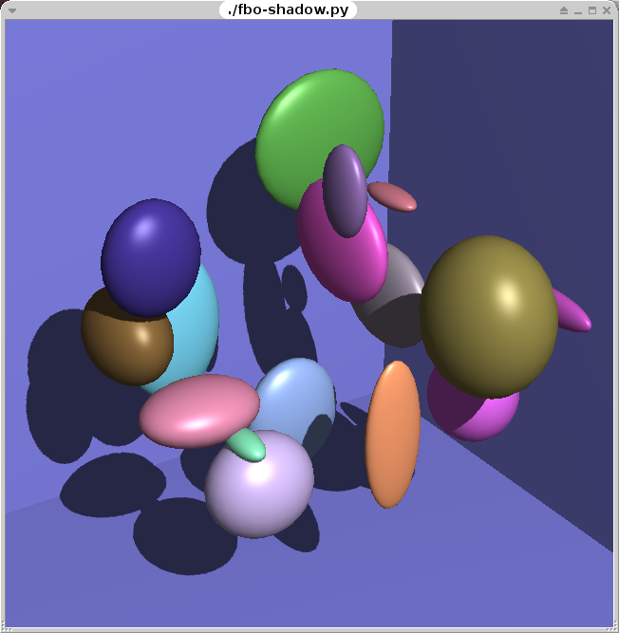Example
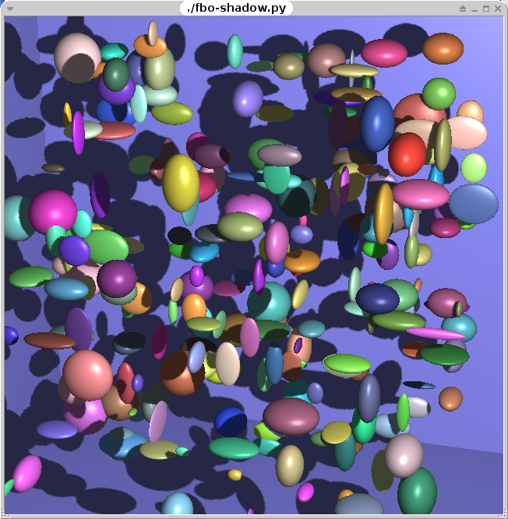Many shadows cast on many objects
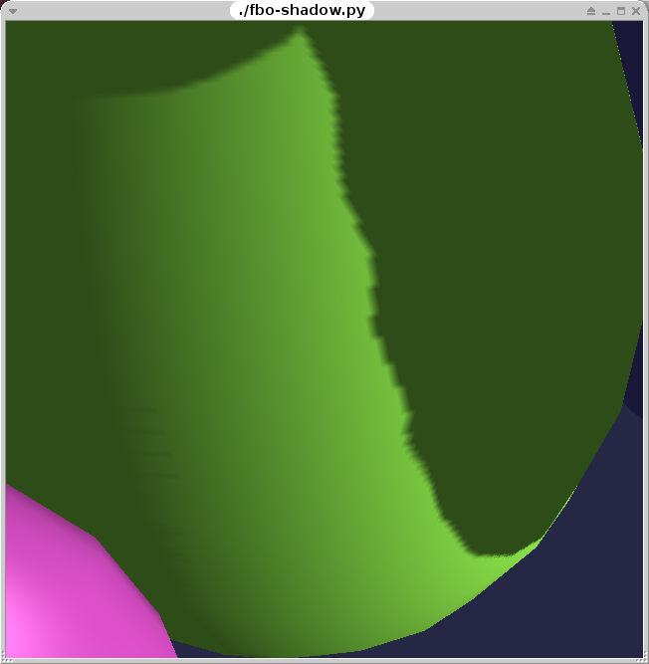Closeup showing pixelation of shadow map
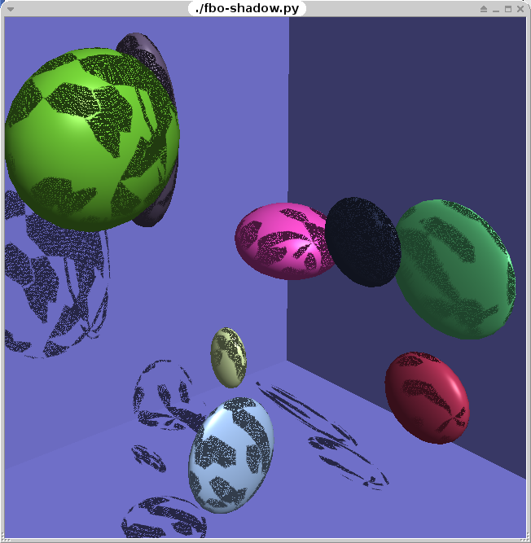Error due to depth precision problems

Problems and solutions
- Depth precision problems:
  - The shadow test compare two float for equality. This must be done carefully to allow for round-off errors.
- Depth fighting occurs at the front surface of any object
  - Front face culling, so shadow starts at back of surface
  - Fighting at back of surface is OK since
unlit due to geometry == unlit due to shadow

