**PBJ Documentation HW**

Purpose:

This document serves as an easy-to-follow, step-by-step guide that shows you how to make peanut butter and jelly sandwich, a quintessential American delicacy.

Tools:

* Toaster/oven – for baking the bread [optional]
  + For oven method only: baking pan, oven mitts
* Stainless steel table knife – for spreading the peanut butter over the bread

Ingredients:

* Two slices of bread
  + You can find bread slices packaged for sell at grocery stores
  + Each individual slices is shaped like a square, and about 2cm thick.
  + If you are health-conscious, use whole-wheat bread instead of white bread
* Peanut butter (x1 jar). Choose from one of the two types below:
  + creamy peanut butter: smooth texture, easier to spread out
  + crunchy peanut butter: crunchier and drier texture, mixed with chunks of peanut
* Jelly/Jam (any flavor that suits your fancy)

Steps:

1. Baking the bread [optional]
   1. Toaster method: Place two slices of bread in the toaster slots. Choose a lower-medium setting, and push down the lever to start toasting. Make sure you don’t pick a setting that’s too high, as you don’t want to end up burning the bread.

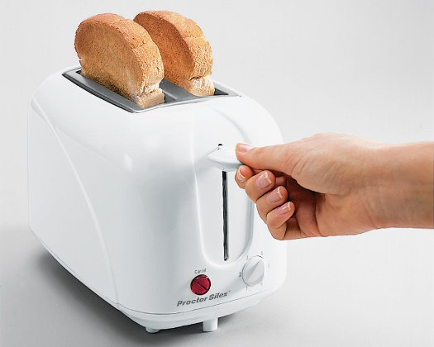[1]

* 1. Oven method: Place the bread slices on top of the baking pan. Preheat the oven to 300°F for 5 minutes. Place the baking pan inside the top shelf of the oven and wait for 2 minutes or until the bread turns into golden-brown color (whichever comes first). Flip each slice to the other side and repeat. Take out the baking pan.

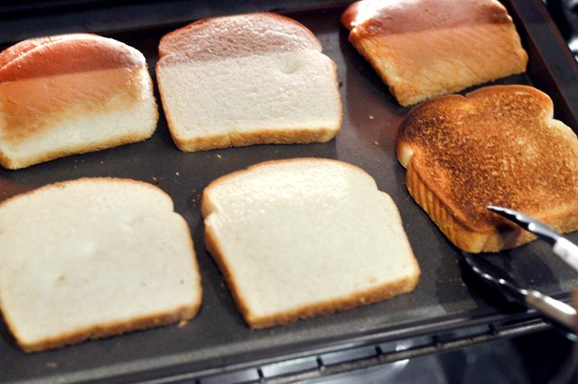[2]

1. The toasted bread should look like the ones below. Notice the golden-brown color of the burn, which is noticeable but not overly done.

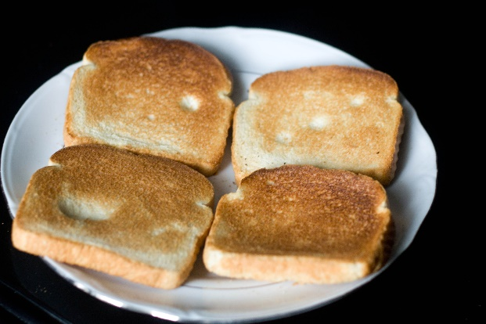[3]

1. Using a table knife, spread an even amount of peanut butter on one side of a bread slice. Using the knife again, spread an even amount of jelly on one side of the other bread slice.

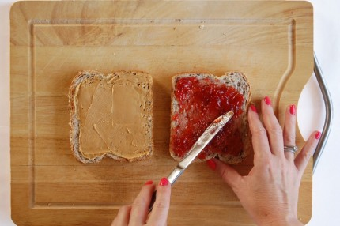[4]

1. Stack the two bread slices together, with the sides containing peanut butter and jelly facing each other on the inside.
2. Enjoy your PBJ!

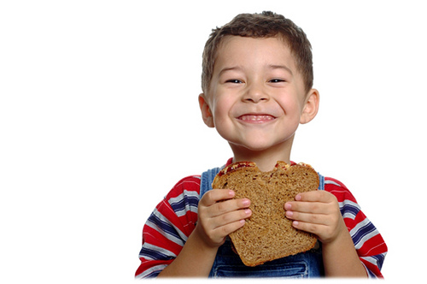[5]

Word count: 382

1. [Digital image]. (n.d.). Retrieved October 26, 2016, from https://www.amazon.com/Proctor-Silex-22203Y-Cool-Touch-Toaster/dp/B0016CPGYQ
2. [Digital image]. (n.d.). Retrieved October 26, 2016, from http://www.livestrong.com/article/416518-how-to-cook-toast-in-an-oven/
3. [Digital image]. (n.d.). Retrieved October 26, 2016, from http://www.livestrong.com/article/416518-how-to-cook-toast-in-an-oven/
4. [Digital image]. (n.d.). Retrieved October 23, 2016, from http://singlemindedwomen.com/womens-health/peanut-butter-and-jelly/
5. [Digital image]. (n.d.). Retrieved October 26, 2016, from https://www.flickr.com/photos/breathela/2511598079