Software Engineering Group Project
Word Template
Author: | A. N. Other
Config Ref: | SE_N66_xxx_xx
Date: | 2010-10-11
Version: | 1.2
Status: | Draft
Department of Computer Science
Aberystwyth University
Aberystwyth
Ceredigion
SY23 3DB
Copyright © Aberystwyth University 2008

CONTENTS
CONTENTS 2
1. Introduction 3
2. Purpose of this Document 3
2.2 Objectives 3
3. BODY OF DOCUMENT 3
REFERENCES 3
DOCUMENT HISTORY 3

Introduction
Clear, consistently followed, document standards are essential in software engineering.

Purpose of this Document
This document is to describe an MS Word template.

Scope
This supports the standards laid down for CS22120 Group Projects [1].

Objectives
The objective of this document is to both carry the template and explain a little of how it works.

BODY OF DOCUMENT
Front material is stored in document properties. These are not the correctly named properties but their use permits automation of running header update. Editing the front material will make changes throughout the document.
Titles, headings, body, bibliography entries, captions and table of content entries are defined as shown in Figure 1
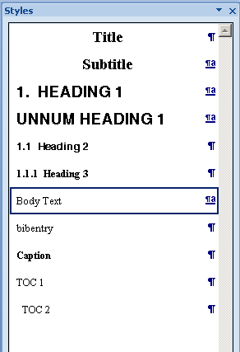
Figure 1: Recommended styles

REFERENCES
[1] Software Engineering Group Projects: General Documentation Standards. C. J. Price, N. W. Hardy. SE.QA.03. 1.5 Release

DOCUMENT HISTORY
Version | CCF No. | Date | Changes made to document | Changed by
1.0 | N/A | 12/09/08 | N/A - original version | CJP
1.1 | N/A | 2010-10-12 | Updated to Office 2007; key field automation increased; paragraph styles updated | NWH

