Project Plan

Monster Mash

Author: Cellan Williams <cew10>

Config Ref: SE_N15_PLAN_01

Date: 29/01/2013

Version: V1.6

Status: Draft

Department of Computer Science

Aberystwyth University

Aberystwyth

Ceredigion

SY23 3DB

Copyright © Aberystwyth University 2012

Table of Contents

Purpose of this Document 3

Scope 3

Objectives 3

Overview 3

Use Case Diagrams 4

User Interface Design 5

Gantt Chart 10

Risk Analysis 12

References 12

Change log 13

## Purpose of this Document

The purpose of this document is to clarify and define the project mandate. It will state the possible constraints that the group could face in regards to producing the Monster Mash game. The processes the group will have to commit will also be defined. This document will have to stay within the requirements and specification of the QA documents.

## Scope

In this document, we will go over the plan for the project, on both a time and user perspective. We have included basic user interaction design, including use case diagrams, as well as decisions we have made in regards to the project.

## Objectives

This document’s objective is to show the reader what materials we used to produce our Monster mash game.

* Use-case diagrams
* User interface design
* Gantt chart
* Risk Analysis

All of the above are material that will be explained in this document with the necessary screenshots and information stated.

## Overview

For the project we have decided to use Glassfish for the server interaction as it is more flexible compared to Google App Engine (GAE) in regards to data persistence and it means that the end users don’t have to register for a Google account when authenticating with our application.

For the Version Control System, we have gone with Git over SVN, as one of our developers know how to use it and is able to teach the rest of the group how to use. Our repository is hosted on [www.github.com](http://www.github.com) under a private account, so we can control who can access it.

We are using Microsoft Word for documentation and Microsoft Visio for diagrams.

## Use Case Diagrams

# 

Here is the Use-Case diagram, clearly showing what the user and system should be able to do. The user needs to be able to:

* Register or log in
* Host a monster farm
* Set monster attributes
* Interact with other players
* Breed, fight and purchase monsters
* Change their password

The system needs to be able to:

* Display:
  + A list of monsters and attributes
  + A list of friends
  + Friend requests
* Communicate with other servers
* Store details of users and monsters
* Allow users to register
* Maintain and manage friend lists
* Manage monsters lifecycle

## User Interface Design

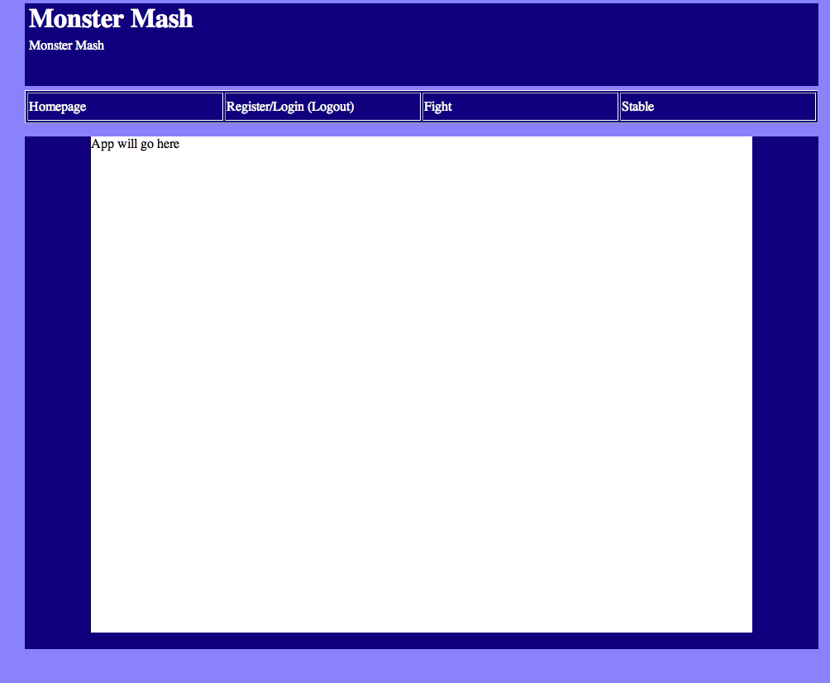

Fig.1 - Main page

This is our main page for the project. Here we have 4 links: Homepage, Login/Register/Logout, Fight and Stable. When the user comes to the main page, to begin with they only can interact with two of the links (Homepage and Register/login). When the user has been authenticated Register/login changes to logout, and two links appear to allow the user to fight monsters and view the stable.

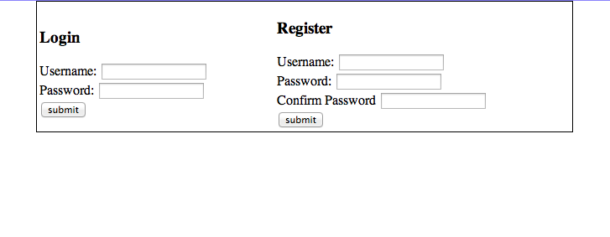

Fig 2 - Registering and Logging in

Here is the form for the user to both login and register. It is clearly marked out so the user can distinguish between both forms.

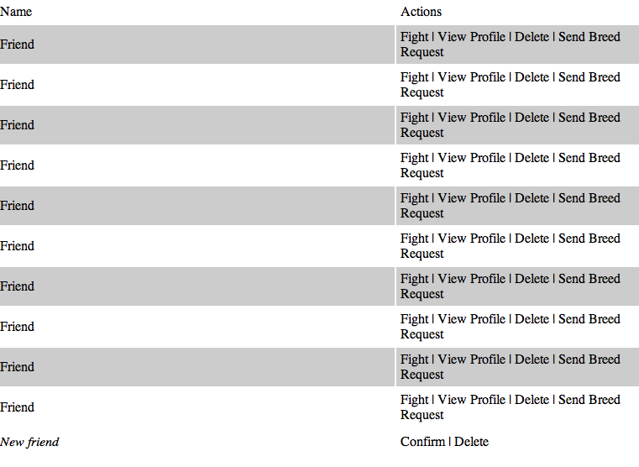

Fig 3 - Friends list

Here is the list of friends which the user may have - both confirmed and requests. With confirmed friends, there are more interactions available, such as fighting and sending breed requests. Unconfirmed friends are in italics at the bottom with only an option to confirm or delete.

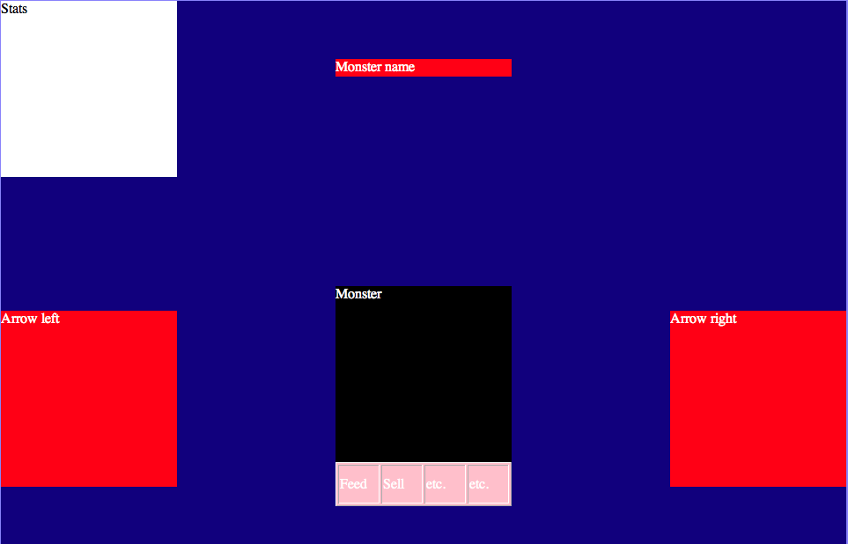

Fig 4 - Monster Information

We will be designing the stable and monster information into more of a console game, so we have the ability to scroll 1 by 1 back and forward between all of our monster. We will also give access to a list. There will be certain actions the user can do with the monster, such as feed and sell.

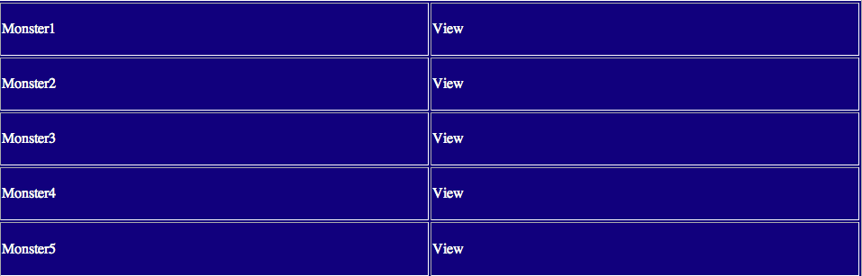

Fig 5 - Stable list

As well as the monster information screen, we have a list with certain quick actions on there, such as view the monster.

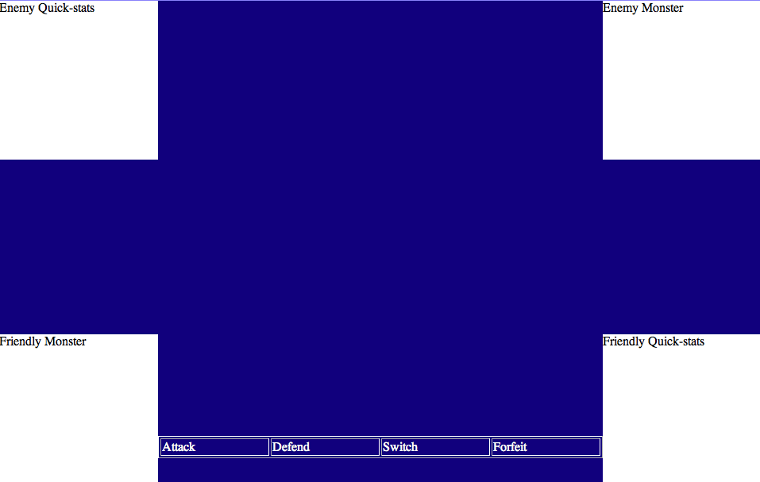

Fig 6 - Fight screen

We have created the interface as simply as we can, with only a certain amount of actions the user can perform during the fight.

## Gantt Chart

|  |  |  |  |  |  |  |
| --- | --- | --- | --- | --- | --- | --- |
| ID | Predecessors | Task Owner | Start Date | End Date | Description | Additional members |
| SE_N15_PLAN_01 | PLAN_02 - 05 | Sam Sherar | 09/10/2012 | 01/11/2012 | Writing the Overall Document |  |
| SE_N15_PLAN_02 |  | Cellan Williams | 09/10/2012 | 01/11/2012 | Creating Use Case diagrams |  |
| SE_N15_PLAN_03 |  | Andy Watkins | 09/10/2012 | 01/11/2012 | User Interaction design |  |
| SE_N15_PLAN_04 |  | Charlie Bird | 09/10/2012 | 01/11/2012 | Risk Analysis |  |
| SE_N15_PLAN_05 |  | Sam Sherar | 09/10/2012 | 01/11/2012 | Gantt Chart |  |
| SE_N15_TEST_01 |  | Grant David | 28/10/2012 | 16/11/2012 | Writing the Test Document |  |
| SE_N15_TEST_02 | TEST_01 | Grant David | 01/12/2012 | 08/01/2013 | Testing Prototypes | Imran Mungul |
| SE_N15_TEST_03 | TEST_02 | Grant David | 29/01/2013 | 04/02/2013 | Testing Final Product | Imran Mungul |
| SE_N15_DS_01 | DS_02 - 05 | Charlie Bird | 02/11/2012 | 11/12/2012 | Writing the Overall Document |  |
| SE_N15_DS_02 |  | Imran Mungul | 02/11/2012 | 16/11/2012 | Decomposition Description |  |
| SE_N15_DS_03 |  | Andy Watkins | 02/11/2012 | 16/11/2012 | Dependancy Description |  |
| SE_N15_DS_04 |  | Cellan Williams | 02/11/2012 | 16/11/2012 | Interface Description |  |
| SE_N15_DS_05 |  | Fiona Samy | 02/11/2012 | 16/11/2012 | Detailed Design |  |
| SE_N15_CODE_01 | CODE_02 - 04 | Kamil Mrowic | 02/11/2012 | 01/12/2012 | Prototypes |  |
| SE_N15_CODE_02 |  | Kamil Mrowic | 02/11/2012 | 01/12/2012 | Server-Server Interaction |  |
| SE_N15_CODE_03 |  | Andy Watkins | 17/11/2012 | 01/12/2012 | User Interface |  |
| SE_N15_CODE_04 |  | Sam Sherar | 02/11/2012 | 01/12/2012 | Data Persistance and Modelling |  |
| SE_N15_CODE_05 | CODE_01 | Kamil Mrowic | 01/12/2012 | 05/02/2013 | Developing Final Product | Sam Sherar, Andy Watkins, Cellan Williams |
| SE_N15_MAN_01 |  | Fiona Samy | 29/01/2013 | 10/02/2013 | Writing User Manual |  |
| SE_N15_MAN_02 |  | Imran Mungul | 29/01/2013 | 10/02/2013 | Writing Technical Manual |  |
| SE_N15_FR_01 |  | Sam Sherar | 06/02/2013 | 16/02/2013 | Writing Final Report | Everyone |
| SE_N15_FR_02 | PLAN | Andy Watkins | 06/02/2013 | 16/02/2013 | Finalising Project Plan document |  |
| SE_N15_FR_03 | TEST | Grant David | 06/02/2013 | 16/02/2013 | Finalising Test Document |  |
| SE_N15_FR_04 | MAN | Fiona Samy | 10/02/2013 | 16/02/2013 | Finalising User manual |  |
| SE_N15_FR_05 | DS | Imran Mungul | 10/02/2013 | 16/02/2013 | Finalising Design Specification document |  |

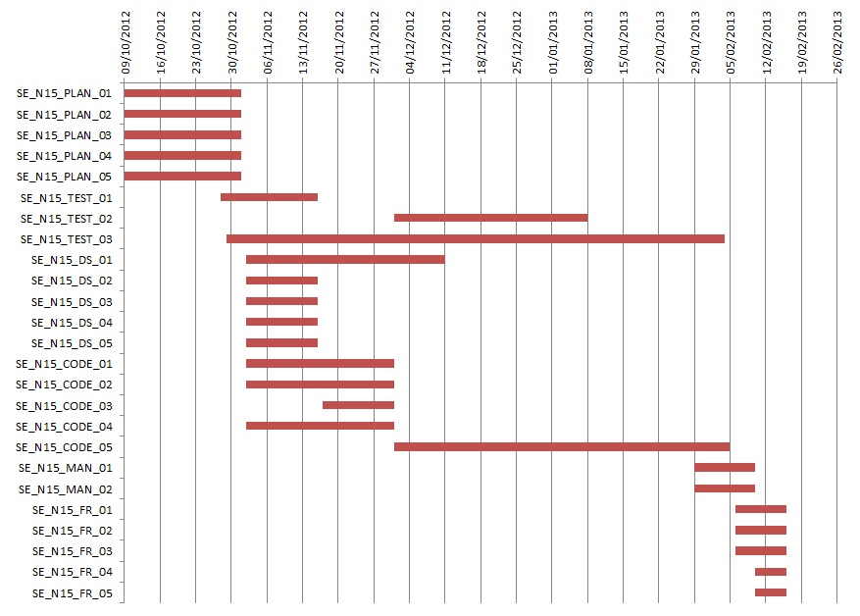

## Risk Analysis

1. Group-to-Group coordination – if not organised and handled correctly this could easily

generate a lot of wasted time. If groups don't agree on common protocols it could become

very awkward to program the server-to-server part of the project. This should be allowed for

when time is being allocated.

2. Slippage – If slippage caused by certain parts of the project occurs then other members should be drafted in to help speed up that part of the project.

3. Illness – If a group member is ill, they should notify the project leader to have their current

assignment reassigned, if possible. If not then they should be included in other assignments

once they are well again, in order to make up for the lost time.

4. Complicated algorithms – if the individual assigned to create an algorithm is struggling with

it, more members of the group can be assigned to reduce time loss.

5. Authentication – should be kept separate from the other group projects in order to maintain

security.

6. User interface – needs to be suitable for a primary/secondary school audience, meaning it

must be simple to understand and use. If the audience can't understand how to use it, it's

unlikely to be popular.

7. Git – Whilst Git is a very useful program, it is very important that space is managed, as

everyone having a copy of the entire repository could take up quite a lot of space.

8. Data Protection – as the application will is aimed at a school audience it is especially

important that data is kept secure, especially if they are to input personal details.

## References

## Change log

|  |  |  |  |  |
| --- | --- | --- | --- | --- |
| Version | CCF Number | Date | Changes | User |
| V1.0 | N/A | 23/10/12 | First draft of the document | sbs1 |
| V1.1 | N/A | 25/10/2012 | User Interface | ajw14 |
| V1.2 | N/A | 26/10/2012 | Gantt Chart | sbs1 |
| V1.3 | N/A | 26/10/2012 | Use Case Diagrams | cew10 |
| V1.4 | N/A | 1/11/2012 | Risk Analysis | cab27 |
| V1.5 | N/A | 1/11/2012 | Overview and introduction | sbs1 |
| V1.6 | N/A | 19/01/2013 | Added Use-Case diagram description  Proofread and corrected mistakes. | cew10 |