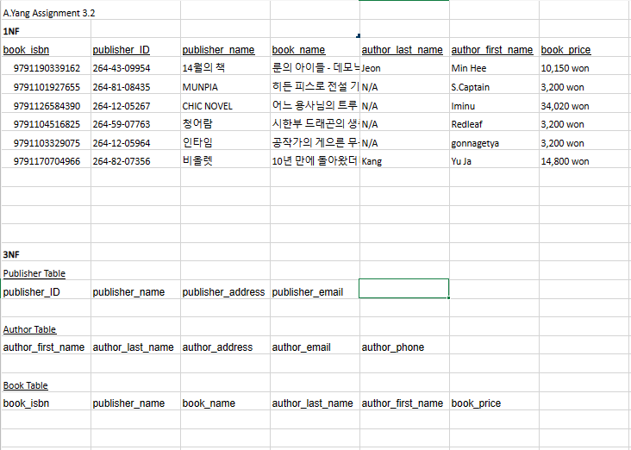

Assumptions:

One book has only one publisher.

One author can have many publishers.

One book can have multiple authors.

One publisher has only one publisher ID.

One book has only one ISBN.

One book can have many book prices.