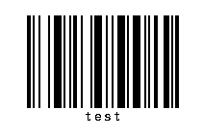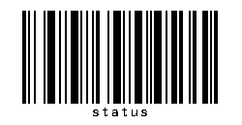

**Scan to toggle test mode. Scans don’t count in test mode.**

**Scan to toggle Status Display**