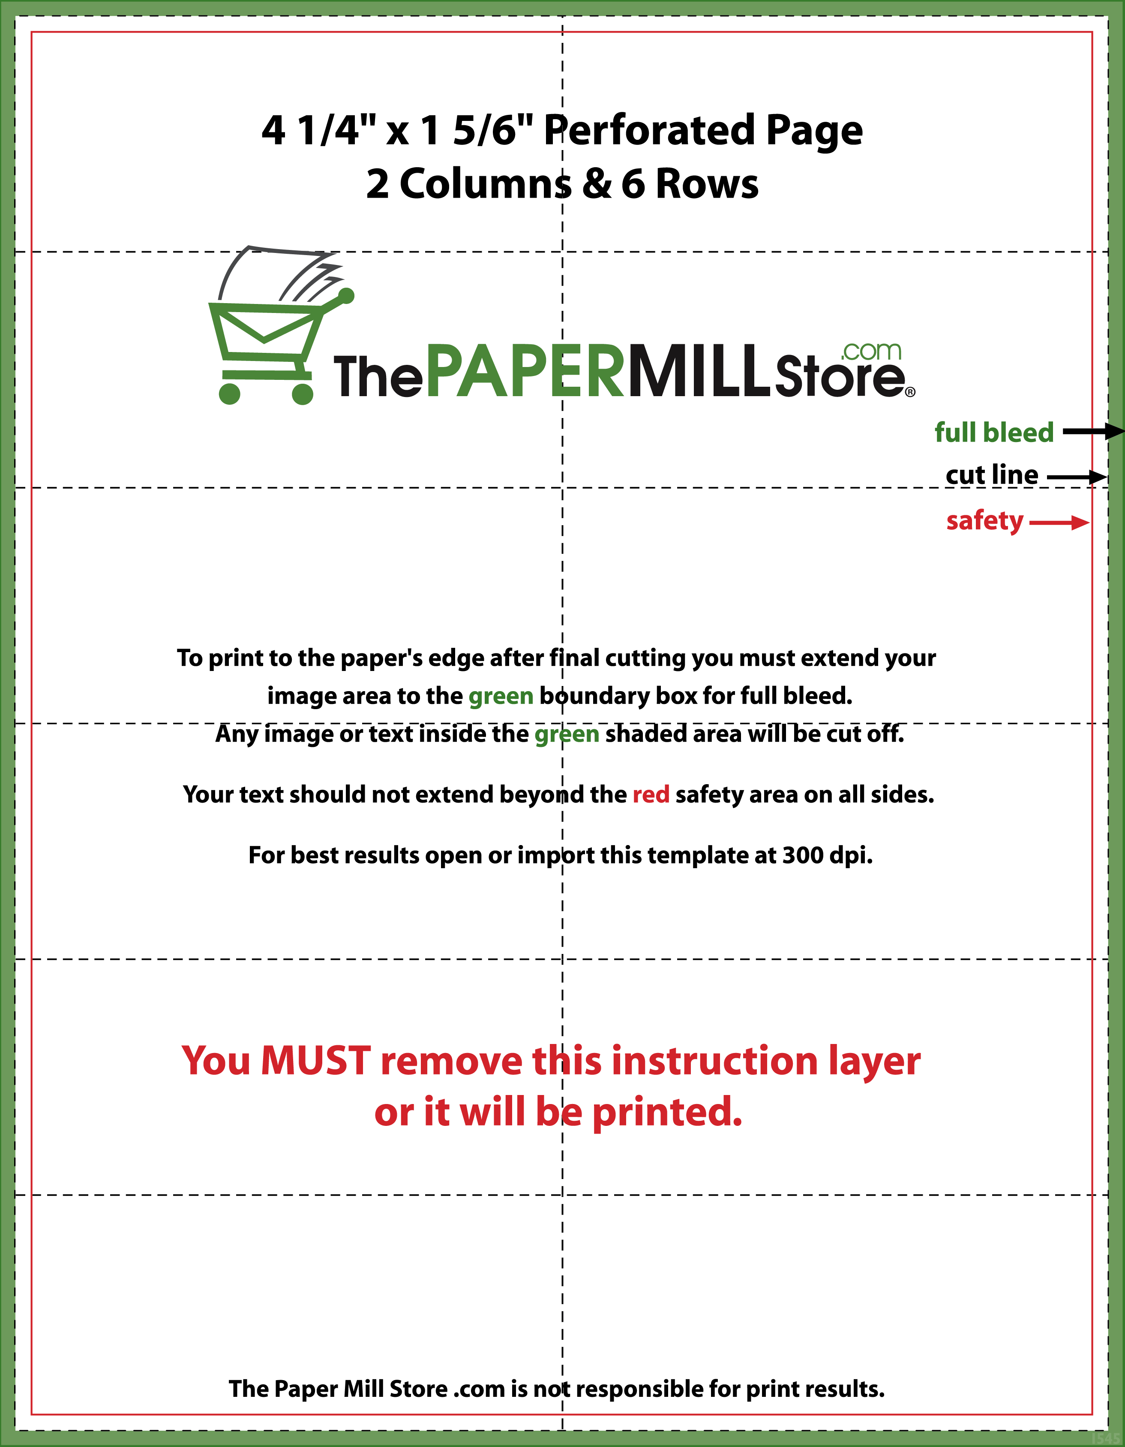­­

# [Buy Perforated Paper Now](http://www.thepapermillstore.com/perforated-paper/coupons-gift-certificates/pf30)