1. Pwd



1. Dir



1. Ls



1. Cd

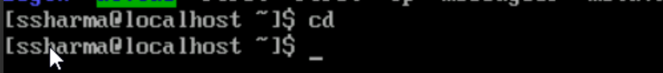

1. Touch



1. Cat

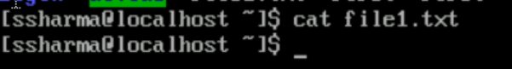

1. Mkdir



1. Rm

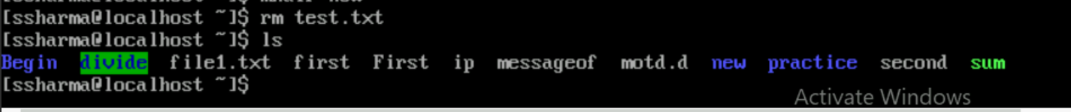

1. Cp

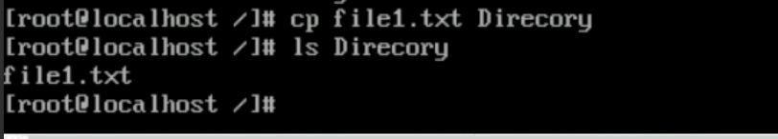

1. Mv

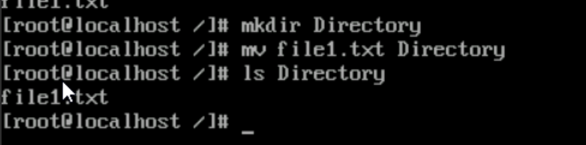

1. Head



1. Tail

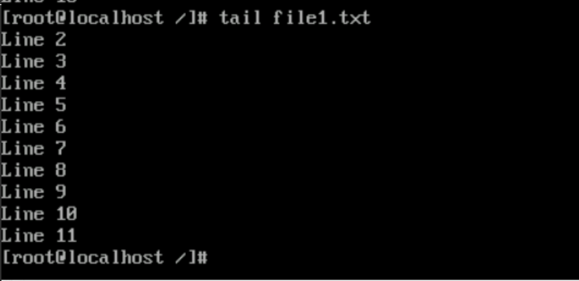

1. Uname

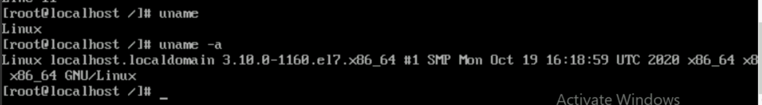

1. Wget



1. Apt-get

Sudo Yum install

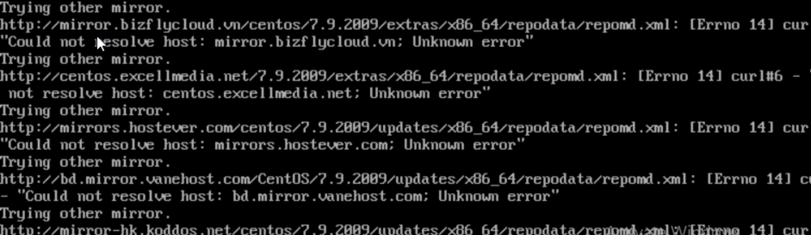

1. History

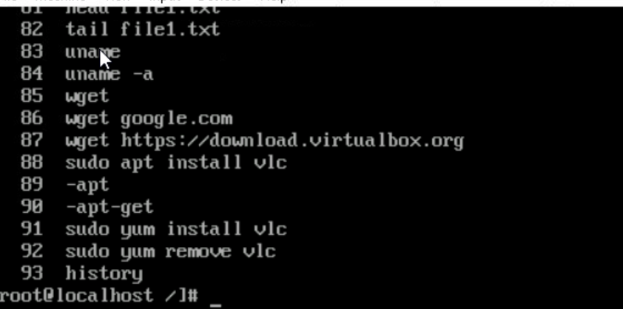

1. Grep

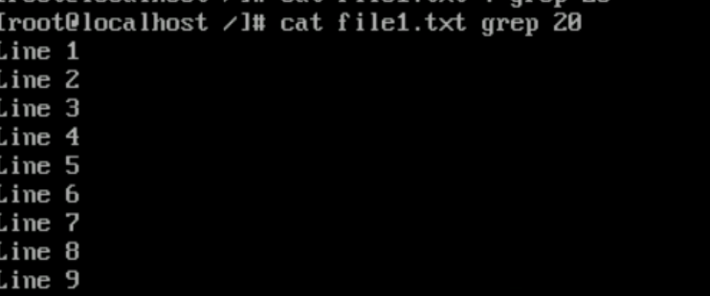

1. Man

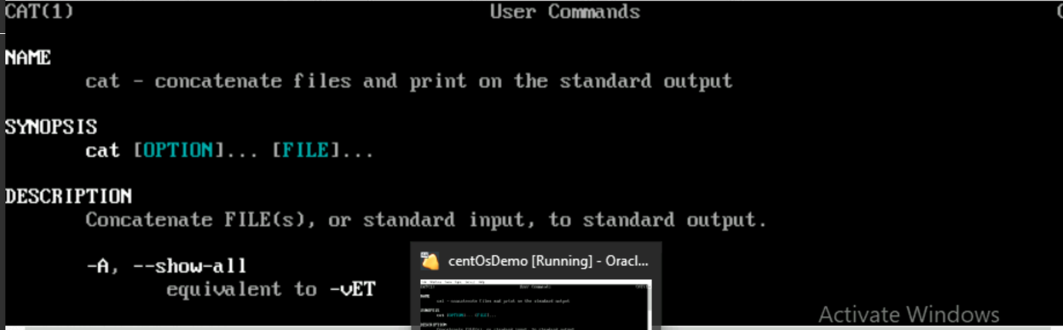

1. Ps

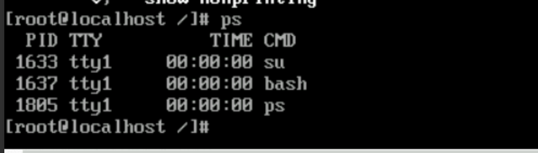

1. Zip or unzip

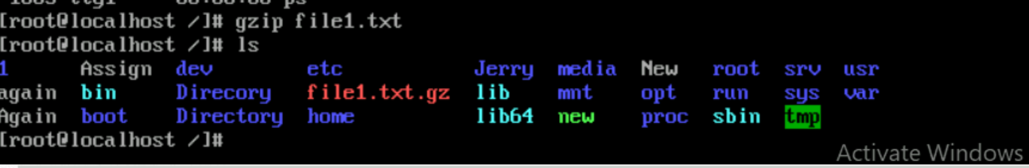

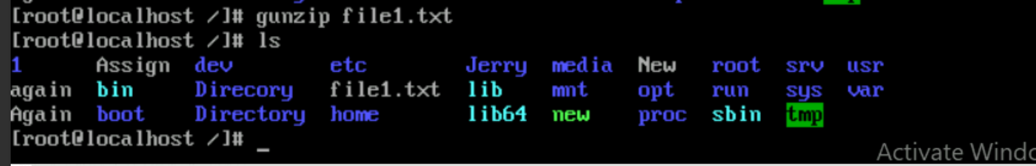

1. Hostname

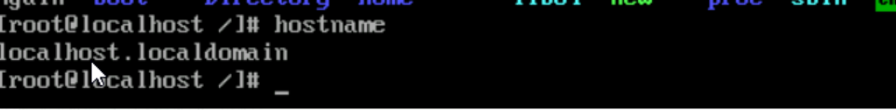

1. Ping

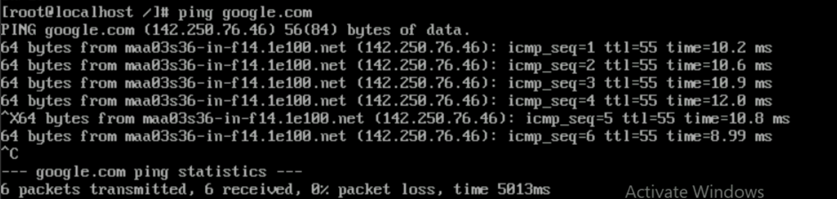

1. W

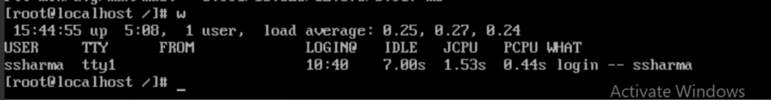

1. Useradd

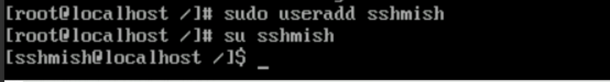

1. Passwd

