2048 GAME
Technical Documentation

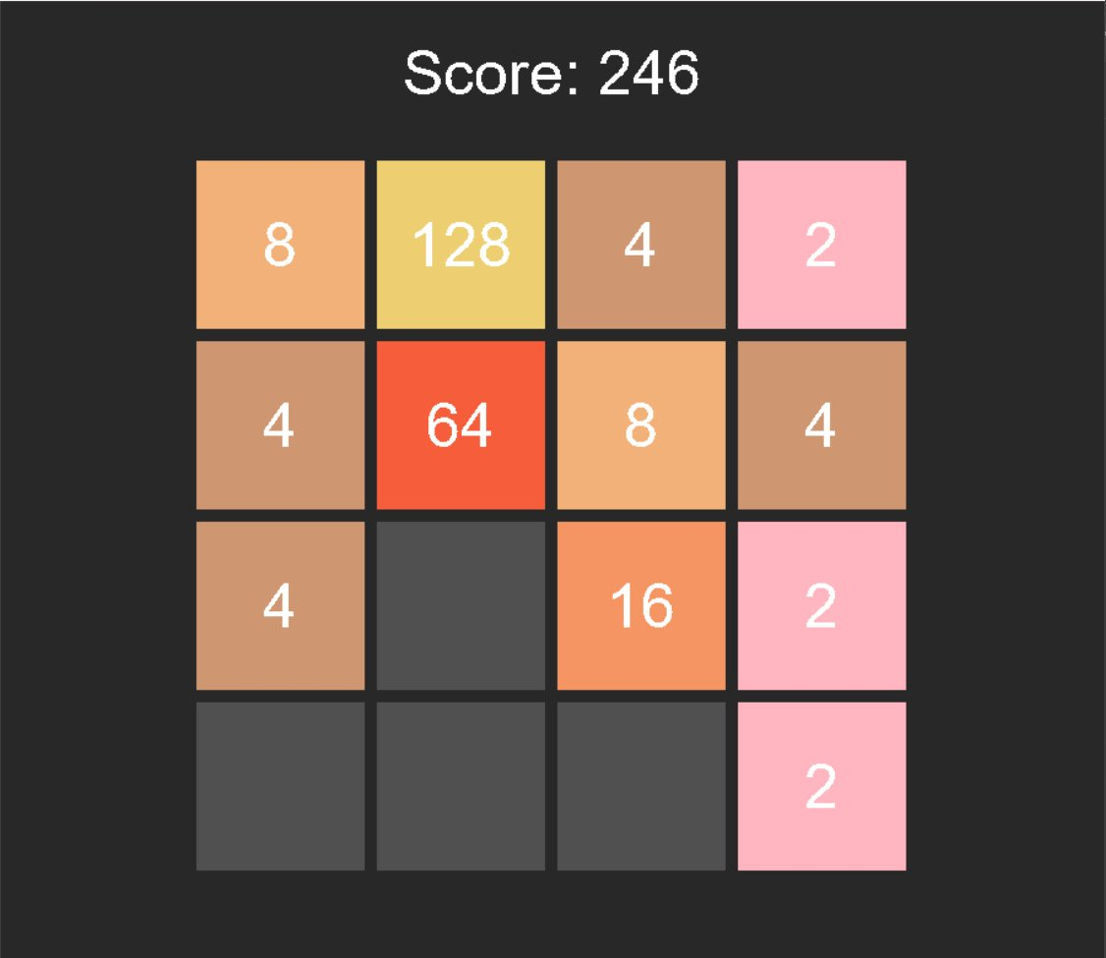

Language: C | Graphics: SDL2 + SDL_ttf
Platform: Windows / Linux | Version: 1.0
Date: 2025

1. Introduction
This document provides a complete technical reference for the 2048 game implemented in the C programming language with SDL2 for graphical rendering. The document covers the overall project architecture, data structures, all function interfaces with pseudocode, game logic, rendering pipeline, and build instructions. It is intended for developers who wish to understand, maintain, or extend the codebase.

1.1 Project Overview
2048 is a single-player sliding tile puzzle game played on a 4x4 grid. The player merges numbered tiles by sliding them in four directions. When two tiles with the same number collide, they merge into one tile whose value is their sum. The goal is to create a tile with the value 2048. The game is implemented across three source files:
- game.h — Public interface header declaring all game logic functions
- game.c — Core game logic: board manipulation, tile movement, scoring
- main.c — SDL2 entry point, event loop, and rendering pipeline

1.2 Technology Stack
Component | Detail
Language | ANSI C (C99 compatible)
Graphics Library | SDL2 (Simple DirectMedia Layer 2)
Font Rendering | SDL2_ttf (TrueType Font extension)
Font File | Arial (C:/Windows/Fonts/arial.ttf)
Window Size | 900 x 800 pixels
Grid Layout | 4x4, centered with 600px width
Random Number | Standard C rand() / srand() seeded with time()

2. Project Architecture

2.1 Module Responsibilities
The project follows a clean separation of concerns between game logic and presentation. The game.c module is completely independent of SDL2 — it operates only on the raw integer board array. This means game logic can be unit-tested or ported to another UI framework without modification. The three files and their responsibilities are:
Module | Responsibility
game.h | Declares the public interface. Any module that needs game logic includes only this header.
game.c | Initializes the board, generates random tiles, performs all four directional moves with merging, checks game-over conditions, and computes the score.
main.c | Initializes SDL2 and SDL_ttf, runs the main event loop, handles keyboard input (WASD), delegates moves to game.c functions, and draws the board each frame.

3. Data Structures

3.1 The Game Board
The entire game state is stored in a single two-dimensional integer array declared in main.c and passed by pointer to all game logic functions. There are no heap allocations for the board.

int board[4][4];
/* Indexing: board[row][col]
row 0 = top row, row 3 = bottom row
col 0 = left column, col 3 = right column */

Each cell holds an integer value representing the tile number: 0 means the cell is empty. Valid tile values are powers of 2 from 2 through 2048 (and beyond if merging continues). The array is stack-allocated, making it very cache-friendly and avoiding dynamic memory management entirely.

3.2 Auxiliary Arrays (Internal to Functions)
The movement functions use three local arrays per row or column to implement the sliding and merging algorithm. These are all stack-allocated and exist only for the duration of the function call:

Array | Type / Size | Purpose
original[4] | int[4] | Snapshot of the row/column before modification, used to detect whether the board changed.
temp[4] | int[4] | Compacted array with all zeros removed, used as the working area for merging adjacent equal tiles.
final[4] | int[4] | Result after merging, re-padded with zeros to restore the full 4-element length.
empty_tiles[16][2] | int[16][2] | Used in add_random_tile() to collect coordinates of all empty cells before randomly selecting one.

2.2 SDL2 Structures Used
The rendering layer uses the following SDL2 types. These are provided by the SDL2 library and are not defined by this project:
- SDL_Window* — Represents the OS window (900x800).
- SDL_Renderer* — Hardware-accelerated 2D renderer attached to the window.
- SDL_Event — Union capturing all input and system events (keyboard, quit, etc.).
- SDL_Rect — Rectangle defined by { x, y, w, h } used for tile and text positioning.
- SDL_Surface* — CPU-side pixel buffer returned by TTF_RenderText_Solid().
- SDL_Texture* — GPU-side texture created from an SDL_Surface via SDL_CreateTextureFromSurface().
- TTF_Font* — Handle to a loaded TrueType font file at a given point size.
- SDL_Color — RGBA colour struct { r, g, b, a } used for text rendering.

4. Function Reference

4.1 Summary Table
Function | Parameters | Return Type | Description
initialize_board | int x[4][4] | void | Sets all 16 cells to zero
add_random_tile | int x[4][4] | void | Places a 2 or 4 in a random empty cell
move_left | int x[4][4] | int (changed) | Slides & merges all rows left
move_right | int x[4][4] | int (changed) | Slides & merges all rows right
move_up | int board[4][4] | int (changed) | Slides & merges all columns up
move_down | int board[4][4] | int (changed) | Slides & merges all columns down
is_game_over | int x[4][4] | int (0 or 1) | Returns 1 if no moves remain
score | int x[4][4] | int | Returns sum of all tile values
set_tile_color | SDL_Renderer*, int value | void | Sets SDL draw color for a tile value
render_board | SDL_Renderer*, board, TTF_Font* | void | Draws full game frame

4.2 Detailed Function Descriptions & Pseudocode

4.2.1 initialize_board
Signature | void initialize_board(int x[4][4])

Iterates through every cell in the 4x4 grid and sets its value to zero, resetting the board to a blank state. This function is called once at program startup before the first two random tiles are placed.

FUNCTION initialize_board(x[4][4]):
FOR i FROM 0 TO 3:
FOR j FROM 0 TO 3:
x[i][j] = 0
END FOR
END FOR
END FUNCTION

4.2.2 add_random_tile
Signature | void add_random_tile(int x[4][4])

Scans the board for all empty cells (value == 0) and stores their coordinates. If no empty cell exists the function returns immediately. Otherwise it picks one empty cell at random and sets it to 2 (50% chance) or 4 (50% chance). This function is called after every successful move.

FUNCTION add_random_tile(x[4][4]):
empty_tiles = empty 16x2 array
count = 0
FOR i FROM 0 TO 3:
FOR j FROM 0 TO 3:
IF x[i][j] == 0:
empty_tiles[count] = (i, j)
count++
IF count == 0: RETURN
index = rand() % count
(row, col) = empty_tiles[index]
IF rand() % 2 == 0:
x[row][col] = 2
ELSE:
x[row][col] = 4
END FUNCTION

4.2.3 move_left
Signature | int move_left(int x[4][4])

For each of the 4 rows, performs the following three-phase algorithm: (1) Compact — remove all zeros and pack non-zero values to the left. (2) Merge — scan left to right; if two adjacent values are equal, double the left one and zero out the right. (3) Re-compact — remove the zero created by merging and push all values left again. Returns 1 if any cell changed, 0 otherwise.

FUNCTION move_left(x[4][4]) -> int:
changed = 0
FOR i FROM 0 TO 3:
original[0..3] = x[i][0..3]
// Phase 1: compact non-zeros to left
temp = {0,0,0,0}
k = 0
FOR j FROM 0 TO 3:
IF x[i][j] != 0: temp[k++] = x[i][j]
// Phase 2: merge adjacent equal pairs
FOR j FROM 0 TO 2:
IF temp[j] != 0 AND temp[j] == temp[j+1]:
temp[j] *= 2
temp[j+1] = 0
// Phase 3: re-compact after merge
final = {0,0,0,0}; k = 0
FOR j FROM 0 TO 3:
IF temp[j] != 0: final[k++] = temp[j]
// Write back & detect change
FOR j FROM 0 TO 3:
x[i][j] = final[j]
IF x[i][j] != original[j]: changed = 1
RETURN changed
END FUNCTION

4.2.4 move_right
Signature | int move_right(int x[4][4])

Exact mirror of move_left. The outer loop iterates rows, but compaction fills from index 3 downward (right-aligned), merging scans right-to-left (j from 3 to 1), and re-compaction also fills from the right. The change-detection logic is identical. See Section 7 for the worked example of this three-phase pattern.

4.2.5 move_up
Signature | int move_up(int board[4][4])

Applies the same three-phase algorithm as move_left but pivots to operate column-by-column. The outer loop iterates columns (j 0–3) and the inner loop iterates rows (i 0–3). Non-zero values are compacted toward row 0, merging scans top-to-bottom, and re-compaction packs results back toward row 0. The return value follows the same changed-flag convention.

FUNCTION move_up(board[4][4]) -> int:
changed = 0
FOR j FROM 0 TO 3: // iterate columns
original[0..3] = board[0..3][j]
temp = {0,0,0,0}
// Phase 1: compact column upward
k = 0
FOR i FROM 0 TO 3:
IF board[i][j] != 0: temp[k++] = board[i][j]
// Phase 2: merge top-to-bottom
FOR i FROM 0 TO 2:
IF temp[i] != 0 AND temp[i] == temp[i+1]:
temp[i] *= 2; temp[i+1] = 0
// Phase 3: re-compact upward
final = {0,0,0,0}; k = 0
FOR i FROM 0 TO 3:
IF temp[i] != 0: final[k++] = temp[i]
// Write back & detect change
FOR i FROM 0 TO 3:
board[i][j] = final[i]
IF board[i][j] != original[i]: changed = 1
RETURN changed
END FUNCTION

4.2.6 move_down
Signature | int move_down(int board[4][4])

Mirror of move_up. Operates column-by-column with compaction filling from row index 3 downward, merging scanning bottom-to-top (i from 3 to 1), and re-compaction packing toward row 3. The implementation is symmetric to move_up in the same way move_right is symmetric to move_left.

4.2.7 is_game_over
Signature | int is_game_over(int x[4][4])

Returns 1 if the game is over, 0 otherwise. The game is over when: (a) no cell is empty, AND (b) no two horizontally adjacent cells share the same value, AND (c) no two vertically adjacent cells share the same value. If any of these conditions is false, a valid move still exists and the game continues.

FUNCTION is_game_over(x[4][4]) -> int:
// Check for any empty cell
FOR i FROM 0 TO 3:
FOR j FROM 0 TO 3:
IF x[i][j] == 0: RETURN 0 // move exists
// Check for horizontal merges
FOR i FROM 0 TO 3:
FOR j FROM 0 TO 2:
IF x[i][j] == x[i][j+1]: RETURN 0
// Check for vertical merges
FOR j FROM 0 TO 3:
FOR i FROM 0 TO 2:
IF x[i][j] == x[i+1][j]: RETURN 0
RETURN 1 // no moves remain
END FUNCTION

4.2.8 score
Signature | int score(int x[4][4])

Computes the current score by summing all values in the board. The score displayed to the user is the sum of all tile values on the board at any given frame. This is a simple heuristic rather than tracking incremental merge values; it is recalculated every render frame.

FUNCTION score(x[4][4]) -> int:
sum = 0
FOR i FROM 0 TO 3:
FOR j FROM 0 TO 3:
sum += x[i][j]
RETURN sum
END FUNCTION

4.2.9 set_tile_color
Signature | void set_tile_color(SDL_Renderer* renderer, int value)

Uses a switch statement to map each tile value to a distinct RGB colour and calls SDL_SetRenderDrawColor(). The palette is divided into three visual bands: low tiles (2–8) use pinks and peaches; mid tiles (16–64) transition through salmon and deep orange-red; high tiles (128–2048) use a family of golden yellows that grow progressively more vivid. Any tile value beyond 2048 falls through to the default case and renders as near-black (60, 58, 50). This makes tiles easy to identify at a glance by colour before reading the number.

4.2.10 render_board
Signature | void render_board(SDL_Renderer* renderer, int board[4][4], TTF_Font* font)

Draws a complete frame. It clears the screen with a dark background (40, 40, 40), renders the score string centred at y=30, then iterates all 16 tiles. Each tile is drawn as a filled SDL_Rect using set_tile_color(); empty cells use dark grey. Non-zero tiles additionally render their number string centred inside the rectangle using SDL_ttf. All SDL_Surface and SDL_Texture handles are allocated and freed within the same frame to avoid resource leaks.

FUNCTION render_board(renderer, board[4][4], font):
ClearScreen(dark grey 40,40,40)
RenderCentred('Score: ' + score(board), y=30)
tileSize = (600 - 5*10) / 4 // 137 px
leftOffset = (900 - 600) / 2 // 150 px
FOR row 0..3, col 0..3:
tile.x = leftOffset + 10 + col*(tileSize+10)
tile.y = 120 + 10 + row*(tileSize+10)
set_tile_color(board[row][col]) // grey if 0
SDL_RenderFillRect(tile)
IF board[row][col] != 0:
RenderCentred(str(value), inside tile)
END FUNCTION

5. Main Game Loop

5.1 Startup & Event Loop
On launch, the RNG is seeded with the current time, the board is zeroed, two random tiles are placed, and SDL2 is initialized. The main loop then runs until the user closes the window. Each iteration polls all pending events, routes keyboard input to the appropriate move function, adds a random tile if the board changed, then unconditionally renders the frame. After rendering, if is_game_over() returns 1, a semi-transparent 'GAME OVER' overlay is drawn on top.

// Startup
srand(time(NULL)); initialize_board; add_random_tile x2
SDL_Init; TTF_Init; open font; create window + renderer
// Main loop
WHILE running:
WHILE SDL_PollEvent(event):
IF SDL_QUIT: running = 0
IF SDL_KEYDOWN:
SWITCH key: W->move_up | A->move_left
S->move_down | D->move_right
IF moved: add_random_tile(board)
render_board(renderer, board, font)
IF is_game_over(board):
draw overlay; draw 'GAME OVER' centred
SDL_RenderPresent(renderer)
// Cleanup: CloseFont, Quit TTF, DestroyRenderer/Window, SDL_Quit

5.2 Input Mapping
Key | SDL Symbol | Action
W | SDLK_w | Slide all tiles upward
A | SDLK_a | Slide all tiles left
S | SDLK_s | Slide all tiles downward
D | SDLK_d | Slide all tiles right
Window Close | SDL_QUIT | Exit the application

6. Rendering Pipeline

6.1 Grid Layout Calculations
Tile positions are computed each frame from a set of constants. The 600 px grid is centred horizontally in the 900 px window (leftOffset = 150 px). With a 10 px gap on all four sides and between each tile, each tile works out to (600 − 5×10) / 4 = 137 px square. Vertically the grid starts 120 px from the top, leaving room for the score label. The tile at grid position (row, col) is placed at pixel coordinates x = 150 + 10 + col × 147 and y = 120 + 10 + row × 147.

6.2 Text Rendering with SDL_ttf
SDL_ttf renders each string to a CPU-side SDL_Surface via TTF_RenderText_Solid(), which is uploaded to the GPU as an SDL_Texture with SDL_CreateTextureFromSurface(). The texture is drawn with SDL_RenderCopy() and both objects are freed immediately. This create-draw-destroy pattern happens every frame for each visible tile number and the score string. It is slightly inefficient but acceptable for a 4×4 grid.

6.3 Game Over Overlay
When is_game_over() returns 1, SDL_BLENDMODE_BLEND is enabled and a full-window rectangle is filled with black at alpha 180, producing a translucent overlay over the board. The 'GAME OVER' string is then rendered centred on screen. The event loop remains active so the window can be closed normally.

7. Algorithm Deep-Dive: Tile Sliding & Merging

7.1 The Three-Phase Algorithm
All four movement functions share an identical algorithmic structure. The direction determines which axis (row/column) is iterated and which end values are compacted toward. The three phases are:

- Compact (remove zeros): non-zero values are packed toward the movement direction, preserving their relative order.
- Merge (combine equals): scanning in the movement direction, the first equal adjacent pair is merged. Only one merge per position per move is possible.
- Re-compact (remove merge zeros): the zero created by the merge is removed by a second compaction pass.

7.2 Example: move_left on Row [0, 2, 2, 4]
Initial: [0, 2, 2, 4]
Phase 1 (compact left): [2, 2, 4, 0] // zero removed
Phase 2 (merge): temp[0]==temp[1]? YES: 2+2=4
[4, 0, 4, 0] // temp[1] zeroed
Phase 3 (re-compact): [4, 4, 0, 0] // zero from merge removed
Result: [4, 4, 0, 0]

7.3 Design Notes
Two compaction passes are necessary because the merge phase creates a zero gap between valid tiles. Without the second pass, values would not be flush with the edge. Regarding merge cascades: the algorithm intentionally merges only one pair per scan so that a tile produced by merging cannot merge again in the same move. For example, [2, 2, 2, 2] becomes [4, 2, 2, 0] after one move — the second pair merges on the next player input. This matches the original 2048 rules.

8. Build & Run Instructions

8.1 Prerequisites
- GCC or compatible C compiler (MinGW-w64 on Windows recommended)
- SDL2 development libraries (SDL2-devel)
- SDL2_ttf development libraries (SDL2_ttf-devel)
- Arial font file at C:\Windows\Fonts\arial.ttf (standard on Windows)

8.2 Windows (GCC / MinGW)
gcc -o 2048.exe main.c game.c \
-I./include \
-L./lib \
-lSDL2 -lSDL2_ttf \
-mwindows

8.3 Linux
# Install dependencies (Ubuntu/Debian):
sudo apt install libsdl2-dev libsdl2-ttf-dev
# Build:
gcc -o 2048 main.c game.c $(sdl2-config --cflags --libs) -lSDL2_ttf
# Note: Change font path in main.c to a valid TTF path, e.g.:
# TTF_OpenFont("/usr/share/fonts/truetype/msttcorefonts/Arial.ttf", 50);

8.4 Makefile (Optional)
CC = gcc
CFLAGS = $(shell sdl2-config --cflags)
LDFLAGS = $(shell sdl2-config --libs) -lSDL2_ttf
TARGET = 2048
SRCS = main.c game.c
all:
$(CC) $(SRCS) -o $(TARGET) $(CFLAGS) $(LDFLAGS)
clean:
rm -f $(TARGET)

9. Known Limitations & Potential Improvements

9.1 Current Limitations
- Score Calculation: The score() function sums all tile values each frame. Standard 2048 only adds the value of merged tiles at the moment of merging. The current approach differs from the original game's scoring.
- No High Score Persistence: The game has no file I/O; the high score resets when the window is closed.
- No Restart Mechanic: After a game over the player must close and relaunch the application to play again.
- Font Path Hardcoded: The font path is hardcoded to C:\Windows\Fonts\arial.ttf, making the game non-portable to Linux/macOS without source modification.
- No Frame Rate Cap: The event loop runs as fast as SDL_RenderPresent() returns, which may consume 100% CPU on some systems.
- Single Merge Limit: The merge phase only catches the first equal pair; given edge-case layouts this can miss a second merge opportunity in the same row until a re-scan happens.

9.2 Suggested Improvements
- Persistent High Score: Use fopen/fwrite to save the best score to a local file between sessions.
- Restart on R Key: Add SDLK_r in the event handler to call initialize_board() and add two new tiles without restarting the application.
- Tile Animations: Use SDL_GetTicks() to interpolate tile positions over ~100ms for smooth sliding animations.
- Correct Score Tracking: Accumulate score only at merge time by adding the merged tile value inside move_left/right/up/down.
- Frame Rate Limiter: Add SDL_Delay(16) at the end of each loop iteration to cap the game at ~60 FPS.
- Win Detection: Check for any tile equal to 2048 after each move and display a 'YOU WIN' overlay.
- Font Abstraction: Accept the font path as a command-line argument or search standard OS font directories.

10. Glossary
Term | Definition
SDL2 | Simple DirectMedia Layer 2. A cross-platform library providing access to audio, keyboard, mouse, joystick, and graphics hardware.
SDL_ttf | SDL extension library for rendering TrueType fonts using the FreeType library.
Renderer | SDL2 abstraction for GPU-accelerated 2D drawing operations.
Tile | A single cell in the 4x4 game grid containing a power-of-2 integer value.
Compaction | The process of removing zero values from an array and shifting non-zero values contiguously to one end.
Merge | The combining of two adjacent equal-valued tiles into a single tile with double the value.
DXA | A unit of measurement in OOXML documents: 1 inch = 1440 DXA.
Game Over | The state where no empty cells remain and no adjacent equal tiles exist in any direction.
Frame | A single rendered image presented to the display, produced by one iteration of the main loop.
Stack-allocated | Memory allocated on the call stack automatically when a function is entered, freed automatically on return.
WASD | Common gaming keyboard layout: W=up, A=left, S=down, D=right.
srand / rand | C standard library functions for seeding and generating pseudo-random numbers.

End of Document
2048 Game — Technical Documentation | Version 1.0 | 2025

