**Plant Monitoring System**

Shubham Gupta, Mukul Rajput, Shaan Raj Pradhan, Shray Sharma

Department of Computer Science & Engineering, SET, Sharda University,

India

{shubhamgupta2650@gmail.com, shaanrajpradhan@gmail.com, mukul.rajput.24@gmail.com, sshray9@gmail.com}

**Abstract:** The aim of this paper is to develop an IoT based Plant Monitoring System, by using different modules such as, Arduino UNO, moisture sensor. Plant monitoring is seen as one of the most important tasks in any farming or agriculture-based environment. During certain situations it is very difficult to monitor the plant as human interaction cannot be available 24/7 To overcome this problem, the Moisture sensor sense the soil is dry or wet and the sensor values are given to ADC to get processed by microcontroller. The moisture sensor detects the water level and converts it into an analog signal, which is used in a small controller via ADC. An analog signal is converted to digital format by an analog-to-digital converter (ADC) and supplies the water if it rises above the threshold value. This IoT device allows the farmer or gardener to have a clear sense of mind, as the sensor will automatically display the amount of moisture content in the soil.

**Keywords:** microcontroller, monitor, sensor, threshold.

**1 Introduction**

In India approximately 60% of citizens are depending on agriculture, annual income of citizens obtains from agriculture. In today’s digital world many farmers are still using traditional methods in their field so; yield of plants is very less. We live in a world where everything can be controlled and operated automatically, but there are still a few important areas in our country where automation has not been adopted or fully utilized, perhaps for a number of reasons one of such costs. One such field is agriculture.

The crop monitoring system is becoming an integral part of the agricultural and agricultural sectors in our country as it can be used to grow crops under conditions that are controlled by excellent production. Automatic is the management of industrial machinery and processes, thus replacing human workers. An automated system will reduce the need for human energy which is why it reduces error.

In order to get a larger size, it is very unlikely that the farmer will notice the efficiency of the system using this technology, farmers can easily view the system using their smart phone. Incorporating novel technology into the field will solve major agricultural problems. One of the fastest growing technologies is IoT.

The IoT concept applies to all fields such as automation, industry, electricity, electricity, health, tracking systems etc. The proposed program is based on an Internet-based agricultural monitoring and irrigation system that assists farmers to adopt a new modern method, which can increase revenues with less work. Agricultural development contributes to national economic growth. The default system can be applied to all types of agricultural field. IoT is a network connection for many electronic devices. Enables access to any information with the help of electronic devices. The proposed system works very well in connecting the Internet to the leading system in the field of plants, smart phones to check the result. The services of the proposed system such as soil temperature and humidity are arranged in a vegetation area to monitor various environmental conditions. This sensor does not require a lot of power supply and low cost. A server-based web application was created. The app has a two-part script and program and coding. The application shows the same result as tested with the help of http protocol. Check for direct contact with the board in case of installable mobile software. The high speed of the internet makes the results visible in just half a second. The code is applied to the server in flash format. The main objective of this project is to improve the agricultural system of monitoring and irrigation to solve the problems facing farmers in India.

In this project we use modules named as IoT, Arduino as controller for the project. This project uses sensors such as a moisture sensor and is also provided with information about the humidity in the atmosphere. By knowing all of this one can act accordingly. Moisture sensor senses that the soil is dry or wet. When the soil dries automatically the water pump will open. sensor values ​​are provided by ADC for processing by Arduino control. The heat sensor detects heat and converts it into an electrical signal (analog), which is used in a small controller with ADC. An analog signal is converted to a digital format by an analog-to-digital converter (ADC). The soil condition and stored temperature are displayed and the same values ​​are updated online using the IoT module installed in the controller. In a large area, it is not possible for a farmer to monitor the performance of the system by using this technology, farmers can easily monitor the system using their smart phone.

**2 Problem Analysis**

The main issue in agriculture is water scarcity. The water is wasted as this resource is not used in an efficient manner. The use of Internet of things in this field will be helpful to reduce the shortage and wastage of water. So that the temperature as well as humidity and light are measured by means of sensors and depend up on the outcome further processing can be performed. We propose a system that will capture all the details about the soil and temperatures of various sensors. Sound information will be sent to the processor and as a result a warning message will be conveyed and the right amount of water will be released to the crop.

The advanced system will pick up the moisture sensor input and send the input signal to the microcontroller and transmit the microcontroller to send the discharge signal to the solenoid valve through the 5V 4 transmission station if the humidity limit is above the marked level and no water is supplied to the plant. water will be provided.

Project development is divided into many steps that begin with understanding the problem and all its requirements. Subsequent detailed literature research is required to obtain the information needed to develop the project. When project development begins, its first module will be to connect IoT-based system components. Additional coding module and other hardware requirements will be made in due course.

**3 System Design**

The working of this system starts is that in this Plant Monitoring System, Soil Moisture sensor SEN13322 will be embedded in the soil of the pot. The moisture sensor is programmed with a threshold value which the result is displayed in LED present on the relay. The LED on the relay will blink in red colour. If the red LED is ON then it indicates that the threshold value is met. Once the Threshold value is met then the micro controller sends a signal to the 5V 4-Channel relay. Transmission and transmission signal to the power supply to open a solenoid valve that supplies water to the plant connected with the pipe from the water tank. As water is supplied to the plant the moisture sensor determines whether its limit value is met, in which case a small controller sends a signal to the transmission. The transmission receives a signal and turns off the power supply.

The overall workflow of the system can be visualized with the help of Fig 1 and Fig 2.

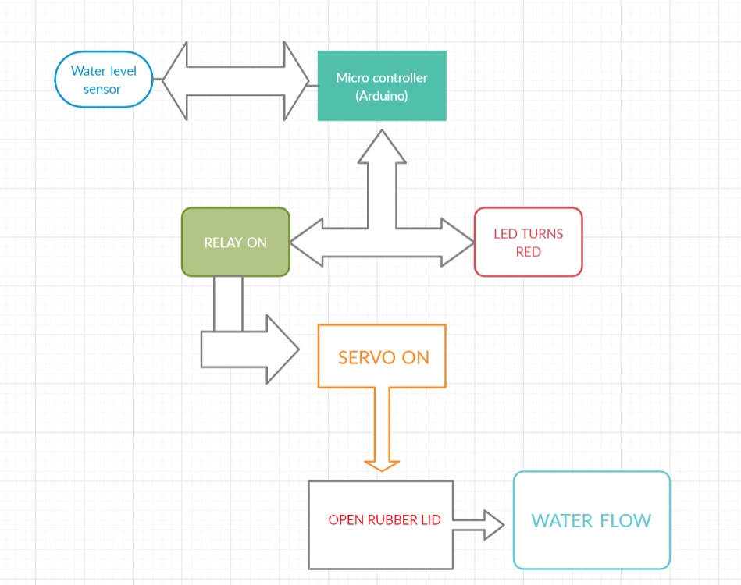

**Fig 1** Case Diagram of the system

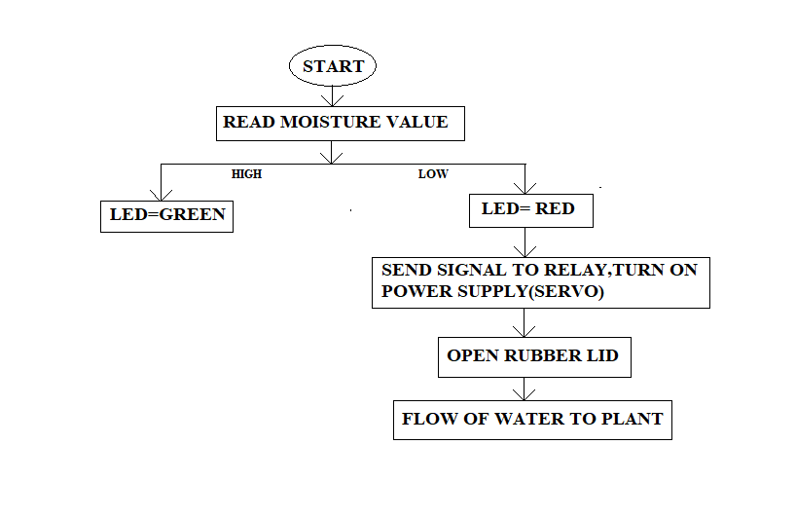

**Fig 2** Work flow diagram

**3.1 Data Flow Diagrams**

The system is described using following Data Flow Diagrams (Fig 3, Fig 4, Fig 5)::

Level 0 DFD

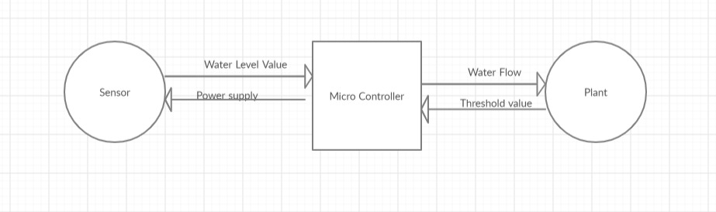

**Fig 3** Level 0 DFD

Level 1 DFD

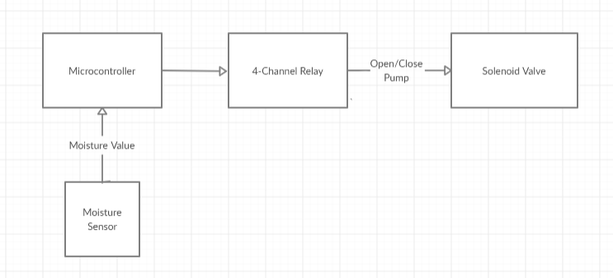

**Fig 4** Level 1 DFD

Level 2 DFD

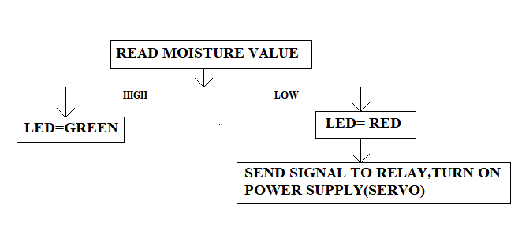

**Fig 5** Level 2 DFD

**4 Implementation**

As discussed in the previous sections, the components used in this project are given below with a small description of them. The implementation of the given components, make the project work successfully. The components used are: Moisture Sensor (SEN13322), **ESP microcontroller, 5V 4-Channel** Relay, Jumper cables, Stopper. The combined project with hardware/components is shown below in Fig 6.

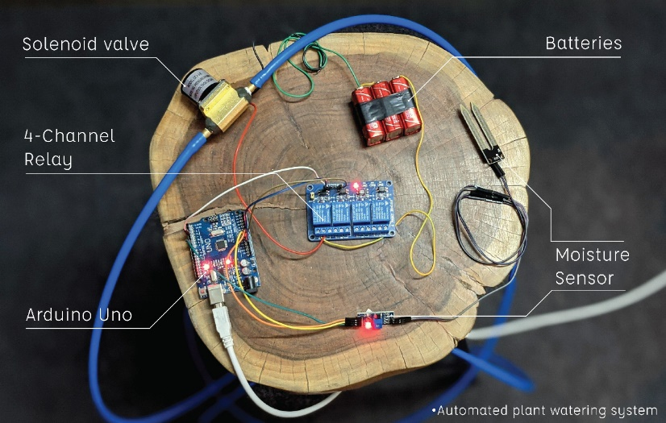

**Fig 6** Plant Monitoring System

**4.1 Moisture Sensor (SEN13322)**

**The soil moisture sensor measures the volumetric content of water with the help of two probes. The two probes get the resistance value to measure the moisture value by passing current in the soil. The soil sensor used in the project is shown in Fig 7.**

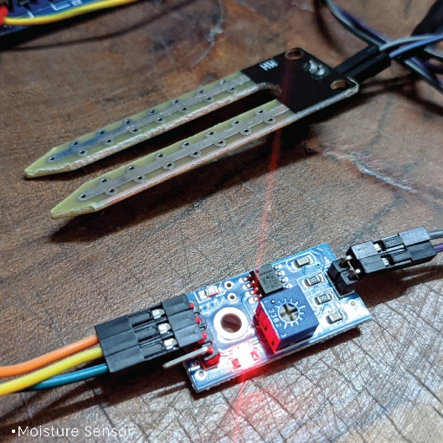

**Fig 7 Soil Moisture Sensor**

**4.2 Arduino UNO**

Arduino Uno is a microcontroller board based on the ATmega328P. It has 14 digital pins, 6 inputs, a 16 MHz ceramic resonator, a USB connector, a power supply jack, a header and a reset button. Arduino Board used is shown in Fig 8.

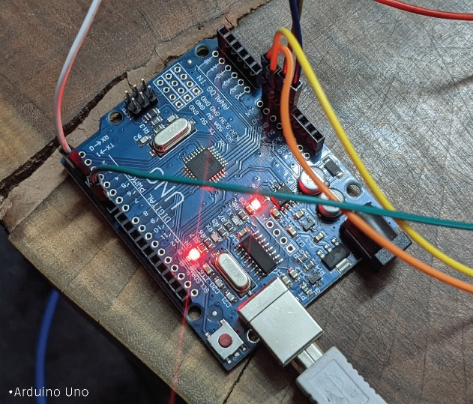

**Fig 8** Arduino UNO Board

**4.3 5V 4-Channel Relay**

Relays are the switches which close and open the circuits electronically. It controls the opening and closing of the circuit contacts of an electronic circuit. It sends the output signal from the microcontroller to the solenoid valve. 4-Channel Relay used is shown in Fig 9.

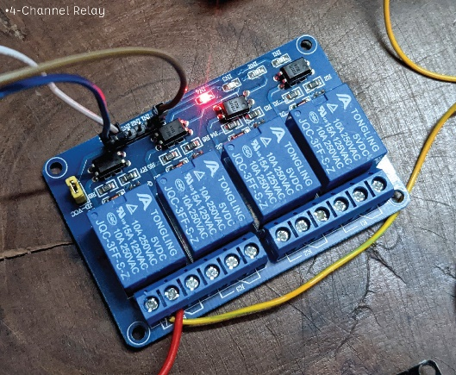

**Fig 9** 4-Channel Relay

**4.4 Solenoid Valve**

A solenoid valve is an electrically-operated valve. Solenoid valves are used to regulate the flow of water through the pipe. Solenoid valve is shown in Fig 10.

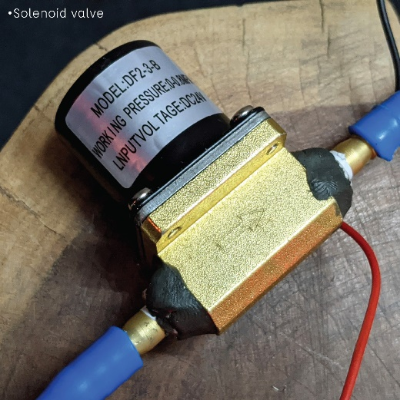

**Fig 10** Solenoid Valve

**4.5 Power Supply**

A battery is a device consisting of electrochemical cells with external connections for powering electrical devices. In this project three 9V batteries are used in series as shown in Fig 11.

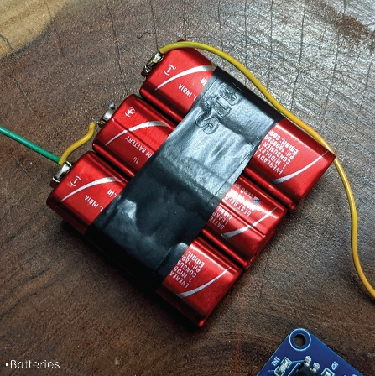

**Fig 11**

**5 Testing and Results**

After developing the project, it is tested on a plant with the input provided in the real time. It was tested when the plant has no water in the soil and when the soil has water in it, to see how the project works accordingly.

The given picture in Fig 12 shows the plant and the soil moisture sensor dipped in the soil when there is no moisture in the soil. Then after measuring the moisture content and the input in provided to the microcontroller the water is supplied.

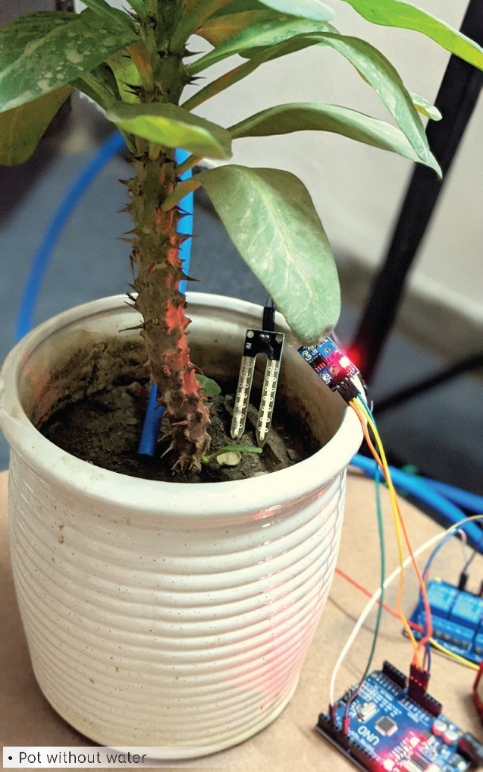

**Fig 12** Pot without Water

In this step, the microcontroller detects the input and accordingly the output is provided to the relay and the water is supplied to the plant from the pipe through the solenoid valve and the plant is watered as shown in the below picture, Fig 13.

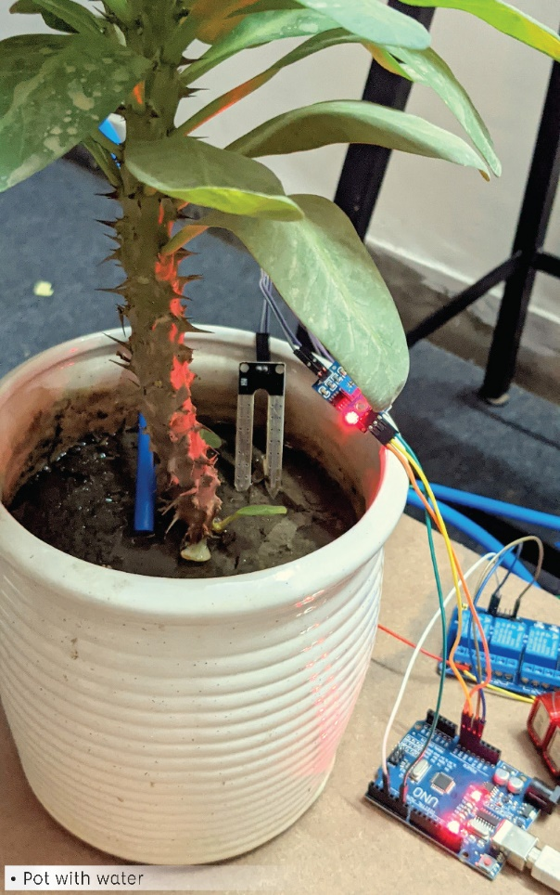

**Fig 13** Pot with Water

As you can see in the below picture in Fig 14, a closeup on to the soil, water is present in the plant as when soil moisture starts to measure the water content and as the water content in the soil gets low, water is supplied again through the pipe from the solenoid valve.

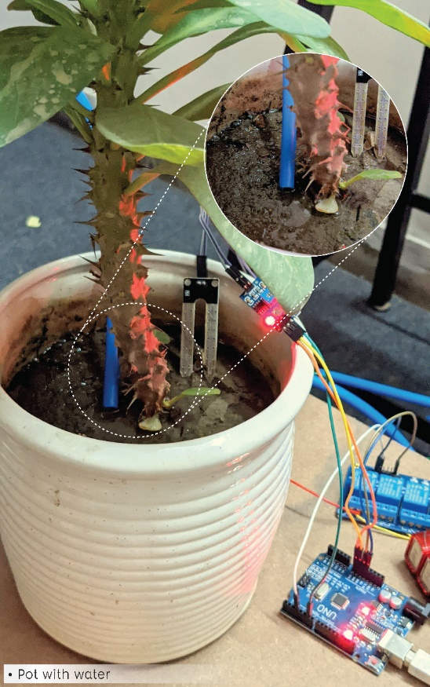

**Fig 14**

**6 Conclusion**

The aim of this project is to develop a Plant Monitoring System that measures the moisture content of the soil of the plant and according to the moisture content the water is supplied through the solenoid valve. The work emphasizes on measuring the moisture, giving input to the microcontroller, giving output to the 5V 4-Channel Relay. Throughout the development of this project, best of the algorithms working in the domain of plant monitoring system were studied. The focus was on selecting an algorithm that gives us a good balance the time taken for processing and supplying water to the plant. This proposed work is made to help the farmers and make their harvest economical by helping them in security purpose travelling side, college and for every bodies etc. By this work, the wastage of water and the consumption of power by motor can be reduced so that they are conserved for the future use. This system provides complete monitoring action of sensors in fields that is very easy to control the field. It also provides huge security to the plants.

**References**

1. Asst. Prof. Kawale Jayashri, Sanjay More, Akshay Bankar, Ganesh Dongre, Pooja Patil, “I0T BASED SMART PLANT MONITORING SYSTEM”, IJARSE, Vol. No. 7, Special Issue No.3, April 2018
2. Gutierrez J, Villa-Medina J, Nieto-Garibay A, Porta-Gandara M. Automated irrigation system using a Wireless Sensor Network and GPRS module. IEEE Transaction on Instrumentation and Measurements. 2014
3. Shaif Choudhury, Soummyo Priyo Chattopadhyay, Avijit Ghose, “SMART IRRIGATION: IOT Based Irrigation Monitoring System”
4. Sreeram Sadasivam, Vishwanath Vadhri, Supradha Ramesh, “Smart Plant Monitoring System”, Springer, 2015
5. Anusha k, Dr. U B Mahadevaswamy, “Automatic IoT Based Plant Monitoring and Watering System using Raspberry Pi”, I.J. Engineering and Manufacturing, 2018
6. Md Mehedi Islam, Sumonto Sarker, Md. Kamal Hossain, Md. Al-Momin, A. B. M. Tauhid, “IoT Based Smart Irrigation Monitoring & Controlling System in Agriculture”, International Journal of Recent Technology and Engineering (IJRTE), ISSN: 2277-3878, Volume-8 Issue-6, March 2020
7. Ramkumar.E, Nagarani.S, Roger Rozario A. P, Arjuman Banu.S, “Tomen: A Plant monitoring and smart gardening system using IoT”, International Journal of Pure and Applied Mathematics, Volume 119 No. 7 2018, 703-710
8. Lan Van, Bing Lin, Tsung Wu, Yun-Wei Lin, Syuan Peng, Lin-Hang Kao and Chun-Hao Chang, “Plant Talk: A Smartphone-Based Intelligent Hydroponic Plant Box”
9. Shiraz Pasha B.R., Dr. B Yogesha, “Microcontroller Based Automated Irrigation System”, The International Journal of Engineering and Science (IJES), Volume3, Issue 7, pp 06-09, June2014.