**PLANT MONITORING SYSTEM**

**A Project Based Learning Report**

**Submitted by:**

**SHUBHAM GUPTA (180101313)**

**SHRAY SHARMA (180101303)**

**SHAAN RAJ PRADHAN (180101287)**

**MUKUL RAJPUT (180101197)**

**In partial fulfillment for the award of the degree**

of

**BACHELOR OF TECHONOLOGY**

**IN**

**COMPUTER SCIENCE AND ENGINEERING**

At



**SHARDA UNIVERSITY**

**Knowledge Park III, Greater Noida, Uttar Pradesh 201310**

**CERTIFICATE**

This is to certify that this project report entitled “Plant Monitoring System” submitted to School of Engineering and Technology, Sharda University, is a Bonafede record of work done by “Shubham Gupta, Mukul Rajput, Shray Sharma, Shaan Raj Pradhan” under my supervision from “22/7/2020” to “12/11/2020”.

Place: Sharda University

Date: 12/11/2020

**ACKNOWLEDGEMENT**

We have taken efforts in this project. However, it would not have been possible without the kind support and help of many individuals and our teacher. We would like to extend my sincere thanks to all of them. We are highly indebted to Mrs. Mandeep Kaur for their guidance and constant supervision as well as for providing necessary information regarding the project & also for their support in completing the project. We would like to express my gratitude towards member of Sharda University for their kind co-operation and encouragement which help me in completion of this project. We would like to express my special gratitude and thanks to External teachers for giving me such attention and time. We thank and appreciations also go to our team in developing the project and people who have willingly helped us out with their abilities.

**Table of Contents**

|  |  |  |
| --- | --- | --- |
|  |  |  |
|  | Title Page | 1 |
|  | Abstract | 3 |
|  |  |  |
| **1.** | **INTRODUCTION** | **3** |
|  | * 1. Problem Definition   2. Project Overview/Specifications   3. Hardware Specification | 3  5  5 |
|  |  |  |
| **2.** | **LITERATURE SURVEY** | **6** |
|  | 2.2 Proposed System | 7 |
|  |  |  |
| **3.** | **SYSTEM ANALYSIS & DESIGN** | **8** |
|  | 3.1 Flowcharts / DFDs  3.2 Design and Test Steps  3.3 Algorithms and Pseudo Code | 8  11  14 |
|  |  |  |
| **4.** | **RESULTS** | **15** |
| **5.** | **CONCLUSIONS** | **15** |
| **6.** | **REFERENCES** | **16** |

**Abstract**

The aim of this paper is to develop an IoT based Plant Monitoring System, by using different modules such as, Arduino UNO, moisture sensor. Plant monitoring is seen as one of the most important tasks in any farming or agriculture-based environment. During certain situations it is very difficult to monitor the plant as human interaction cannot be available 24/7 To overcome this problem, the Moisture sensor sense the soil is dry or wet and the sensor values are given to ADC to get processed by microcontroller. The moisture sensor detects the water level and converts it into an analog signal, which is used in a small controller via ADC. An analog signal is converted to digital format by an analog-to-digital converter (ADC) and supplies the water if it rises above the threshold value. This IoT device allows the farmer or gardener to have a clear sense of mind, as the sensor will automatically display the amount of moisture content in the soil.

**Introduction**

**Problem Definition**

The main issue in agriculture is water scarcity. The water is wasted as this resource is not used in an efficient manner. The use of Internet of things in this field will be helpful to reduce the shortage and wastage of water. So that the temperature as well as humidity and light are measured by means of sensors and depend up on the outcome further processing can be performed. We propose a system that will capture all the details about the soil and temperatures of various sensors. Sound information will be sent to the processor and as a result a warning message will be conveyed and the right amount of water will be released to the crop.

In India approximately 60% of citizens are depending on agriculture, annual income of citizens obtains from agriculture. In today’s digital world many farmers are still using traditional methods in their field so; yield of plants is very less. We live in a world where everything can be controlled and operated automatically, but there are still a few important areas in our country where automation has not been adopted or fully utilized, perhaps for a number of reasons one of such costs. One such field is agriculture.

The crop monitoring system is becoming an integral part of the agricultural and agricultural sectors in our country as it can be used to grow crops under conditions that are controlled by excellent production. Automatic is the management of industrial machinery and processes, thus replacing human workers. An automated system will reduce the need for human energy which is why it reduces error.

In order to get a larger size, it is very unlikely that the farmer will notice the efficiency of the system using this technology, farmers can easily view the system using their smart phone. Incorporating novel technology into the field will solve major agricultural problems. One of the fastest growing technologies is IoT.

The IoT concept applies to all fields such as automation, industry, electricity, electricity, health, tracking systems etc. The proposed program is based on an Internet-based agricultural monitoring and irrigation system that assists farmers to adopt a new modern method, which can increase revenues with less work. Agricultural development contributes to national economic growth. The default system can be applied to all types of agricultural field. IoT is a network connection for many electronic devices. Enables access to any information with the help of electronic devices. The proposed system works very well in connecting the Internet to the leading system in the field of plants, smart phones to check the result. The services of the proposed system such as soil temperature and humidity are arranged in a vegetation area to monitor various environmental conditions. This sensor does not require a lot of power supply and low cost. A server-based web application was created. The app has a two-part script and program and coding. The application shows the same result as tested with the help of http protocol. Check for direct contact with the board in case of installable mobile software. The high speed of the internet makes the results visible in just half a second. The code is applied to the server in flash format. The main objective of this project is to improve the agricultural system of monitoring and irrigation to solve the problems facing farmers in India.

In this project we use modules named as IoT, Arduino as controller for the project. This project uses sensors such as a moisture sensor and is also provided with information about the humidity in the atmosphere. By knowing all of this one can act accordingly. Moisture sensor senses that the soil is dry or wet. When the soil dries automatically the water pump will open. sensor values ​​are provided by ADC for processing by Arduino control. The heat sensor detects heat and converts it into an electrical signal (analog), which is used in a small controller with ADC. An analog signal is converted to a digital format by an analog-to-digital converter (ADC). The soil condition and stored temperature are displayed and the same values ​​are updated online using the IoT module installed in the controller. In a large area, it is not possible for a farmer to monitor the performance of the system by using this technology, farmers can easily monitor the system using their smart phone.

**Project Overview/Specifications**

The working of this system starts is that in this Plant Monitoring System, Soil Moisture sensor SEN13322 will be embedded in the soil of the pot. The moisture sensor is programmed with a threshold value which the result is displayed in 2 LEDs connected with the micro controller. The two LEDs are red and green in color. If the red LED is ON then it indicates that the threshold value is not met and if the green LED is ON then it means that the threshold value assigned is met. Once the Threshold value is met then the micro controller sends a signal to the 5V 4-Channel relay. The relay then sends a signal to the power supply to turn on the servo which opens the rubber lid of the water reservoir and water is supplied to the plant. As the water is being supplied to the plant the moisture sensor detects if its threshold value is met, if so then the micro controller sends the signal to the relay. The relay receives the signal and turns the power supply off.

**Hardware/Software Specification**

* Arduino UNO R3 Development Board
* 5V 4-Channel relay
* Soil Moisture sensorSEN13322

# 20 Female to Male Jumper Wires 20 cm

# 20 Female to Female Jumper Wires 20 cm

# Water Container

# Power Supply 9V Battery

**Literature Survey**

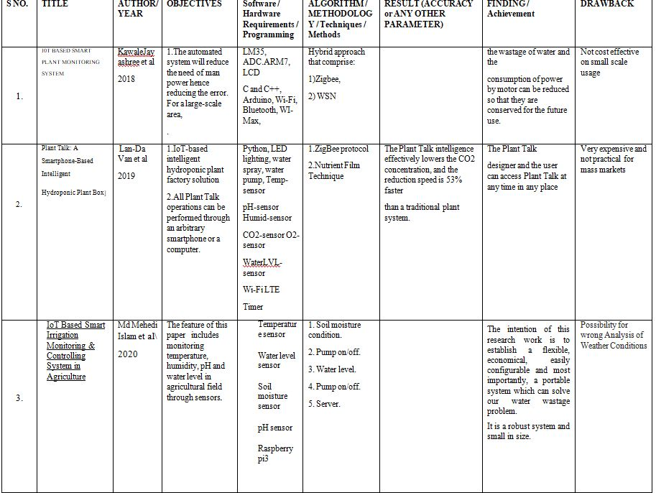

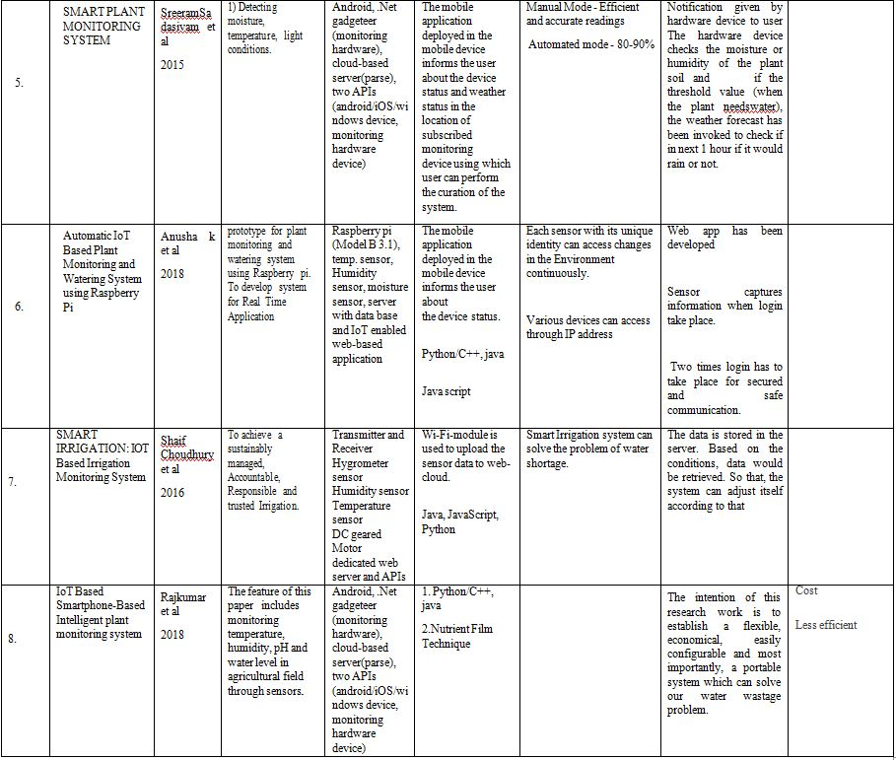

**Proposed System**

The developed system will take input through the moisture sensor and send the input signal to the microcontroller and further the microcontroller sends the output signal to the solenoid valve through the 5V 4 relay channel to water the plant if the moisture value threshold is above the marked level then water is supplied to the plant otherwise no water will be supplied.

Development of project is divided into multiple steps that start with understanding the problem and all its needs. Then detailed literature survey is required to get hold of the knowledge that is essential to develop the project. When development of project starts, its first module will be to connect the componentsfor the IoT based system. Further module of coding and other hardware requirements will be done on later basis.

**System Analysis & Design**

The working of this system starts is that in this Plant Monitoring System, Soil Moisture sensor SEN13322 will be embedded in the soil of the pot. The moisture sensor is programmed with a threshold value which the result is displayed in LED present on the relay. The LED on the relay will blink in red color. If the red LED is ON then it indicates that the threshold value is met. Once the Threshold value is met then the micro controller sends a signal to the 5V 4-Channel relay. Transmission and transmission signal to the power supply to open a solenoid valve that supplies water to the plant connected with the pipe from the water tank. As water is supplied to the plant the moisture sensor determines whether its limit value is met, in which case a small controller sends a signal to the transmission. The transmission receives a signal and turns off the power supply.

**Flowcharts / DFDs**

The overall workflow of the system can be visualized with the help of Fig 1 and Fig 2.

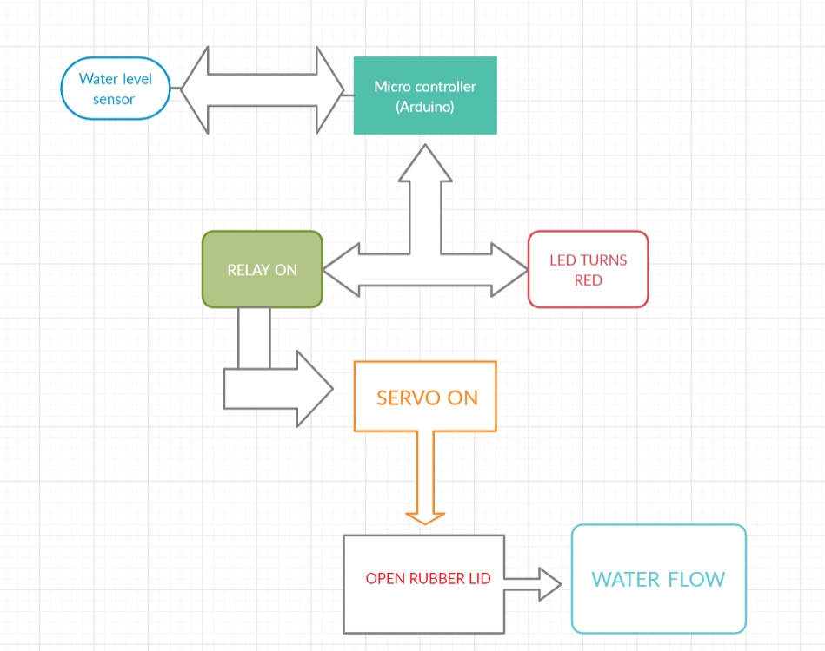

**Fig 1** Case Diagram of the system

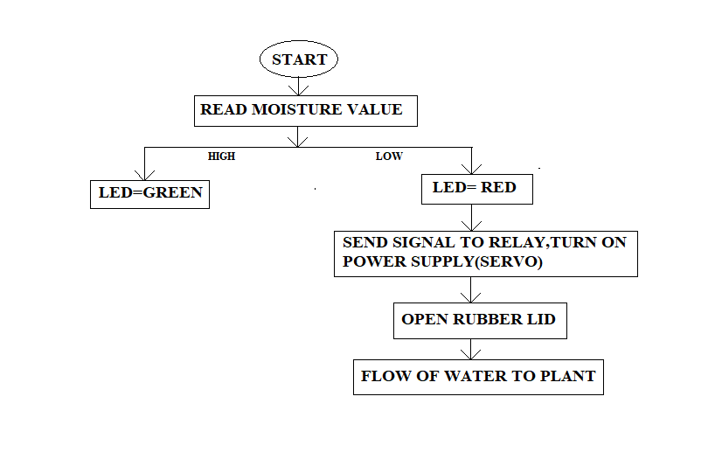

**Fig 2** Work flow diagram

**Data Flow Diagrams**

The system is described using following Data Flow Diagrams (Fig3, Fig 4, Fig 5)::

Level 0 DFD

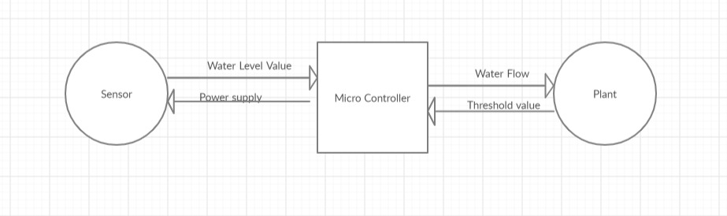

**Fig 3** Level 0 DFD

Level 1 DFD

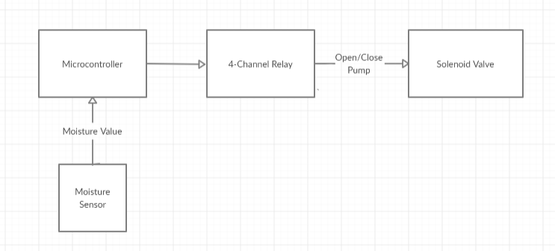

**Fig 4** Level 1 DFD

Level 2 DFD

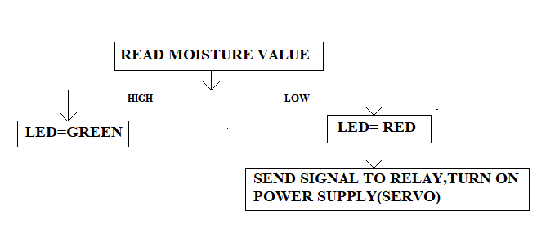

**Fig 5** Level 2 DFD

**Design and Test Steps**

As discussed in the previous sections, the components used in this project are given below with a small description of them. The implementation of the given components, make the project work successfully. The components used are: Moisture Sensor (SEN13322), **Arduino UNO, 5V 4-Channel** Relay, Jumper cable, 9V Battery, Solenoid Valve. The combined project with hardware/components is shown below in Fig 6.

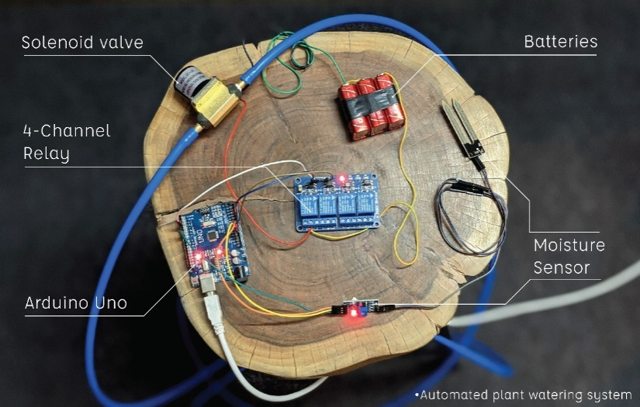

Fig 6

4.1 Moisture Sensor (SEN13322)

**The soil moisture sensor consists of two probes which are used to measure the volumetric content of water. The two probes allow the current to pass through the soil and then it gets the resistance value to measure the moisture value. The soil sensor used in the project is shown in Fig 7.**

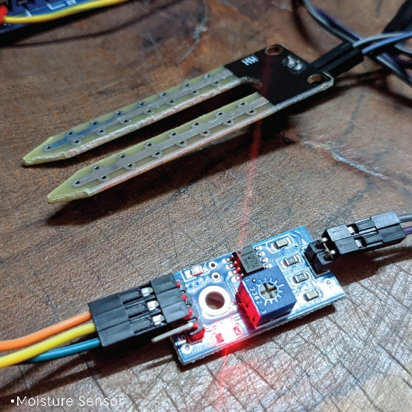

**Fig 7**

**4.2 Arduino UNO**

Arduino Uno is a microcontroller board based on the ATmega328P (datasheet). It has 14 digital input/output pins (of which 6 can be used as PWM outputs), 6 analog inputs, a 16 MHz ceramic resonator (CSTCE16M0V53-R0), a USB connection, a power jack, an ICSP header and a reset button. It contains everything needed to support the microcontroller. Arduino Board is shown in Fig 8.

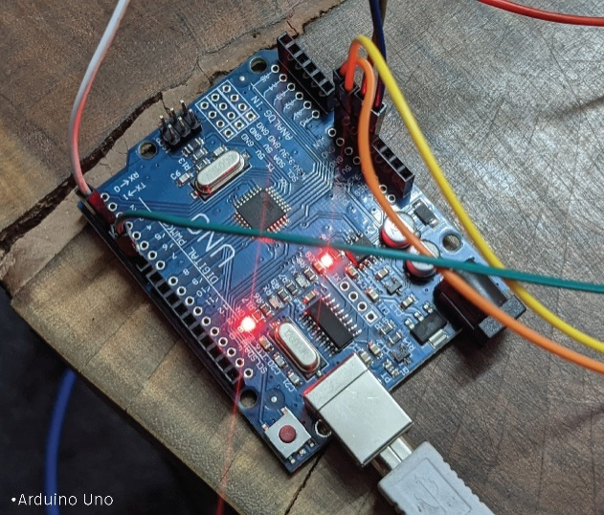

Fig 8

4.3 5V 4-Channel Relay

Relays are the switches which aim at closing and opening the circuits electronically as well as electromechanically. It controls the opening and closing of the circuit contacts of an electronic circuit. Relay is shown in Fig 9.

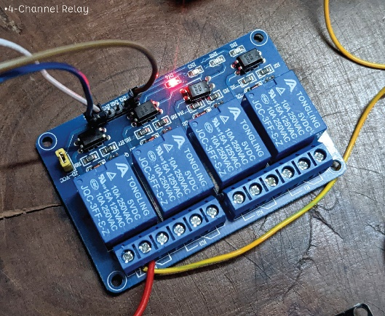

Fig 9

4.4 Solenoid Valve

A solenoid valve is an electromechanically-operated valve. Solenoid valves differ in the characteristics of the electric current they use, the strength of the magnetic field they generate, the mechanism they use to regulate the fluid, and the type and characteristics of fluid they control. Solenoid valve is shown in Fig 10.

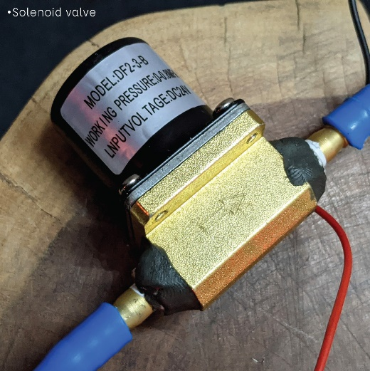

Fig 10

4.5 Power Supply

A battery is a device consisting of one or more electrochemical cells with external connections for powering electrical devices. In this project three 9V batteries are used in series. Fig 11

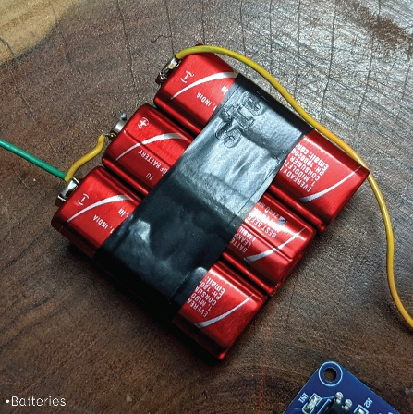

Fig 11

**Algorithms and Pseudo Code**

int water; //random variable  
void setup()

{  
pinMode(3,OUTPUT); //output pin for relay board, this will send signal to the relay  
pinMode(6,INPUT); //input pin coming from soil moisture sensor  
}

void loop()

{  
water = digitalRead(6); // reading the incoming signal from the soil moisture sensor  
if(water == HIGH) // if water level is full then cut off the relay  
{  
digitalWrite(3,LOW); // if low then cut off the relay  
}  
else  
{  
digitalWrite(3,HIGH); //if high then water is supplied  
}  
delay(400);  
}

**Results**

After developing the project, it is tested on a plant with the input provided in the real time. It was tested when the plant has no water in the soil and when the soil has water in it, to see how the project works accordingly.

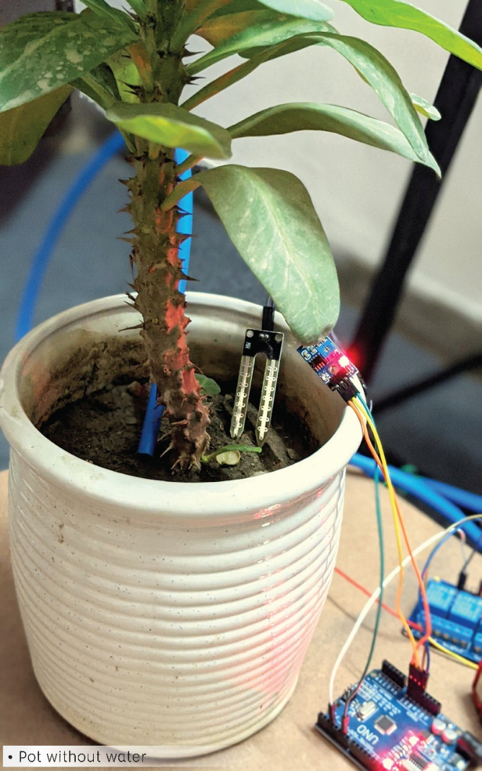 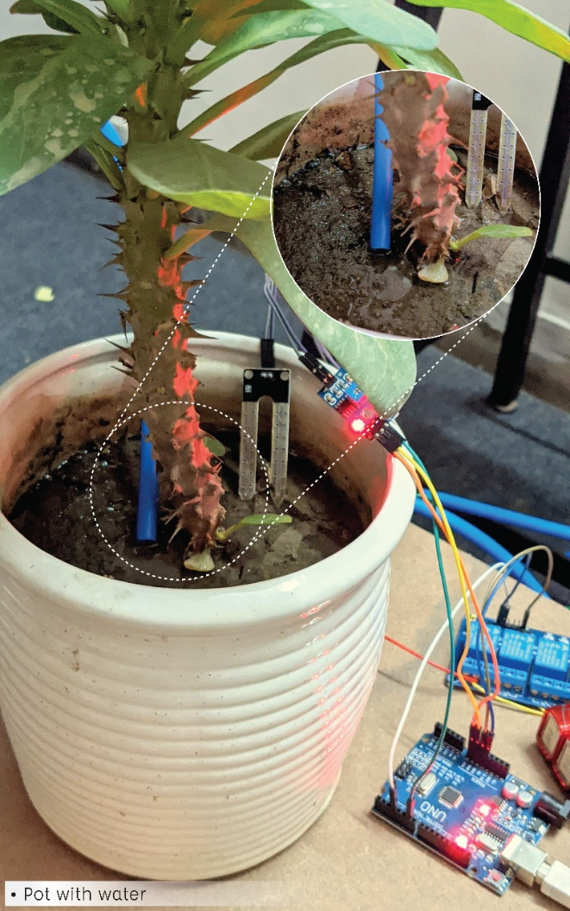

Pot without water Pot with water

**Conclusions**

The aim of this project is to develop a Plant Monitoring System that measures the moisture content of the soil of the plant and according to the moisture content the water is supplied through the solenoid valve. The work emphasizes on measuring the moisture, giving input to the microcontroller, giving output to the 5V 4-Channel Relay. Throughout the development of this project, best of the algorithms working in the domain of plant monitoring system were studied. The focus was on selecting an algorithm that gives us a good balance the time taken for processing and supplying water to the plant. This proposed work is made to help the farmers and make their harvest economical by helping them in security purpose travelling side, college and for every bodies etc. By this work, the wastage of water and the consumption of power by motor can be reduced so that they are conserved for the future use. This system provides complete monitoring action of sensors in fields that is very easy to control the field. It also provides huge security to the plants.

**References**

1. Asst. Prof. Kawale Jayashri, Sanjay More, Akshay Bankar, Ganesh Dongre, Pooja Patil, “I0T BASED SMART PLANT MONITORING SYSTEM”, IJARSE, Vol. No. 7, Special Issue No.3, April 2018
2. Gutierrez J, Villa-Medina J, Nieto-Garibay A, Porta-Gandara M. Automated irrigation system using a Wireless Sensor Network and GPRS module. IEEE Transaction on Instrumentation and Measurements. 2014
3. Shaif Choudhury, Soummyo Priyo Chattopadhyay, Avijit Ghose, “SMART IRRIGATION: IOT Based Irrigation Monitoring System”
4. Sreeram Sadasivam, Vishwanath Vadhri, Supradha Ramesh, “Smart Plant Monitoring System”, Springer, 2015
5. Anusha k, Dr. U B Mahadevaswamy, “Automatic IoT Based Plant Monitoring and Watering System usingRaspberry Pi”, I.J. Engineering and Manufacturing, 2018
6. Md Mehedi Islam, Sumonto Sarker, Md. Kamal Hossain, Md. Al-Momin, A. B. M. Tauhid, “IoT Based Smart Irrigation Monitoring & Controlling System in Agriculture”, International Journal of Recent Technology and Engineering (IJRTE), ISSN: 2277-3878, Volume-8 Issue-6, March 2020
7. Ramkumar.E, Nagarani.S, Roger Rozario A. P, Arjuman Banu.S, “Tomen:A Plant monitoring and smart gardeningsystem using IoT”, International Journal of Pure and Applied Mathematics, Volume 119 No. 7 2018, 703-710
8. Lan-Da Van, Yi-Bing Lin, Tsung-Han Wu, Yun-Wei Lin, Syuan-Ru Peng, Lin-Hang Kao and Chun-Hao Chang, “Plant Talk: A Smartphone-Based IntelligentHydroponic Plant Box”
9. Shiraz Pasha B.R., Dr. B Yogesha, “Microcontroller BasedAutomated Irrigation System”, TheInternational Journal ofEngineering and Science (IJES), Volume3, Issue 7, pp 06-09, June2014.