**Project Base Learning (PBL) Report**

**On**

Quiz Game

B.Tech. 2nd Year, Section E

Session: 2019-20

Submitted By

**Shray Sharma (2018008770)**

Submitted To: Mrs. Megha Chabra



Sharda University

School of Engineering and Technology

Department of Computer Science and Engineering

November 2019

**Abstract**

The sole intention behind the consideration of this Project is to generate and manage a

Simple database for question. This project is developed considering “QUIZ” information Keeping on text of the customer in mind.

Here, data is stored in a text file by “CSE” and this database is basically used as MASTER file.

The quiz game is designed to increase learning of players by playing a multiple choice quiz contest on various topics which is interactive, user friendly and fun to play.

The various topics include Science, Mathematics, GK etc the user can add and modify questions according to his own wish.

**Chapter – 1**

**Introduction**

This 'QUIZ GAME' Project is designed for a question in which user

can generate and manage a simple database for questions. The question number is automatically generated

by the software and is stored in a binary file by the name 'QUESTION'. This data base is basically used as a MASTER file to be used as a look up table for information like Quiz Option, Submenu, either Computer/Mathematics/Science or General and the Return.

There is a sub menu in the application which contains topics about general knowledge. User can play a quiz on any of these topics and he gets a 5

for every correct answer and zero for every wrong answer and in the end his total score is calculated.

**Chapter – 2**

**Project Requirements & Design**

Requirements:

2.1 Hardware Requirement

1. Processor

-pentium 4

1. RAM

-512 RAM

1. HARD DISK

-100gb

2.2 Software Requirements

-Turbo C++

-GCC Compiler

DESIGN -

Earlier QUIZ Game was conducted manually in which there used to be a Quiz Master asking questions with a book which was neither flexible nor friendly.

So an automated Quiz Game is designed to play quiz game in a more interactive and fun way which is flexible and more reliable.

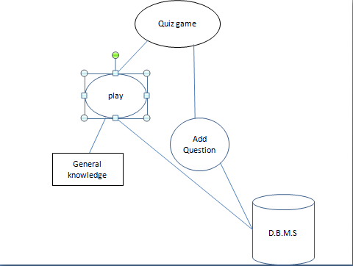

**Chapter – 3**

**Project Implementation**

#include<iostream.h>

#include<fstream.h>

#include<conio.h>

#include<string.h>

#include<stdlib.h>

#include<dos.h>

void main(void)

{

char name[50],ch[11],id[20],pass[8],ch1;

char asd1[]="\n\n Press any key to continue.....";

int x,choice,choice1,chc,i;

clrscr();

cout<<" \n\n\n\t\t\t Quiz Contest\n";

cout<<"GENERAL INSTRUCTIONS\n";

cout<<"This is a multiple choice quiz contest.\n";

cout<<"5 points will be awarded for each correct answer and\n";

cout<<"If more than one options are entered,";

cout<<"\n\t FIRST OPTION to be entered will be considered\n";

cout<<"Press any key to continue";

getch();

clrscr();

randomize();

do

{

x=0;

gotoxy(30,9);

char name[]="ENTER YOUR NAME:";

for(i=0;name[i]!='\0';i++)

{

delay(80);

cout<<name[i];

}

cin>>name;

for(i=0;asd1[i]!='\0';i++)

{

delay(100);

cout<<asd1[i];

}

getch();

clrscr();

gotoxy(33,9);

char asd[]="WELCOME TO OUR QUIZSHOW";

for(i=0;asd[i]!='\0';i++)

{

delay(100);

cout<<asd[i];

}

cout<<" "<<name;

for(i=0;asd1[i]!='\0';i++)

{

delay(100);

cout<<asd1[i];

}

getch();

xy: clrscr();

cout<<"1.Student";

cout<<"\n2.Admin";

cout<<"\n\nEnter you choice:";

cin>>chc;

for(i=0;asd1[i]!='\0';i++)

{

delay(100);

cout<<asd1[i];

}

getch();clrscr();

if(chc==2)

{

cout<<"ENTER YOUR ID:";

cin>>id;

cout<<"ENTER YOUR PASS:";

for(i=0;i<8;i++)

{

ch1=getch();

pass[i]=ch1;

if(ch1!=13)

cout<<"*";

else if(ch1==13)

break;

}

pass[i]='\0';

if(strcmp(pass,"admin")==0)

{

cout<<pass;

getch();

clrscr();

char load[]="LOADING.................";

for(i=0;load[i]!='\0';i++)

{

delay(250);

cout<<load[i];

}

clrscr();

cout<<"WELCOME\n";

cout<<"ENTER Qs \n";

cout<<"press 1 to continue";

cin>>choice1;

if(choice1==1)

{

clrscr();

ofstream file("CSE.txt",ios::app);

char que[100],ans1[10],ans2[10],ans3[10],ans4[10];

int cor_ans;

cin.getline(que,100);

cout<<"ENTER Q:";

cin.getline(que,100);

cout<<"\nENTER OPTION 1:";

cin.getline(ans1,10);

cout<<"\nENTER OPTION 2:";

cin.getline(ans2,10);

cout<<"\nENTER OPTION 3:";

cin.getline(ans3,10);

cout<<"\nENTER OPTION 4:";

cin.getline(ans4,10);

file<<que<<endl;

file<<ans1<<endl<<ans2<<endl<<ans3<<endl<<ans4<<endl;

cout<<"\nENTER THE ANS:";

file<<"ANS:";

cin>>cor_ans;

file<<cor_ans;

file.close();

cout<<"\t\t\t\t\n\npress any key to continue";

getch();

goto xy;

}

}

else

{

goto xy;

}

}

for(i=10;i>0;i--)

{

int rndnum;

rndnum=random(i);

if(rndnum==1)

{

cout<<"\n Enter answer in form of 'a','b' and'c'only.";

cout<<"\n What is called as ' THE HOLY LAND'?";

cout<<"\n a.Jerusalem \t b.Mathura";

cout<<"\n c.Mecca \td.New york";

cout<<"\nYour choice:";

cin>>ch[1];

if(ch[1]=='a')

{

x=x+10;

cout<<"\n Good Job.";

cout<<"\n Your score is "<<x;

}

else

{

cout<<"\n Sorry wrong answer.";

goto abc;

}

}

if(rndnum==2)

{

cout<<"\n What is called as ' THE ROOF OF THE WORLD'?";

cout<<"\n a.Nepal \t b.Rome";

cout<<"\n c.Tibet \t d.Itlay";

cout<<"\nYour choice:";

cin>>ch[2];

if(ch[2]=='c')

{

x=x+10;

cout<<"\n Good Job.";

cout<<"\n Your score is "<<x;

}

else

{

cout<<"\n Sorry wrong answer.";

goto abc;

}

}

if(rndnum==3)

{

cout<<"\n What is called as ' THE LAND OF RISING SUN'?";

cout<<"\n a.Chicago \t b.Japan";

cout<<"\n c.Tibet \t d.North Korea";

cout<<"\nYour choice:";

cin>>ch[3];

if(ch[3]=='b')

{

x=x+10;

cout<<"\n Good Job.";

cout<<"\n Your score is "<<x;

}

else

{

cout<<"\nSorry wrong answer.";

goto abc;

}

}

if(rndnum==4)

{

cout<<"\n What is called as ' THE GIFT OF NILE'?";

cout<<"\n a.Chicago \t b.Egypt";

cout<< "c.Africa \t d.Mexico";

cout<<"\nYour choice";

cin>>ch[4];

if(ch[4]=='b')

{

x=x+10;

cout<<"\n Good Job.";

cout<<"\n Your score is "<<x;

}

else

{

cout<<"Sorry wrong answer.";

goto abc;

}

}

if(rndnum==5)

{

cout<<"\n What is called as ' THE LAND OF MIDNIGHT SUN'?";

cout<<"\n a.Norway \t b.Japan";

cout<<"\n c.Australia \td.South korea";

cout<<"\nYour choice:";

cin>>ch[5];

if(ch[5]=='a')

{

x=x+10;

cout<<"\n Good Job.";

cout<<"\n Your score is "<<x;

}

else

{

cout<<"\n Sorry wrong answer.";

goto abc;

}

}

}

abc:

if(x==100)

{

cout<<"THANK YOU FOR PLAYING\n";

cout<<"No cheating"<<name<<"you have done this before";

break;

}

if(x==90)

{

cout<<"THANK YOU FOR PLAYING\n";

cout<<"\n"<<name<<"you are extremely intelligent";

cout<<"\nYpur score is 90";

}

if(x==80)

{

cout<<"THANK YOU FOR PLAYING\n";

cout<<"\n "<<name<<" you are intelligent.";

cout<<"\n Your Score is 80";

}

if(50==x||x==70||x==60)

{

cout<<"THANK YOU FOR PLAYING\n";

cout<<"\n "<<name<<" you are average";

cout<<"\n Your Score is "<<x<<".";

cout<<"\n Better luck next time";

}

else

if(x<=40)

{

cout<<"THANK YOU FOR PLAYING\n";

cout<<"\n No use........ Not even 5 questions right";

cout<<"\n\n\n Do you want to play again?(y/n)";

cin>>ch[11];

clrscr();

}

}while(ch[11]=='Y'||ch[11]=='y');

getch();

}

**Chapter – 4**

**Results**

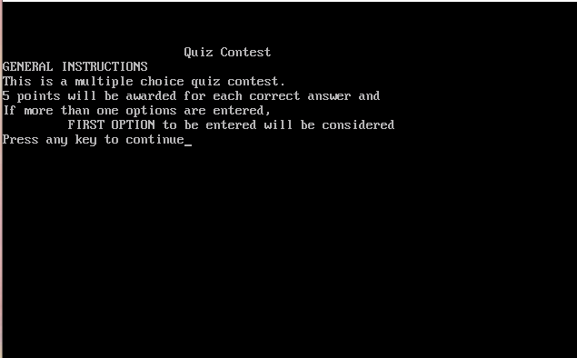

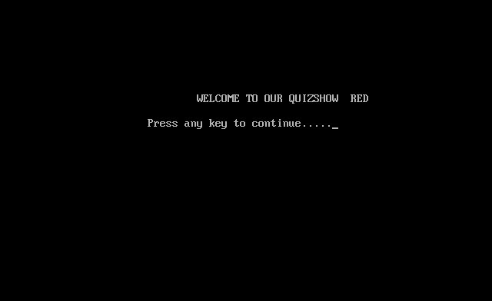

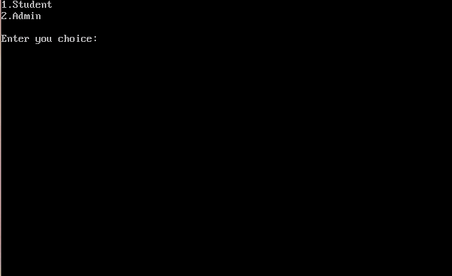



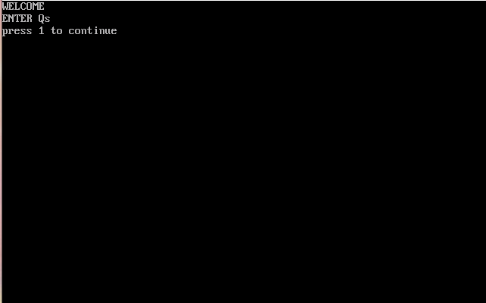

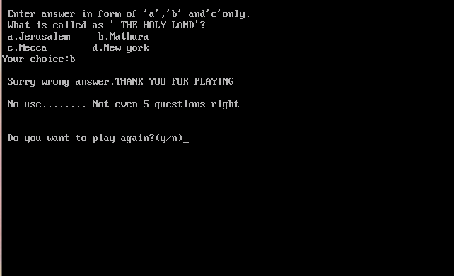

**Chapter – 5**

**Conclusion**

The Quiz Game designed is very interactive, user friendly and easy to play.

The game allows the user to choose the topic of his interest and test his

Knowledge.

The question database can be easily modified like adding, deleting or changing the questions is very

Easy.