Basic Details

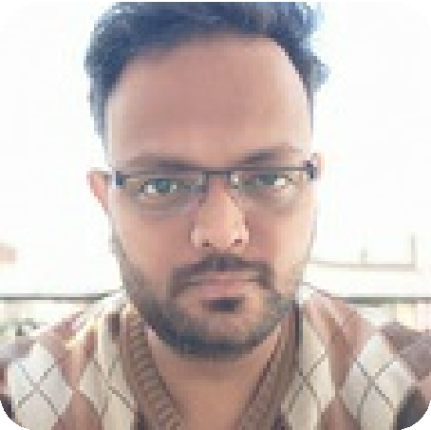

Shubham Kumar

“I have completed my Bachelor’s in Engineering. I am working as a Software Developer. Modern yet traditional, I am deeply inclined in our values, ethics and culture. I would want a partner who understands and values my beliefs. If you require any further details, feel free to

contact.”

Family

Father's Name

No. of Siblings Mother’s Status Family Type

: Ramesh Chand Saini

: 1

: Homemaker

: Nuclear

Date of Birth Height

Marital Status Email ID

Contact No.

: 25-June-1995

: 6' 3"

: Never Married

: shubhamkumar.net@ gmaiI.com

: +91-9568140501

# Religious Background

Religion Community Mother Tongue

“I have completed my Bachelor’s in Technology(CSE). I am working as a Software Developer. Modern yet traditional, I am deeply inclined in our values, ethics and culture. I would want a partner who understands and values my beliefs. If you require any further details, feel free to

contact.”

Shubham Kumar

: Hindu

: Saini

: Hindi

# Location, Education & Career

Living in : Chandigarh, Punjab

Grew up in : India

Ethnic Origin : India

Highest Qualification : B.E/ B.Tech - Bachelor

of Engineering / Bachelor of Technology

Family

Father's Name

Father’s Occupation

No. of Siblings

Mother’s Status Family Type

College Attended

: S R M University (SRM Institute of Science & Technology)

: Ramesh Chand Saini

: Retired/Business

: 1 Younger Sister

: Homemaker

: Nuclear