**Test Results: -**

**Exercise 2 - Array Quartering Utility**

**Package com.ge.exercise2**

**Input:-**

If you consider the following array of data

a b c d

e f g h

i j k l

m n o p

Operation #1 for row 0 should return a b c d

Operation #2 for column 0 should return a e i m

Operation #3 for quadrant 0,0 should return a b e f

**Output:-**

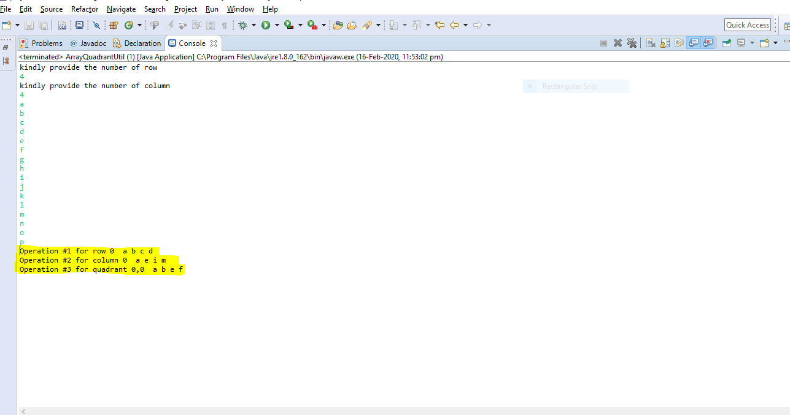

**Exercise 5 - Bad Warehouse**

**Package com.ge.exercise5**

**Input:-** for testing purpose I am preparing the static item list and passing the value.

According to the value passing from static item list below is the output screen shot:-

1. Update the software as necessary to accomplish the following
   * Add a new type of item that is perishable.
   * Perishable items are to degrade in value twice as fast as normal items

**Output:-**

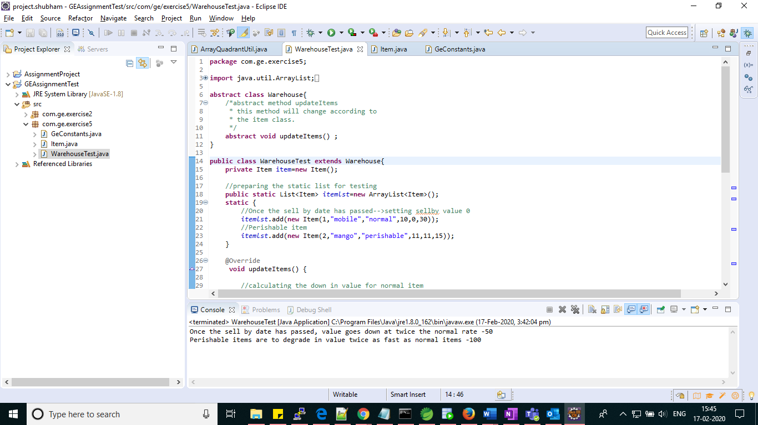

**Note:- Code has been committed to the GitHub repository within the respective package and class name .**

**EOF**