**Big Data Lab 5**

I have used the open source project bomber agent. For this I took only one gesture which was punch. The aim of the app was to play the gesture so that the bomb is thrown away. The screenshot of the app can be shown as:



The code is used to train the data with punch data.

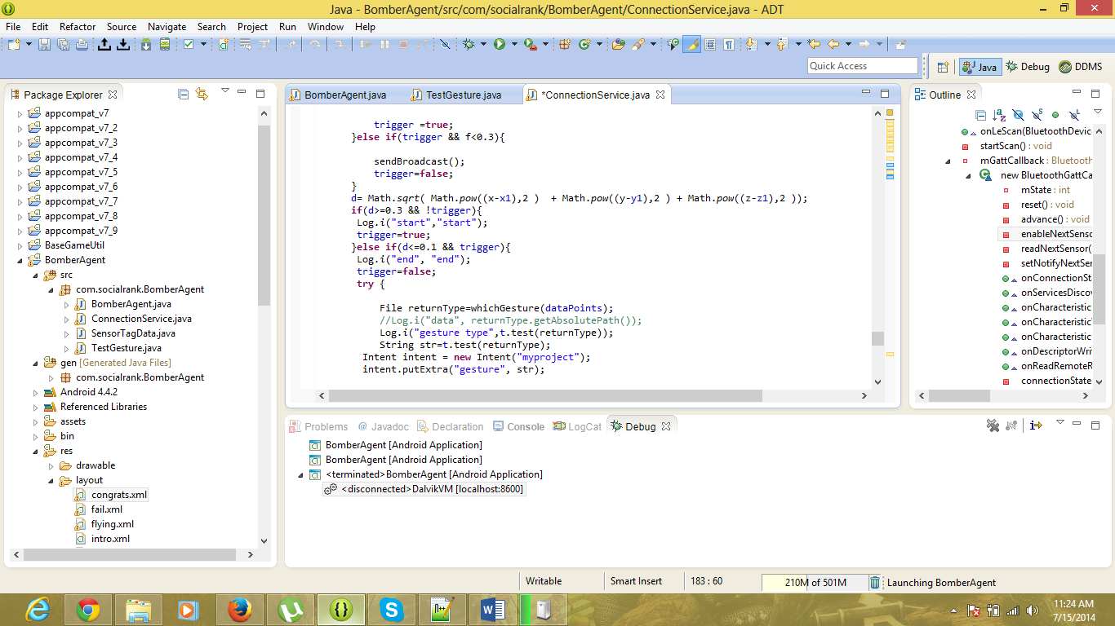

The broadcast is received in the BomberAgent class and checked for the gesture. The flightover function is called to change the view to congrats.xml.

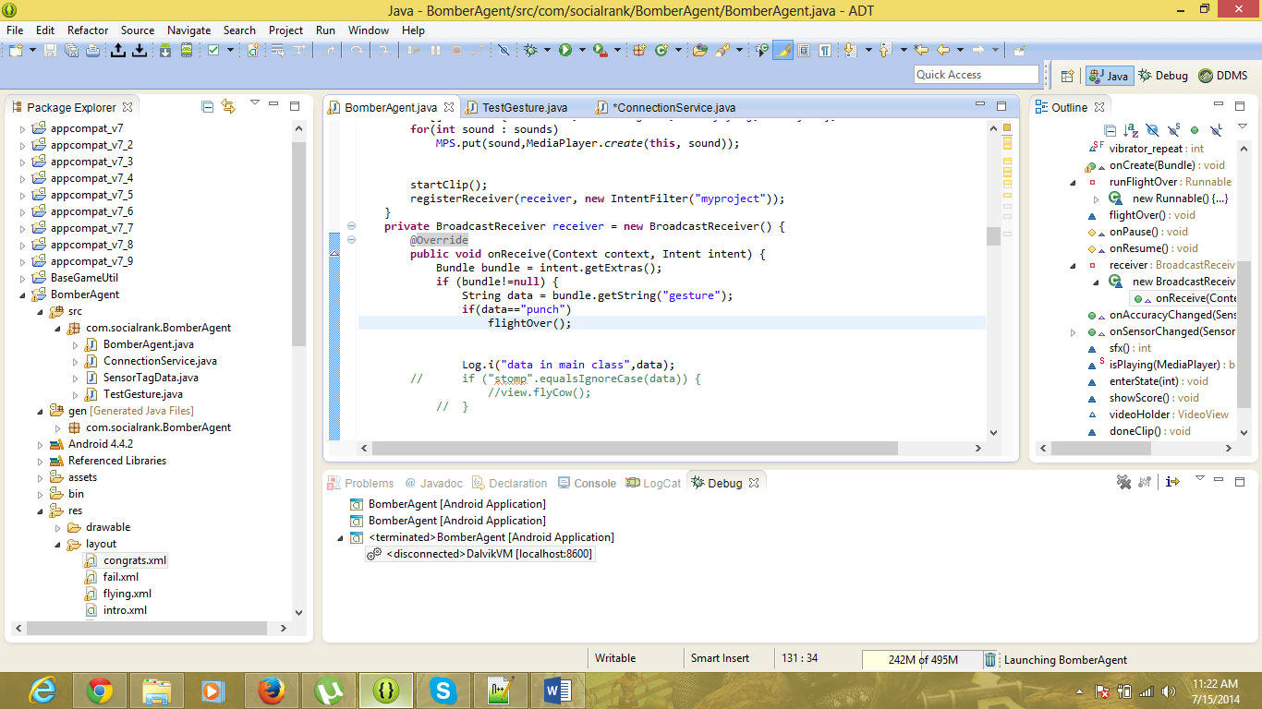

The congrats.xml can be viewed as:



If any other gesture than punch is used then the app goes to the screen called fail.xml as shown:

