1. Find the number of students who scored less than 5(50%).

A = Load ‘/home/acadgild/dataset4pigtask2of9.txt’ Using PigStorage As (Name:chararray,

ColUnd:chararray, Dob:chararray, Stream:chararray, Grade:float, State:chararray, City:chararray);

B = Filter A By Grade<5;

C = Group B All;

D = Foreach C Generate COUNT(B);

Dump D;

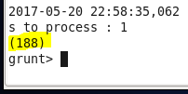

1. List the name of students who are from Alaska.

A = Load ‘/home/acadgild/dataset4pigtask2of9.txt’ Using PigStorage As (Name:chararray,

ColUnd:chararray, Dob:chararray, Stream:chararray, Grade:float, State:chararray, City:chararray);

B = Filter A By State==’alaska’;

C = Foreach B Generate Name;

Dump C;

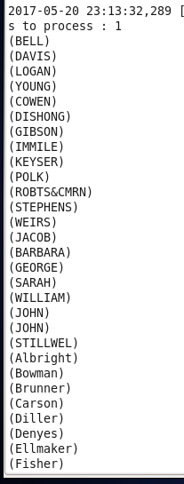

1. How many government collages are there in Alabama?

A = Load ‘/home/acadgild/dataset4pigtask2of9.txt’ Using PigStorage As (Name:chararray,

ColUnd:chararray, Dob:chararray, Stream:chararray, Grade:float, State:chararray, City:chararray);

B = Filter A By State==’alabama’;

C = Filter B By ColUnd==’goverenment’;

D = Group C All;

E = Foreach D Generate COUNT(C);

Dump E;

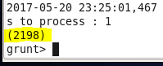

1. List the name of students who are from Oregon and persuing BE.

A = Load ‘/home/acadgild/dataset4pigtask2of9.txt’ Using PigStorage As (Name:chararray,

ColUnd:chararray, Dob:chararray, Str:chararray, Grade:float, State:chararray, City:chararray);

B = Filter A By State==’oregon’;

C = Filter B By Str==’BE’;

D = Foreach D Generate Name;

Dump D;

