1st after starting hive created database ‘acadgildemp’.  
then used the database as:

hive> use acadgildemp  
hive>set hive.cli.print.current.db=true;

Created table ‘employee’ and loaded the data from ‘emp_details.txt’ into this this table.  
And calculating the number of employees corresponding to each skill from the table ‘employee’:

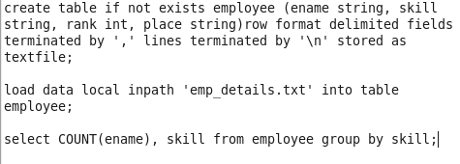

Output:

