**Assignment 14.2**

**Now using the old dataset i.e.**

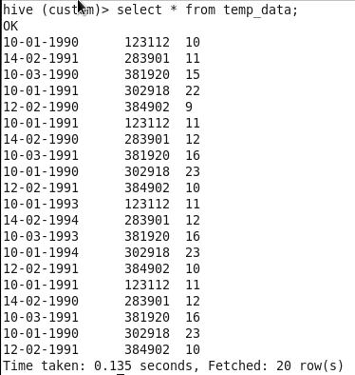

**We will solve the 14.2 assignment:**

1. **Fetch date and temperature from temp_data where zip code is greater than 300000 and less than 399999.**

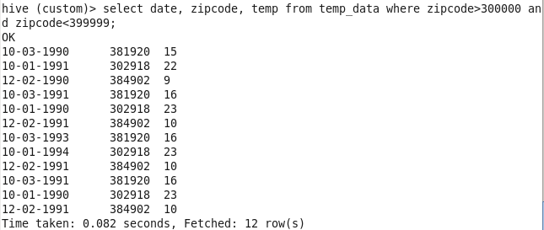

1. **Calculate maximum temperature corresponding to every year from temp_data table.**



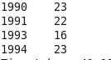

1. **Calculate maximum temperature from temp_data table corresponding to those years which have at least 2 entries in the table.**



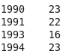

1. **Create a view on the top of last query, name it temp_data_vw.**

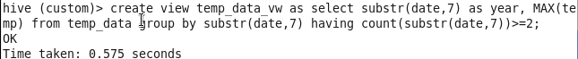

1. **Export contents from temp_data_vw to a file in local file system, such that each file is '|' delimited.**



