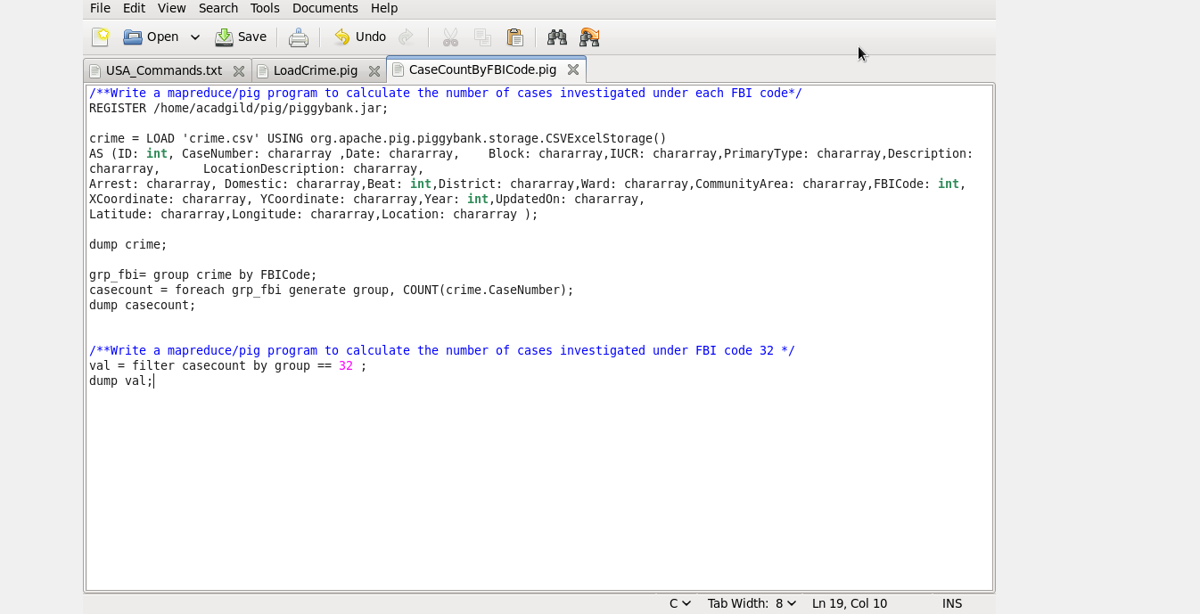

***Result : CaseCountByFBICode***

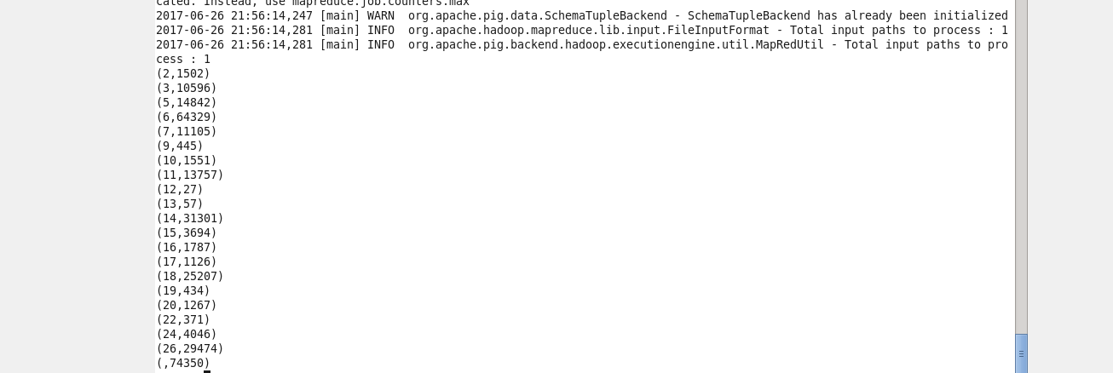

***Result : CaseCountByFBICode where FBICode = 15***

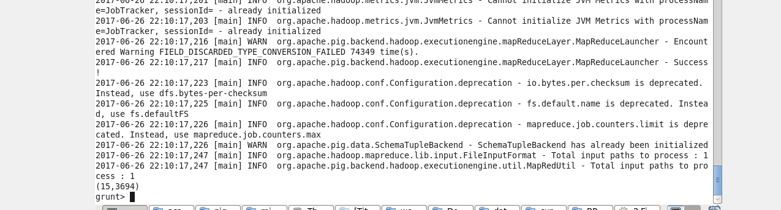

***2.*** Write a MapReduce/Pig program to calculate the number of arrests in theft district wise

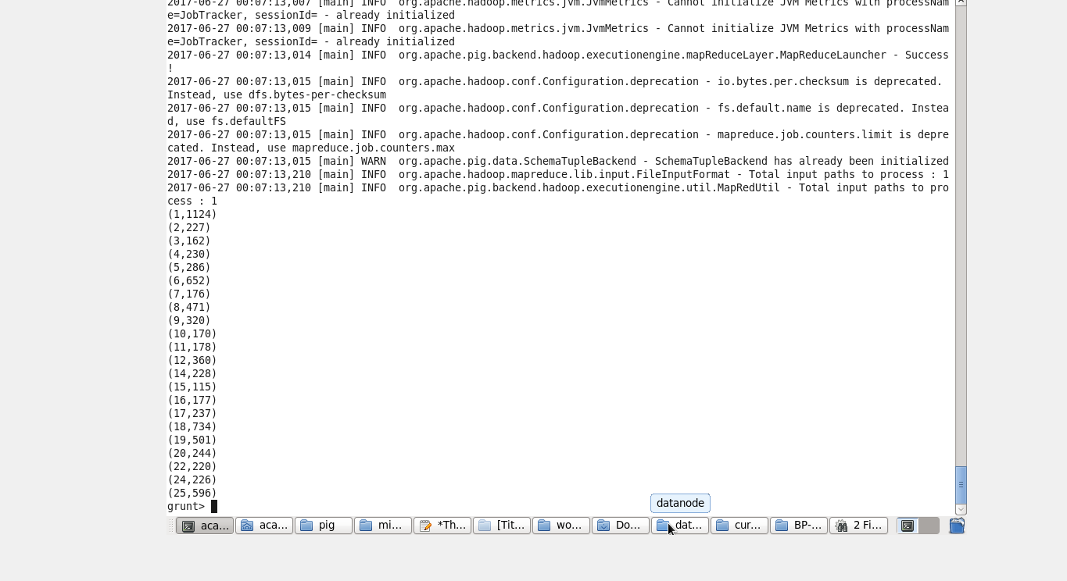

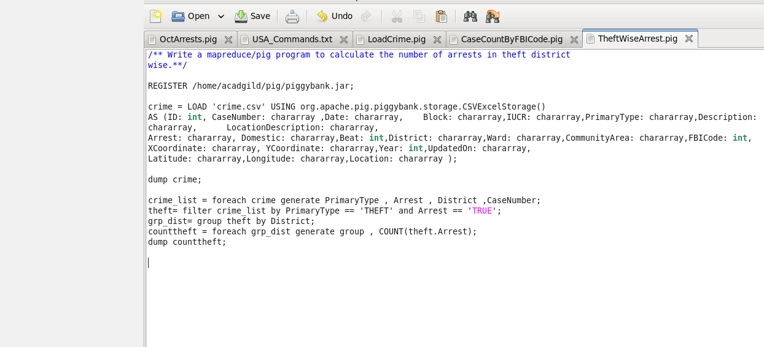

***3.*** Write a MapReduce/Pig program to calculate the number of arrests done between October 2014 and October 2015.

(Crime file Date Error in parsing all )

