**USA Consumer Forum Data Analysis : Project -2 : Assignment 2.2**

Data : <https://drive.google.com/file/d/0B1QaXx7tpw3SQTlnQ0MzVW5HajA/view?usp=sharing>

Flume Agent : Copying files

flume-ng agent –n agent1 –f /home/acadgild/pig /major_proj/consumer_complaints.conf

**Agent Running**

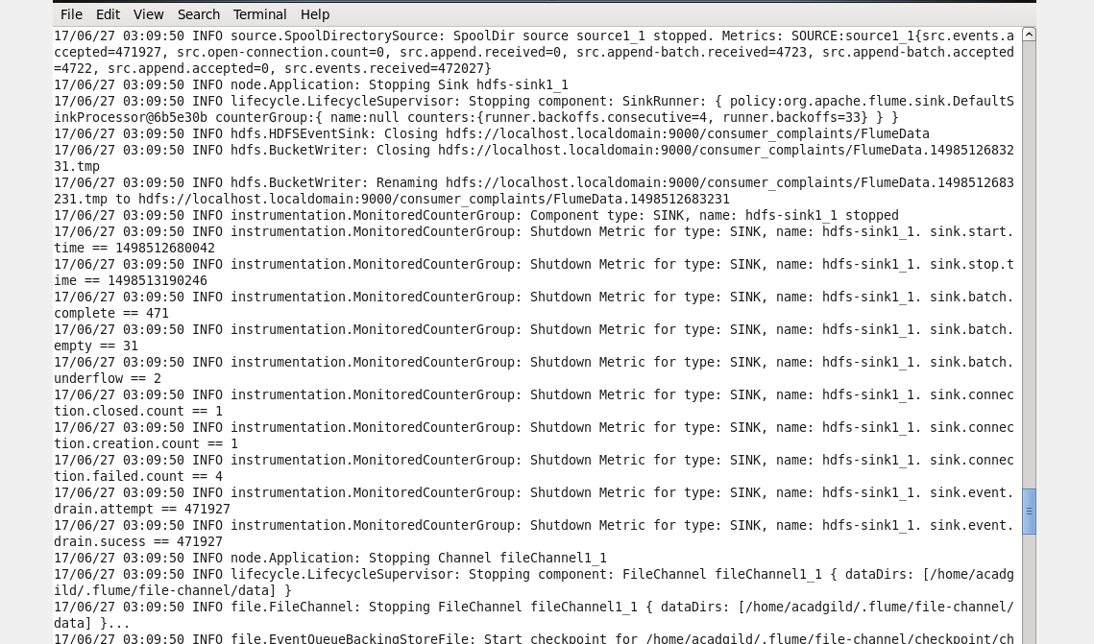

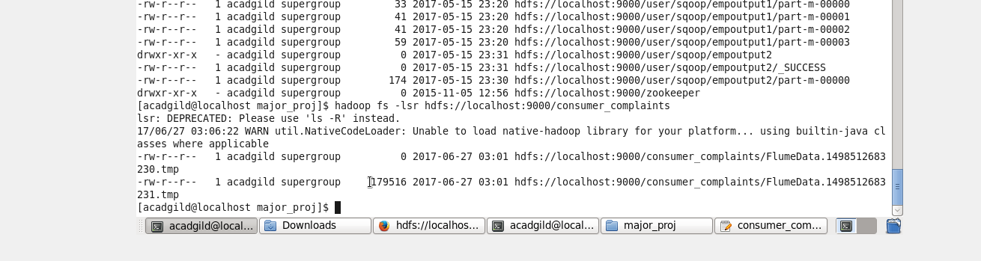

**Load Customer and no of Complaints which got timely response.**

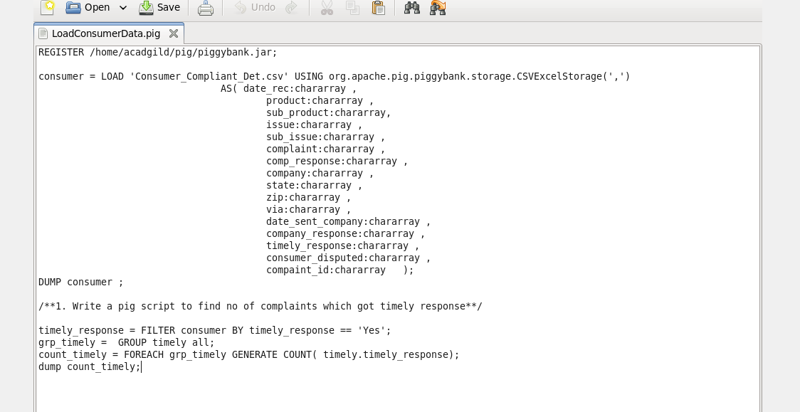

**REsult**

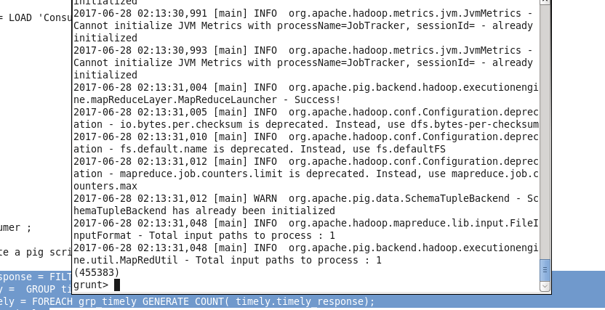

2. **Write a pig script to find no of complaints where consumer forum forwarded the complaint same day they received to respective company**

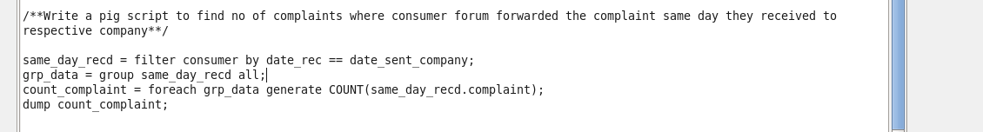

**Result**

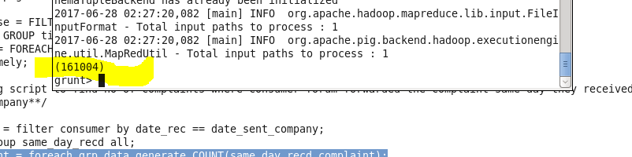

**3. Write a pig script to find list of companies toping in complaint chart (companies with maximum number of complaints)**

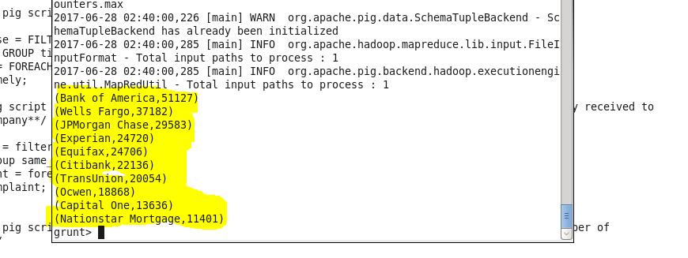

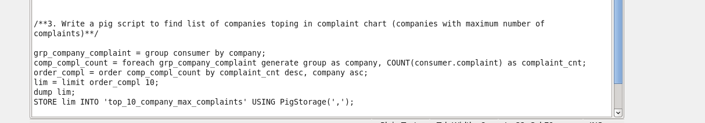

4. **Write a pig script to find no of complaints filed with product type has “ Debt collection” for the year 2015**

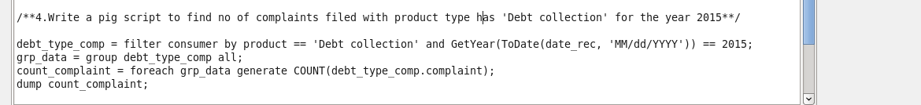

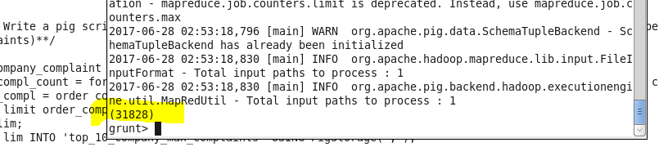

**Store to local filesystem**

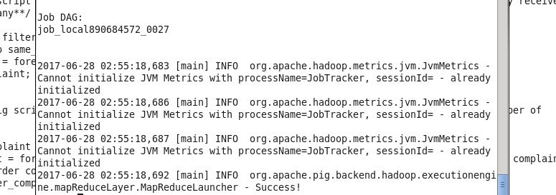

**SQOOP Save to MySQL**

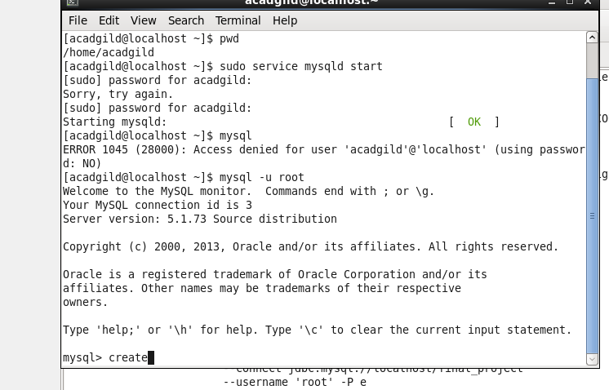

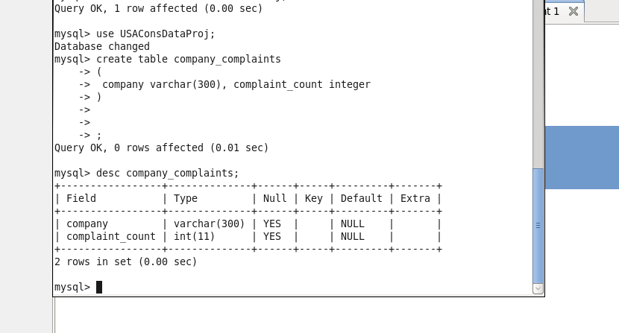

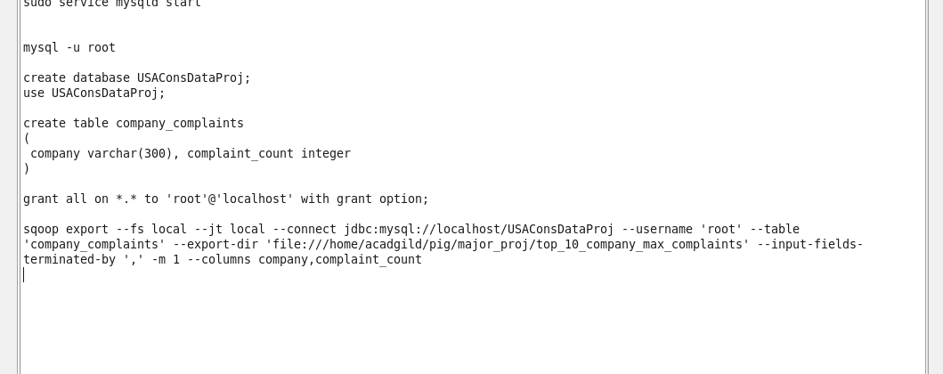

**Exported using Sqoop Command**

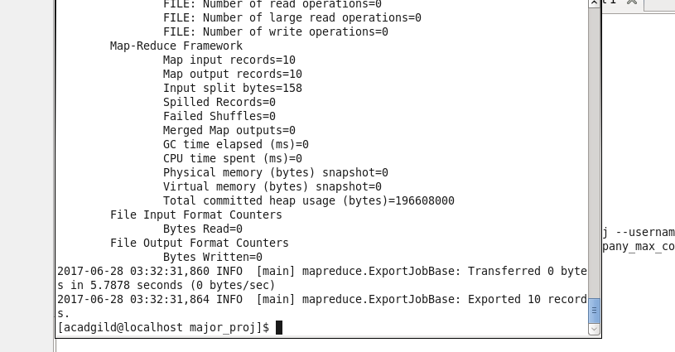

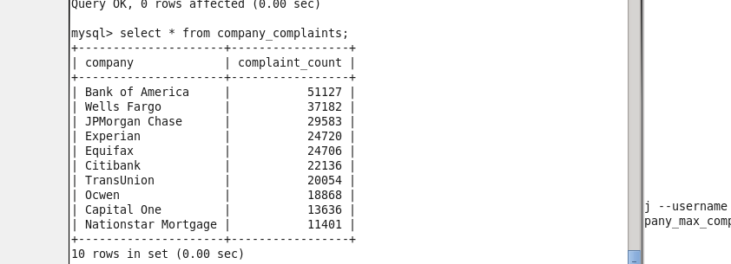

**SQOOP Export for the 4th Problem**

