Write a wordcount program to implement wordcount using Pig.

Answer :

Input :

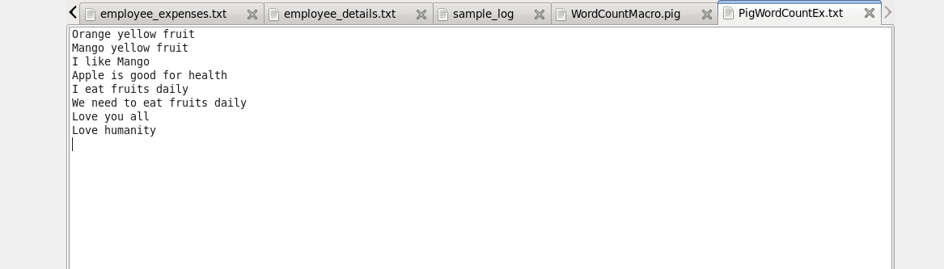

**Macro**

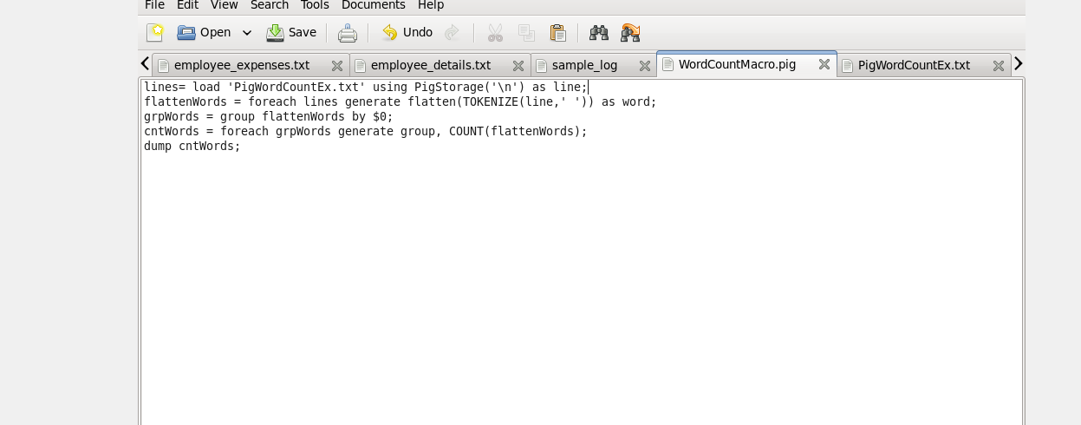

Output

