FPT University
Training Center Programming FPT - APTECH
--------o0o--------



eProject Report Sem III

Online Bus Ticket Reseveration

Class : C0708M
Sem : III
Group : II
Teacher : Nguyễn Ngọc Tú
Members:
1) Vũ Tuấn Minh(Leader)
2) Nguyễn Việt Anh
3) Trần Quang Hợp

Table of content

Chapter I: Introduction

1. Existing Scenario…...……………………………………...…….…….
2. Synopsis…………………………………………………………….…..

Chapter II :Analysis and Design

- Proposed Solution ……………………………………………………
- Customer Requirement Specification……………………………….
- Architecture …………………………………………...……………...
- Data Flow Diagrams……………………………………………….....
- Entity Relationship(ER) Diagram…………………………………...
- Database Design/Structure…………………………………………..
- Design Detail………………………………………………………...
- Tsks sheet……………………………………………………………..

Chapter I: Introduction

Introduction
SRC Travel Agencies is a domestic privatized transportation company that runs the
vehicles all over the country. They have several branches at different locations of the
country, so that they can provide the transportation facilities between the places. They
want an online application to be developed, where the details of the bookings done and
the customer will be updated from time to time and one can track the details of the
available seats immediately

1. Exiting Scenario

SRC Travel Agencies is the agency that provides the transportation facility to the
customers based on their requirements. They provide different buses like Express,
Luxury, and Volvo (Has two types A/C and Non A/C). The charges are different for
different buses. The charges are in the below mentioned format.

Express < Luxury < Volvo (Non A/C) < Volvo (A/C)

The charges also depend on the distance the customer wants to travel and as well on
the age of the customer. The charges also depends on the age, i.e., up to the age of 5 years
there will not be any charges, in between 5 to 12 there will be half charges and for above
twelve the charges will be full till the age of 50 and for the age above fifty they will get a
discount of 30%. They implement this in order to attract the customers.

They maintain all the records of the bus reservation counter through Online service
itself but the application is only accessed by the Admin and the Employers alone. Until
now they used to issue the tickets in the buses alone as it is difficult to track the details of
the bookings done as it provides the service allover the country.

2. Synopsis

The Website is to be developed for the Windows platform using .Net Framework 3.5, Visual Studio 2008 and Microsoft SQL Server 2005, technique ASP.NET MVC 2.0 as the back-end.

Chapter II: Anlysis and design

1. Proposed Solution

Now they want incorporate an online service application where they can maintain the
records of the buses along with the details of the customers. The customer can now book
the tickets by visiting the booking counters at their place (near by) to the respective
destination as required. They want the application to be linked with the database, so that
what ever details are entered like the details of the customers, buses, and bookings can be
viewed by the other centers as well as it is an online application.

They also want to incorporate some feature which performs the tasks that they actually erform, and an application where the customer can register with the site and then book the tickets online instead of visiting the booking counter.

A database should be maintained where the bus details along with the bus number,
route, the places it covers through out the distance and also the timings are needed to be
maintained. Also the details of the customers that are entered at the time of booking the
tickets are needed to be gathered in the database. So that they can track the details of the
customer at any time using the search option based on the starting place, age, name,
destination place and Date and Time and even based on the bus they had chosen.

The database should also maintain the list of the Employers as they alone book the
tickets with the username and password. The list that is to be maintained is personal
details, contact details, location, qualification, age, etc are needed to be gathered.

There should be buttons like New, Update and Cancel are to be included. Based on the button chosen the respective action is needed to be performed. Also if the Employee
record is entered (The Employee details will be maintained by the Admin alone), it
should automatically generate a six digit code, and it will ask for the username and the
password (the password can be changed by the Employee) through which he can login in
to the a/c so as to perform the booking tasks.
Also for canceling the ticket, there is a limit like, if cancelled before 2 days then the
whole money will be returned, and if done one day before, then 15% is debited from the
total amount and the remaining amount is returned and if done on that day 30% is debited
from the total amount and the remaining is to be returned back. This action is also to be
performed by the application alone.
They want the application to be maintained in different details like the buses and the
bookings information. When they try to book a ticket it should ask for the customer
details like the name of the customers for whom the tickets are booked, Date and Time,
Starting and Destination place and the age ( as the charges depends on the age). Also the
Bus no. and the seat no. for which the ticket (s) booked are to be entered so that they can
keep track of the bookings done.
Whenever a customer enquires for the availability they can check through the Enquiry
form where the details like Destination Place, Starting Place, Date and Time are asked,
by entering these details (all fields are not mandatory) the availability details should be
displayed. Also there should be a search option through which the records of the
customers and the buses can be known easily with the same above options.
After the ticket is booked, one should be able to print the ticket, including the details
like age, name, Date and time for which the ticket is booked and as well the destination
and Starting locations and the charges for the ticket including the taxes.
The application alone should be able to calculate the payments as per the age criteria
and the distance. Also it has to be updated in the site.
Note :
1. To book the ticket or to fetch the details (Search and Enquiry) first they need to
Login and only then they will be able to perform such actions.
2. This application is solely for the booking department to book the tickets and is
purely maintained by them. It is not applicable for the customers and they
(customers) cannot book the tickets online by themselves.
3. The Admin maintains the list of the buses and as well the Employees which
cannot be accessed by the Employee. The Employee can alone change his
Password from the booking window)

Non-Financial :

- An online application needed to be developed which is to be solely used and
maintained by the booking department alone (regarding the bookings like booking,
Enquiry and Updating and canceling). It is implemented so as to automate the
process. Also the total authority is taken care of by the admin (Employee, Buses and
charges)
- Also for booking or to perform other actions one has to login with the username and
the password assigned.
- There will be a new, Update, Cancel, search buttons available on each page with
which the employee details
- The customer needed to visit to the booking to enquire or book the tickets and he can
collect the tickets in the bus alone.
- It also maintains a database that consists of the list of buses along with the five digit
code that will be assigned to each bus for easy reference.
- Also the application should develop a unique six digit code whenever a new
employee detail is entered.
- Employee s personal, contact, age, qualifications etc are needed to be collected.
There will be an Enquiry form, Booking Form, and the also a page where the search
options will be available. Also the Price list is to be maintained separately, where one
can access the details of the price by entering the details of the Place of starting and
destination, age, number of seats, etc
- The charges are as per the age, bus type and the distance and are to be maintained by
the application alone.

Financial :

The charges vary depending on the type of the bus opted, distance of travel and as well the age of the customer, which is to be calculated by the application alone. The price list
can be updated by the Admin alone. Also the Reimbursement of the amount will also be
as defined by the admin and is calculated by the application alone by considering the
above parameters
.
2. Customer Requirement Specification(CRS)

- The details of the buses, Price list, and Employee details are to be maintained and
controlled solely by the (Manager) Admin alone.
- The Employer can change alone the password assigned to him.
- Also first the employer needed to login first in order to perform the booking
actions.
- Calculations of the charges and the reimbursements are to be implemented by the
application alone as designated by the Admin
- The details of the buses and seats available are to be maintained and can be
updated regularly (ofcourse only by the admin)
- Enquiry form, Booking form and the pricing list are to be maintained in separate
pages.
- There should be new, update, cancel and search options available

3. Architecture and Design of the Project 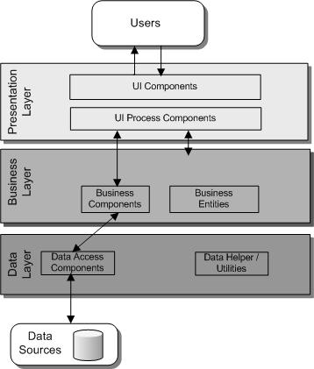

4.Data Flow Diagram

Requirement Analysis
Number | Actor | Function | Small Function
1 | Admin | Employee Management | - Add new Employee
1 | Admin | Employee Management | - Edit information Employee
1 | Admin | Employee Management | - Delete Employee
1 | Admin | Employee Management | - Display list Employee
2 | Admin | Customer Management | - Add new Customer
2 | Admin | Customer Management | - Edit information Customer
2 | Admin | Customer Management | - Delete information Customer
2 | Admin | Customer Management | - Display list Customer
3 | Customer | Search Route and Ticket Booking | - Search information of route
3 | Customer | Search Route and Ticket Booking | - Ticket booking
3 | Customer | Search Route and Ticket Booking | - Review information of route
3 | Customer | Search Route and Ticket Booking | - Cancellation booking

4.1 Employee Management

A. Add New Employee
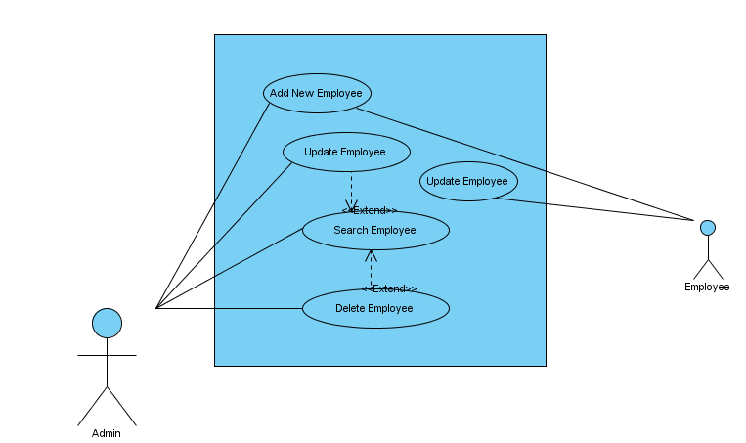

USE CASE # | UC01_01
USE CASE Name | Create New Employee
ACTOR | Admin
Purpose | Add new information to the System
Preconditions | Admin login
Postconditions in words | A new employeer is added to the System
Trigger | Admin enable function add new employee
Extended Use Cases
MAIN SUCCESSFUL SCENARIO | Actor Action | System Action
MAIN SUCCESSFUL SCENARIO | 1. Admin access system select function employee management
MAIN SUCCESSFUL SCENARIO |  | 2. System display function employee management
MAIN SUCCESSFUL SCENARIO | 3. Admin select function Add new employee
MAIN SUCCESSFUL SCENARIO |  | 4. Form Add new is display
MAIN SUCCESSFUL SCENARIO | 5. Admin enter information into form add new employee
MAIN SUCCESSFUL SCENARIO | 6. Click Button Submit
 |  | 7. System processing information and then saved to the database
OTHER SUCCESSFUL SCENARIOS | Step | Branching Action
UNSUCCESSFUL SCENARIOS | Conditions | Actions
UNSUCCESSFUL SCENARIOS | 6a. When you click the button submit,inspection data is invalid | Display warning, check information until valid data is transferred to the next step
Developer | MinhVT
Creation date and last modified date | 02/06/2010

B. Edit Employee Information

USE CASE # | UC01_02
USE CASE Name | Edit Employee Information
ACTOR | Admin
Purpose | Edit information employee in System
Preconditions | Admin login to the System
Postconditions in words | Employee information will be update add new information
Trigger | Admin enable function Edit employee information
Included Use Cases | Search Employee
Extended Use Cases
MAIN SUCCESSFUL SCENARIO | Actor Action | System Action
MAIN SUCCESSFUL SCENARIO | 1. Admin access system select function employee management
MAIN SUCCESSFUL SCENARIO |  | 2. System display function employee management
MAIN SUCCESSFUL SCENARIO | 3. Admin select search function employee needs change
MAIN SUCCESSFUL SCENARIO |  | 4. System display employee information to needs change
MAIN SUCCESSFUL SCENARIO | 5. Admin change employee information
MAIN SUCCESSFUL SCENARIO | 6. Admin click button Edit
MAIN SUCCESSFUL SCENARIO |  | 7. The System display a message asking Admin select Yes or No.
MAIN SUCCESSFUL SCENARIO | 8. Admin conduct selection
MAIN SUCCESSFUL SCENARIO |  | 9. System processing information was change then saved to the database
MAIN SUCCESSFUL SCENARIO |  | End Use Case
OTHER SUCCESSFUL SCENARIOS | Step | Branching Action
OTHER SUCCESSFUL SCENARIOS | 8a. Admin Click Button Yes | Next to step 9
 | 8b.Admin Click Button No | System Reset Information
UNSUCCESSFUL SCENARIOS | Conditions | Actions
UNSUCCESSFUL SCENARIOS | 6a. When you click the button edit,inspection data is invalid | Display warning, check information until valid data is transferred to the next step
Developer | MinhVT
Creation date and last modified date | 03/06/2010

C. Delete Employee Information

USE CASE # | UC01_03
USE CASE Name | Delete Employee Information
ACTOR | Admin
Purpose | Delete information Employee
Preconditions | Admin login to the System
Postconditions in words | One or more employee will be removed from the System
Trigger | Admin enable function Delete employee information
Included Use Cases | Search Employee
Extended Use Cases
MAIN SUCCESSFUL SCENARIO | Actor Action | System Action
MAIN SUCCESSFUL SCENARIO | 1. Admin access system select function employee management
MAIN SUCCESSFUL SCENARIO |  | 2. System display function employee management
MAIN SUCCESSFUL SCENARIO | 3. Admin select search function employee needs delete
MAIN SUCCESSFUL SCENARIO |  | 4. System display employee information to needs delete
MAIN SUCCESSFUL SCENARIO | 5. Admin Click Button Delete
MAIN SUCCESSFUL SCENARIO |  | 6. The System display a message asking Admin select Yes or No
MAIN SUCCESSFUL SCENARIO | 7. Admin conduct selection
MAIN SUCCESSFUL SCENARIO |  | 8. System remove employee information in database
MAIN SUCCESSFUL SCENARIO |  | End Use Case
OTHER SUCCESSFUL SCENARIOS | Step | Branching Action
OTHER SUCCESSFUL SCENARIOS | 5a. Admin click button yes | System processing information was removed then saved to the database
OTHER SUCCESSFUL SCENARIOS | 5b. Admin click button no | System exit delete function then back the user management
UNSUCCESSFUL SCENARIOS | Conditions | Actions
Developer | MinhVT
Creation date and last modified date | 04/06/2010

D. Search Employee Information

USE CASE # | UC01_04
USE CASE Name | Search Employee Information
ACTOR | Admin
Purpose | Search Employee Information
Preconditions | Admin login to the System
Postconditions in words | System display employee information needs search
Trigger | Admin enable function Search employee information
Extended Use Cases
MAIN SUCCESSFUL SCENARIO | Actor Action | System Action
MAIN SUCCESSFUL SCENARIO | 1. Admin access system select function employee management
MAIN SUCCESSFUL SCENARIO |  | 2. System display function employee management
MAIN SUCCESSFUL SCENARIO | 3. Admin employee search function
MAIN SUCCESSFUL SCENARIO |  | 4. System display employee information to needs search
MAIN SUCCESSFUL SCENARIO |  | End Use Case
OTHER SUCCESSFUL SCENARIOS | Step | Branching Action
OTHER SUCCESSFUL SCENARIOS | 3a. Click button search | System display user information to needs search.
OTHER SUCCESSFUL SCENARIOS | 3b. Click button close | System exit search function then back the employee management
UNSUCCESSFUL SCENARIOS | Conditions | Actions
Developer | MinhVT
Creation date and last modified date | 05/06/2010

4.2 Customer Management

A. Add new Customer
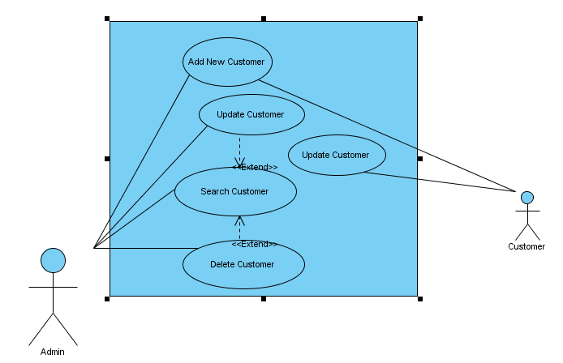
USE CASE # | UC02_01
USE CASE Name | Add new Customer
ACTOR | Admin
Purpose | Add new information to the System
Preconditions | Admin login
Postconditions in words | A new customer is added to the System
Trigger | Admin enable function add new customer
Extended Use Cases
MAIN SUCCESSFUL SCENARIO | Actor Action | System Action
MAIN SUCCESSFUL SCENARIO | 1. Admin access system select function customer management
MAIN SUCCESSFUL SCENARIO |  | 2. System display function customer management
MAIN SUCCESSFUL SCENARIO | 3. Admin select function Add new customer
MAIN SUCCESSFUL SCENARIO |  | 4. Form Add new is display
MAIN SUCCESSFUL SCENARIO | 5. Admin enter information into form add new customer
MAIN SUCCESSFUL SCENARIO | 6. Click Button Submit
 |  | 7. System processing information and then saved to the database
OTHER SUCCESSFUL SCENARIOS | Step | Branching Action
UNSUCCESSFUL SCENARIOS | Conditions | Actions
UNSUCCESSFUL SCENARIOS | 6a. When you click the button submit,inspection data is invalid | Display warning, check information until valid data is transferred to the next step
Developer | AnhNN
Creation date and last modified date | 02/06/2010

B. Edit Customer

USE CASE # | UC02_02
USE CASE Name | Edit Customer
ACTOR | Admin
Purpose | Edit customer in System
Preconditions | Admin login to the System
Postconditions in words | Customer information will be update add new information
Trigger | Admin enable function Edit customer
Included Use Cases | Search Category
Extended Use Cases
MAIN SUCCESSFUL SCENARIO | Actor Action | System Action
MAIN SUCCESSFUL SCENARIO | 1. Admin access system select function customer management
MAIN SUCCESSFUL SCENARIO |  | 2. System display function customer management
MAIN SUCCESSFUL SCENARIO | 3. Admin select search function customer needs change
MAIN SUCCESSFUL SCENARIO |  | 4. System display customer information to needs change
MAIN SUCCESSFUL SCENARIO | 5. Admin change customer information
MAIN SUCCESSFUL SCENARIO | 6. Admin click button Edit
MAIN SUCCESSFUL SCENARIO |  | 7. The System display a message asking Admin select Yes or No.
MAIN SUCCESSFUL SCENARIO | 8. Admin conduct selection
MAIN SUCCESSFUL SCENARIO |  | 9. System processing information was change then saved to the database
MAIN SUCCESSFUL SCENARIO |  | End Use Case
OTHER SUCCESSFUL SCENARIOS | Step | Branching Action
OTHER SUCCESSFUL SCENARIOS | 8a. Admin Click Button Yes | Next to step 9
 | 8b.Admin Click Button No | System Reset Information
UNSUCCESSFUL SCENARIOS | Conditions | Actions
UNSUCCESSFUL SCENARIOS | 6a. When you click the button edit,inspection data is invalid | Display warning, check information until valid data is transferred to the next step
Developer | AnhNN
Creation date and last modified date | 03/06/2010

C. Delete Customer

USE CASE # | UC02_03
USE CASE Name | Delete Customer
ACTOR | Admin
Purpose | Delete Customer information
Preconditions | Admin login to the System
Postconditions in words | One or more customer will be removed from the System
Trigger | Admin enable function Delete customer information
Included Use Cases | Search Customer
Extended Use Cases
MAIN SUCCESSFUL SCENARIO | Actor Action | System Action
MAIN SUCCESSFUL SCENARIO | 1. Admin access system select function customer management
MAIN SUCCESSFUL SCENARIO |  | 2. System display function customer management
MAIN SUCCESSFUL SCENARIO | 3. Admin select search function customer needs delete
MAIN SUCCESSFUL SCENARIO |  | 4. System display customer information to needs delete
MAIN SUCCESSFUL SCENARIO | 5. Admin Click Button Delete
MAIN SUCCESSFUL SCENARIO |  | 6. The System display a message asking Admin select Yes or No
MAIN SUCCESSFUL SCENARIO | 7. Admin conduct selection
MAIN SUCCESSFUL SCENARIO |  | 8. System remove customer information in database
MAIN SUCCESSFUL SCENARIO |  | End Use Case
OTHER SUCCESSFUL SCENARIOS | Step | Branching Action
OTHER SUCCESSFUL SCENARIOS | 5a. Admin click button yes | System processing information was removed then saved to the database
OTHER SUCCESSFUL SCENARIOS | 5b. Admin click button no | System exit delete function then back the customer management
UNSUCCESSFUL SCENARIOS | Conditions | Actions
Developer | AnhNN
Creation date and last modified date | 04/06/2010

D. Search Customer

USE CASE # | UC02_04
USE CASE Name | Search Customer
ACTOR | Admin
Purpose | Search Customer Information
Preconditions | Admin login to the System
Postconditions in words | System display customer information needs search
Trigger | Admin enable function Search category information
Extended Use Cases
MAIN SUCCESSFUL SCENARIO | Actor Action | System Action
MAIN SUCCESSFUL SCENARIO | 1. Admin access system select function customer management
MAIN SUCCESSFUL SCENARIO |  | 2. System display function customer management
MAIN SUCCESSFUL SCENARIO | 3. Admin use search function
MAIN SUCCESSFUL SCENARIO |  | 4. System display customer information to needs search
MAIN SUCCESSFUL SCENARIO |  | End Use Case
OTHER SUCCESSFUL SCENARIOS | Step | Branching Action
OTHER SUCCESSFUL SCENARIOS | 3a. Click button search | System display customer information to needs search.
OTHER SUCCESSFUL SCENARIOS | 3b. Click button close | System exit search function then back the customer management
UNSUCCESSFUL SCENARIOS | Conditions | Actions
Developer | AnhNN
Creation date and last modified date | 05/06/2010

4.3 Online Bus Ticket Booking Service

A. Search Route
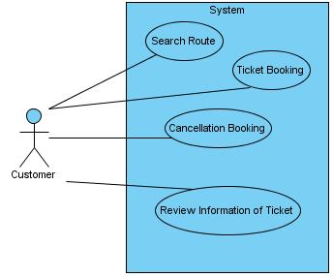

USE CASE # | UC03_01
USE CASE Name | Search Route
ACTOR | Customer
Purpose | Search information of route in the System
Preconditions | Customer access website
Postconditions in words | List route match will view in the screen for customer
Trigger
Extended Use Cases
MAIN SUCCESSFUL SCENARIO | Actor Action | System Action
MAIN SUCCESSFUL SCENARIO | 1. Customer access website
MAIN SUCCESSFUL SCENARIO |  | 2. Popular information about service will show.
MAIN SUCCESSFUL SCENARIO | 3. Customer choose search form and require route match with them
MAIN SUCCESSFUL SCENARIO |  | 4. System searching and respone results.
MAIN SUCCESSFUL SCENARIO | 5. Customer choose route most match with them.
MAIN SUCCESSFUL SCENARIO | 6. Click Button Booking
 |  | 7. System processing information require login (if not login), then update to database
OTHER SUCCESSFUL SCENARIOS | Step | Branching Action
UNSUCCESSFUL SCENARIOS | Conditions | Actions
UNSUCCESSFUL SCENARIOS | 6a. When you click the button submit,inspection data is invalid | Display warning, check information until valid data is transferred to the next step
Developer | MinhVT
Creation date and last modified date | 02/06/2010

B. Ticket Booking

USE CASE # | UC03_02
USE CASE Name | Ticket Booking
ACTOR | Customer
Purpose | Bus ticket booking
Preconditions | Customer login to the System
Postconditions in words | System will authentication information of customer, following update to database.
Trigger
Included Use Cases
Extended Use Cases
MAIN SUCCESSFUL SCENARIO | Actor Action | System Action
MAIN SUCCESSFUL SCENARIO | 1. Customer ticket booking
MAIN SUCCESSFUL SCENARIO |  | 2. System display information of that bus (seats, sleeper,amenities,departure,arrival,price….)
MAIN SUCCESSFUL SCENARIO | 3. Customer choose seats which they want and extend service.
MAIN SUCCESSFUL SCENARIO |  | 4. System display total price which customer must payment.
MAIN SUCCESSFUL SCENARIO | 5. Customer agree.
MAIN SUCCESSFUL SCENARIO | 6. Customer click button Process
MAIN SUCCESSFUL SCENARIO |  | 7. The System require customer’s account of bank
MAIN SUCCESSFUL SCENARIO | 8. Customer input code and click submit
MAIN SUCCESSFUL SCENARIO |  | 9. System processing information was change then saved to the database
MAIN SUCCESSFUL SCENARIO |  | End Use Case
OTHER SUCCESSFUL SCENARIOS | Step | Branching Action
OTHER SUCCESSFUL SCENARIOS | 8a. If Customer’s account of bank have enough money | Next to step 9
 | 8b. If Customer’s account of bank have not enough money | System Reset Information and send to message to customer
Developer | MinhVT
Creation date and last modified date | 03/06/2010

C. Cancellation Booking

USE CASE # | UC03_03
USE CASE Name | Cancellation Booking
ACTOR | Customer
Purpose | Delete information booking
Preconditions | Customer login to the System
Postconditions in words | Customer must input code of ticket
Trigger
Included Use Cases
Extended Use Cases
MAIN SUCCESSFUL SCENARIO | Actor Action | System Action
MAIN SUCCESSFUL SCENARIO | 1. Customer require cancellation booking
MAIN SUCCESSFUL SCENARIO |  | 2. System display cancellation form
MAIN SUCCESSFUL SCENARIO | 3. Customer input code of ticket
MAIN SUCCESSFUL SCENARIO |  | 4. System process and send to confirm message to customer
MAIN SUCCESSFUL SCENARIO | 5. Customer choose YES or NO
MAIN SUCCESSFUL SCENARIO |  | 6. The System process and view result to customer.
MAIN SUCCESSFUL SCENARIO |  | End Use Case
OTHER SUCCESSFUL SCENARIOS | Step | Branching Action
OTHER SUCCESSFUL SCENARIOS | 5a. Admin click button yes | System processing information was removed then saved to the database
OTHER SUCCESSFUL SCENARIOS | 5b. Admin click button no | System exit delete function then back the Service Packs management
UNSUCCESSFUL SCENARIOS | Conditions | Actions
Developer | MinhVT
Creation date and last modified date | 04/06/2010

D. View Information of Ticket Booked

USE CASE # | UC03_04
USE CASE Name | View Information of Ticket Booked
ACTOR | Customer
Purpose | Search information of route which customer choosed.
Preconditions | Customer login to the System

Postconditions in words
Trigger
Extended Use Cases
MAIN SUCCESSFUL SCENARIO | Actor Action | System Action
MAIN SUCCESSFUL SCENARIO | 1. Customer access function view info route on website.
MAIN SUCCESSFUL SCENARIO |  | 2. System display form search
MAIN SUCCESSFUL SCENARIO | 3. Customer input code of ticket
MAIN SUCCESSFUL SCENARIO |  | 4. System display all information of route.
MAIN SUCCESSFUL SCENARIO |  | End Use Case
UNSUCCESSFUL SCENARIOS | Conditions | Actions
Developer | MinhVT
Creation date and last modified date | 05/06/2010

5.Entity Relationship (ER) Diagram

6. Database Design/Structure

Table Design

7.Design Detail
8.Tasks sheet

Project Ref. No.: |  | Project Title: | Activity Plan Prerared By: | Date of Preparation of Activity Plan:
Sr.No. | Task | Project Title: | Activity Plan Prerared By: | Actual  Start Date | Actual Days | Team Member Names | Status
1 | Task  Sheet | OnlinePost OfficeManagement
2 | eProject Analysis | OnlinePost OfficeManagement
3 | Data Abstraction | OnlinePost OfficeManagement
4 | Normalize database | OnlinePost OfficeManagement
5 | Problem definition | OnlinePost OfficeManagement
6 | Customer Requirement Specification | OnlinePost OfficeManagement
7 | Architecture & Design of the Project | OnlinePost OfficeManagement
8 | Data flow Diagram | OnlinePost OfficeManagement
9 | Entity Relationship Diagram | OnlinePost OfficeManagement
10 | Database Design Structure | OnlinePost OfficeManagement
11 | Repair and Fix | OnlinePost OfficeManagement
12 | Repair and Complete | OnlinePost OfficeManagement
13 | eProject Design | OnlinePost OfficeManagement
14 | Develope | OnlinePost OfficeManagement
15 | Testing | OnlinePost OfficeManagement

