Overview
This document describes how to install sample certificates to support code samples. Not all samples require all certificates to be installed. Consult the readme for the specific sample to determine which certificates you need to run the sample.

Certificates
Open the Certificates MMC console to the CurrentUser and LocalMachine stores. Here is a table of instructions for each certificate.
Password for all private keys is “indigo”.

Filename | Description | Store Name | Store Location
RPKey.pfx | Private key pair for target services. | LocalMachine | Personal
RPKey.cer | Public key for target services. | CurrentUser | Personal, TrustedPeople
RPKey.cer | Public key for target services. | LocalMachine | TrustedPeople
IPKey.pfx | Private key pair for identity provider services. | LocalMachine | Personal, Trusted Root Certification Authorities
IPKey.cer | Public key for identity provider services. | LocalMachine | TrustedPeople
SubjectKey.pfx | Private key pair for client applications. | CurrentUser | Personal
SubjectKey.cer | Public key for client applications. | LocalMachine | Personal, TrustedPeople

Create an SSL Certificate
These instructions assume that you want to create a self-signed certificate for testing on your local machine.

Create the Certificate
- Launch the Visual Studio 2005 command line and use makecert.exe to create localhost certificate using this command:
makecert -r -pe -n CN=localhost -ss my -sr currentuser -sky exchange -sp "Microsoft RSA SChannel Cryptographic Provider" -sy 12 c:\localhost.cer

Export the Certificate
- Export the private key from the CurrentUser store. First load the MMC console (mmc.exe) and open the certificates Snap In for the CurrentUser and LocalMachine stores.
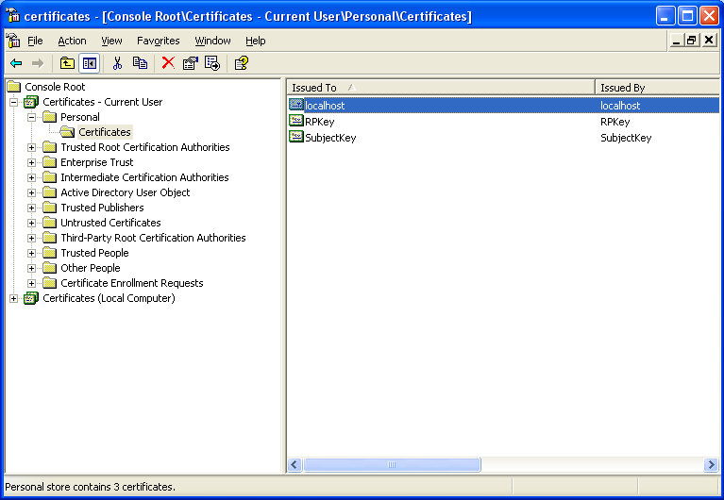
- Export the private key from the CurrentUser “Personal” store following the steps in these screenshots.
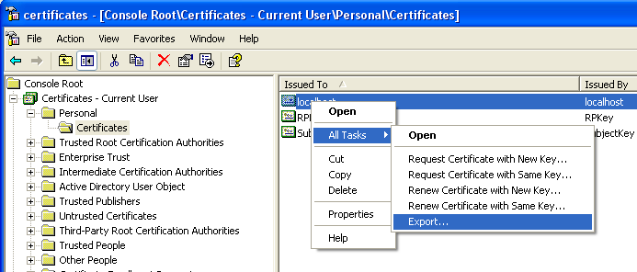

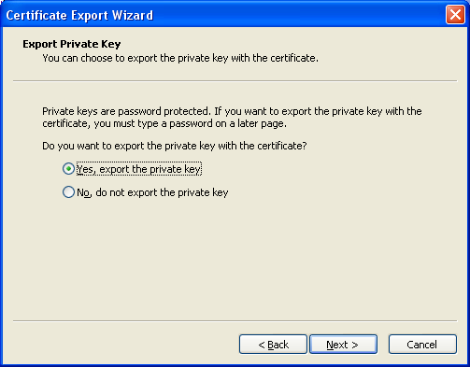

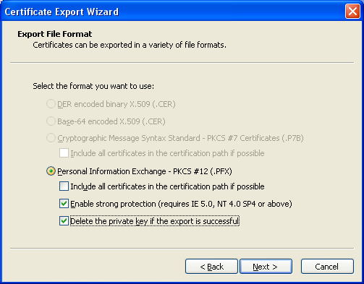

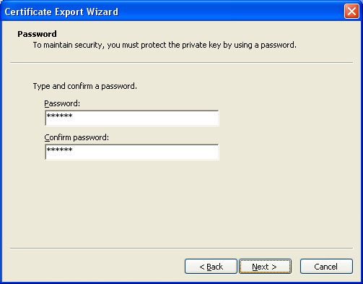

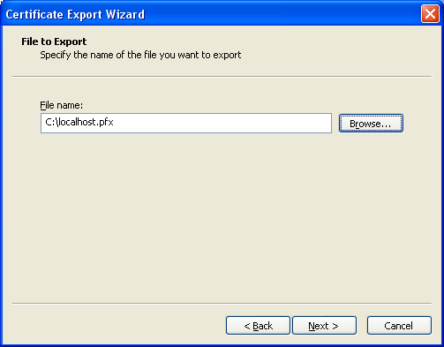

Attach the Certificate to IIS
These instructions will walk you through importing a certificate for use as an SSL certificate in IIS.

Import the Certificate
- Using the Certificates MMC console, import the private key “localhost.pfx” into the LocalMachine “Personal” store providing the same password you used during key export.
- Now, import the public key “localhost.cer” into the LocalMachine “Trusted Root Certification Authorities” store.
- Now the key is ready to be attached to an IIS web site.

Attach the Certificate to IIS
- From the IIS console, select the web site for the SSL certificate. Open the Properties dialog.
- From the Directory Security tab, select Server Certificate. Walk through the steps to assign the localhost certificate to the web site shown in the screenshots.
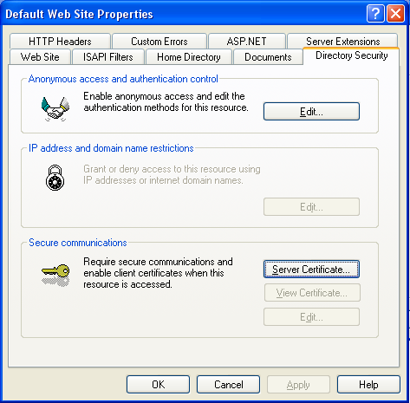

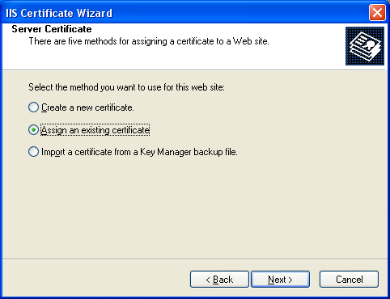

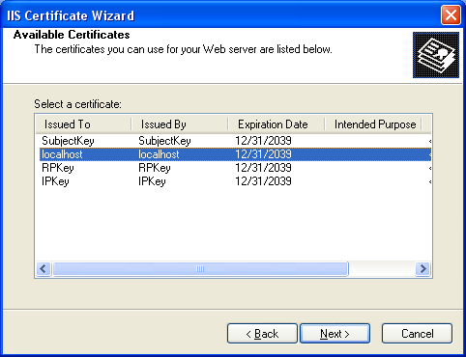

Other Resources
- Michele’s Blog – www.dasblonde.net
- Michele’s Book Blog – www.thatindigogirl.com
- IDesign Code Library – www.idesign.net

If you have issues or questions contact me: mlb@dasblonde.net

