Name : Siddhanth S
Reg No : 411625104067
Department : CSE
Subject : Python
Batch : 5

Mini Project 4:

Simple Calculator using Python

1. Project Title
Simple Calculator using Python Functions

2. Problem Statement
To design and implement a simple calculator that can perform basic arithmetic operations such as addition, subtraction, multiplication, and division using Python functions.

3. Objective
• To understand input and output operations in Python
• To implement functions in Python
• To use conditional statements (if-elif-else)
• To perform basic arithmetic calculations
• To improve logical thinking and programming skills

4. Tools Used
• Python 3

5. Description
This project is a simple calculator developed using Python.
The program allows the user to select a mathematical operation such as addition, subtraction, multiplication, or division.
The user enters two numbers and selects the desired operation. The program then calls the corresponding function and displays the result.
Functions are used to make the program modular and easy to understand.

6. Algorithm
- Start the program
- Display calculator menu options
- Read user choice for operation
- Read two numbers from the user
- If choice is addition, call add() function
- If choice is subtraction, call subtract() function
- If choice is multiplication, call multiply() function
- If choice is division, call divide() function
- Display the result
- If invalid choice, display error message
- End program

7. Program(Python code)
def add(a, b):
return a + b
def subtract(a, b):
return a - b
def multiply(a, b):
return a * b
def divide(a, b):
if b == 0:
return "Error! Division by zero."
return a / b
print("SIMPLE CALCULATOR ")
print("1. Add")
print("2. Subtract")
print("3. Multiply")
print("4. Divide")
choice = input("Enter choice (1/2/3/4): ")
num1 = float(input("Enter first number: "))
num2 = float(input("Enter second number: "))
if choice == '1':
print("Result:", add(num1, num2))
elif choice == '2':
print("Result:", subtract(num1, num2))
elif choice == '3':
print("Result:", multiply(num1, num2))
elif choice == '4':
print("Result:", divide(num1, num2))
else:
print("Invalid input")

8. Sample Output

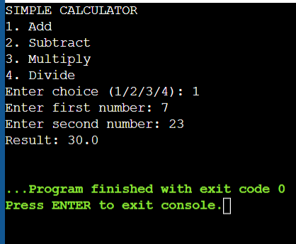

9. Result
The Simple Calculator successfully performs basic arithmetic operations such as addition, subtraction, multiplication, and division based on user input.

10. Conclusion
This project demonstrates the use of Python functions and conditional statements to perform arithmetic calculations. It helps beginners understand modular programming and improves problem-solving skills.

