**What is a Java Collection Framework?**

A Java collection framework provides an architecture to store and manipulate a group of objects. A Java collection framework includes the following:

* Interfaces
* Classes
* Algorithm

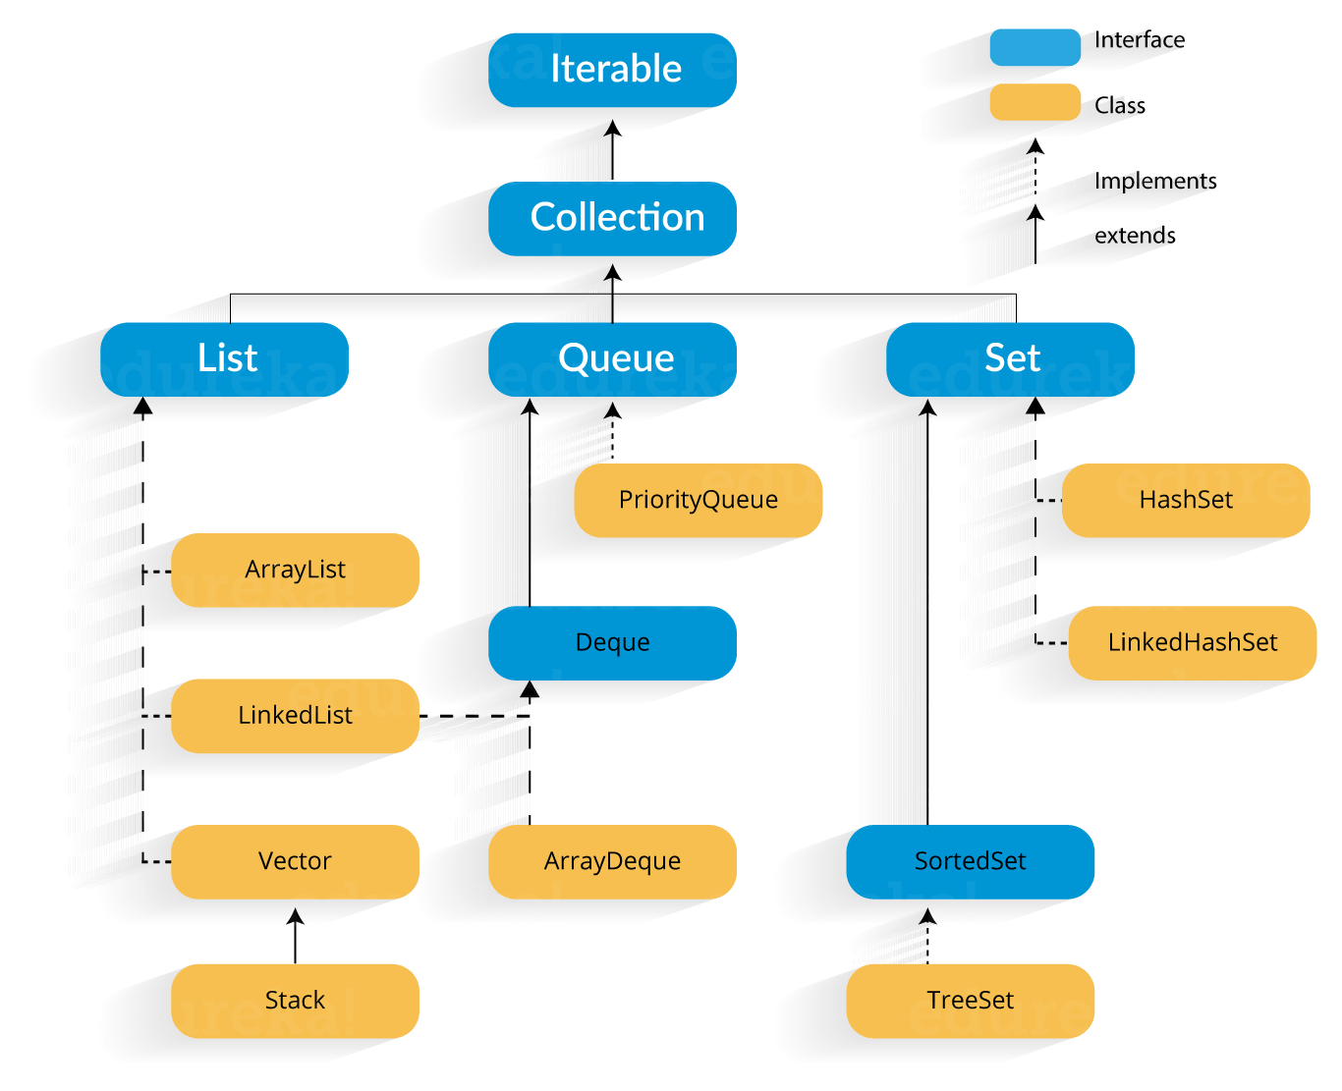

**Java collections: List**

A List is an ordered Collection of elements which may contain duplicates. It is an interface that extents the Collection interface. Lists are further classified into the following:

1. ArrayList
2. LinkedList
3. Vectors

**ArrayList:** ArrayList is the implementation of List Interface where the elements can be dynamically added or removed from the list. Also, the size of the list is increased dynamically if the elements are added more than the initial size

**LinkedList:** LinkedList is implemented as a double linked list. Its performance on add and remove is better than Arraylist, but worse on get and set methods.

**Vector:** Vector is similar with ArrayList, but it is synchronized. ArrayList is a better choice if your program is thread-safe. Vector and ArrayList require space as more elements are added. Vector each time doubles its array size, while ArrayList grow 50% of its size each time.

## ****Java Collections: Sets****

A Set refers to a collection that cannot contain duplicate elements. Set has its implementation in various classes such as HashSet, TreeSetand LinkedHashSet.

**HashSet :** Its an Unordered and unsorted set of unique elements.

**LinkedHashSet :** Its an unsorted set of unique elements maintains the insertion order.

**TreeSet :** Its an sorted set of unique elements.

## ****Java Collections: Map****

A Map refers to a collection of key-value pair. In map every element can be assigned a unique key.

**HashMap :** HashMap is not Tread-safe. (Better in performance than HashTable) (not sorted)

**HashTable :** HashTable is Thread-Safe Map.

**LinkedHashMap :** It maintains the insertion order.

**TreeMap :** It arranges the entries in sorted order of their keys.