Shan Sikdar
CS542
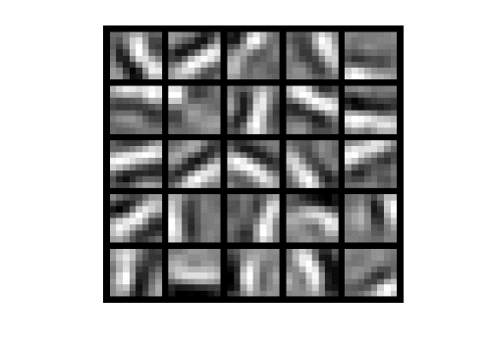

Sparse Encoder Homework

- Explain what the auto-encoder does.

An Autoencoder basically tries to see if it can learn and recreate the input. Therefore it uses y(i) = x(i)
for each training value in the training set. It is an unsupervised learning algorithm that applies back propagation. Essentially it is trying to learn an approximation to the identity function. It limits the amout of hidden nodes in the network in an attempt to learning interesting patterns about the data.

- Give a comparison with/without the regularization terms included
(I have pictures of the different results with the parameters at the end of the writeup)
lambda term:
For the lambda term I found that without the the lambda term, the sparse autoencoder begins to learn some of the patterns a little bit, but not well at all. For the most part it becomes a pixelated mess.
Increasing the lambda factor from .0001 to .001 (so a factor of 10) the network converged way to quickly and didn't learn any of the patterns. Decreasing by factor of 10 had had similar results to setting lambda equal to 0.

sparsity term:
Using the paramters: sparsityParam = 0.01; lambda = 0.0001; beta = 10; ,
I achieved pretty good results. Changing the sparsity term to 0 the network failed to learn anything at all. Changing the sparsity term from 0.01 to 0.001 the network started to learn more of a pattern but still the results were not very good. Changing the sparsity term from .01 to .1 produced better results than 0 and .001 but it seemed that increasing it by a power of 10 hurt performance.

Beta:
Decreasing beta to zero, the results were really bad, which makes sense since your weighing your average hidden outputs with a weight of 0.
An interesting pattern I found was increasing beta from 3 to 6 to 12 to 96, the autoencoder was still able to learn all the patterns. (although at 96 it was a little more blurry.)

- Set # hidden units to > 64 and increase the regularization term associated with the sparsity. See whether you can observe the same results/visuals with #hidden units = 25. (You may have to decrease the number of patches as it may take very long to train the neural network).

So increasing the number of hidden nodes to 64 and changing beta to 64, it still managed to get very good results and learn the patterns. When trying to increase the sparsity parameter I had the same problem as described above with sparsity parameter.

- interpret the results
The sparse auto-encoder is essentially trying to learn the identity function of the pictures in order to group edges of the picture together.
Hidden Layer: This means if by increasing beta and hiddenSize to 64 gets as good results as 25 layers, it is better to use 25 layers since it can still learn the patterns and take less computational parameters. However this shows that there is a way to learn the Identity function pretty well.
Experiments with lambda show that regularization is pretty essential for the neural network but should be used in moderation. The beta parameter representing the average of the hidden layers shows to work well with a relatively high number as long as its within reason. This shows you want the hidden layer to learn the patterns and activate to a large amount. The sparsity parameter shows that you want to encourage sparsity but too much and the network converges far too fast to learn anything.
Lambda:
sparsityParam = 0.01; lambda = 0.0001; beta = 3;

After setting the lambda term to 0:
sparsityParam = 0.01; lambda = 0; beta = 3;
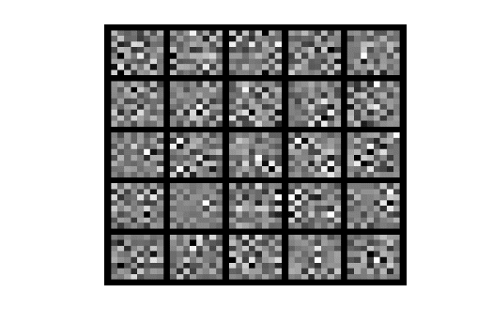

sparsityParam = 0.01; lambda = 0.001; beta = 3;
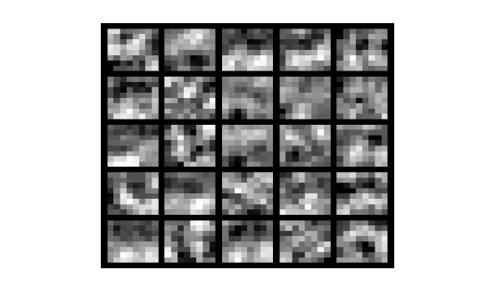
sparsityParam = 0.01; lambda = 0.00001; beta = 3;
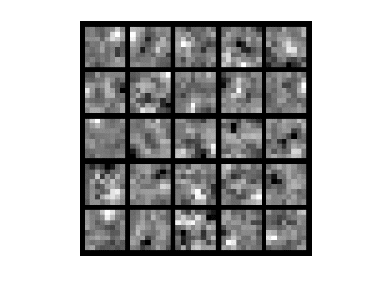

Sparsity Parameter:

sparsityParam = 0.01; lambda = 0.0001; beta = 10;
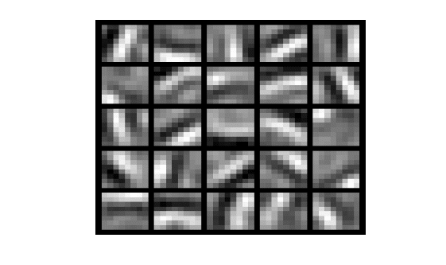

sparsityParam = 0.001; lambda = 0.0001; beta = 10;

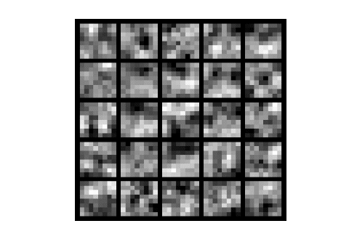

sparsityParam = 0.1; lambda = 0.0001; beta = 10;

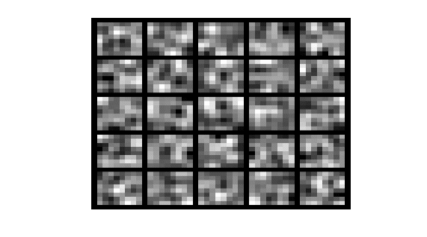

sparsityParam = 0; lambda = 0.0001; beta = 10;
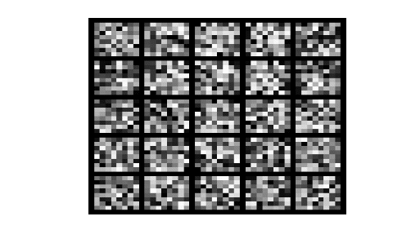

Beta:

Beta = 0

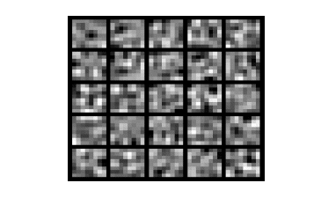
Beta = 3
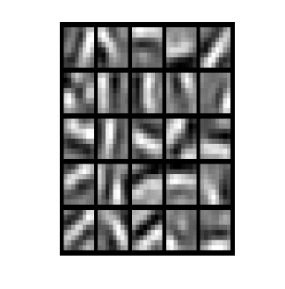
Beta = 6

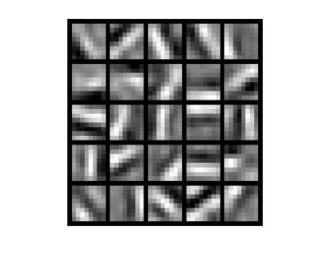
Beta = 12
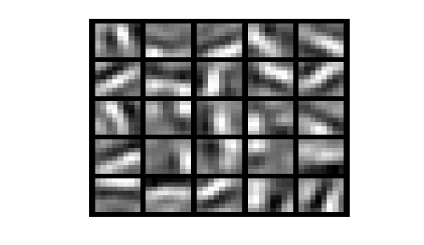

Beta = 96
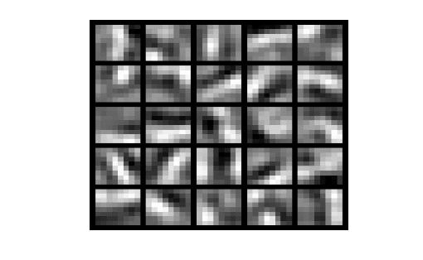

Hidden layer 64
visibleSize = 8*8; hiddenSize = 64; sparsityParam = 0.01; lambda = 0.0001;
beta = 12; Note: Left is with 1000, the right is with 10000.
