sparsityParam = 0.01; % desired average activation of the hidden units.
% (This was denoted by the Greek alphabet rho, which looks like a lower-case "p",
% in the lecture notes).
lambda = 0.0001; % weight decay parameter
beta = 10; % weight of sparsity penalty term

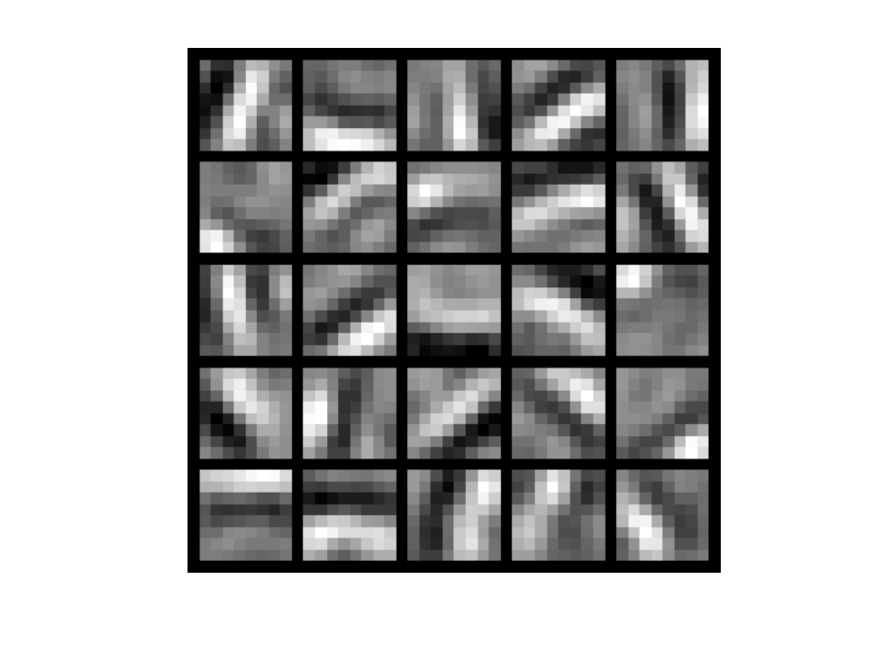

sparsityParam = 0.001; % desired average activation of the hidden units.
% (This was denoted by the Greek alphabet rho, which looks like a lower-case "p",
% in the lecture notes).
lambda = 0.0001; % weight decay parameter
beta = 10; % weight of sparsity penalty term

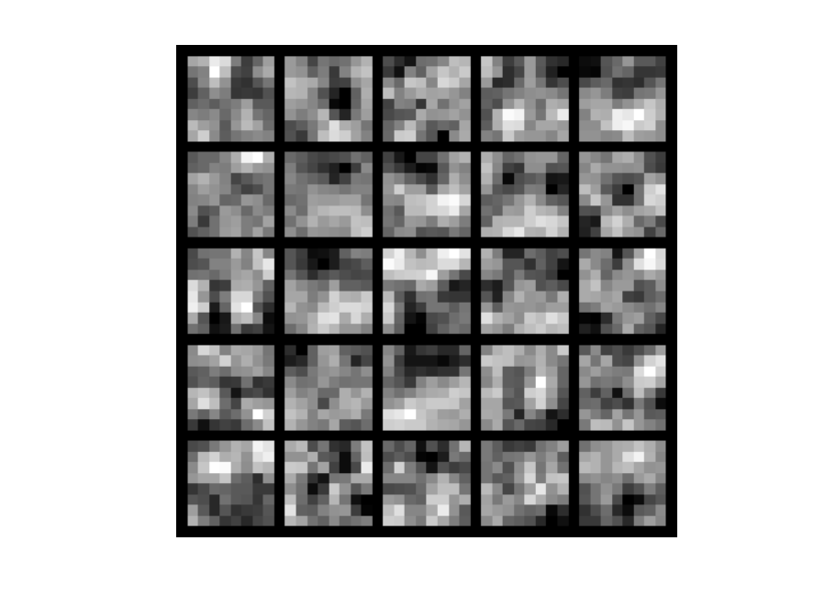
visibleSize = 8*8; % number of input units
hiddenSize = 25; % number of hidden units
sparsityParam = 0.1; % desired average activation of the hidden units.
% (This was denoted by the Greek alphabet rho, which looks like a lower-case "p",
% in the lecture notes).
lambda = 0.0001; % weight decay parameter
beta = 10; % weight of sparsity penalty term

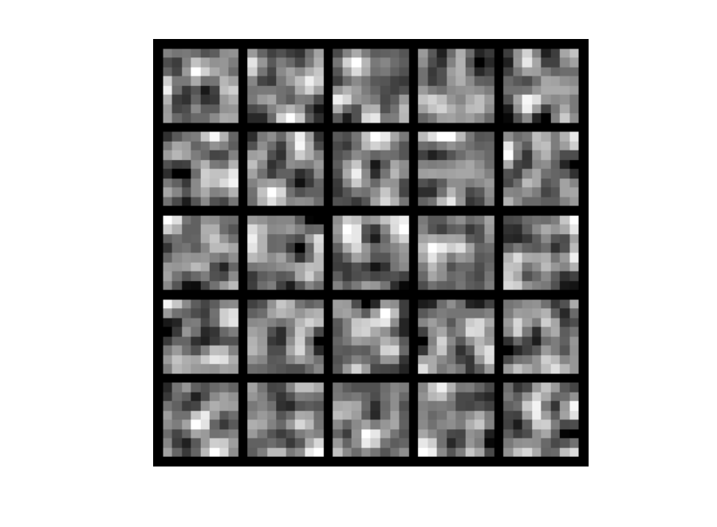
visibleSize = 8*8; % number of input units
hiddenSize = 25; % number of hidden units
sparsityParam = 0.01; % desired average activation of the hidden units.
% (This was denoted by the Greek alphabet rho, which looks like a lower-case "p",
% in the lecture notes).
lambda = 0.00001; % weight decay parameter
beta = 10; % weight of sparsity penalty term

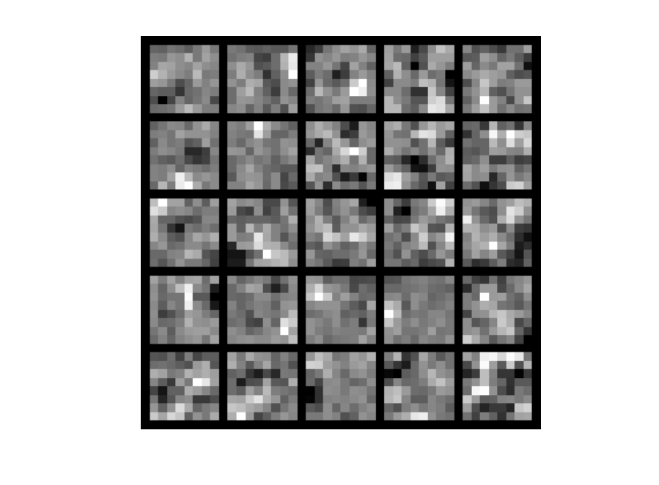

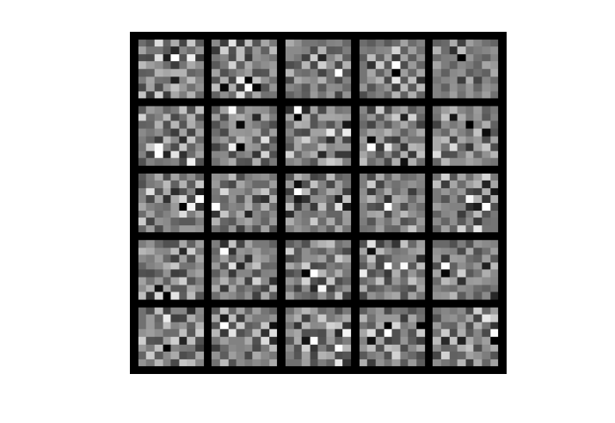
sparsityParam = 0.01; % desired average activation of the hidden units.
% (This was denoted by the Greek alphabet rho, which looks like a lower-case "p",
% in the lecture notes).
lambda = 0; % weight decay parameter
beta = 20; % weight of sparsity penalty term

sparsityParam = 0.01; % desired average activation of the hidden units.
% (This was denoted by the Greek alphabet rho, which looks like a lower-case "p",
% in the lecture notes).
lambda = 0.0001; % weight decay parameter
beta = 3;

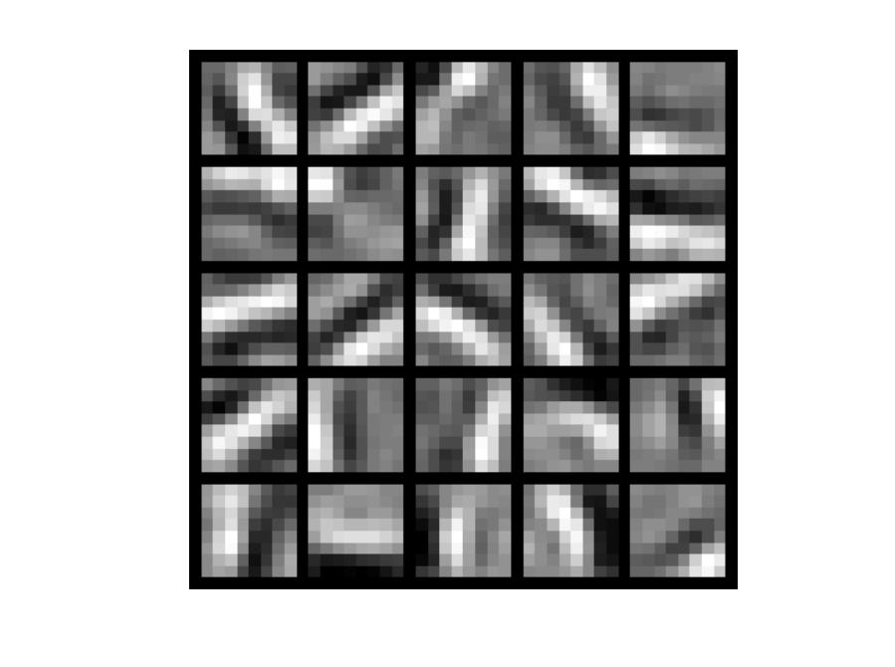

visibleSize = 8*8; % number of input units
hiddenSize = 25; % number of hidden units
sparsityParam = 0.01; % desired average activation of the hidden units.
% (This was denoted by the Greek alphabet rho, which looks like a lower-case "p",
% in the lecture notes).
lambda = 0.01; % weight decay parameter
beta = 3; % weight of sparsity penalty term
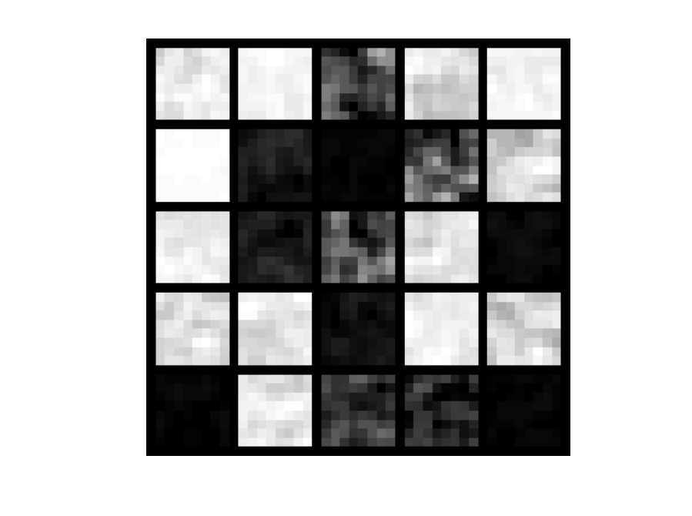
Converged too fast

visibleSize = 8*8; % number of input units
hiddenSize = 64; % number of hidden units
sparsityParam = 0.05; % desired average activation of the hidden units.
% (This was denoted by the Greek alphabet rho, which looks like a lower-case "p",
% in the lecture notes).
lambda = 0.0001; % weight decay parameter
beta = 12; % weight of sparsity penalty term

