Shan Sikdar

cs591 HW4 Writeup

Problem 1.

I creates a wave using code from hw3:

a = createWave(10, 1.0, 1.0, -1.57)

DFT Results: 1 , 0.0, 3.14

FFT Results: 1 , 0.0, 3.14

Also testing with x = [1,2,3,4,5,6,7,8] gave same results so it works for window sizes that are a power of 2.

Problem 2.
(sample output attached at the bottom)

The problem of the picket fence effect is we are unable to view the underlying continuous spectrum, since we are limited to integer multiples, but looking at padding results (I used both FFT and DFT out of curiosity) padding with zeros doesn't seem to help this problem. To make a window size of 16, padding with 7 zeros created the most error, while only padding with one zero seemed to have less error. But if only padding seven zeros produced a significant error with larger powers of two the error would become more and more significant. I initially used a = createWave(15, 1.0, 1.0, -1.57) to compare results. (sample results attached below) But now considering a wave sample from SteelString.wav. The error will turn out to be much worse since in this case the waves will be more complex: the phase can be anything, and the wave is a synthesis of many sine waves. The create wave test cases in effect show the smallest error you can really have from padding with zeros since its the simplest wave. Scaling the results or any other patch will not be very effective since a lot the error also relies on the angle component of the Fourier transform.

Problem3.
(sample output attached at the bottom)

Comparing the difference of DFT and DFT-Hann window version on a createWave(11, 1.0, 1.0, -1.57)
padded with zeros, I've observed that the amplitudes are greatly decreased and that there is a tapering effect. This will help the leakage problem because since the amplitudes are decreased the spray noise that goes throughout the rest of the spectrum will be diminished but the analysis still shows where peaks occur. I think by increasing the window size we can adjust the hann window to get the same effect as without the window. Non-integral frequencies will be greatly diminished by some factor and for all intents and purposes be turned into zero for the analysis.

Problem 4.

DFT without Hann: As I increased the window size the peak seemed to get lower and lower. Also peaks occur at different harmonic frequencies based on the window size. So for every window size we can find an a specific integral frequency such that we could create the fundamental frequency of the bell.
In other words for all N, there exists a K, such that N/K = fundamental/44100 where N is window size and F is a harmonic frequency.

With Hann Windows Some graphs.
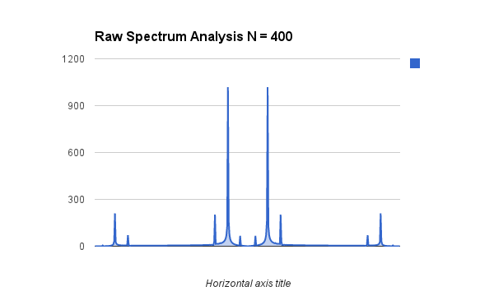
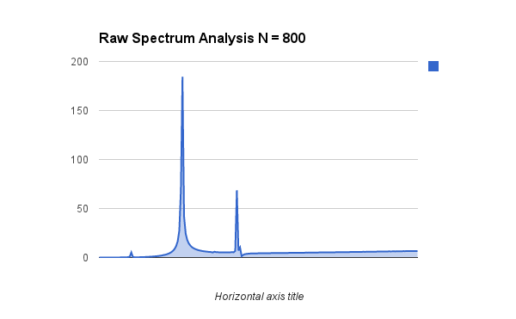

Problem 5: Used N = 800, found peaks using matlab, calculated ferquency using f*44100/N, created a timber file, created envelope file using code from last homework, and then used the additive synthesis code from last hw as well.

Here is a screenshot in audacity. Original bell file is on top and my recreation and on the bottom is my attempt.

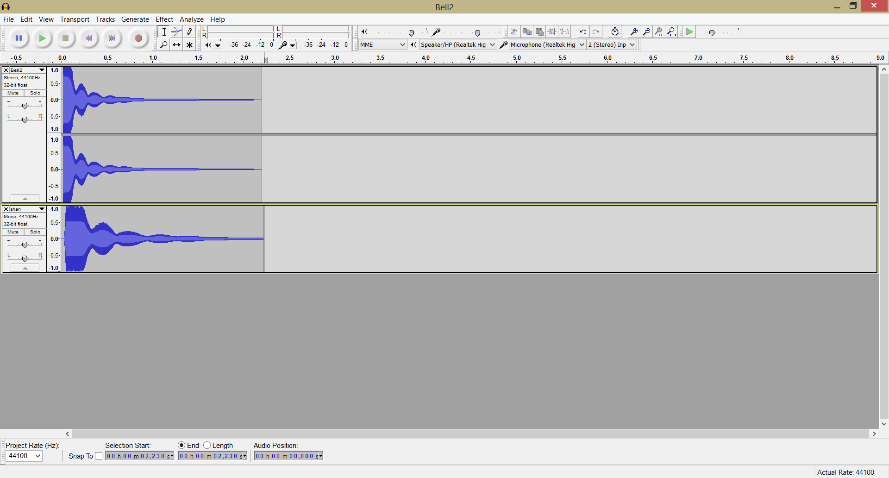

Problem 2, sample results.

FFT
PrintFullSpectrum results so only one half of the mirror image is outputed.

N = 9

0 , 0.0, 0.0
1 , 0.5, -0.2
2 , 0.52, -1.96
3 , 0.18, 2.55
4 , 0.08, -2.35
5 , 0.04, 2.16
6 , 0.06, -2.75
7 , 0.0, 1.77

N=12
0 , 0.0, 3.14
1 , 0.76, -0.78
2 , 0.4, -3.14
3 , 0.1, -2.35
4 , 0.0, -0.96
5 , 0.04, 2.36
6 , 0.04, -3.14
7 , 0.02, -2.36

N = 15
0 , 0.0, 0.0
1 , 0.96, -1.37
2 , 0.1, 1.96
3 , 0.06, 2.16
4 , 0.04, 2.36
5 , 0.04, 2.55
6 , 0.02, 2.75
7 , 0.02, 2.95

N = 16
0 , 0.0, 3.14
1 , 1.0, -1.57
2 , 0.0, -1.95
3 , 0.0, -1.67
4 , 0.0, -1.13
5 , 0.0, -1.25
6 , 0.0, -0.33
7 , 0.0, 0.0

Same thing except with DFT
N=9
0 , 0.0, 0.0
1 , 0.5, -0.2
2 , 0.52, -1.96
3 , 0.18, 2.55
4 , 0.08, -2.35
5 , 0.04, 2.16
6 , 0.06, -2.75
7 , 0.0, 1.77

N=12
0 , 0.0, 0.0
1 , 0.76, -0.78
2 , 0.4, -3.14
3 , 0.1, -2.35
4 , 0.0, -0.31
5 , 0.04, 2.36
6 , 0.04, -3.14
7 , 0.02, -2.36

N=15
0 , 0.0, 0.0
1 , 0.96, -1.37
2 , 0.1, 1.96
3 , 0.06, 2.16
4 , 0.04, 2.36
5 , 0.04, 2.55
6 , 0.02, 2.75
7 , 0.02, 2.95

N=16
0 , 0.0, 3.14
1 , 1.0, -1.57
2 , 0.0, -2.27
3 , 0.0, -1.29
4 , 0.0, -0.12
5 , 0.0, 1.24
6 , 0.0, 1.22
7 , 0.0, -2.44

Problem 3 sample output
0, 0.0, 3.14
1, 0.34, -0.59
2, 0.23, -2.75
3, 0.01, -1.77
4, 0.03, 2.36
5, 0.03, -2.94
6, 0.01, -1.96
7, 0.01, 2.16
8, 0.02, -3.14
9, 0.01, -2.16
10, 0.01, 1.96
11, 0.03, 2.94
12, 0.03, -2.36
13, 0.01, 1.77
14, 0.23, 2.75
15, 0.34, 0.59

0, 0.0, 0.0
1, 0.01, -0.59
2, 0.03, -2.75
3, 0.0, -1.77
4, 0.01, 2.36
5, 0.02, -2.94
6, 0.01, -1.96
7, 0.01, 2.16
8, 0.02, -3.14
9, 0.01, -2.16
10, 0.01, 1.96
11, 0.02, 2.94
12, 0.01, -2.36
13, 0.0, 1.77
14, 0.03, 2.75
15, 0.01, 0.59

