Reminder: Download the Kaggle Data

Just a quick reminder if you haven't done this yet. Login to Kaggle and go to:

<https://www.kaggle.com/c/house-prices-advanced-regression-techniques/data>

Download the train.csv and test.csv and put them in the regression\_model/regression\_model/datasets directory

<https://github.com/trainindata/deploying-machine-learning-models/tree/master/packages/regression_model/regression_model/datasets>

He meant put the model in:

D:\Formation\Data\_Science\Deployment\_of\_machine\_learning\_models\deploying-machine-learning-models\packages\regression\_model\regression\_model\datasets

And He performed the following manip in the 6.2 video

Find registry

Follow the path below

Computer\HKEY\_LOCAL\_MACHINE\SYSTEM\CurrentControlSet\Control\FileSystem

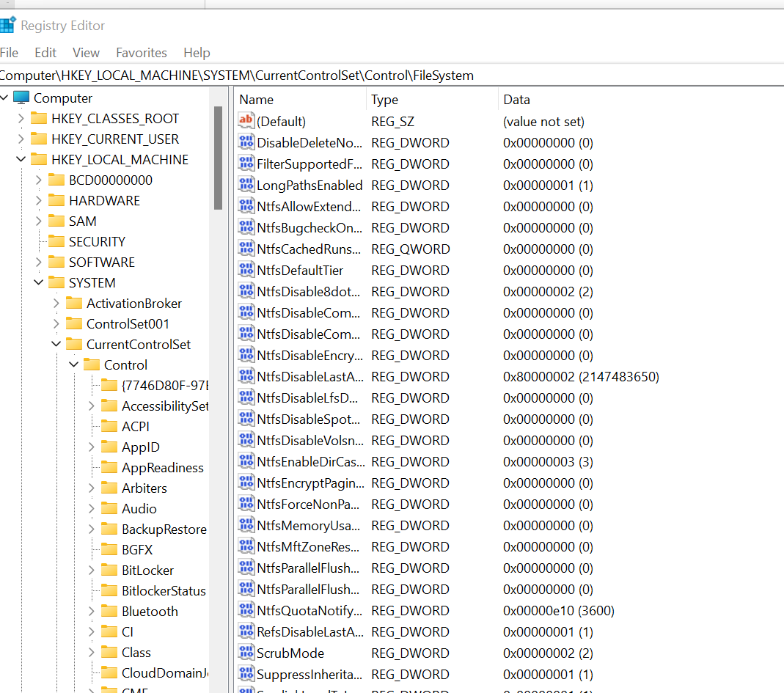

And put longPathsEnabled to 1

You're ready to go! Hum not quite

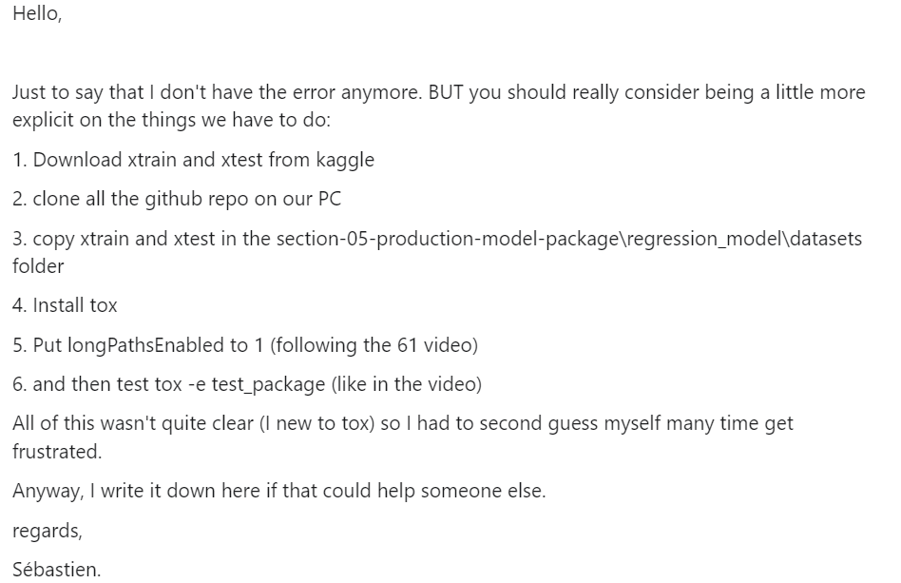

Section Notes & Further Reading

#### Further Reading Materials

Python Conventions

- [PEP8](https://www.python.org/dev/peps/pep-0008/)

- [PEP 484 - typehints](https://www.python.org/dev/peps/pep-0484/)

- [Using requirements files](https://realpython.com/lessons/using-requirement-files/)

- [Tox Overview](https://christophergs.com/python/2020/04/12/python-tox-why-use-it-and-tutorial/" \t "_blank)

- [Building Python Packages](https://packaging.python.org/tutorials/packaging-projects/)

- [Why not use Python for config](https://hitchdev.com/strictyaml/why-not/turing-complete-code/)

- [Primer on pyproject.toml](https://snarky.ca/what-the-heck-is-pyproject-toml/)

Section Gotchas

- Make sure you download the Kaggle files

- For Windows users the [MAX\_PATH limitation](https://docs.python.org/3/using/windows.html#removing-the-max-path-limitation)