ABSTRACT

Insurance is the equitable transfer of the risk of a loss, from one entity to another in exchange of payment. It is a form of risk management primarily used to hedge against the risk of a contingent, uncertain loss. Personal accident insurance policy offers compensation in case of death, partial of total disability or mutilation resulting from an accident.

The insurer is a company selling the insurance, the insured or policy holder is the person buying the policy. The amount of money to be charged for a certain amount of insurance coverage is called the premium risk management.

Personal Accident Insurance is a cover meant for compensation in case of an accident causing injury/ death to person/ persons by violent external means. ). The purpose of personal accident insurance is to pay fixed compensation for death or disablement resulting from accidental bodily injury. Insurers pay compensation for death, permanent total disablement, permanent partial disablement (like loss of finger, etc.) and temporary total disablement (like fractures). A personal accident policy gives financial relief to insured people if they sustain any injury/ death due to accidents.

CONTENTS:

1. Introduction……………………………………………………… 3
2. Business Objective………………………………………………. 3
3. Flow Diagram……………………………………………………. 4
4. Functional Requirements………………………………………… 5
   1. Underwriting Process………………………………………… 5
   2. Renewal Process……………………………………………… 5
   3. Claim Process………………………………………………… 6
   4. Settlement Process……………………………………………. 6
5. Implementation…………………………………………………… 7
6. Conclusion……………………………………………………… 8

INTRODUCTION

Personal Accident Insurance is a cover meant for compensation in case of an accident causing injury/ death to person/ persons by violent external means. Insurers pay compensation for death, permanent total disablement, permanent partial disablement (like loss of finger, etc.) and temporary total disablement (like fractures). The purpose of personal accident insurance is to pay fixed compensation for death or disablement resulting from accidental bodily injury. A personal accident policy gives financial relief to insured people if they sustain any injury/ death due to accidents.

The personal accident insurance policy is issued to cover the risk of accidents by external means resulting in the death or bodily injury. The bodily injury may result in to the permanent total disability or partial disability or temporary total disability. This policy can be issued to an individual or in group. The premium rates depend upon the person engaged in activities to earn his livelihood. The sum insured will depend upon the income of the person.

The personal accident insurance policy provides that, if at any time during the currency of this policy, the insured (person who has taken the policy) shall sustain any bodily injury resulting solely and directly accident caused by external violent and visible means, then the insurance company shall pay to the insured or his legal personal representative(s), as the case may be, the sum or sums set, forth, in the policy, if resulting in specified contingencies such as death, permanent disablement etc.

BUSINESS OBJECTIVE:

The main objective is to develop a computerized application to manage the overall activities involved in the Personal Accident Insurance Process. It mainly focuses on the generation of premium amount and how claims and renewals are granted based on certain conditions.

Tools-

1. Cobol
2. Jcl
3. Vsam

FLOW DIAGRAM

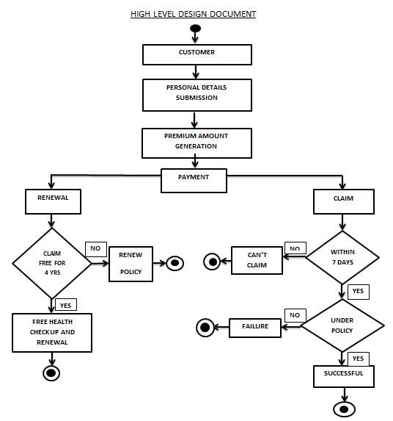

This activity diagram we shows how customer actually applies for insurance. First and foremost requirement is personal details such as name, age, contact details, health details etc of the person who wants to have a insurance are collected. Based on these details the premium amount is calculated for that particular person. Once the premium amount is generated there are different processes he/she needs to go through. The customer makes a payment of premium amount.

After certain duration, policy renewal is required which will allow the customer to extend the insurance. Renewal also includes free health checkup and cumulative bonus in case the person doesn’t claim for 4 years continuously.

There are certain insurance policies decided by the insurance company. Those insurance policy decide what amount of acclamation needs to be fulfilled. A person can only claim if the notice is provided within 7 days of the injury/accident. Now the expenses are checked against the insurance policy and the claim amount is calculated for that person.

FUNCTIONAL REQUIREMENTS:

1. UNDERWRITING PROCESS-

It is the very first process of this project. In this step the insured person details and the policy details are accepted and premium amount is generated.

Details of the proposers are entered after which the insured’s personal details and sum insured are entered. The physical status such as existing disabilities is collected at the time of registration process. According to the given information the premium amount is calculated and discounts are also offered on the premium amount based on certain criteria such as family discount, special discount etc.

1. RENEWAL PROCESS-

This module consists the renewal of the plan before expiration of the insurance plan. That is, you need to renew the policy plan before the expiration as to avail the facility.

* Within one month of the expiry of the policy, the policy can be renewed by the proposer.
* During renewal the number of persons covered under the policy can be increased or decreased and the existing insured’s personal details and sum insured is subject to change.
* The age of the insured should be automatically incremented during the renewal of the policy.
* Claim free renewals for 4 continuous years is subject to a free health checkup. A claim free renewal will also lead to the benefits of cumulative bonus.

1. CLAIM PROCESS-

In this file the insured person , who wants to claim the amount , will request for the same by giving the information mentioned in the requirements above for accessing the claim , failing in which , the claim won’t be granted. The claim can be generated only when the details are validated and a preliminary notice is provided. The company should receive the intimation within 7 days from the date of hospitalization. Only those expenses that are covered under the policy are considered and the claim amount is payable.

1. SETTLEMENT PROCESS:

This process takes care of premium payment. When the proposer pays premium amount, the amount is verified after which details like the mode of payment, cheque /DD No, cheque or DD Date and bank name and address are collected from the proposer.

IMPLEMENTATION

1. Premium amount generation:

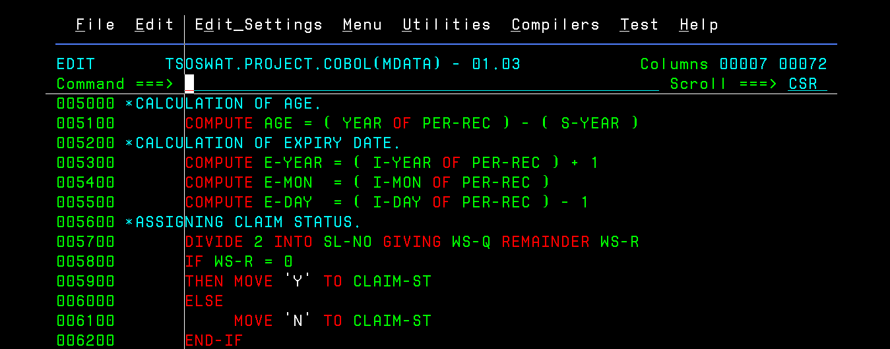

Calculation of premium amount.

Execution Jcl:Masterf.

Output:

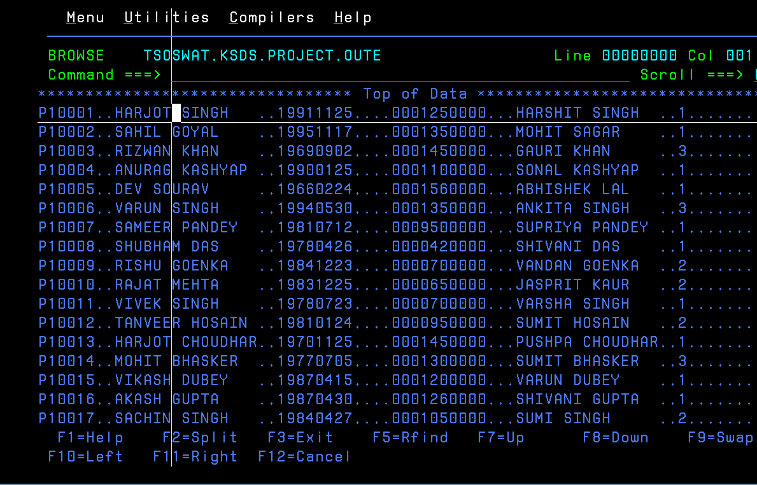

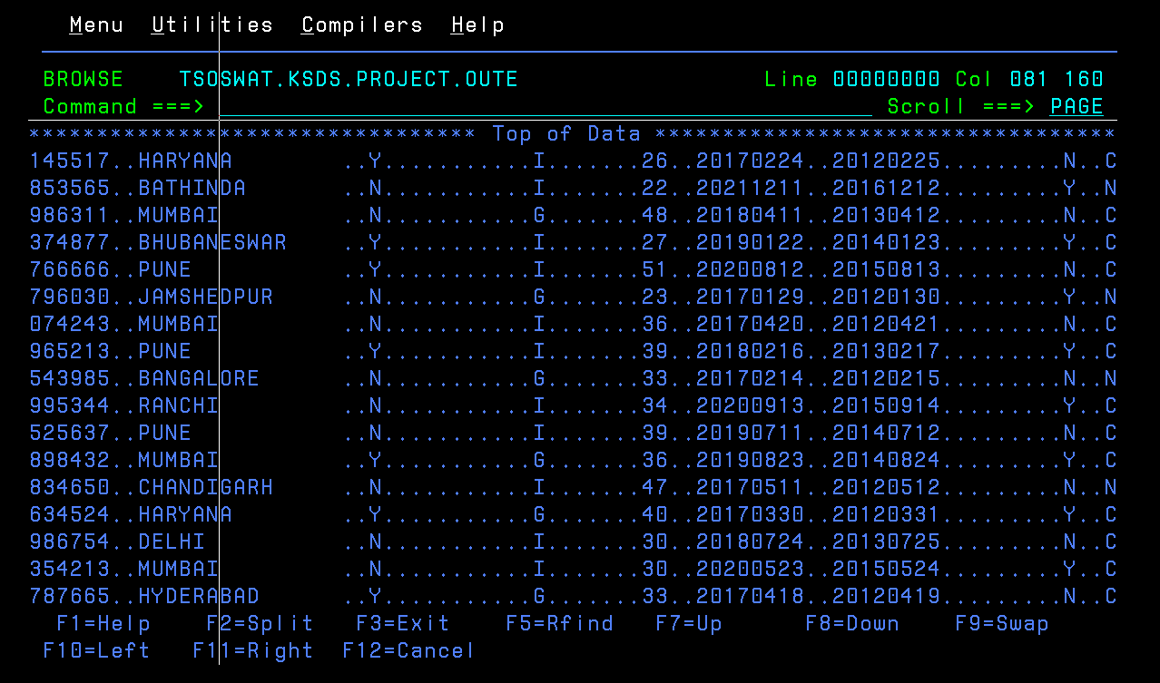

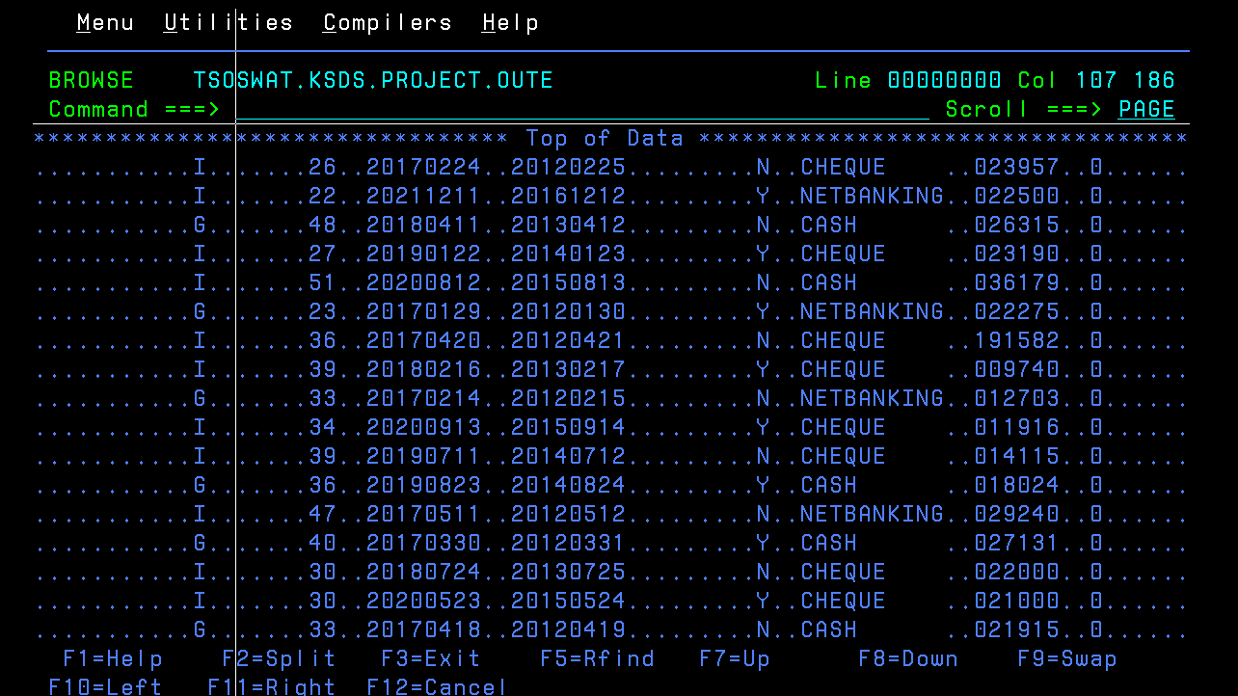

1. RENEWAL PROCESS:

renewcal

Output:

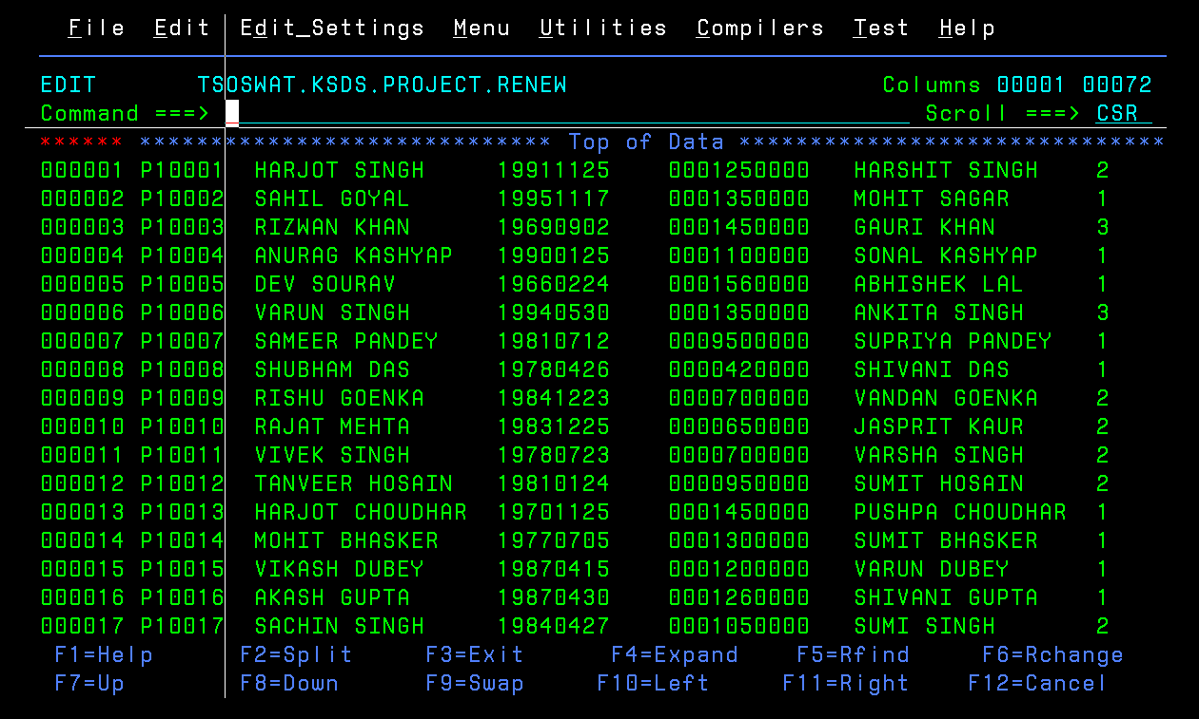

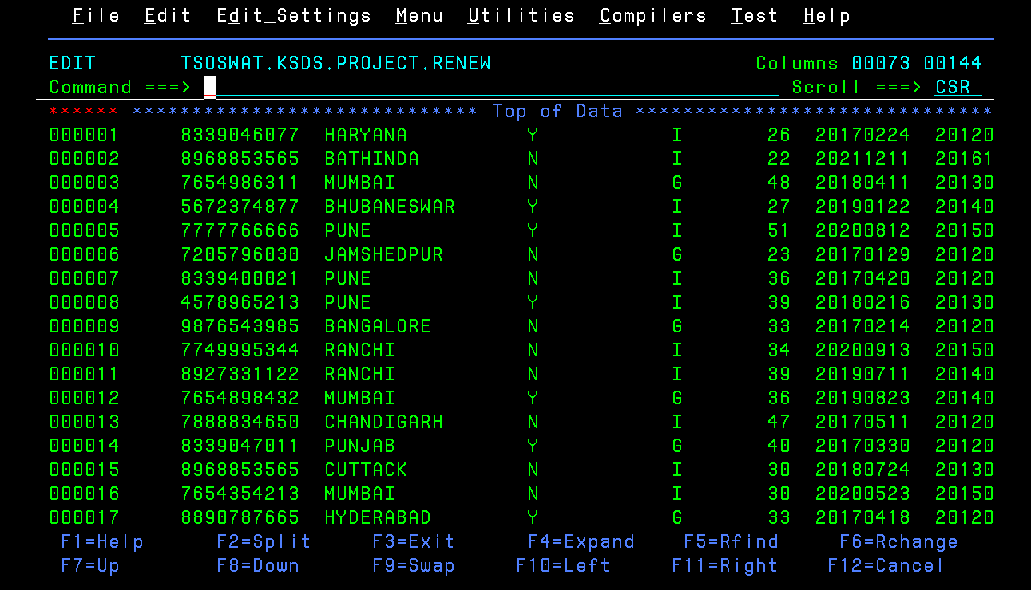

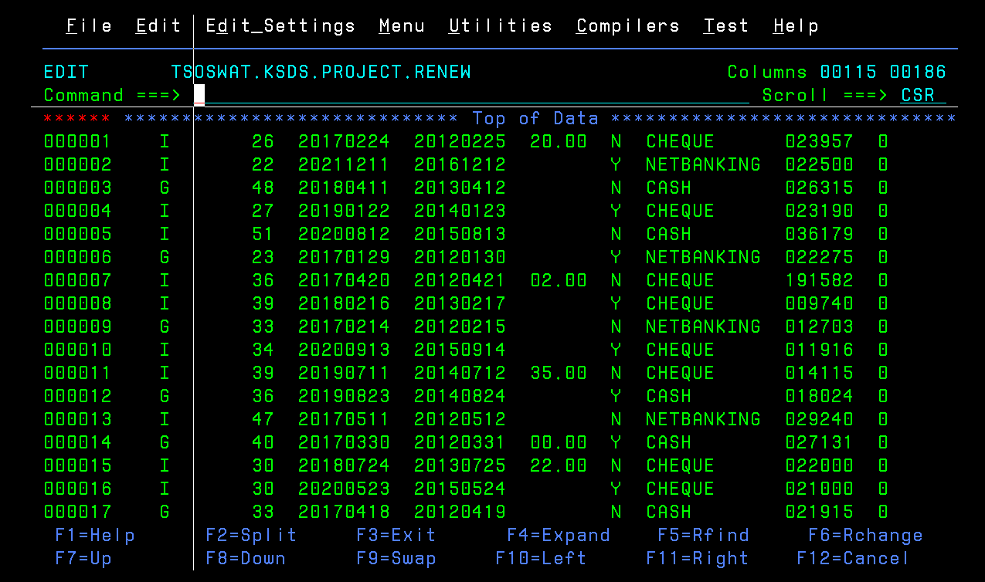

1. CLAIM AMOUNT GENERATION:

Output:

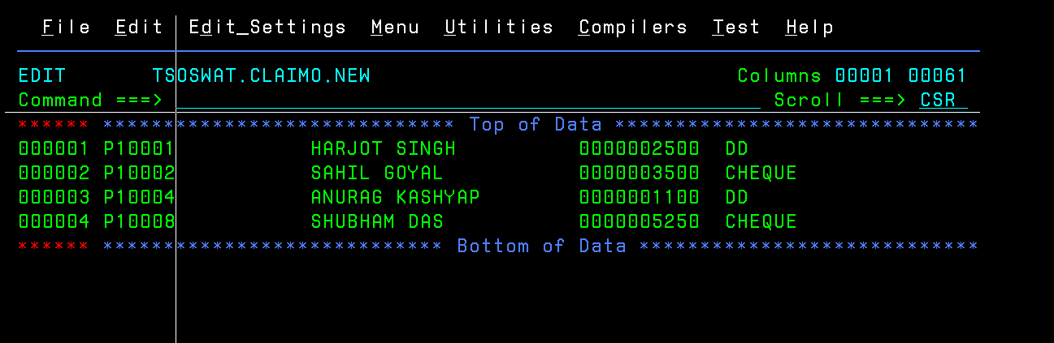

Conclusion: