TEAM PROJECT REPORT
FinSight: An Evidence-Grounded Multimodal
Fish-Health Triage Agent
A structured agent workflow for safer and explainable Nile tilapia health assessment
Team 5 - Fullstack Tribe | 2026 SZU-ISC Summer Camp | August 2026

Abstract
FinSight is a multimodal fish-health triage agent for Nile tilapia in freshwater aquaculture. Unlike a general-purpose chatbot that responds directly to a free-text description, FinSight enforces a structured evidence workflow. It combines fish images, visible and behavioral signs, water-quality measurements, recent husbandry history, and answers to adaptive follow-up questions. Qwen extracts visible-only image observations; a curated retrieval-augmented generation (RAG) layer supplies traceable fish-health evidence; and deterministic agent modules rank several plausible causes while exposing supporting evidence, conflicts, missing information, uncertainty, confirmation requirements, safe actions, and escalation triggers. The integrated prototype covers five deliberately overlapping conditions and connects the complete frontend-backend-AI-RAG-report path through one shared CaseRecord. Verification completed with 53 backend tests passed, 56 RAG/agent tests passed with one skipped, and a successful frontend production build. The result is not an automated veterinary diagnosis. It is a safer, repeatable, and explainable decision-support workflow that helps users collect better evidence and seek appropriate confirmation.

1 Problem and Objective
Fish-health complaints are usually incomplete. A farmer may report lethargy or a skin lesion but omit dissolved oxygen, ammonia, mortality progression, recent fish introduction, handling, or equipment failure. A conversational model can still produce a fluent answer, yet fluency does not guarantee that critical evidence was collected or that uncertainty was handled consistently. This is especially risky because infectious disease and environmental stress frequently share signs such as gasping, reduced appetite, abnormal swimming, eye changes, and skin damage [1-4].
Our objective was therefore not to build another fish-themed chat interface. We designed FinSight as a fixed, inspectable triage process that refuses to treat an image as proof, actively requests missing evidence, retrieves information from a curated source set, and compares multiple explanations before presenting a report. The system is intentionally scoped to Nile tilapia and five conditions: streptococcosis, motile Aeromonas septicemia, columnaris disease, Tilapia Lake Virus disease (TiLV), and water-quality stress/hypoxia.
Core contribution. FinSight converts an open-ended health concern into a controlled evidence workflow: collect multimodal observations, detect missing critical information, retrieve trusted evidence, compare plausible causes, and return an uncertainty-aware report rather than an unsupported diagnosis.

2 System Design and Agent Workflow
The architecture is built around a single validated CaseRecord rather than loosely connected prompts. The frontend converts every intake field into the backend schema; the backend stores the shared case state; the vision module adds visible findings to the same object; and the RAG/agent module reads that enriched record. This contract prevents symptoms, water readings, and recent husbandry history from being lost between modules and makes the final report traceable to the data that produced it.
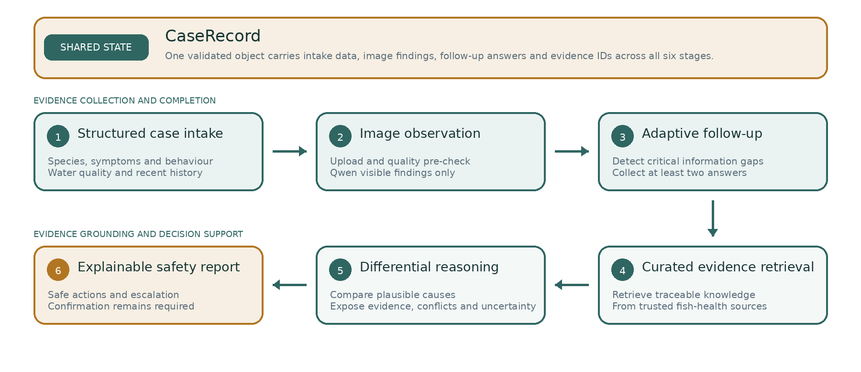
Figure 1. FinSight architecture and controlled evidence flow.

2.1 Controlled sequence
The workflow proceeds through six visible user stages: case intake, image observation, follow-up questions, evidence retrieval, differential analysis, and final report. Behind the interface, the backend performs twelve integrated steps: it creates the CaseRecord, invokes Qwen on the uploaded image, stores the findings, detects missing fields, generates at least two case-specific questions, records the answers, retrieves knowledge chunks, ranks plausible causes, assesses uncertainty, constructs safe actions and escalation guidance, and returns a structured report to the frontend.

2.2 Safety and grounding by design
Qwen's image prompt explicitly prohibits disease names, pathogen claims, and treatment recommendations. Invalid or low-quality images are rejected or downgraded; structured JSON output is validated; leaked diagnostic language is filtered; and API failures fall back without blocking the case. The reasoning layer can return an insufficient-evidence state instead of forcing a ranking. Every candidate remains unconfirmed until appropriate laboratory or professional examination, and the report avoids drug selection or dosing advice.

3 Implementation and Integration
Layer | Implemented responsibility
Frontend | Next.js interface for image upload, structured intake, follow-up questions, analysis progress, and an explainable report.
Backend | FastAPI endpoints and Pydantic validation create and maintain the shared CaseRecord across the complete workflow.
Vision | Qwen3-VL-8B performs image quality checks and returns visible observations only; diagnostic terms are filtered.
RAG & agent | ChromaDB and local sentence embeddings retrieve curated evidence; deterministic modules detect gaps, rank causes, assess uncertainty, and build safe actions.
Report | The UI separates observed, user-reported, retrieved, missing, and inferred information and exposes evidence IDs, alternatives, uncertainty, confirmation, and escalation.
Table 1. Implemented system layers and responsibilities.

3.1 Multimodal data handover
The frontend captures species, life stage, symptom duration, mortality trend, visible symptoms, behavioral signs, six water-quality fields, recent events, notes, and an optional fish image. Blank measurements remain null rather than being treated as normal. The mapping from recentHistory was updated during integration so each selected husbandry event is stored as a semantic history field, such as history.recent_introduction, history.stocking_density_change, history.transport_handling, or history.filtration_failure. This lets the RAG and differential modules read exact signals instead of a single rolled-up recent_events string. Image findings are stored in CaseRecord.images[].visible_findings, while follow-up answers are now written back into the structured fields the agent actually reads, such as water_quality.ammonia_mg_l, water_quality.dissolved_oxygen_mg_l, and relevant history entries. This shared-state design is the key handover between the interface, vision model, agent, and report.

3.2 Evidence base and target conditions
The knowledge base uses JSON/JSONL records with stable condition, chunk, source, and evidence identifiers. It includes clinical signs, risk factors, water-quality associations, confirmation methods, conflicting evidence, safe actions, and escalation triggers. Sources prioritize FAO, WOAH, university veterinary extension material, and peer-reviewed literature [1-5]. Images are used for observation, not disease confirmation.
Verified project asset | Current integrated result
Target scope | Nile tilapia; 5 conditions
Curated sources | 13 official or peer-reviewed source records
Knowledge base | 29 traceable evidence chunks
Evaluation data | 8 synthetic cases; 4 representative disease images
Verification | 53 backend tests passed; 56 agent/RAG tests passed, 1 skipped; frontend production build passed
Table 2. Verified assets and integrated validation results.

3.3 Explainability beyond a chat response
The report distinguishes observation from inference and keeps the ranked differential separate from confirmation. Users can inspect the top cause and alternatives, supporting and conflicting evidence IDs, uncertainty, missing information, recommended confirmation, immediate safeguards, and expert-escalation conditions. An agent trace records workflow events such as image analysis, missing-information detection, retrieval volume, candidate comparison, and report generation; it is an audit log, not hidden chain-of-thought reasoning.

4 User Experience and Explainable Output
The interface makes the agent workflow visible rather than hiding it behind a chat box. Users first provide structured multimodal evidence, then respond to targeted questions that explain why each missing value matters. The final view presents an explicit decision-support warning and compares possible causes side by side. This design reduces the chance that a plausible sentence will be mistaken for a confirmed diagnosis.
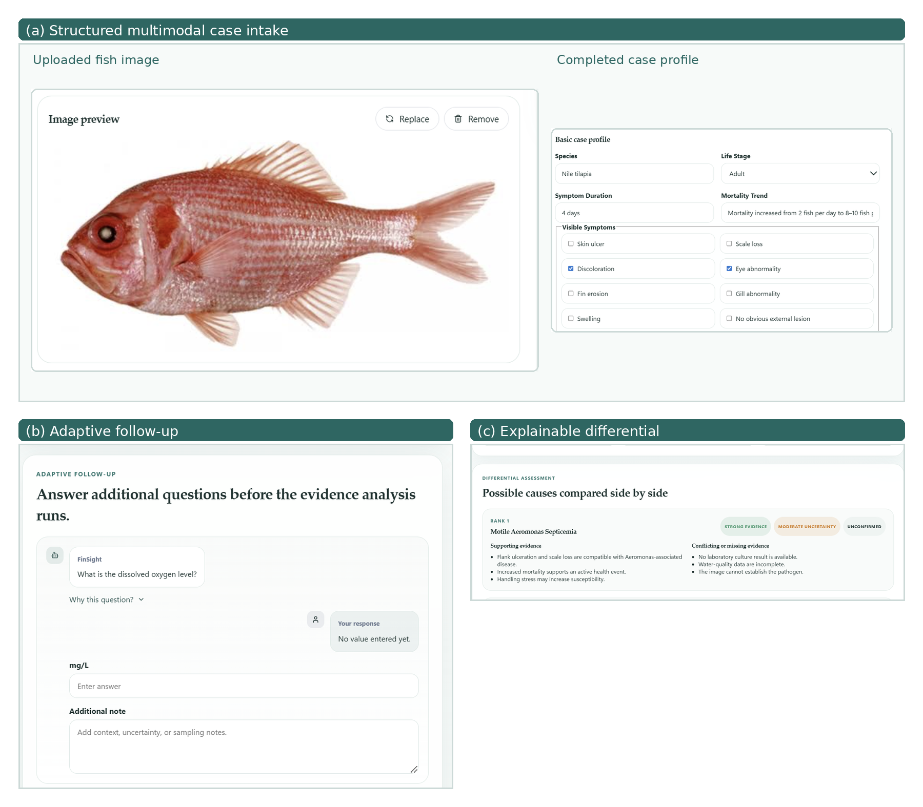
Figure 2. FinSight user workflow: (a) structured multimodal case intake, (b) adaptive questions for missing evidence, and (c) evidence-grounded differential comparison.

5 Evaluation and Results

5.1 Evaluation strategy
Evaluation was designed around the quality of the complete decision process, not diagnosis accuracy alone. The eight synthetic cases cover a clear infectious pattern, missing water data, image-supported columnaris signs, TiLV suspicion following fish movement, acute low-oxygen stress, an insufficient-information case, concurrent disease signs plus hypoxia, and overlapping streptococcosis/Aeromonas/TiLV signs. Each case specifies expected follow-up topics, relevant evidence, acceptable alternatives, safe actions, confirmation requirements, and claims the system must not make.
This approach tests whether the agent asks useful questions, retrieves relevant chunks, grounds major claims, preserves alternatives, recognizes contradictions, states uncertainty, recommends confirmation, avoids unsafe treatment claims, and provides actionable escalation. It is more demanding than checking whether one disease name matches an answer key because it evaluates the path by which the system reaches and communicates a triage result.

5.2 Verification results
Verification target | Result | What the check covers
Backend API and workflow | 53 passed | Case creation/update, upload, follow-up, report, error handling, and integration behavior
RAG and agent reasoning | 56 passed; 1 skipped | Retrieval, missing information, follow-up logic, ranking, uncertainty, safety, Qwen adapters, and trace
Frontend | Build passed | Production compilation and API-integrated intake-to-report flow
Table 3. Integrated software verification results.

5.3 Demonstrated outcomes
- End-to-end integration: frontend data, image observations, follow-up state, evidence retrieval, ranked causes, and report output pass through a single CaseRecord contract.
- Evidence-first reasoning: image observations are separated from disease inference, and retrieved claims remain linked to stable evidence and source identifiers.
- Graceful uncertainty: incomplete cases can trigger targeted questions or an insufficient-evidence result instead of a confident guess.
- Operational resilience: image pre-checks, bounded retries, structured-output validation, caching, and deterministic fallbacks keep the demonstration usable when external AI behavior, API keys, campus network access, or local RAG dependencies are unavailable. The RAG ingestion path also forces eager CPU loading for the local sentence-transformer embedding model to avoid intermittent ChromaDB setup failures during local runs.
- Safety-oriented reporting: the output includes confirmation steps, safe immediate actions, and escalation conditions while explicitly stating that it is decision support.

5.4 Interpretation
The verified result is a complete camp-scale prototype with strong software and workflow evidence. The test counts demonstrate implementation reliability across components; they should not be interpreted as clinical sensitivity or specificity. Similarly, the synthetic case suite demonstrates controlled behavior across difficult scenarios but does not replace expert-labeled field validation. This distinction allows the project to present a substantial technical achievement without overstating medical performance.

6 Discussion, Limitations, and Conclusion

6.1 Why FinSight is more than a chatbot wrapper
FinSight's value lies in orchestration. A generic model can answer immediately from an incomplete description; FinSight instead requires a consistent evidence lifecycle. Structured intake reduces ambiguity, the missing-information module turns absence into an explicit next action, RAG constrains the factual basis to a curated collection, deterministic ranking and uncertainty modules make behavior repeatable, and the report exposes the basis and limits of the result. The contribution is therefore the combination of structured workflow, trusted evidence support, and an explainable report.

6.2 Current limitations and responsible scope
The prototype intentionally focuses on Nile tilapia and five conditions, so it should not be generalized to all species or diseases. The current evidence collection, four representative disease images, and eight synthetic cases are sufficient for a focused demonstration but not for clinical deployment. Field validation requires substantially more expert-reviewed images and cases, laboratory-confirmed ground truth, external-site testing, calibration of retrieval and ranking, persistent and secure case storage, and evaluation across languages and farming environments. Professional veterinary or aquatic-animal-health judgment remains essential.

6.3 Conclusion
The team delivered a working evidence-grounded fish-health triage system that unifies a polished interface, FastAPI integration, a shared structured case contract, Qwen multimodal observation, curated RAG, adaptive follow-up, differential comparison, uncertainty assessment, safety checks, and an explainable report. The system does not claim to replace laboratory diagnosis. Its achievement is more practical: it turns incomplete observations into a disciplined, traceable, and safer decision-support process. Within the time and scope of the summer camp, FinSight demonstrates how multimodal AI agents can be engineered for reliability and accountability rather than fluency alone.

References
[1] FAO. Cultured Aquatic Species Information Programme: Oreochromis niloticus. Source
[2] World Organisation for Animal Health (WOAH). Infection with Tilapia Lake Virus (TiLV): Technical Disease Card, 2022. Source
[3] FAO. Water Quality for Aquaculture and Impact of Aquaculture to Environments. Source
[4] University of Florida IFAS Extension. Streptococcal Infections of Fish. Source
[5] WorldFish. From the basics to emerging diagnostic technologies: What is on the horizon for tilapia disease diagnostics? 2023. Source

