Arbitrary Waveform Generator (Flutter) — Detailed Code Documentation

This document explains the structure and behavior of the AWG Flutter app, organized page-by-page by
.dart file. Where helpful, 1–2 line code excerpts illustrate key ideas.
Author: Serene Singh
Format: File-by-file reference

TABLE OF CONTEXT
Arbitrary Waveform Generator (Flutter) — Detailed Code Documentation 1
TABLE OF CONTEXT 1
Project Overview 2
lib/main.dart 3
lib/core/app_theme.dart 3
lib/core/widgets/slider_with_input.dart 3
lib/features/awg/models/waveform_type.dart 3
lib/features/awg/models/waveform_params.dart 3
lib/features/awg/services/waveform_generator.dart 4
lib/features/awg/services/drawable_estimator.dart 4
lib/features/awg/controllers/playback_controller.dart 4
lib/features/awg/painters/waveform_painter.dart 4
lib/features/awg/painters/drawable_painter.dart 4
lib/features/awg/ui/widgets/app_tab_scaffold.dart 5
lib/features/awg/ui/widgets/control_panel.dart 5
lib/features/awg/ui/screens/awg_screen.dart 5
lib/features/awg/ui/screens/drawable_screen.dart 5
Data Flow & Responsibilities 6
Extending the App Safely 7
Final Notes 7

Project Overview
The app provides two primary experiences: (1) an AWG preview where users configure frequency, amplitude, offset, and waveform type. This display works more as a function generator than and AWG; (2) a drawable canvas where users sketch a waveform that’s heuristically analyzed for amplitude, frequency, and type. The codebase is split into small, single-responsibility files across core, features, and UI layers.
- Core: Theme and common widgets.
- Features_AWG: Models, services (generation/estimation), controller (ticker/phase), painters for drawing, and UI screens/widgets.
- Composition: A tabbed scaffold lets users switch between AWG and Drawable views.
- UI: Screens and widgets that organize the primary experiences

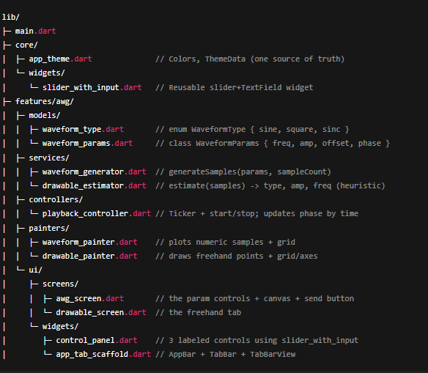

lib/main.dart
Bootstraps the Flutter app with a dark theme and a tabbed home screen. Device Preview is enabled for development (this is the app simulation on run).
runApp(DevicePreview(enabled: true, builder: (context) => const MyApp()));
- Creates a MaterialApp using a shared dark theme from core/app_theme.dart.
- Sets home to AppTabScaffold, which hosts the AWG and Drawable tabs.

lib/core/app_theme.dart
Centralizes theming. Keeping a single source of truth for colors allows quick visual changes across the app.
static ThemeData get dark => ThemeData(brightness: Brightness.dark, primarySwatch: Colors.cyan, ...);
- Dark palette improves contrast for waveform visualization.

lib/core/widgets/slider_with_input.dart
Reusable control that pairs a Slider with a numeric TextField. It keeps screens lean and standardizes input handling.
controller.text = val.toStringAsFixed(2); onChanged(val);
- Clamps and applies numeric input; emits changes via onChanged.
- Accepts min/max/divisions to support different parameter ranges.

lib/features/awg/models/waveform_type.dart
Enumeration of supported waveform shapes.
- `sine`, `square`, `sinc`, `triangle` — extendable without touching UI logic except dropdown items.

lib/features/awg/models/waveform_params.dart
An immutable data object for waveform generation parameters. Makes function signatures explicit and testable.
const WaveformParams({required frequency, required amplitude, required offset, required phase, required type});
- Holds frequency, amplitude, offset, phase (for animation), and type.
- copyWith(...) allows easy state updates without mutable coupling.

lib/features/awg/services/waveform_generator.dart
Pure function that transforms WaveformParams into uniform samples. Being pure makes it trivial to test and reuse.
values[i] = p.amplitude * sin(p.frequency * t + p.phase) + p.offset;
- Sine: standard sinusoid with amplitude, offset, and phase shift.
- Square: sign(sin(...)) scaled to amplitude and offset.
- Sinc: sin(x)/x centered at π; unnormalized except for zero guard.
- Triangle: (2/π) * asin(sin(x)); this is a compact, clean triangle formula.
Tip: If sending to hardware, scale/quantize these samples to DAC resolution and obey Vpp/offset limit

lib/features/awg/services/drawable_estimator.dart
Analyzes freehand samples to estimate amplitude, a zero-crossing-based frequency heuristic, and whether the shape is square-like or sine-like.
final freq = zeroCrossings / 2; final type = ratio > 0.85 ? WaveformType.square : WaveformType.sine;
- Smoothing: lightweight moving average to reduce jitter.
- Amplitude: (max - min) / 2 over smoothed samples.
- Frequency heuristic: counts zero crossings; unitless without a real timebase.
- Type decision: checks how often samples stay near two plateaus.
Because the drawable canvas has no real time axis, the frequency value is comparative, not Hz.

lib/features/awg/controllers/playback_controller.dart
Owns a Ticker and advances phase while running; notifies listeners to repaint the waveform preview.
_ticker = vsync.createTicker((elapsed) { if (_isRunning) { _phase += 0.05; notifyListeners(); } });
- start()/stop(): flips isRunning and starts/stops the ticker.
- phase is read by the screen to shift the waveform visually.
- Currently uses a fixed step per tick; you can tie it to elapsed time for true time-based motion.

lib/features/awg/painters/waveform_painter.dart
Renders a grid with numeric labels and a polyline through precomputed samples in the range −100..100.
path.lineTo(x, midY - samples[i] * scaleY);
- Horizontal labels: −100 to 100 (visual units).
- Vertical labels: 0.0 to 1.0 scaled across width for quick reading.
- Purely visual; does not impose units like volts/seconds.

lib/features/awg/painters/drawable_painter.dart
Draws a draggable freehand path with grid and axes. Uses a sentinel Offset.infinite to break strokes between drags.
if (p == Offset.infinite) { started = false; continue; }
- Grid labels visualize a −100..100 vertical range.
- Axes at center improve symmetry and orientation while drawing

lib/features/awg/ui/widgets/app_tab_scaffold.dart
Hosts the two primary tabs: AWG and Drawable. The TabController lives here to keep tab state local and simple.
- AppBar title and TabBar are defined once.
- TabBarView holds `AWGScreen` and `DrawableScreen`.

lib/features/awg/ui/widgets/control_panel.dart
A simple container that composes three SliderWithInput controls for frequency, amplitude, and offset. Keeps screens decluttered.
- No business logic; forwards callbacks for state updates.
- Reusable if a second channel needs its own control set in the future.

lib/features/awg/ui/screens/awg_screen.dart
The primary configuration screen. Manages parameter state, renders the waveform preview, and exposes control buttons.
- State: frequency, amplitude, offset, waveform type, and selected channel.
- Ticker via PlaybackController animates phase for a moving preview.
- generateSamples(...) produces ~400 points for smooth drawing.
- Two dropdowns: waveform type (sine/square/sinc/triangle) and channel (1/2).
- Start/Stop toggles the ticker; Send button is a UX stub for hardware.
Hook the Send action to a transport (e.g., BLE/UART/Wi■Fi) to forward samples or param changes to your AWG hardware.

lib/features/awg/ui/screens/drawable_screen.dart
Captures user strokes, converts them into normalized samples (−100..100), and feeds them to the estimator for live readouts.
final samples = points.map((p) => ((h/2 - p.dy) / (h/2)) * 100).toList();
- Gestures: onPanUpdate appends points; onPanEnd appends Offset.infinite to segment paths.
- Estimator returns (type, amplitude, frequency heuristic) shown in an overlay card.
- Clear resets the points and estimation state.

Data Flow & Responsibilities
- UI (screens/widgets) — owns ephemeral state and user interactions.
- Controllers — manage animation timing and notify listeners.
- Services — pure computations for generation and analysis.
- Painters — render visuals from already-prepared data.
- Models — simple structs/enums to pass strongly-typed data around.
This separation helps you test math without rendering and swap UI without changing algorithms.

Extending the App Safely
- Add new waveforms by extending WaveformType and adding one branch in waveform_generator.dart.
- Introduce true time-based animation by computing phase delta from elapsed microseconds.
- Scale samples to match DAC resolution (e.g., 12-bit) and clamp to hardware limits (±5 V, 100 kHz).
- Implement channel-specific routing in your transport layer (e.g., include `channel` in the message).
- If needed, add a second ControlPanel bound to Channel 2 parameters.

Final Notes
This document is designed as a quick orientation and deep reference. You should be able to understand and safely modify the code without reading every source file end-to-end. For unit tests, target services (generation, estimation) first; they’re pure and deterministic.

