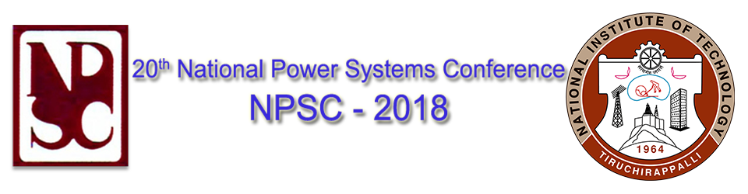

Tutorial – 3

Theme: HVDC & FACTS

**FACTS Devices and Applications**

By

Dr. Aniruddha M. Gole, HVDC Manitoba

Dr. Om Nayak, Nayak Corporation

**Abstract**

The tutorial will present the fundamentals of reactive power compensation and show how such compensation can be provided by power-electronic apparatus such as Static Var Compensators (SVC) and static synchronous compensators (STATCOMS). Systems incorporating such devices are referred to as flexible ac transmission systems or (FACTS). The use of FACTS apparatus for a range of purposes ranging from fundamental frequency reactive power injection for voltage support, active harmonic filtering, load balancing and flicker mitigation in arc furnaces will be presented. Demonstrations using EMT simulation with PSCAD will be presented, and the participants will be given the opportunity to simulate and investigate simple SVC and STATCOM circuits used for voltage support. The use of a real-time simulator for testing actual controllers FACTS apparatus will be demonstrated via Real-time Hardware in the Loop (HIL) simulation using a real-time digital model running on NovaCor of a STATCOM converter and its network interfaced to an actual controller implemented on a Texas Instrument C2000 Microcontroller.

**Biography**

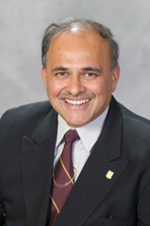**Prof. Aniruddha M. Gole** is Distinguished Professor and NSERC Industrial Chair in Power Systems Simulation at the Department of Electrical and Computer Engineering, at the University of Manitoba. He has over 30 years of experience in the development of modelling tools for power networks incorporating power-electronic equipment such as HVDC and FACTS converters. He is one of the original developers of the widely used PSCAD/ EMTDC simulation program. Dr. Gole has also made important contributions to the development of the real-time digital simulator RTDS from RTDS Technologies of Winnipeg, Canada.

Dr. Gole is a Registered Professional Engineer in the Province of Manitoba, Canada. He is a Fellow of the Canadian Academy of Engineering and a Fellow of the IEEE. For his contributions to the modelling of Flexible Ac Transmission System (FACTS) devices, he received the IEEE Nari Hingorani FACTS medal in 2007. Currently Dr. Gole serves on the Long-Range Planning Committee of the IEEE Power and Energy Society.

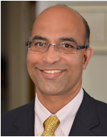

**Dr. Om Nayak** is the Managing Director of Nayak Power Systems. He has extensive hands-on experience with RTDS and PSCAD simulators as a developer, user and promoter in India and USA.  Dr. Nayak obtained his bachelor’s degree in Electrical Engineering from Mysore University and M.Sc. and Ph.D. degrees from University of Manitoba, Canada, specializing in power systems. His previous industry experience includes his work at Bosch in Bangalore, Siemens in Chennai and Manitoba HVDC Research Centre in Winnipeg, Canada. He is a Senior Member of the IEEE and supporter of IEEE Scholarship Plus initiative.