**PROFILE** 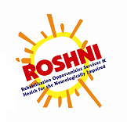

**ROSHNI (Ramakrishna Ashrama, Gwalior)**

**ROSHNI-R**ehabilitation **O**pportunities **S**ervices **& H**ealthfor the **N**eurologically **I**mpaired

**Vision -** Create an environment in which persons with disabilities and their families are supported and fully accepted with equal rights into society.

**Mission-** Support persons with Neurological developmental disabilities and their families through services and trainings. We provide an enabling environment to help Persons with Disabilities become empowered and live meaningful lives.

ROSHNI is a project of the Ramakrishna Ashrama Gwalior, based in northern Madhya Pradesh. Since its inception, ROSHNI has made every effort to reach out to the local community and the surrounding districts at every possible level and has been providing a wide range of services for all age groups.

As of 31st March 2015, 2134 persons have been registered with ROSHNI for various services. We provide **Home Management [OPD] Services**, and a **Special School,** together with a focus on **Early Intervention** and **Vocational Training** as well **Training** forparents andprofessionals. Our current activities include – assessment/treatment procedures; individual/group special education; therapy/ vocational training; **Medical & Awareness activities, Self Advocacy and** **Training**.

**ROSHNI** is the **Information/ Facilitation Centre for the National Trust for the Welfare of Persons with Autism, Cerebral Palsy, Mental Retardation & Multiple Disabilities,** providing training & mentoring for Local & outstation NGOs in the neighbouring districts in Northern Madhya Pradesh. and providing schemes that are beneficial for persons with developmental disabilities .

* The **Early Intervention** (Infants 0-6 years) is an important project which urgently needs to be developed further. A Survey was conducted in 2000- 2004.Subsequently an **Early Intervention Unit**- was initiated in 2003. Awareness with medical professionals in conjunction with **Gwalior Academy of Paediatricians** has resulted in early referrals from the surrounding urban and rural areas. There are 17 children currently attending the Early Intervention Unit for Cerebral Palsy and other multiple developmental disabilities.

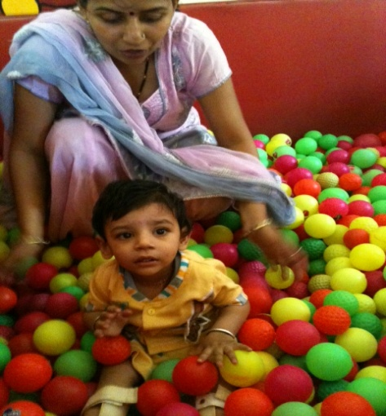

**Early Intervention- Developmental Disorders**

* **ROSHNI** had a Pilot Project in the Neo natal ICU at a private Hospital from December 2004-2007, but despite these efforts, some children reach **ROSHNI** at a later age and miss the formative years.
* The **Swami Vivekananda Autism ComDEALL Early Intervention Unit for Children with Autism Spectrum and Communication Disorders** (Age 2-6 years), was started in 2012, with the aim of preparing the young children for mainstream Schools. There are currently 12 children in the Unit. A Total of 25 children have been registered, since the ComDEALL Unit commenced.In the above unit we start intensive therapeutic and educational services, at an early age, to enable them to gain education in mainstream schools. The **ROSHNI Parents’ Support Group,** meets every month and Parents and Community workers are trained, to empower them to take care of their children’s special needs, No other Centre in the Gwalior and Chambal region has a programme focusing on Early Intervention with under 6 year olds, no other organisation is offering such comprehensive services ,including dedicated Early Intervention services.

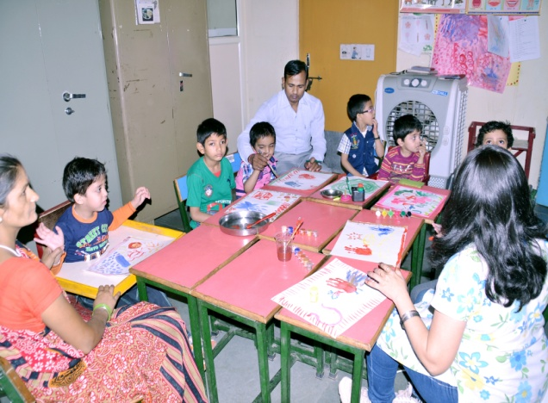

**Swami Vivekananda ComDEALL Early Intervention of Autism & Communication Disorders**

* We are thus keen to Fund Raise for this Project to offer continued effective services for all categories of developmental disabilities.

Apart from providing direct rehabilitation services to persons with disability, ROSHNI launched its **Teachers’ Training Programme in 2003**, aimed at promoting **Inclusive Education** in mainstream schools. This was supported by the Volkart Foundation till 2007. The objective is to facilitate **Inclusive Education** for the children with disabilities and to identify and support children with Specific Learning Disabilities in mainstream schools, who are increasingly accessing ROSHNI services. We also have **The Rehabilitation Council Of India** recognition to conduct courses at ROSHNI, Ramakrishna Ashrama .

The **Vocational Training Unit** has a growing number of young adults attending the programme and income generation is a target area. We would like to reach out to many more beneficiaries in the rural areas and satellite towns

The work on Phase II of the **ROSHNI Swarna Jayanti Building** commenced in March 2013 and the civil work is complete and the **Vocational** and **Training Units** will run in more spacious conditions; on the completion of the same. **ROSHNI** is the only NGO in the district which aims to meet the needs of people with neurological impairments, from birth, with a Life Span approach.

ROSHNI has played a pioneering and path-breaking role in securing the rights of people with autism and demystifying the condition through ceaseless advocacy and various awareness drives. The focus has been to move away from seeing ‘disability’ as one homogeneous entity, to the understanding that the needs of individuals with autism are unique, and hence policies and services must be geared to cater to these specific needs.

In a largely voiceless sector, wherein the condition itself precludes the existence of a large number of self-advocates, ROSHNI has been the voice of those with autism. We continue to lobby to secure the rights of the autism community, in any situation where persons with autism may be differentiated against purely because of their autism. Whether it is a child with autism being denied the right to board an aircraft or being asked to leave a mainstream school, ROSHNI has brought parents, media and the general population together against such discrimination.

**Advocacy at ROSHNI has taken many forms over the years:**

* Over the years, ROSHNI has organized a multitude of enjoyable **events** like charity dinners, concerts, autism walks all of which incorporate a ‘fun element’ whilst raising awareness about and advocating for the rights of people with autism.

* In a country where appropriate **legislation and services** for people with disabilities are few and far between, the advocacy drives led by ROSHNI has helped establish some effective policies and legislation, catering to the specific needs of individuals with autism in India.

* Where possible ROSHNI strongly supports individuals with Autism to be **self-advocates**.

* The mandate of ROSHNI is to create an inclusive environment where people with autism can live and work as fully participating members of their community. ROSHNI continues, successfully to place many children with autism in mainstream schools, and provides the necessary support to remain in that **inclusive education** setting.

* Apart from routinely making information available to promote awareness and providing training to parents and professionals, ROSHNI has conducted **professional awareness** projects to facilitate early and accurate diagnosis, provide relevant information about autism and on how to provide further assistance to parents of children with Autism.

* ROSHNI continues to actively raise awareness through the **media** among the general public: through print and electronic, social networking etc. Team members from ROSHNI are often approached by print and electronic media to share information about autism.

* Another form of advocacy that ROSHNI undertakes to strengthen and empower the autism community is through interactions and **partnerships** with other non-governmental organisations and persons interested in autism, both within India and abroad. These relationships help in the sharing of experiences and ensuring that support is provided to as many families as possible.

* Within India, ROSHNI participates in activities of organizations dealing with the mentally and physically challenged to help foster relationships with regional groups.

# SELF ADVOCACY PROGRAMME

At ROSHNI, we realize that our mission ‘To facilitate a barrier free environment - informational, attitudinal and physical – to create opportunities for education, employment and socialization for persons with Autistic Spectrum Disorder (ASD)’ has its roots in creating awareness about autism and bringing autism out of the ‘closet’. Our awareness raising activities are therefore focused on reaching out to people from all walks of lives.

We organize a multitude of enjoyable events all of which incorporate a ‘fun element’ whilst raising awareness about autism such as celebrating World Autism Awareness Day (WAAD) on 2 April, autism awareness walks, music concerts, dance performances, charity dinners, art shows and carnivals.

.'

### **Music Concerts & Dance Performances**

The awareness concerts organized by ROSHNI are always crowd pullers, and our crowd includes both young and old! In addition to being an excellent platform to spread awareness amongst people across all ages and vocations, the concerts also act as fundraisers for the programmes and services of ROSHNI

### **World Autism Awareness Day (WAAD)**

The United Nations on 19 November 2007 by unanimous consent declared 2nd April as World Autism Awareness Day (WAAD) starting in 2008. This, needless to say, was a historical marker for the autism community throughout the world, a large section of whom remain invisible and outside the ambit of basic services suited to their needs.

The autism community across the world is now celebrating WAAD. Through April events are organized by people with autism, their parents, other care givers and autism groups in honour of this day. From Colombia to Cameroon, Malaysia to Malta, walks, seminars, discussions, plays, performances, radio programs, presentations, art carnivals, meetings with heads of state and local dignitaries are organised. All activities aim to bring autism into our social consciousness.

# INCLUSIVE EDUCATION

The mandate of ROSHNI is to create an inclusive environment where people with autism can live, and work as fully participating members of their community. To us, inclusion means giving people the opportunity to join in with what they want to, having the choice to live where they feel comfortable, and not only doing what someone else thinks they ought to. It includes efforts to facilitate a barrier free environment - informational, attitudinal and physical – to create opportunities for all people.

For children, the term inclusion is often used in reference to educational settings, which is one form of inclusion.

*Inclusive education requires teamwork and is a responsibility that needs to be shared by the whole school.

*Effective inclusion does not simply mean placing a child with a disability in a ‘regular’ school. It also refers to providing more options for all children, and structuring schools in a way which every child including those who are differently abled can learn. All children may experience difficulties in learning at some stage. Therefore support by teachers in whichever environment/ skill set they may be facing problems is crucial.

*Inclusive education is a process involving the genuine restructuring of curriculum, teaching methods, and classroom organization that requires constant effort. When the teacher differentiates instruction according to content, process or product, it increases the likelihood that all students can meaningfully participate in class activities.

*Activity based learning is well suited to inclusion of learners with a wide variety of educational needs and learning styles.

*Teaching materials may also be adapted to match the student’s characteristics and interests.

*As the teacher plans her lessons and implements instructions for the students, it is important to think about each student’s ability and uniqueness and build on those.

*It is essential to support learning by providing multiple, flexible methods for both the teacher’s presentation of the lesson, as well as opportunities for the students to display what they know or have learnt.

* Equally important is empowering students by allowing for multiple, flexible methods for engagement, helping them to make certain decisions, and set goals on their own.

* Teachers in inclusive schools can use cooperative groups and peer supports to capitalise on student differences. Establishing a sense of community is essential for creating a successful classroom where all students want to contribute, are respected and cared about. The classroom is where students can learn to value differences, appreciate commonalities, and better understand concepts such as fairness, cooperation, equity and justice.

* It is necessary that the teacher learns students’ communication strengths and preferences, and provides individualised sensory supports to maximise learning.

* Schools often place greater emphasis on academic achievements and may overlook social skills training. If the child’s time is spent in one to one sessions with a resource teacher, then the peer interaction is limited only to playgrounds. These may be difficult for a child with autism as these interactions are free ranging and fast paced. Peer interactions on task-based situations are easier. Therefore opportunities must be set for appropriate and meaningful positive interactions.

* By supporting meaningful learning outcomes for all students, teachers can endorse the idea that a disability need not be a ‘handicap’ to learning, ability and friendship.

ROSHNI and Inclusive Education

School is not just a place for learning academics. It is in the classroom where we learn many life skills. We learn social skills – we learn to compromise, to bargain and persuade. We learn communication – we learn to get attention, ask for help, compliment and describe. We learn language skills which are much more demanding than questions and answers of any tests. Preparation for adult life is the main objective of schooling. Therefore it is desirable that all children go to inclusive schools. This is also in harmony with the UN Convention for Rights of Persons with Disabilities.

Since children with autism have distinct learning and thinking styles when compared to the non-autistic population, there is often a misinterpretation of their behaviours and language. Therefore as a prerequisite to inclusion it is essential that all teachers learn more about autism.

ROSHNI has successfully placed many children with autism in mainstream schools and continually works with these schools to facilitate and sustain their inclusion. Through various training workshops, along with individualized training modules, ROSHNI also empowers mainstream schoolteachers with a better understanding of children with autism, and strategies to achieve their successful inclusion. In addition, the ROSHNI team also works with schools and government organisations to cater to their specific needs related to including children with autism in the mainstream classroom.

While we support inclusion, we also believe that inclusion should not replace sensitive, specialised training, particularly for children with more support needs and those with severe social impairments. High quality, specialised special education can have an enormous impact on the future functioning of children with autism. The ultimate goal is not just inclusion in school for the sake of inclusion. The term inclusion with respect to the differently abled has a far wider connotation and needs to encompass the life span of the individual, of which the school environment is one component.

Perhaps one model for how this can be achieved is through early specialised education where skills for later integration in the mainstream are taught. Inclusion in the truest sense means respecting individual differences, not ignoring them. It also involves respecting the need for an individual to learn and function to best of his capacity, in the environment that suits his individual learning needs the best, while making the necessary accommodations to facilitate the same.

# PROFESSIONAL AWARENESS

ROSHNI has long recognised that increasing awareness about autism amongst professionals (paediatricians, psychiatrists, psychologists, educators, and others) is key to ensuring that all children with autism receive an early and accurate diagnosis. In India, as in many other countries, paediatricians are often the first point of contact for families with a child with autism.

**First Awareness Project among Paediatricians**

From 1998 to 2001 Action For Autism received a grant from the Rajiv Gandhi Foundation to conduct an awareness project among paediatricians across the country with the following three objectives:

1. To systematically raise the awareness and basic understanding of autism among paediatricians, and thereby facilitate an increase in the number of early and accurate diagnoses of the condition. It was also appreciated that raising awareness about autism would in turn raise awareness of the conditions most often mistaken for autism: mental retardation, hyperkinesias, attention deficit disorder, and would also increase the accurate diagnoses of these conditions.
2. To systematically reach parents in all localities of India who had children newly diagnosed as autistic, provide relevant information about the condition, and provide information on how to receive further assistance. The same information would also be provided to parents of children who had already received a diagnosis of autism earlier and were now consulting as ‘follow ups’.
3. To gauge the number of children newly diagnosed with autism in India during the upcoming year/s, in order to estimate the incidence of the condition in India

A baseline level of awareness was ascertained through a survey asking paediatricians to indicate from a list, the criteria they viewed as relevant in making a diagnosis and other questions related to the diagnostic process. Over 600 paediatricians responded to the survey. Participants were then provided information on autism, diagnostic procedures and tools (the DSM-IV criteria and the Checklist of Autism for Toddlers), and information that they could share with parents of newly diagnosed children.

A second round of surveys was conducted to determine whether any changes in beliefs could be documented. Participants were subsequently sent an additional resource that they could share with parents and other professionals which focused on understanding and interventions for autism.

**Second Awareness Project among Paediatricians**

The results of these two surveys were compiled and submitted in a report to the Rajiv Gandhi Foundation. Based on the positive response that AFA received to this project, we undertook a second awareness project among paediatricians starting in 2007 with support from Action Aid and Irish Aid. All paediatricians registered with the Indian Academy of Paediatrics were invited to participate through an introductory letter and a copy of the awareness survey. Every paediatrician who responded to this letter was then sent information on autism. Specifically, doctors received a poster in Hindi and English that could be placed in their office, depicting some ‘early signs’ of autism. In addition, paediatricians received a copy of Autistic Spectrum Disorder: A Guide for Paediatricians in India. This booklet is a compilation of questions that are frequently asked during the period leading up to and just after a diagnosis of autism.

The information gathered through the project is currently under analysis. We are studying the awareness of autism, including diagnostic beliefs, diagnostic practices, and comparing the experience of diagnosis in 1998 and 2008 among other things. The data collected from this project was presented at the International Meeting for Autism Research in May 2010. The next phase of the project includes an adaptation of these materials and distribution of the same to professionals in other fields, as well as continued contact with paediatricians in India.

**Roshni Ramakrishna Ashrama -Achievements- Highlights( 17years )**

* Awareness Raising– Govt., Medical, Social & Educational Organizations**.**
* Parents Partnership and Training by Home management, OPD and Special School in 1998-1999.
* Roshni started his sub-centre at Indira Gandhi Working Women’s Hostel in association of Social Health in India ASHI, Kampoo in 1999.
* Community Based Rehabilitation and Survey with CareNidhi, Delhi and FPAI (2000- 2004).
* ROSHNI conducts Nat Trust Caregiver Training for 6 months in 2003 in which we trained 17 caregivers.
* Two Parents Support Groups: one for Parents of Children with Autism and the other one for Parents of Children with Cerebral Palacy in 2003.
* ROSHNI **National Trust Information Centre** was inaugurated by Rev Swami Atmasthanandaji Maharaj, currently President Ramakrishna Math & Mission in March 2004.
* Attended the **Anjali Children’s Festival** in Bhubaneswar, organised by Swabhiman,1st time in November 2004 and annually since then.
* Ma Sharda Mother’s Group formed in 2004; runs Ramakrishna Vidya Mandir School Canteen together with Roshni students.
* Advocacy for Rights of PWD, Barrier-Free Environment- A Rally on this was conducted with NGOs & District Collectors’ Support on 3rd December 2004,for Ramps at Gwalior Railway Station which proved successful as it was implemented in 2006.
* Early Intervention Pilot Project at Neo natal ICU in Kilkari Hospital from 2004 to 2007.
* Foundation Stone for ROSHNI’s new Model Building with ACCESS FOR ALL, by Shri Babulal Gaur, former **Chief Minister MP** in November 2005. Advocacy for Barrier Free Environment in public places at Gwalior has been on, since 2005.
* Inclusive Education & Training - Mainstream Teachers & Rehab Professionals, Community workers & Parents- supported by Volkart Foundation, Mumbai from 2005 till 2010.
* ROSHNI Conducts State Level Special Olympics 2005 & 2006 at Lakshmibai National University of Physical Education, Gwalior.
* ROSHNI became a **National Trust State Nodal Agency Partner** (SNAP) MP in 2007 and hosted the Annual SNAP Meeting in September 2008- visited by Smt. P Natarajan, Chairperson National Trust to Roshni, Ramakrishna Ashrama, Gwalior.
* **Ramakrishna Ashrama celebrates Golden Jubilee & ROSHNI Swarna Jayanti Building** Inaugurated by Hon Governor MP & Former C J India Oct 2008.
* Conducted an Awareness Rally **Badhte Kadam** with **National Trust** in November 2009 with the support of 13 local NGOs & Schools to welcome the Team from Delhi.The Rally continues in 2010 starting from Morena and going through the interior rural districts of Sheopur, Magroni, Distt Shivpuri, Guna, Ashok Nagar to finish at Bhopal.
* Media Workshop for Electronic and the Print Media of Gwalior, at ROSHNI Ramakrishna Ashrama, on 13th May 2009 for creating awareness on the National Trust and its schemes.
* 6 months training of Kashida Embroidery & Jewellery Making by the **MP Hastha Shilp & Hathkargha Vikas Nigam, Bhopal** from September 2009 till March 2010. Inclusive Group of 10 disabled & 10 non-disabled for Artisan cards and Health Insurance Cards. Advance course was held from March 2011 till September 2011.Newspaper bag order for Mrignayanee Emporia since 2012.
* A 3 day **Organisational Development & Strategic Planning workshop** conducted by Mike Rosenkrantz volunteer /consultant NT for 43 members from 28 NGOs, in May 2010 at Gwalior.
* The **Rehabilitation Council of India** approved Bhoj Open University Foundation Course for teachers which was conducted from June to December-2011, with 4 batches of government school teachers from Sheopur, Guna , Ashoknagar, Datia & from NGOs.
* The director is the NGO member of the **National Trust Local level Committee** **Gwalior**, of which the **District Collector** is chairperson and every 3rd member is a person with disabilites. The Gwalior Local Level Committee was awarded the **National Trust Best LLC Award** for 2012.
* **Swami Vivekanand ComDEALL Autism Spectrum Disorder (ASD) Early Intervention unit** was formally inaugurated in April 2012 by **Shrimant Yashodhara Raje Scindia(**Member of Parliament,Gwalior).The unit is conducted by a trained Team, comprising Developmental Therapist, Occupational Therapist, Speech and Language Therapist, and Special Educator.
* Training o**n Autism Spectrum Disorders** & ADHD for Medical Professionals on 23rd April 2013; by ***Dr Deepak Gupta, consultant*** *at* ***Sir Ganga Ram Hospital, Delhi*** funded by **The National Trust, Delhi & Gwalior Academy of Paediatricians.** Our association with the IAP continues till date.
* The **150th Birth anniversary “Vivekananda Jayanti” and National Youth Day** is celebrated at the Ramakrishna Ashrama, with various competitions and activities every year.The Inter School Competitions for all the schools were held from 8th to 16th January 2015 and **Ms Devika Malik,** **Para athelete** was the chief Guest for the **Inclusive Sports Day** held on 16th January, at Sarada Balgram.
* **Training –**Training for Professionals& Mainstream teachers at Roshni.

|  |  |
| --- | --- |
| DATE | ACTIVITIES |
| 31/3/2014 | Classroom Management for Inclusion of children with Autism & Communication Disorders. |
| 26/11/2014 | Augmentative & Alternative Communication (AAC) & Sensory Integration Needs - Ms Aparna Bhonsle (Speech and Language Therapist) |
| 16/12/2014 | Inclusion of Children with Developmental Disabilities in Regular Classrooms & Specific Learning Disabilities. Dr Priti Haria ,Special Educator and Assistant Professor, The Richard Stockton College of New Jersey, USA. |
| 6/4/2015 | Need for Activity Based Learning, Ms Priti Kapoor (Special Educator ) & Ms Aparna Bhonsle |
| 25/5/2015 | Kendriya Vidyalaya No 1, Gwalior/ IGNOU Curricular Adaptations For Inclusion, Roshni . |
| 4/11/2015 | Kendriya Vidyalaya Sangathan Zonal IET Gwalior - Teaching & Learning Material for children with Special Needs, Roshni team. |

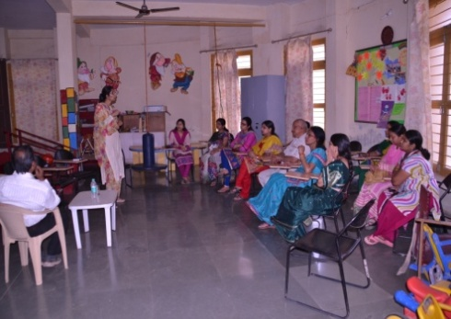 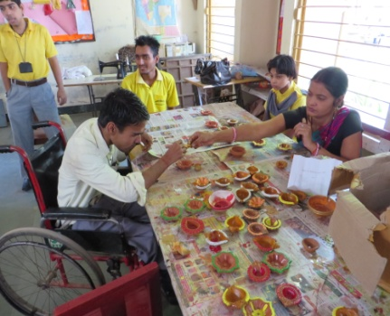 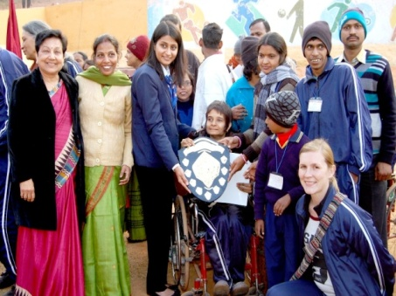

**E-Mail ID-** [**roshnigwalior@yahoo.co.in**](mailto:roshnigwalior@yahoo.co.in)**;** [**roshnigwalior@gmail.com**](mailto:roshnigwalior@gmail.com)

**Website-** [**www.roshni-rka.org**](http://www.roshni-rka.org)

.